MPEG BookKeeper

User Manual

Author: Cody Jones 2014

Contents

Section | Page
WeeklyRecap | 2
JCABuilder | 4
PMWorkbookCompiler | 6
QuarterlyReporter | 7
Example Timesheet | 10
Example JCAs | 11

WeeklyRecap

The WeeklyRecap program takes its input information from a collection of .xls format timesheets. It collects pertinent information from each employee timesheet, and compliles a recap file containing all |Jobs| for the week. This recap file is used as the input for the JCABuilder program.

Terms:
Job - A job represents a single row on an employee's timesheet. It contains the following fields:
- Job Name – the name of the project.
- Job Number – the job number.
- Initials – the initials of the employee.
- Class Code – The class code of the employee.
- Hours – The hours (labor or vehicle) the employee entered for the job for the week.
- Miles – The vehicle miles.
- FDT – Field density test charges.
- Other – Other charges.
- Type – An explanation of the Other charges.
- Prevailing Wage – If the job is charged at prevailing wage, the prevailing wage label is stored here.

Program Flow:
- Each timesheet in the input folder is opened and read.
    - For each timesheet:
      - Normal billable hours are read:
        - The program begins reading two rows after the “Project Name” heading:
          - For each row with non-zero hours in the column with the “Total” heading.
            - A |Job| is created with all information in the row, to be added to the recap file.
        - The program ends reading at the row just above the “Total Chargeable Hours” heading.
      - Other charges are read:
        - The program begins reading one row below the “Project Name” heading below the “Other Charges...” heading.
          - If any of the cells listed in the following columns are non-zero, a |Job| is created with the information in the row: Name, Hours, Miles, Other, FDT, Type.
        - The program ends reading one row above the “Total for Expense Report” label.
- Once all timesheets have been read, the recap file is written to a file in the timesheets folder named “WeeklyRecap_MM_DD_YYYY.xls”
- At the end of the program a log file containing all program output will be saved in the Timesheets folder under the file name “logfile.txt”.

Formatting Requirements:
- Required Labels: (Labels must match EXACTLY and are case sensitive)
  - “Project Name” - (must appear twice: once in the labor section and once in the other charges section)
  - “Project No.” - (must appear twice: once in the labor section and once in the other charges section)
  - “Initials”
  - “Initial-V”
  - “Total”
  - “P3=FDT”
  - “”P” ?”
  - “FDT”
  - “OTHER”
  - “TYPE”
  - “Total Chargeable Hours”
  - “Total for Expense Report”

- Formatting
  - All labor hours must be listed between the “Project Name” and “Total Chargeable Hours” headings, beginning two rows after the “Project Name” heading.
  - All other charges must be listed between the second “Project Name” and “Total for Expense Report” headings, beginning one row after the second “Project Name” heading.
  - For labor charges:
    - Every row in the “Total” column must contain a Sum() formula.
    - Any non-empty hours cell must contain a number (as opposed to letters).
  - For other charges:
    - Every row must contain Sum() formulas in both of the first hours and miles cells in the columns with the first “H” and “M” headings.

JCABuilder
The JCABuilder program reads jobs from a recap file (generated by the WeeklyRecap program) and adds charges to a new column in each relevant JCA.

Program Flow:
- A new folder is created in the JCA folder to contain all the updated JCAs. The folder is named “JCAs_MM_DD_YYYY.xls”. The date in the filename comes from the date input into the program, not the date of runtime.
- Jobs are read from the input Recap excel file.
- The jobs are sorted by job number.
- For each JCA with at least one job listed in the recap file:
  - The JCA is located.
    - The JCAs file name must match the job number listed on the timesheet and recap exactly.
    - If no JCA is found, the jca and all its jobs are listed in program output and the logfile.
  - All previous weeks are copied one column to the right. Blank cells are inserted over the cells for the most recent week (i.e. in column E).
  - For each labor charges Job:
    - Program searches for a row with matching employee initials and class code.
      - If a row can be found, the jobs hours are inserted into the row.
      - Otherwise the job is rejected and will be listed in program output, the logfile, and the recap_out file.
  - All inside charges are calculated as the sum of all vehicle hours, vehicle miles, and FDT charges across all employees for the week.
    - All inside charges are inserted into the JCA.
  - Formulas are updated:
    - All formulas in Column C for labor, inside, and reimbursable charges are updated to reflect the new range of columns.
    - The formulas in Column D, for the Total Labor, Total Inside Charges, and Total Reimbursable Chages are updated to reflect the new range of Columns.
    - For each week column, totals fromulas are overwritten for consistency.
  - The JCA file is written (saved).
- An output recap file is written, containing all jobs which were not able to be written to a JCA, as well as the reason each job could not be written. The output recap is saved in the same folder as the recap in file, with the same name with “_out” appended to it.
- All program output is saved to a logfile under the name “logfile.txt” in the new JCA folder.

Formatting Requirements:

- Required Labels:
  - JCA
    - “INSIDE CHGS”
    - “REIMB CHGS”
    - “VEHICLE (HRS)”
    - “MILES”
    - “FDT TEST”
    - “WEEK ENDING DATE:”
    - “WP/Assistant”
    - “PROJ MGR :”
    - “JCA Upload Format”
  - Recap
    - “End of Recap”
- Formatting:
  - JCA
    - Must be new format.
      - Must contain the “JCA Upload Format” label
    - Carry over from earlier sheets.
      - Must appear in the last column (furthest to the right)
      - Must apear only as totals; all cells between the “PERSONNEL” and “WEEK ENDING DATE:” labels must be blank.

PMWorkbookCompiler

The PMWorkbookCompiler collects and compiles the most recent sheets of a JCA into new Workbooks sorted by project manager, so that each PM has a complete list of charges to each of his or her jobs for the week.

Program Flow:
- Create a folder within the given JCA input folder called “Project Manager Workbooks”.
- For each JCA in the input folder:
  - Sort by project manager.
- For each PMWorkbook:
  - Copy all sheets into workbook.
  - Save workbook.
- List JCAs which could not be sorted or copied.
- Save a logfile in the project manager workboooks folder under the name “PMWorkbook_logfile.txt”.

Formatting Requirements:
- JCA:
  - JCAs must be the new “JCA Upload Format” and adhere to all JCA formatting requirements listed above under the JCABuilder formatting requirements.

QuarterlyReporter:

QuarterlyReporter collects all JCAs in the input JCA folder with unbilled charges or recent (in the given year) write offs. It sorts the JCAs by project manager. For each manager, a report is made with one project per row, with the following information: job name, job number, project manager, writeoffs for each quarter, unbilled charges, remaining budget, job status, and schedule of charges. Each row of the report also contains three check boxes for project managers to fill in: write off/on, bill, or carry over. At the bottom of each report are totals of unbilled charges and writeoffs for the entire quarter.

Input:
- JCA folder: a folder containing all active JCAs.
- Status File: a readout excel file generated by the Miller Pacific project database containing the current job status of all projects.
  - Use the database's active/dormant option.
  - Due to a quirk of the database's excel file as well as the way the jxl API is written, the database file must be opened and then saved in excel before QuarterlyReporter can read it.
- Reports Folder: the folder where the reports will be saved.
- Date: the date which the JCAs were last updated
- Quarter: the current financial quarter.
- Year: the current year.

Program Flow:
- Input is checked for validity.
- Each JCA in the input folder is checked for unbilled charges or recent writeoffs. Any JCAs meeting these criteria move on to the next step.
- All information is read for each JCA.
- Information is sorted by project manager.
- For each project manager, a report is created.
- Each report is filled in and saved.
- All rejected JCAs are listed along with the reason they were rejected.
- Program output is saved to a logfile in the reports folder named “logfile.txt”.

Formatting Requirements:
- JCA:
  - Labels:
    - New Format:
      - “JCA Upload Format”
      - “JOB:”;
      - “PROJ NAME:”
      - “PROJ MGR :”
      - “Unbilled Charges”
      - “Actual Budget Remaining”
      - "Write Off's (On's are negative #)"
      - “PERSONNEL”
      - “INSIDE CHGS”
      - “REIMB CHGS”
      - “WEEK ENDING DATE:”
      - “TOTAL LABOR”
      - “Billings\Retainer”
      - “BUDGET”
      - “HRS” - each weekly column of data must have this label.
    - Old Format:
      - “JOB NO.:”
      - “PROJ NAME:”
      - “PROJ MGR :”
      - “Unbilled Charges”
      - “Actual Budget Remaining”
      - "Write Off's (On's are negative #)"
      - “ITEM” - (used to find the SOC to the right of the label)
  - Formatting:
    - New Format:
      - Schedule of charges is listed in cell B2.
      - Only numbers or blanks are found in the data entry section.
- Write off labeling:
  - All write offs must be labeled as followed “Q# YYYY” with the exception of a November write off, which can be labeled as “Nov YYYY” or “11/1/YYYY”.
  - ie. “Q1 2014”, “Q2 2014”, “Q3 2014”, “Nov 2014”, “Q4 2014”.
  - Any writeoffs labeled with the year given as input at runtime will be sorted to the corresponding column on the report. All other writeoffs will be summed up in the “Prior” column of the report.

Terms
- Data entry section – the section of a new format JCA were charges are entered weekly by a user or by the JCABuilder. See example JCA.

Example Timesheet
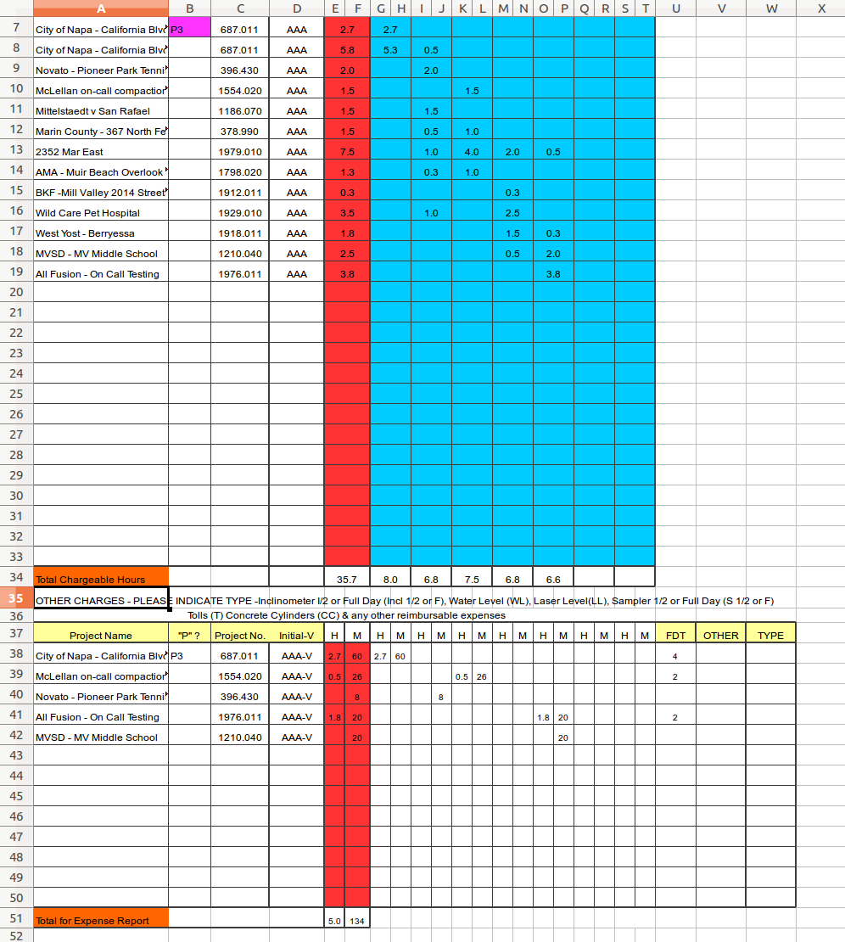
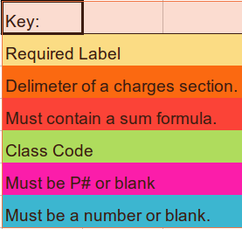

Example JCAs

Example JCA with JCABuilder Requirements Highlighted:
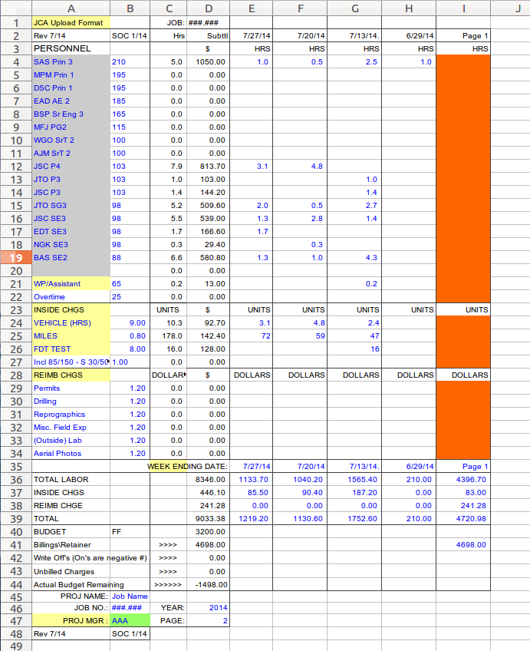
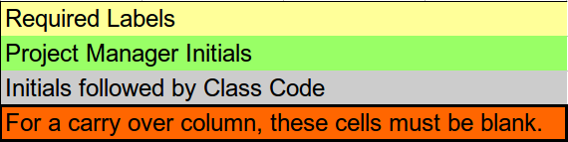

Example JCA with QuarterlyReporter Requirements Highlighted:

