MPEG Bookkeeper

User Manual

Author: Cody Jones 2014

Contents

Section | Page
Description | 2
General Requirements and Information | 3
Main Interface | 5
Weekly Recap | 6
JCA Builder | 8
PM Workbook Compiler | 10
Quarterly Reporter | 11
Example Timesheet | 13
Example JCAs | 14

Description
MPEG Bookkeeper is a software aide which performs common and tedious data management operations for the accounting department of Miller Pacific Engineering Group (MPEG). It is meant to supplement the use of existing excel spreadsheets, rather than perform as a standalone database and accounting program. It does so by automating four frequently utilized accounting functions: collecting all expenses and employee hours for a work week, sorting job costs to specific job excel spreadsheets, compiling job info for project managers, and summarizing cost and budget info for all projects in a single excel spreadsheet. These functions are hereon referred to respectively as Weekly Recap, JCA Builder, PM Workbook Compiler, and Quarterly Reporter. Weekly Recap collects data from weekly employee time sheets into a single excel spreadsheet referred to as a recap. JCA Builder reads a recap and disperses the information into appropriate Job Cost Assessment (JCA) forms. PM Workbook Compiler takes most recent sheet from all active JCAs and compiles them into a single excel workbook for each project manager. Quarterly Reporter summarizes important project budget and expenses info across all JCAs in a single excel spreadsheet. The goal of MPEG Bookkeeper is to streamline the collection, storage, and distribution of accounting data so that the accountant may focus on keeping employees and projects on budget.

Notes
MPEG Bookkeeper utilizes the jexcel API in order to interact with excel spreadsheets. Many thanks to Andy Khan, the creator of this open source API. As required, MPEG Bookkeeper extends jexcelapi's GNU General Public License 2.0. For more on the jexcelapi see http://www.andykhan.com/jexcelapi/ and http://jexcelapi.sourceforge.net/. As a consequence of using this API, it should be noted that MPEG Bookkeeper can only interact with the .xls format of excel files.

General Requirements and Information
- MPEG Bookkeeper can only interact with .xls format excel files.
- MPEG Bookkeeper operates on batches of excel files as input. To make user input easier, the program expects each class of file to be in a unique folder; i.e. all JCAs for JCA Builder should be in a single folder. This is also true for weekly collections of employee time sheets. In this way the user is responsible only to supply the program with the directory containing the relevant files.
- All processes in the program also require a week ending or valid thru date. To ease user interaction, week ending dates default to the most recent Sunday. Be sure to modify this field if running the program on older data.
- Each tab contains both a start and stop button. Start will begin the relevant process using the input info currently in the input fields. Once a process is running, that process cannot be started again until that process completes or is stopped. The stop button will safely stop the process mid run.
- The user can run multiple processes at the same time, i.e. PM Workbook Compiler and Quarterly Reporter can be run simultaneously. This is safe but not recommended, as the program is not optimized for multiple threads and can slow down significantly.
- JCA Builder creates new and updated copies of the JCAs each time it is run. These copies are created in a new sub-folder of the JCAs folder. Therefore to update the main database, the new JCAs should be copied back into the main JCA folder, overwriting the old JCAs. There are a number of reasons for this design decision:
  - Data safety: if something were to crash the program while JCA Builder was overwriting an existing JCA, that JCA may become corrupt.
  - Human intervention: the user may view and add extra charges to the JCAs before incorporating the changes into the active files.
  - Convenience: all JCA updates week by week are stored together, so that all new charges for the week are completely summed up in this folder of JCAs. Also, PM Workbook Compiler may be run on this sub-folder so that the project managers receive a summary workbook for this week only.
- Program output is saved to logfile.txt in the relevant output folder after each program run for later review.

A Note on Organization
To make the use of MPEG Bookkeeper as efficient as possible, it is recommended (but not required) that all excel files are stored in a directory structure similar to:
- Database
  - TimeSheets
    - A folder containing a folder for each week of time sheets.
  - Recaps
    - A folder for recap files made by Weekly Recap and JCABuilder.
  - JCAs
    - A folder containing the must up to date JCAs.
    - JCABuilder will create a new folder for each week's updated JCAs within this folder.
  - PMWorkbooks
    - A folder where PM Workbook Compiler can create new folders for each week of project manager workbooks.
  - Quarterly Reports
    - A folder where Quarterly Reporter can create new folders to contain the output reports each time it is run.
By following this structure and saving the settings to reflect each of these folders, minimal user input is needed when running the program.

Main Interface
The graphical user interface of MPEG Bookkeeper consists of a single window containing a collection of tabs, one for each operation (Weekly Recap, JCA Builder, PM Workbook Compiler, and Quarterly Reporter). Each tab contains a scrolling text log on the left which displays program output, and a collection of buttons and input fields on the right. To run a portion of the program, simply supply the relevant input data, and click the start button on the bottom right of the window.

Input
Each portion of MPEG Bookkeeper requires some input, usually a directory containing files to work on, and a date up to which the the output will be up to date. Each portion of the programs specific input requirements will be discussed in that portions section of this manual.

Settings
MPEG Bookkeeper supports saved settings for common directories used as input to the program, so that the user does not have to navigate to each directory every time the program is run. The user may change the settings under the Settings > Edit Settings selection at the top of the window. This will open the settings window wherein the user may make selections and then hit apply to load the new settings into the running program, and save to save the settings for the next time the program is run. The settings are saved to a text file called MPEGBookkeeper.dat in the same directory as the program itself.

Help
By navigating to Help > User Manual using the menu at the top of the window, this user manual can be displayed. This requires that a pdf copy of this user manual is stored in the same folder as MPEGBookKeeper.exe under the filename MPEGBookkeeperUserManual.pdf.

Weekly Recap

The Weekly Recap program takes its input information from a collection of .xls format time sheets. It collects pertinent information from each employee time sheet, and compiles a recap file containing all |Jobs| for the week. This recap file is used as the input for the JCA Builder program.

Terms
Job - A job represents a single row on an employee's times heet. It contains the following fields:
- Job Name – the name of the project.
- Job Number – the job number.
- Initials – the initials of the employee.
- Class Code – The class code of the employee.
- Hours – The hours (labor or vehicle) the employee entered for the job for the week.
- Miles – The vehicle miles.
- FDT – Field density test charges.
- Other – Other charges.
- Type – An explanation of the Other charges.
- Prevailing Wage – If the job is charged at prevailing wage, the prevailing wage label is stored here.

Input
- Time Sheets Folder – A folder containing all of this weeks time sheets.
- Recaps Folder – A folder where the output recap file will be written to.
- Week Ending Date - The date of the end of the week for which these time sheets apply.

Program Flow
- Each timesheet in the input folder is opened and read.
    - For each timesheet:
      - Normal billable hours are read:
        - The program begins reading two rows after the “Project Name” heading:
          - For each row with non-zero hours in the column with the “Total” heading.
            - A |Job| is created with all information in the row, to be added to the recap file.
        - The program ends reading at the row just above the “Total Chargeable Hours” heading.
      - Other charges are read:
        - The program begins reading one row below the “Project Name” heading below the “Other Charges...” heading.
          - If any of the cells listed in the following columns are non-zero, a |Job| is created with the information in the row: Name, Hours, Miles, Other, FDT, Type.
        - The program ends reading one row above the “Total for Expense Report” label.
- Once all timesheets have been read, the recap file is written to a file in the Recaps folder named “WeeklyRecap_MM_DD_YYYY.xls”
- At the end of the program a log file containing all program output will be saved in the Recaps folder under the file name “logfile.txt”.

Formatting Requirements
- Required Labels: (Labels must match EXACTLY and are case sensitive)
  - “Project Name” - (must appear twice: once in the labor section and once in the other charges section)
  - “Project No.” - (must appear twice: once in the labor section and once in the other charges section)
  - “Initials”
  - “Initial-V”
  - “Total”
  - “P3=FDT”
  - “”P” ?”
  - “FDT”
  - “OTHER”
  - “TYPE”
  - “Total Chargeable Hours”
  - “Total for Expense Report”

- Formatting
  - All labor hours must be listed between the “Project Name” and “Total Chargeable Hours” headings, beginning two rows after the “Project Name” heading.
  - All other charges must be listed between the second “Project Name” and “Total for Expense Report” headings, beginning one row after the second “Project Name” heading.
  - For labor charges:
    - Every row in the “Total” column must contain a Sum() formula.
    - Any non-empty hours cell must contain a number (as opposed to letters).
  - For other charges:
    - Every row must contain Sum() formulas in both of the first hours and miles cells in the columns with the first “H” and “M” headings.

JCA Builder
The JCA Builder program reads jobs from a recap file (generated by the WeeklyRecap program) and adds charges to a new column in each relevant JCA.

Input
- JCA Folder – A folder containing all of the JCAs. The output JCAs will be written to a new folder under this one.
- Recap File – A recap file as output by Weekly Recap.
- Week Ending Date - The date of the end of the week for which these time sheets apply.

Program Flow
- A new folder is created in the JCA folder to contain all the updated JCAs. The folder is named “JCAs_MM_DD_YYYY.xls”. The date in the filename comes from the date input into the program, not the date of runtime.
- Jobs are read from the input Recap excel file.
- The jobs are sorted by job number.
- For each JCA with at least one job listed in the recap file:
  - The JCA is located.
    - The JCAs file name must match the job number listed on the timesheet and recap exactly.
    - If no JCA is found, the jca and all its jobs are listed in program output and the logfile.
  - All previous weeks are copied one column to the right. Blank cells are inserted over the cells for the most recent week (i.e. in column E).
  - For each labor charges Job:
    - Program searches for a row with matching employee initials and class code.
      - If a row can be found, the jobs hours are inserted into the row.
      - Otherwise the job is rejected and will be listed in program output, the logfile, and the recap_out file.
  - All inside charges are calculated as the sum of all vehicle hours, vehicle miles, and FDT charges across all employees for the week.
    - All inside charges are inserted into the JCA.
  - Formulas are updated:
    - All formulas in Column C for labor, inside, and reimbursable charges are updated to reflect the new range of columns.
    - The formulas in Column D, for the Total Labor, Total Inside Charges, and Total Reimbursable Chages are updated to reflect the new range of Columns.
    - For each week column, totals fromulas are overwritten for consistency.
  - The JCA file is written (saved).
- An output recap file is written, containing all jobs which were not able to be written to a JCA, as well as the reason each job could not be written. The output recap is saved in the same folder as the recap in file, with the same name with “_out” appended to it.
- All program output is saved to a logfile under the name “logfile.txt” in the new JCA folder.

Formatting Requirements
- Required Labels:
  - JCA
    - “INSIDE CHGS”
    - “REIMB CHGS”
    - “VEHICLE (HRS)”
    - “MILES”
    - “FDT TEST”
    - “WEEK ENDING DATE:”
    - “WP/Assistant”
    - “PROJ MGR :”
    - “JCA Upload Format”
  - Recap
    - “End of Recap”
- Formatting:
  - JCA
    - Must be new format.
      - Must contain the “JCA Upload Format” label
    - Carry over from earlier sheets.
      - Must appear in the last column (furthest to the right)
      - Must apear only as totals; all cells between the “PERSONNEL” and “WEEK ENDING DATE:” labels must be blank.

PM Workbook Compiler

The Project Manager(PM) Workbook Compiler collects and compiles the most recent sheets of a JCA into new Workbooks sorted by project manager, so that each PM has a complete list of charges to each of his or her jobs for the week.

Input
- JCA Folder – A folder containing all of the JCAs with which to compile the workbooks.
- PM Workbooks Folder – A new folder will be created within this one to hold the output project manager workbooks.
- Week Ending Date - The date of the end of the week for which these time sheets apply.

Program Flow
- Create a folder within the given PM Workbooks Folder input folder called “Project Manager Workbooks_MM_DD_YYYY”.
- For each JCA in the input folder:
  - Sort by project manager.
- For each PMWorkbook:
  - Copy all sheets into workbook.
  - Save workbook in the newly created PM Workbooks Folder.
- List JCAs which could not be sorted or copied.
- Save a logfile in the new project manager workboooks folder under the name “PMWorkbook_logfile.txt”.

Formatting Requirements
- JCA:
  - JCAs must be the new “JCA Upload Format” and adhere to all JCA formatting requirements listed above under the JCABuilder formatting requirements.

Quarterly Reporter

Quarterly Reporter collects all JCAs in the input JCA folder with unbilled charges or recent (in the given year) write offs. It sorts the JCAs by project manager. For each manager, a report is made with one project per row, with the following information: job name, job number, project manager, write offs for each quarter, unbilled charges, remaining budget, job status, and schedule of charges. Each row of the report also contains three check boxes for project managers to fill in: write off/on, bill, or carry over. At the bottom of each report are totals of unbilled charges and write offs for the entire quarter.

Terms
Data entry section – the section of a new format JCA were charges are entered weekly by a user or by the JCABuilder. See example JCA.

Input
- JCA folder – A folder containing all active JCAs.
- Reports Folder – A folder will be created within this one to contain all of the output reports.
- Status File – A readout excel file generated by the Miller Pacific project database containing the current job status of all projects.
  - Use the database's active/dormant option.
  - Due to a quirk of the database's excel file as well as the way the jxl API is written, the database file must be opened and then saved in Excel before QuarterlyReporter can read it.
- Valid thru – The date (MM/DD) which the JCAs were last updated.
- Year – The current year.

Program Flow
- Input is checked for validity.
- Each JCA in the input folder is checked for unbilled charges or recent writeoffs. Any JCAs meeting these criteria move on to the next step.
- All information is read for each JCA.
- Information is sorted by project manager.
- For each project manager, a report is created.
- A new folder is created within the provided Reports Folder with the name “WIP_Reports_MM_DD_YYYY”
- Each report is filled in and saved to the new reports folder.
- All rejected JCAs are listed along with the reason they were rejected.
- Program output is saved to a logfile in the new reports folder named “logfile.txt”.

Formatting Requirements
- JCA:
  - Labels:
    - New Format:
      - “JCA Upload Format”
      - “JOB:”;
      - “PROJ NAME:”
      - “PROJ MGR :”
      - “Unbilled Charges”
      - “Actual Budget Remaining”
      - "Write Off's (On's are negative #)"
      - “PERSONNEL”
      - “INSIDE CHGS”
      - “REIMB CHGS”
      - “WEEK ENDING DATE:”
      - “TOTAL LABOR”
      - “Billings\Retainer”
      - “BUDGET”
      - “HRS” - each weekly column of data must have this label.
    - Old Format:
      - “JOB NO.:”
      - “PROJ NAME:”
      - “PROJ MGR :”
      - “Unbilled Charges”
      - “Actual Budget Remaining”
      - "Write Off's (On's are negative #)"
      - “ITEM” - (used to find the SOC to the right of the label)
  - Formatting:
    - New Format:
      - Schedule of charges is listed in cell B2.
      - Only numbers or blanks are found in the data entry section.
- Write off labeling:
  - All write offs must be labeled as followed “Q# YYYY” with the exception of a November write off, which can be labeled as “Nov YYYY” or “11/1/YYYY”.
  - ie. “Q1 2014”, “Q2 2014”, “Q3 2014”, “Nov 2014”, “Q4 2014”.
  - Any writeoffs labeled with the year given as input at runtime will be sorted to the corresponding column on the report. All other writeoffs will be summed up in the “Prior” column of the report.

Example Timesheet
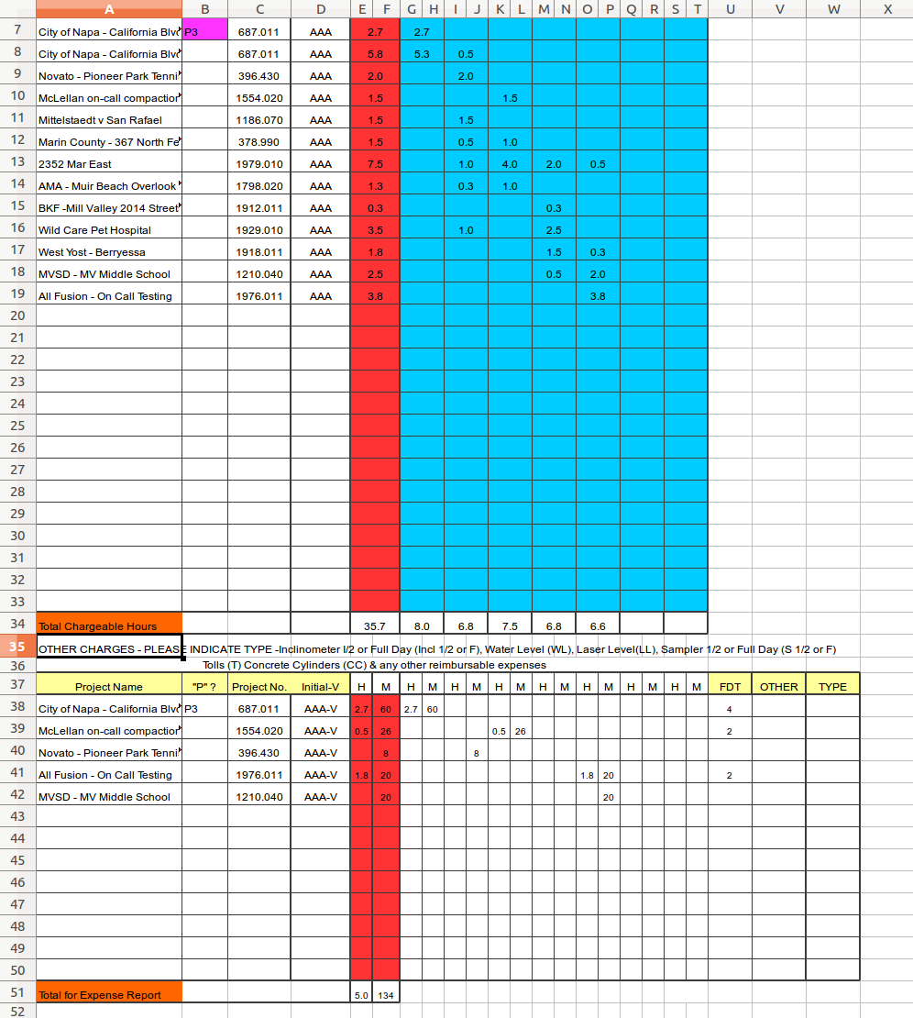
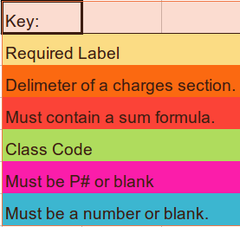

Example JCAs

Example JCA with JCABuilder Requirements Highlighted:
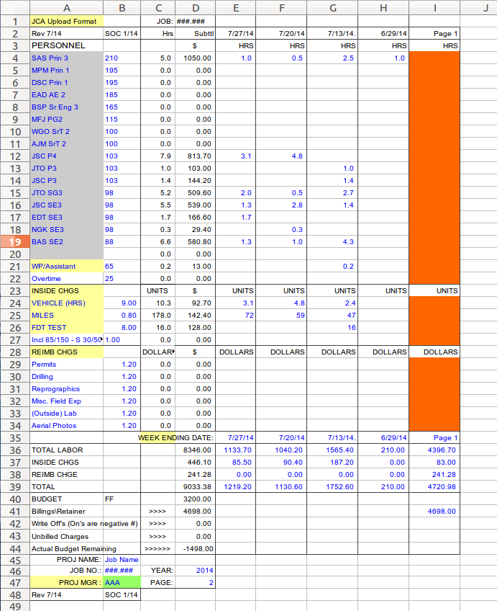
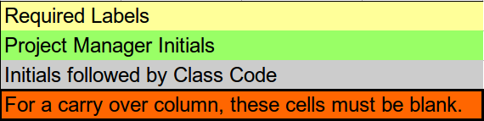

Example JCA with QuarterlyReporter Requirements Highlighted:

