How to Open a Port

A Simple Guide from the Dev
Note:
If your network provider puts you behind NAT, this may not work. You must have a public IP address first.

1. Entering the Router Menu
- Press Win + R, type cmd, and press OK. 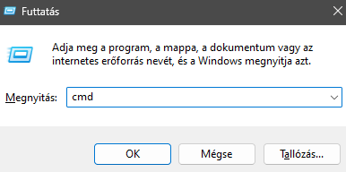

2. Finding Your Router IP
- In the command prompt, run the command ipconfig.
- Choose the network adapter you are using:
  - If you play only on LAN, choose the adapter used by all players.
  - If you need external connections, choose the one connected to the internet.
- Find the IPv4 Default Gateway (example: 192.168.1.1) and paste it into your browser’s address bar.
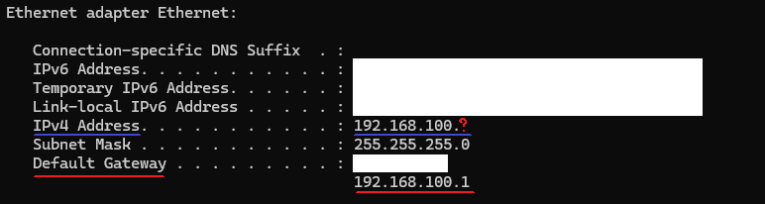

3. Entering the Router
- Login with your router username and password (usually on the bottom of the router).
- Locate Port Forwarding in the router menu (location and name may vary depending on the manufacturer).

4. Applying a New Port Forward Rule
- Create a new rule to forward your chosen port (default Minecraft port: 25565) from your router to your PC.
- Protocol: Select TCP/UDP. If the router does not support both in one rule, create two rules (one for TCP, one for UDP).
- Internal IP: Use your PC’s IPv4 address from ipconfig. If your gateway is 192.168.1.1, your PC is often something like 192.168.1.2.
- Port: Use the port you want to run the server on (usually 25565).
- Internal/External Port: If asked, set them to the same value.
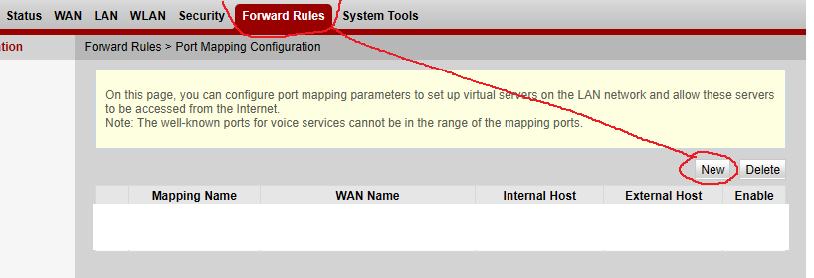

5. Apply and Test
- Apply the rule.
- Open the program and navigate to:
MENU → IP CONTROL SETTINGS → Is Port Open
- After selecting the correct port, the check should succeed.
- If it does not, you may be behind a NAT network. In this case, port forwarding will not work.
Alternatives:
- Use a VPN (may be slower)
- Use a third-party tunnel service (may require payment), for example:
Minekube Connect – The Ingress Tunnel for Minecraft Servers

