Books to Read

I am a Strange Loop

By Douglas Hofstadter

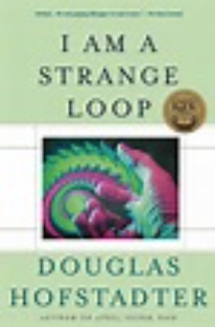

Godel Escher Bach: An Eternal Golden Braid

By Douglas Hofstadter

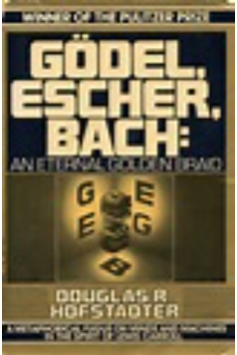

The Minds Eye

By Douglas Hofstadter

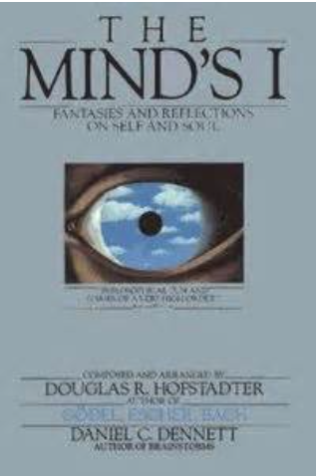

[Metamagical Themas: Questing For The Essence Of Mind](http://www.amazon.com/Metamagical-Themas-Questing-Essence-Pattern/dp/0465045669)

By Douglas Hofstadter

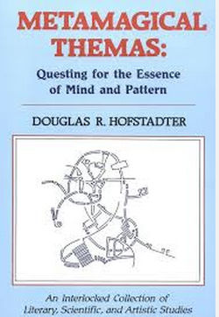

The Web of Life

By Fritjof Capra

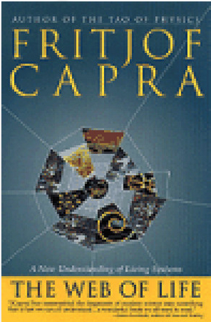

Dark Matter and Dinosaurs

By Lisa Randall

