iptables Firewall Configuration Lab
Linux Network Security | NETinVM Virtual Lab Environment
Cue Patrick Khan | June 2026

Project Overview
This lab demonstrates hands-on Linux firewall configuration using iptables, the standard packet filtering framework in the Linux kernel. Working inside a fully virtualised multi-segment network (NETinVM on VMware Workstation Pro), I configured a dedicated firewall machine (fw) to control traffic between three network zones: an Internet-facing segment, a DMZ, and an internal private network.

The objective was to design and apply a layered firewall rule set that enforces the principle of least privilege, implements stateful packet inspection, and supports NAT, mirroring real-world enterprise network security design.

Lab Environment
Component | Details
Platform | NETinVM (Network-in-a-VM) on VMware Workstation Pro
Firewall OS | Linux (Debian 12 bookworm)- machine: fw
Tool | iptables (Netfilter packet filtering framework)
Internet Segment | 10.5.0.0/24- host: exta (10.5.0.10)
DMZ Segment | 10.5.1.0/24- host: dmza / web server (10.5.1.10)
Internal Segment | 10.5.2.0/24- host: inta (10.5.2.10)
Firewall Interfaces | eth0 (Internet) | eth1 (DMZ) | eth2 (Internal)

Environment Setup
The NETinVM environment was launched inside VMware Workstation Pro. The desktop provides icons for configuring and running KVM virtual machines, accessing documentation, and viewing credentials.

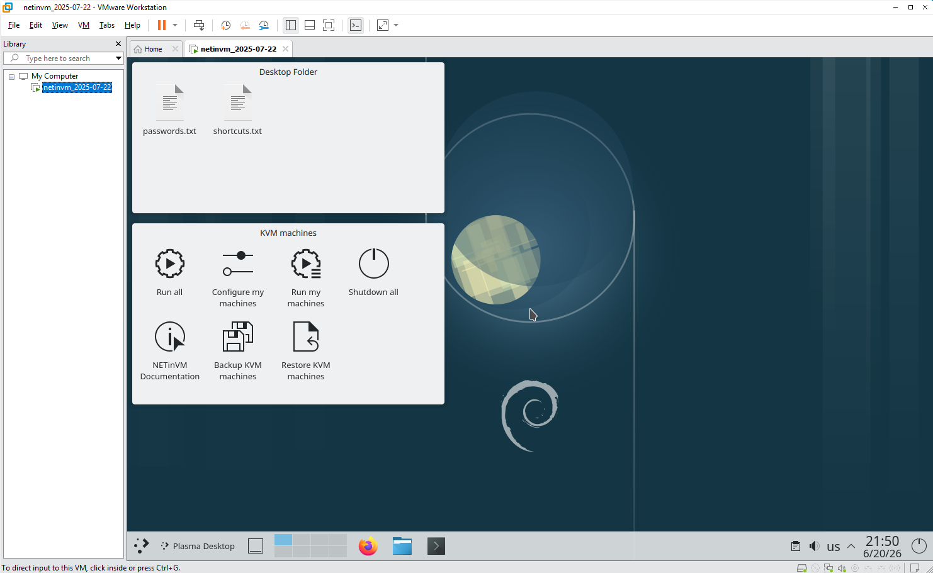
Figure 1- NETinVM desktop running inside VMware Workstation Pro
The NETinVM run script was opened to verify which machines were enabled. Initially only exta was uncommented, which meant fw, dmza, and inta did not start. The remaining machines were added to the script and saved before re-running.

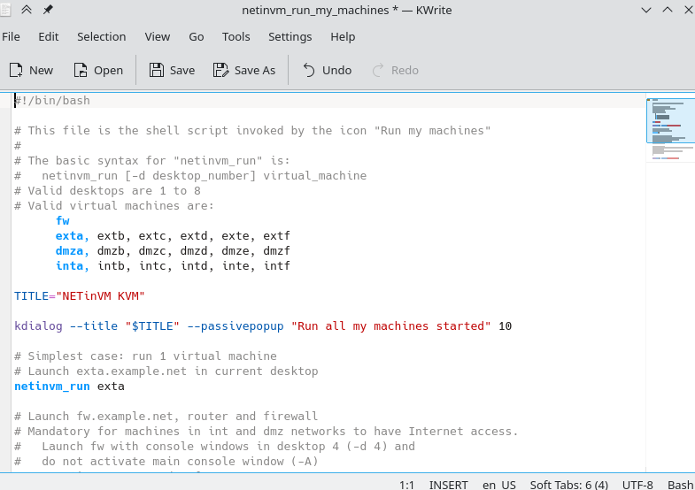
Figure 2- NETinVM run script showing machine configuration

Firewall Rules Applied
The following 10 rules were designed and applied to the firewall in sequence on the fw machine logged in as root. Q2 was written for documentation only and not executed to avoid flushing the active rule set mid-configuration.

# | Objective | Command(s) | Explanation
1 | List filter table rules | iptables -t filter -L -v -n | View all chains in the filter table with packet/byte counters, suppressing DNS lookups.
2 | Flush all filter rules | iptables -t filter -F | Removes all rules from every chain. Written for reference; not executed live.
3 | Set OUTPUT chain to DROP | iptables -t filter -P OUTPUT DROP | Implements deny-by-default on outbound traffic from the firewall itself.
4 | Allow established connections | iptables -A INPUT -m state --state ESTABLISHED,RELATED -j ACCEPT  iptables -A FORWARD -m state --state ESTABLISHED,RELATED -j ACCEPT  iptables -A OUTPUT -m state --state ESTABLISHED,RELATED -j ACCEPT | Stateful rule allowing return traffic across all chains. Prevents lockout after DROP policies.
5 | Allow internal DNS to Cloudflare | iptables -A FORWARD -i eth-int -o eth-ext -p udp -s 10.5.2.0/24 -d 1.1.1.1 --dport 53 -m state --state NEW -j ACCEPT  iptables -A FORWARD -i eth-int -o eth-ext -p udp -s 10.5.2.0/24 -d 1.0.0.1 --dport 53 -m state --state NEW -j ACCEPT | Restricts DNS to Cloudflare resolvers only (1.1.1.1 / 1.0.0.1).
6 | DNAT: Redirect HTTPS to DMZ | iptables -t nat -A PREROUTING -i eth-int -p tcp -s 10.5.2.0/24 --dport 443 -m state --state NEW -j DNAT --to-destination 10.5.1.10:443 | Destination NAT transparently routes HTTPS from internal users to the DMZ web server.
7 | Allow DMZ outbound HTTPS | iptables -A FORWARD -i eth-dmz -o eth-ext -p tcp -s 10.5.1.10 --dport 443 -m state --state NEW -j ACCEPT | Permits the DMZ web server to initiate HTTPS connections to the Internet.
8 | Allow SSH: Internet to DMZ | iptables -A FORWARD -i eth-ext -o eth-dmz -p tcp -s 10.5.0.10 -d 10.5.1.10 --dport 22 -m state --state NEW -j ACCEPT | SSH access to DMZ strictly limited to a single authorised Internet host (10.5.0.10).
9 | Firewall outbound to update server | iptables -A OUTPUT -p tcp -d 82.194.78.250 --dport 443 -m state --state NEW -j ACCEPT  iptables -A OUTPUT -p tcp -d 82.194.78.250 --dport 22 -m state --state NEW -j ACCEPT | Allows the firewall to reach the Debian update server via HTTPS and SFTP.
10 | Allow internal RDP to DMZ | iptables -A FORWARD -i eth-int -o eth-dmz -p tcp -s 10.5.2.0/24 -d 10.5.1.89 --dport 3389 -m state --state NEW -j ACCEPT | Pre-stages RDP access from the internal subnet to a planned DMZ RDP server.

Rule Verification- Screenshots

Baseline Rule Listing (Q1)
After logging into fw as root, the initial iptables -t filter -L -v -n command was run. This confirmed the starting state of the firewall with INPUT and FORWARD chains already set to DROP policy from a prior configuration.

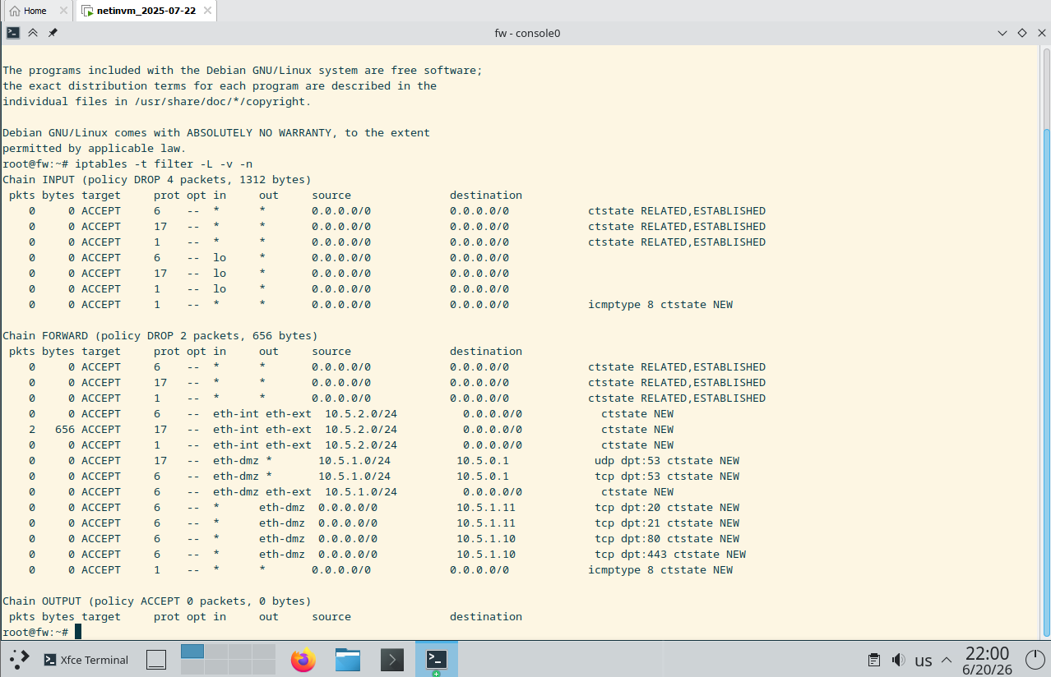
Figure 3- Initial iptables filter table listing showing INPUT and FORWARD at DROP policy

OUTPUT Chain Set to DROP (Q3)
After running iptables -t filter -P OUTPUT DROP, the rule listing was verified. The Chain OUTPUT line confirms the policy changed to DROP with 0 packets and 0 bytes, completing the deny-by-default stance across all three chains.

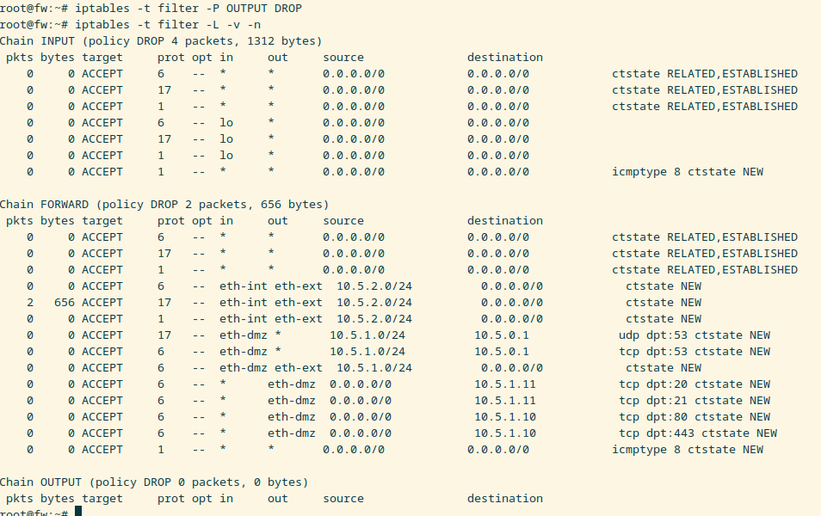
Figure 4- Chain OUTPUT confirmed policy DROP after Q3 execution

Stateful Connection Rules Applied (Q4)
Three ESTABLISHED, RELATED rules were applied across INPUT, FORWARD, and OUTPUT chains simultaneously. Silent execution (no output) confirmed all three rules were accepted by the kernel without error.

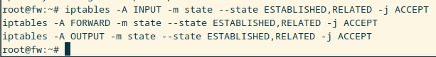
Figure 5- Stateful rules applied silently across all three chains

Final Complete Rule Set (All Rules Applied)
After applying all 10 rules, a final iptables -t filter -L -v -n and iptables -t nat -L -v -n was run to verify the complete rule set. All rules are visible across INPUT, FORWARD, OUTPUT, and PREROUTING chains, including the Cloudflare DNS rules, SSH, HTTPS, DNAT redirect, update server access, and RDP pre-staging rule.

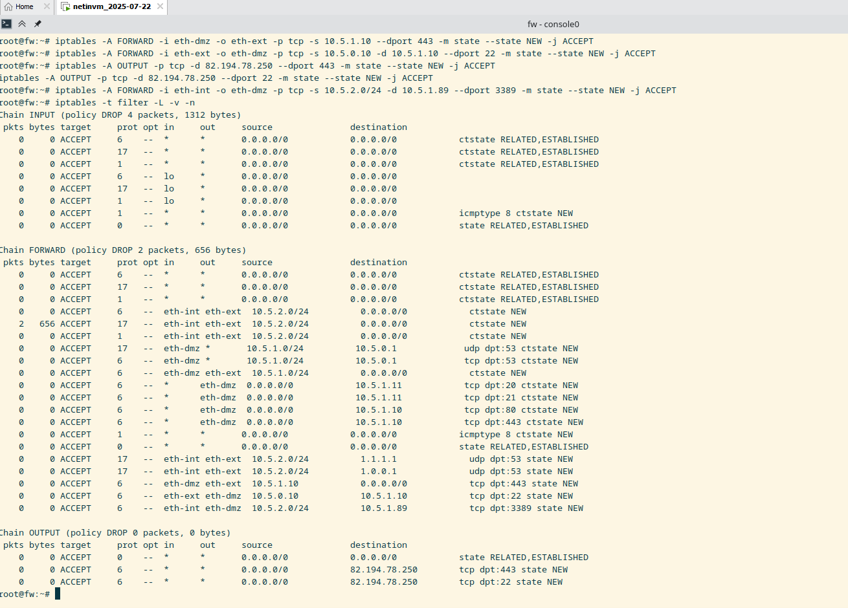
Figure 6- Final complete rule set across filter and nat tables after all rules applied

Skills Demonstrated
Skill / Concept | Demonstrated Through
Default-deny policy | Q3- OUTPUT chain set to DROP; verified via rule listing
Stateful packet inspection | Q4- ESTABLISHED, RELATED matching across all three chains
DNS traffic filtering | Q5- DNS restricted to Cloudflare resolvers, UDP port 53 only
Destination NAT (DNAT) | Q6- Transparent HTTPS redirection from internal to DMZ web server
DMZ segmentation | Q7, Q8, Q10- Controlled inter-zone traffic with IP scoping
Principle of least privilege | Q8- SSH restricted to a single source IP
Firewall-originated traffic control | Q9- OUTPUT chain rules for traffic from fw itself
Virtual environment troubleshooting | Diagnosed VM startup failure and corrected NETinVM run script

Tools & Technologies
Tool / Technology | Purpose
iptables | Linux Netfilter packet filtering- rule creation, chain policy, NAT
VMware Workstation Pro | Type 2 hypervisor hosting the NETinVM virtual lab
NETinVM | Pre-built multi-VM network-in-a-VM lab environment
Linux CLI (Bash) | Live rule execution, verification, troubleshooting

