Task Division

第一种分类(Cognitive Process Dimension)：

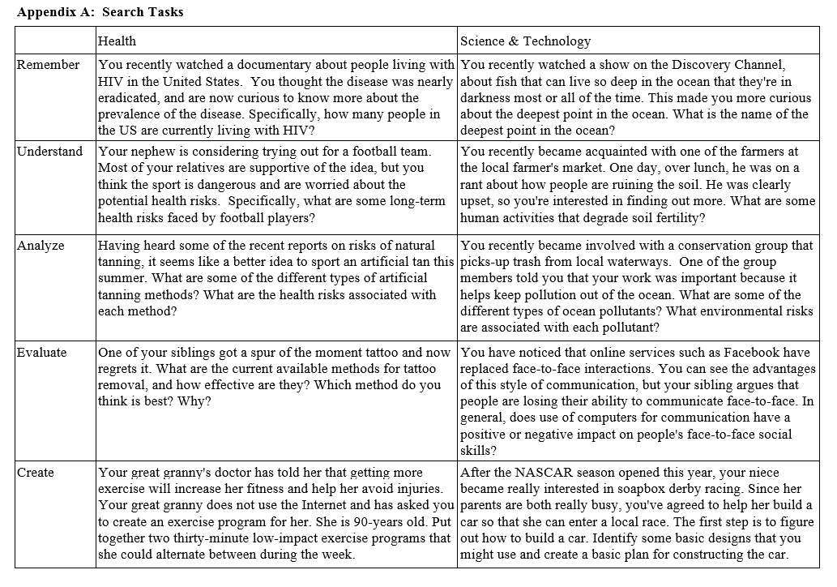

|  |  |
| --- | --- |
|  | task |
| Remember |  |
| Understand | 5, 9, 11, 15, 16, 17, 26, 32, 35, 47 |
| Analyze | 1, 2, 3, 4, 8, 10, 13, 14, 23, 24, 27, 31, 42, 43, 44, 45, 48 |
| Evaluate | 12, 18, 41 |
| Create |  |

第二种分类：

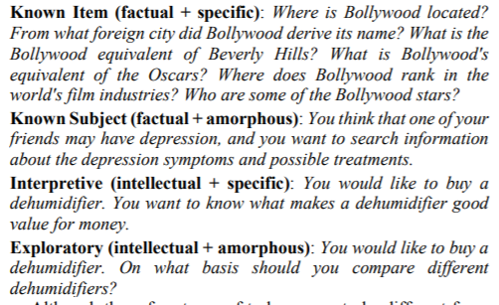

|  |  |  |
| --- | --- | --- |
|  | Specific | Amorphous |
| Factual | 4, 6, 11, 15, 16, 17 | 10, 13, 23, 24, 26, 32, 35 |
| Intellectual | 2, 12, 14, 18, 42, 44, 47, 48 | 1, 3, 8, 9, 27, 31, 41, 43, 45 |

1. 分布并不均匀，能否修改问题，是不是搜索问题本身的局限
   1. 可以修改问题
   2. 不同类问题数量一致，每个用户一个task
   3. 问题时间统一（保留问题，无关变量）
2. 今年招了6个，PhD information，是stem专业，托福，前三年free funding，至少有TA，RA，春秋两季免学费
3. 和老师的分类

另一位同学的编码：

|  |  |  |
| --- | --- | --- |
|  | Specific | Amorphous |
| Factual | 3, 6, 13, 15, 16, 32, 42 | 1, 11, 12, 17, 18, 23, 24, 26, 35 |
| Intellectual | 2, 4, 8, 9, 10, 14, 31 | 27, 41, 43, 44, 45 |

最终分类：

|  |  |  |
| --- | --- | --- |
|  | Specific | Amorphous |
| Factual | 3, 6, 11, 13, 15, 16, 32 | 1, 12, 23, 24, 26, 35, 42 |
| Intellectual | 2, 4, 8, 9, 10, 14, 31 | 27, 41, 43, 44, 45, 47, 48 |