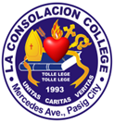
LA CONSOLACION COLLEGE-PASIG
641 Mercedes Avenue, Brgy. San Miguel, Pasig City
LEARNING PLAN
S.Y. 2026-2027
Subject: Language |  | Grade Level: Kinder 2 |  |  | Date Coverage: Week 6 – August 3-7, 2026  Term 1
I Learning Objectives: At the end of the lesson the students will be able to:  - Identify the names of things in the house.  - Tell the uses of common things in the house by using “is” and “are”  - Recite rhyme about things in the house and;  - Cut out and paste the pictures of the things found in the house. |  |  | II Subject Matter  Lesson: Learning about things in the house.  Reference/s: Early Beginnings: Language Kinder worktext
III - Learning Competencies:
- The learner demonstrates understanding of common household objects by identifying their names, describing their uses with “is” and “are,” and creatively expressing knowledge through rhymes and art activities.
III- Values Statement:
God gave us our home and the things inside it to help us live safely and happily. When we take care of the things in our house, use them properly, and share them with love, we show respect and gratitude to God and our family.
IV- Procedures:
a. Routine Activities

- Prayer
- Circle Time
- Attendance

b. Motivation:
My house
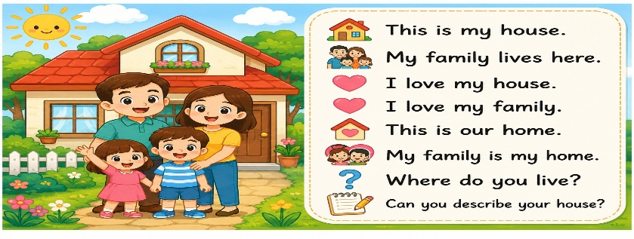

c. Learning Strategies
Picture Talk: The teacher will show pictures of things inside the house.
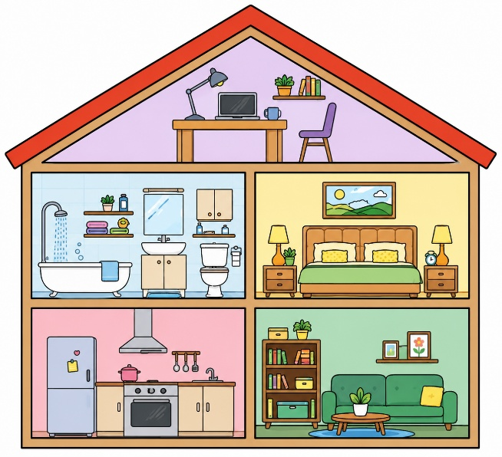

Instructions: Share the things that you see inside the house.
Questions:
- What can you see in each room?
- Do you have the same things in your house?
- How are you going to take care of your house?
V- Assessment:
- Color the correct picture being described.
- Box the correct name of the picture.

VI- Closure: The teacher will recap the importance of the things inside house.
VII- Assignment: Cut out and paste the pictures of your things you use in your house. Page 40

Remarks:
Prepared by:  Ms. Kathrynn Ross L. Acola | Checked by:  Mrs. Emma P. Dunque Lpt. |  |  | Observed by:  Mrs. Emma P. Dunque Lpt.

