**Activity 1**

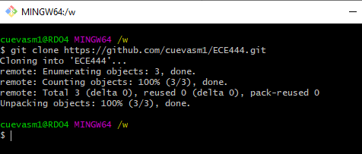

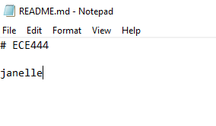

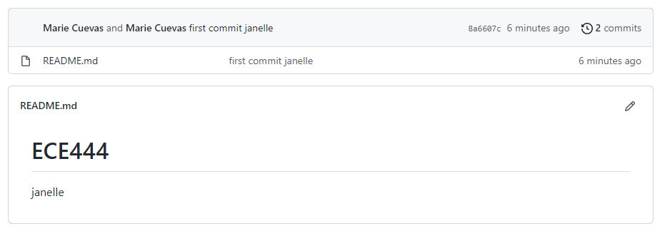

**Activity 2**

Git add .

Git add filename.txt

Git commit –m “commit message”

Git branch

Git checkout main

Git merge develop

Git push origin main

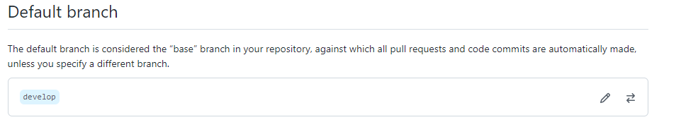

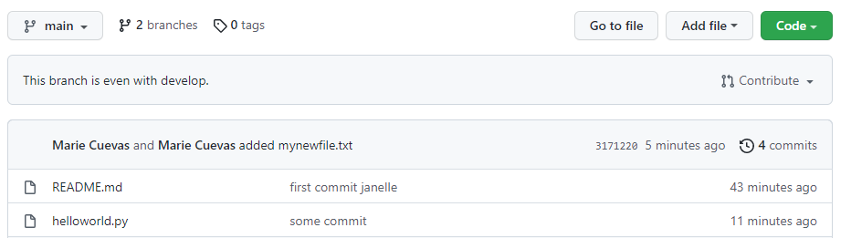

**Activity 3**