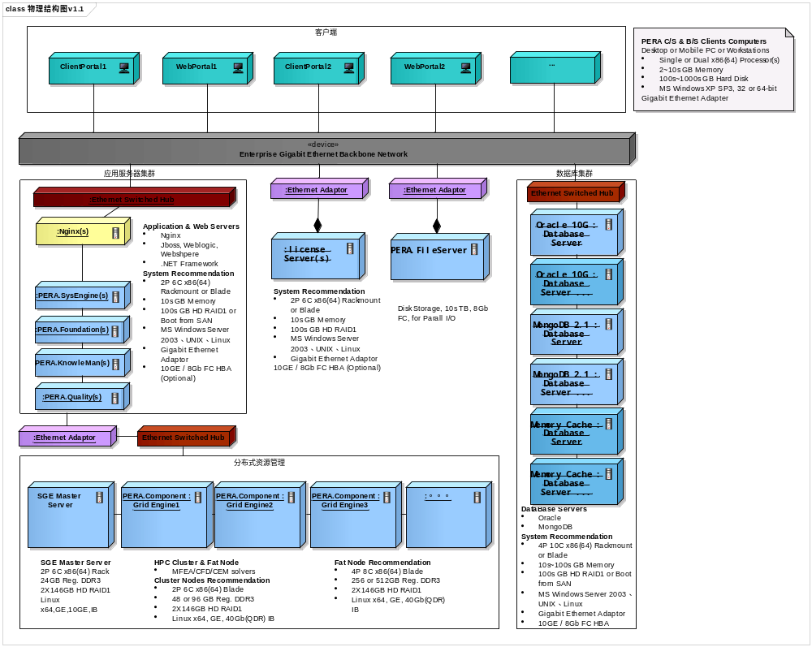
配置
- DRM搭配N个Agent（N<30）
  - DRM Master Server
      - 2P 6C x86(64) Rackmout or Brade
      - 8sGB Memory
      - 100sGB HD RAID1
      - Window、Linux
      - Gigabit Ethernet Adaptor
  - Agent
      - 2P 6C x86(64) Rackmout or Brade
      - 48sGB Memory
      - 146sGB HD RAID1
      - Window、Linux
      - Gigabit Ethernet Adaptor
- DRM搭配N个Agent（N>30）
  - DRM Master Server
      - 个数M=N/30
      - 2P 6C x86(64) Rackmout or Brade
      - 8sGB Memory
      - 100sGB HD RAID1
      - Window、Linux
      - Gigabit Ethernet Adaptor
    - LoadBalance Server
      - 2P 6C x86(64) Rackmout or Brade
      - 8sGB Memory
      - 100sGB HD RAID1
      - Window、Linux
      - Gigabit Ethernet Adaptor
    - Agent
      - 2P 6C x86(64) Rackmout or Brade
      - 48sGB Memory
      - 146sGB HD RAID1
      - Window、Linux
      - Gigabit Ethernet Adaptor
- DRM搭配SGE
  - DRM Master Server
      - 2P 6C x86(64) Rackmout or Brade
      - 8sGB Memory
      - 100sGB HD RAID1
      - Window、Linux
      - Gigabit Ethernet Adaptor
  - SGE Master Server
      - 参见上图配置
  - SGE FatNode
      - 参见上图配置

