**产品研发三维可视化技术及解决方案概述**

**数据管理开发组**

**陆兴海 宋晓辉**

**2011年9月8日**

# 简述

三维可视化（3D Visualization）技术是上世纪八十年代发展起来的一门集计算机数据处理、图形显示的一门综合技术。产品三维可视化是指在航空、航天、兵器等诸多行业中，在产品研发阶段，采用三维可视化工具对零部件、装配件及产品整机模型进行可视化查看。

随着需求的不断深入和技术的不断进步，基于“查看”衍生了很多其他的扩展功能，如仿真分析结果的后处理、生成报告功能、元数据抽取功能、在线实时设计、支持更多的非产品模型等等，这些功能在极大程度上丰富了三维可视化的技术体系，也使得多用户协同、决策分析等变得更加便捷，对产品开发周期的缩短起到了一定的辅助作用。

本文分析了当今三维可视化技术的主要需求和功能特征，比对分析了主流的三维可视化工具，并详细分析了其中企业比较流行使用的工具及其功能，并对协同环境下的三维可视化工具及技术应用做了说明，最后对应用前景进行展望。

# 可视化模型分类

从产品研发的过程分类来讲，三维可视化文件主要分为几大类。一类是产品设计模型即CAD模型，这类模型一般是由专业的CAD设计软件直接产生输入的，类型相对比较单一；另一类模型是仿真分析模型，即CAE模型，是由不同专业的CAE工具软件产生的输出，而且，在仿真的不同阶段，会产生一系列相关的中间和结果文件，如几何模型（简化）、网格模型、载荷工况、边界条件、脚本、计算结果、仿真报告等；所以从这个角度来看，CAE模型的可视化比起CAD模型来讲要复杂很多，很难像CAD模型可视化工具那样，开发出一个“大而全”的全能CAE模型三维可视化工具。第三类是CAM类软件，如SuperForm、Magma等软件的结果文件格式等；第四类是用户常用的文档、视频等文件格式，如Office系列软件、常见的图片格式、flash等（本部分不属于三维可视化范畴，但是也属于可视化的技术体系，所以一并介绍）。

# 三维可视化技术的实现

## OPENGL

提到三维可视化技术，就不能不提到OpenGL(Open Graphics Library) 即“开放的图形程序接口”，它是行业领域中最为广泛应用的 2D/3D 图形 API。在OpenGL的基础上有Optimizer、Volumizer、Performer等多种高级图形库，如OpenGL Optimizer是一种多平台工具箱，提供高层次的构造、交互操作，在CAD/CAM/CAE和AEC的应用中提供最优的图形功能。OpenGL Volumizer处理体渲染，便于对基于体素的数据集可视化。OpenGL Performer是一种实时三维图形渲染工具。由于OpenGL是与硬件无关的软件接口，可在不同的平台之间进行移植，所以获得了广泛的应用，A/W公司的三维动画软件Maya、PTC公司的Pro/Engnieer等几千个软件都是基于OpenGL开发的。本文所涉及的很多三维可视化工具也是采用OpenGL作为底层技术实现的。

## 模型格式转换

从可视化读取格式角度来讲，三维可视化文件分为两大类。

1）一类是CAD/CAE工具软件本身定义和产出的文件格式，如Catia的*.CATPart格式、Ansys Workbench的*.rst文件格式等；

2）另一类是通用的三维可视化工具所定义的统一格式，一般来讲这是一种轻量化的格式，大小能压缩到原文件格式的1/10甚至更小（有些软件允许用户定义导出轻量化文件的特定信息，此时的压缩比会根据定义用户配置有所不同），这种模型“轻量化”带来的好处是解决了网络传输问题、文件共享、存储空间和快速后处理等问题。

根据原始模型转换与否来分类，可视化工具分为两种，一种是需要统一转换为统一的格式，然后用统一的浏览器来解析显示三维图形，如Vcollab、GLVIew等都属于这类解决方案；另一种是提供多种格式的“转换适配器”，AutoVue就是该种方案的典型代表。如下图所示GLView应用VTFx作为统一的文件格式处理可视化问题的解决方案。

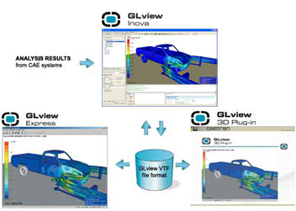

# 企业对三维可视化的需求

## 模型的表达和解释

在产品研发的过程中的几何模型、网格模型和结果模型等，一般除产生模型的设计分析工具之外，希望提供一种轻量化的模型表达和解释，而不需要安装原版的软件。这也是企业的应用需求，一般由于license等限制，不需要每个参与研发的人员电脑上都要安装对应的设计分析软件，大多时候，只是需要对模型进行简单的“查看”，这也是对于三维可视化工具的最基础需求。针对查看，一般的可视化工具都提供了一系列操作功能，如模型的缩放、平移、旋转、标注、动画（线性、瞬态、动仿真）；这些丰富的操作方式，增强了模型的表达方式，使得用户可以更好的理解和分析各种模型；注：本文提到的三维可视化工具一般不是指的产生文件模型的那个CAD或者CAE工具软件，而是脱离了原有工具软件的一种轻量化浏览工具。

## 统一“格式工厂”

所谓格式工厂指的是一种可以兼容多种文件格式的可视化工具解决方案。如上面小结分析的，在很多情况下，用户不需要安装多种复杂的设计分析软件而仅仅是“看一眼”模型。这种需求下，能支持在同一环境下查看多种格式文件的工具便孕育而生。目前，主流的面向CAD几何模型的可视化工具软件已经能够支持大多数的CAD软件格式（多种软件的多个版本），而CAE结果文件的可视化工具一般也能支持几十种文件格式之多。并且大多数可视化工具软件都采用了开放式的技术架构，基于“插件”思想，能够实现以后其它文件格式的不断扩展；

## 网络共享和协同

设计和仿真分析结果的一大特点就是体积庞大，这些大数据带来的问题不仅是文件存储空间的消耗，同时还有传输不便、共享和协同难以实现；基于轻量化的可视化技术有效缩小了文件的大小，使得多部门人员利用网络基于统一的模型进行工作成为可能；如下图所示Vcollab CAE结果文件可视化软件的转换压缩对比。

表：Vcollab Sample File Size Reductions

|  |  |  |  |
| --- | --- | --- | --- |
| **CAE Software** | **CAE Results File Size ( MB)** | **CAX File Size (MB)** | **Size reduction** |
| MSC NASTRAN | 289 | 46.4 | 84% |
| MSC MARC | 243 | 23.9 | 90% |
| ANSYS | 14000 | 92 | 99% |
| ABAQUS (ODB) | 628 | 48 | 92% |
| FLUENT | 347 | 13.1 | 96% |
| NASTRAN ( Seven results extracted) | 289 | 46.4 | 84% |
| NASTRAN ( One result extracted) | 289 | 11.6 | 96% |

由上表分析，原始的文件在转换成Vcollab识别的CAX文件之后，其大小会达到原始文件大小的16%~4%，在不影响基本的显示信息的情况下，这样的压缩效率还比较让人满意的。同时我们应注意表格的最后两行中的对比，同一个NASTRAN结果文件，在抽取结果数量不同的时候，压缩率会有比较大的不同，而这点也是一些可视化软件的一个特点——即按需抽取，在模型转换的过程中，用户可以指定需要抽取的信息，最终转换的统一格式文件的大小 根据用户定义信息的多少而有所不同。从这个角度来讲，模型的转换过程并不纯粹是一个压缩的过程（压缩会在一定程度上减小模型的大小），但是更重要的是转换过程中的信息裁剪，通过保留关键的模型信息，满足基础的可视化要求。网络协同共享的另一个问题就是嵌入式的集成浏览工具，一个基本的需求是用户能便捷地访问到工作资源，通过Web浏览器就是其中的重要一项，此外，模型文件能够嵌入到Office Word文档、PPT文件、企业的其他集成设计平台甚至移动手持设备中。模型无处不在，才能让用户真正体验到共享和协同带来的便捷和愉悦。因此，模型的浏览工具应该能够跨多种操作系统平台，支持多种Web浏览器，提供基于DLL等多种的集成方式，能够轻松地被集成到用户的工作环境中。

## 后处理与决策支持

决策支持是今年来三维可视化工具扩展出的多种“附加”功能，如对比分析及报告功能、模型信息抽取、远程可视化等。

1）对比分析及报告生成：该功能在CAE文件可视化工具中更为常见，大部分常见的CAE仿真软件对结果后处理及报告生成相对较弱，而同时大多企业在仿真分析的过程中都需要最终提交对模型的仿真分析结果报告，这些报告占用了仿真分析人员的很多时间。另外企业中一般需要可以自定义报告的格式，并且输出为Word、Excel和Pdf等多种文件格式。另外在分析的过程中，用户可以选取多个模型文件进行对比，通过生成曲线图、对比表格等多种手段找到分析的最优解。

2）模型信息抽取：由于对模型轻量化是对模型文件进行了裁剪和转换，那么可视化工具必定对原始CAD或CAE文件的格式定义非常清楚。所以，可以将包含在文件模型中的各种元数据提取出来，这些模型的信息可以是元数据信息、文本信息、绘图信息乃至图片信息。这些模型的关键的信息，是用户对数据进行分析的基础。主流的可视化工具提供了对模型信息，尤其是元数据信息的自动和手动抽取功能，如果将该功能集成到企业的数据管理系统中，则可以在极大程度上提高决策支持的水平。

3）远程可视化：实时可视化功能目前只在少数的可视化工具中进行了尝试。主要解决了设计调整和局部优化问题。

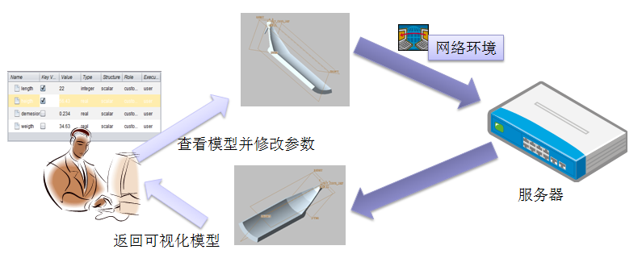

远程实时可视化应用场景

如下图所示应用场景，用户在线查看模型，同时可以修改模型的关键参数信息，确定之后，系统将信息提交到网络环境中的服务器中进行重新计算，之后返回新的可视化模型。这种在线的实时设计功能，扩展单纯的“查看”功能，用户可以对关键设计变量进行优化设计，通过可视化的手段进行结果调整，在一定程度上提高了设计和分析的效率。但是该功能属于快速设计，是辅助设计分析的一种手段，并不能完全替代原本的设计软件来使用。

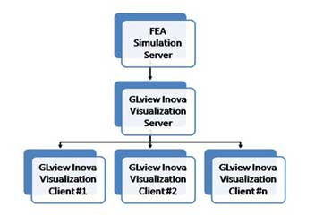

# 主流三维可视化解决方案

从三维可视化技术发展和协同研发的客观要求出发，很多公司都提出了不同的可视化解决方案。这些公司分为两类，第一类是CAD/CAE软件供应商，在其产品整合、平台推广的过程中，各自提出了自身的可视化技术框架，如达索系统、Siemens等；另一类公司是第三方软件公司，其主要目标是面向各类主流的设计分析软件，尽可能多地兼容各种文件格式，形成一种通用的第三方可视化解决方案。

## 可视化解决方案说明

当前主流厂家的设计分析过程中的三维可视化解决方案如下表所示，之后会对相关的方案进行相应说明。

表：可视化工具列表

|  |  |  |  |  |
| --- | --- | --- | --- | --- |
| **解决方案** | **厂商** | **格式** | **领域** | **支持软件及文件** |
| GLview | Ceetron | VTFx | CAE | NASTRAN 、ABAQUS、ANSYS  LS-Dyna等十多种主流CAE软件的20+种文件格式 |
| Vcollab | VCTI | CAX | CAE | ENSIGHT GOLD 、ABAQUS、ANSYS等十多种主流CAE软件的20+文件格式 |
| Ensight | CEI | 无 | CAD  CAE  CAM  其它 | AcuSolve、ANSYS Emag、ABAQUS、POLY-3D、SolidWorks等大量有限元分析、计算流体力学、计算机辅助设计和其他软件程序包的输出格式100多种； |
| 3D XML | 达索系统 | 3DXML | CAD  OTHER | Catia、SolidWorks、Pro/E等 |
| CreoView | PTC | PVS/ed/pvz  Edz/ | CAD | Asm, DWG, DWF, HPGL/ BMP,JPG, GIF) and PDF documents等40种格式，也可以通过升级的方式支持如(JT, STEP, STL, VRML, DGN, GBF, IGES)等格式 |
| AutoVue | ORACLE | 无 | CAD | Engineering & Construction / Energy / Utilities、Industrial Manufacturing / Automotive / Aerospace & Defense等多个行业几百种格式 |
| eDrawings | Solidworks | eDrawings | CAD | DWG and DXF、Pro/ENGINEER、CATIA V5等主流CAD软件的多种格式 |
| Design Review | Autodesk | DWFx | CAD | AutoCAD、Revit 和 Invento的DXF、DWG等文件格式 |
| JT2go | Siemens PLM | JT | CAD | CGM, TIF, DWG UG NX、SolidEdge、Catia和Pro/E等主流CAD软件的文件结果文件格式 |
| SpinFire | Actify | .3D | CAD | CADDS 4&5、CATIA v4/v5 、CGM 、I-DEAS、SolidWorks 、AP203/ AP214 STEP 、Parasolid等上百种格式 |

### Glview

**1、产品简介**

（1）End user products

Ceetron's end user products consist of a postprocessor for full 3D visualization and interpretation of CAE models and results - GLview Inova, and free tools for presenting and sharing Finite Element Analysis (FEA) data - GLview Express and GLview 3D Plugin. The link between these components is the compact, flexible and efficient VTFx file format.

（2）Software developer products

Ceetron’s software developer products consist of C++ object libraries for development of post-processors and advanced 3D visualization solutions as well as export of simulation results to the GLview Express format (encrypted VTFx).

**2、模块构成**

* GLview Inova ：GLview Inova is a modern, full-blown post-processor – ready to use with all major CAE software systems on the market. GLview Inova is designed for engineers in the CAE community. It can be used as is, or as a basis for further customization to meet special needs. GLview Inova is built entirely on the GLview Visualization API and the GLview Express Writer API, and it runs on Windows and Linux platforms with a unified look and feel. Direct file interfaces to all the major CAE systems are integrated.
* GLview Report Builder：GLview Report Builder is an interactive reporting tool that makes it easy for the simulation engineer to capture data when it is found, directly from his or her favorite post-processor. The GLview Report Builder collects and organizes all data in one place, and creates reports in multiple formats from the same source.The GLview Report Builder is created in compliance with industry standards, and enables the utilization of company document templates for layout and formatting of reports, such as existing MS Word or MS PowerPoint templates. It exports output to the native file format of the software tool used to write and finalize reports, e.g. *.docx,*.pptx, *.odf, *.html, *.txt. Converting to PDF is straight forward.
* GLview Express Free ：GLview Express is a free 3D viewer for presentation and distribution of 3D models and results generated by GLview Inova or the GLview Express Writer. GLview Express enables full 3D interactivity and high performance graphics, and is the CAE world's equivalent to Adobe Acrobat Reader.
* GLview 3D Plugin Free ：GLview 3D Plugin is a free 3D viewer for presentation and distribution of 3D models and results generated by GLview Inova or the GLview Express Writer. GLview 3D Plugin can be embedded into PowerPoint presentations and web pages (Internet Explorer) and enables full 3D interactivity and high performance graphics.
* [GLview 3D Visualization API](http://www.ceetron.com/glview-3d-visualization-api.aspx) ：The GLview 3D Visualization API is an object library for development of post-processors and advanced 3D visualization solutions. The API is the core technology for all Ceetron’s products and project deliverables.
* [GLview Report Builder SDK](http://www.ceetron.com/glview-report-builder-sdk.aspx)：All providers of CAE software can benefit from the advantages of GLview Report Builder by offering it as an integrated feature in their own software. The GLview Report Builder SDK makes the integration straight forward. The SDK is an object-oriented ANSI C++ library and includes a fully documented programming interface that can be used between any pre- or post-processor and the GLview Report Builder application. A complete set of examples and tutorials are included in the documentation. Integration services are available from Ceetron AS.
* [GLview Express Writer](http://www.ceetron.com/glview-express-writer.aspx) ：The GLview Express Writer is a file writer for export of simulation results to GLview Express file format (encrypted VTFx) from any FEA based solver. The GLview Express Writer is a C++ object library with optional C/Fortran wrapping.

**3、主要解决方案**



图

**4、支持格式**

见附件“GLview解决方案支持文件格式”。

**5、二次开发API**

GLview Visualization API，计算结果的3D可视化应用程序编程接口，使用ANSI C＋＋架构。

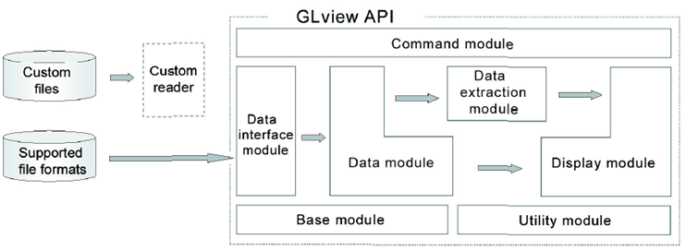

图

GLview Express Writer，通过它可以把分析数据转换为VTF格式。

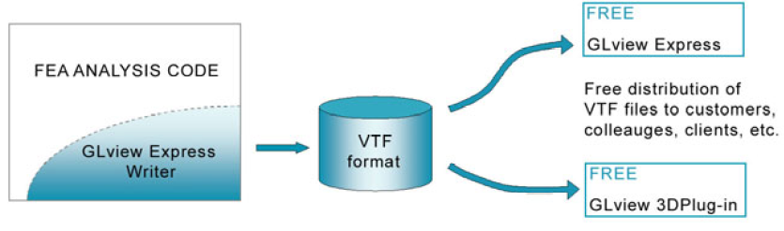

图

**6、其它功能特点**

（1）远程可视化

Functionality to do remote visualization and post-processing using GLview Inova was introduced as an option with version 8.

Advantages ：

* Significantly reduces transfer of data on the network - the analysis files can stay on the server where they were produced
* Significantly reduces amount of stored data - no need for local copies of large analysis files
* Significantly improves post-processing performance, especially with large models
* Removes problems that arise from maintaining and working with multiple copies of analysis files
* Removes out-of-resource problems with post-processing multiple large models on a desktop computer



图

（2）密码保护

In version 8 of the GLview Express viewer, support for password protected and encrypted [VTFx](http://www.ceetron.com/vtfx-format.aspx) files was added.

**7、系统要求**

* Windows XP/Vista (Intel), 32-bit and 64-bit
* Linux kernel 2.4.18-3 or later, GNU GCC runtime environment version 2.96 or later, and XFree86 4.1.0 (for OpenGL), 32-bit and 64-bit.

**8、备注：**

可以嵌入到Web中，也可以嵌入到Office中。应用GLview 3D Plugin实现。

### Vcollab

**1、产品简介**

VCollab是一种通用的PLM可视化的解决方案。它允许用户在没有本地应用程序的情况下察看和操作任何CAX文件。VCollab使用户能够安全地操作、提交、可视化、存档3D模型文件和仿真数据，同时允许使用者之间相互协作。

VCollab是第一个为实现CAD/CAM/CAE数据的多学科可视化及协同的虚拟平台。VCollab帮助企业最有效的利用模型及模拟仿真数据：

**2、模块构成**

* VMoveCAE：CAE Data Translator ，Works in Batch Mode as well as GUI Mode. Generates light weight CAX files from CAE results files.
* VCollab Presenter：Light Weight CAE viewer ,To view VCollab CAX files. Extends visualization to decision support. Works within MS Office, MS SharePoint and Web Browser integration.
* VCollab Professional：Thick Client / DMU type tool for CAX ,Multiple model overlays, Parts and Results filtering, Annotations, Viewpoints, Walkthrus, AVI/GIF Animations, Stereo Views can be created.
* VCollab Presenter Lite：Light Weight CAE viewer ,(w/ Limited Functionality)
* **CAX Writer API：Provides ability to write CAX files from 3rd party CAE solvers, Post Processors, in-house CAE applications.**

**3、主要解决方案**

CAX - A vendor neutral, common data format to store and visualize 3D CAE/CFD data with extension to CAD – in an ultra compact form. Stores meta data with models.

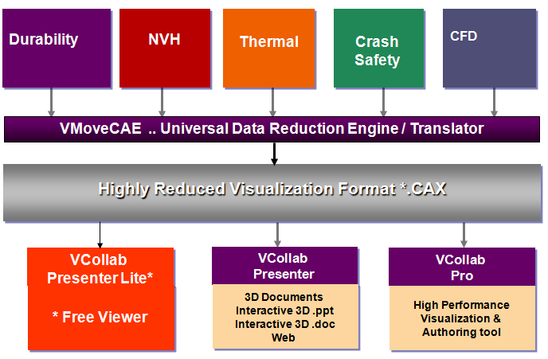

图

对CAD数据的可视化解决方案：

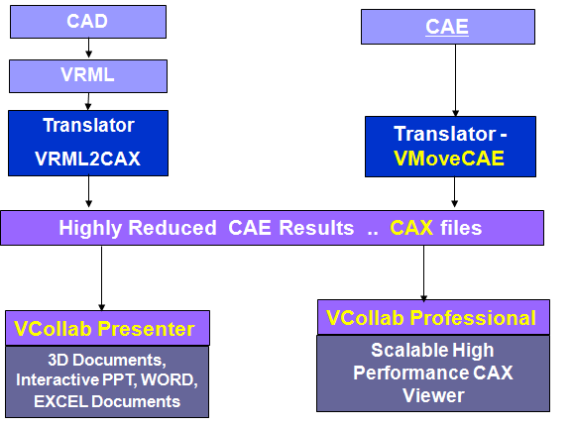

图

如图所示，Vcollab中将CAD软件转换过的VRML文件通过VRML2CAX转换器转为CAX文件之后，通过可视化浏览工具进行查看。主要问题是，用户需要将原始的CAD格式转换为VRML格式，这个转换过程对实际的使用过程是不太方便，提出的CAD可视化方案没有太大的实际意义。

**4、支持格式**

见“Vcollab解决方案支持文件格式”

**5、二次开发API**

提供CAX Writer API、VMoveCAE。Tool to reduce CAE data and generate compact CAX files.提供三种方式来对文件进行转换，比较常见的集成方式是采用批处理的方式进行处理。

* GUI
* Batch command
* Remote execution on HPC (ex. Scripts )

在进行转换的时候，可以根据信息进行“抽取”，即属性过滤：Attributes based filters机制：

* Filter results
* Filter Load Cases
* Filter parts
* Volume feature extractions

**6、其它功能特点**

（1）元数据/参数抽取：VMoveCAE installation folder also contains a console application named CaeInfo.exe for generating and displaying metadata from native CAE files in XML format. This metadata information includes the parts and element sets defined in the CAE simulation file as well as the available results. The metadata is displayed on to the screen by default. Its usage is as follows.

（2）Remote Visualization：可视化的时候，输入一些关键参数，系统去服务器端进行计算，将重新生成的模型加载显示到前端；

（3）Visual CAE Data Portal：？？？；

**7、系统要求：**

* Windows XP Professional（32-bit and 64-bit）
* Windows Vista（32-bit and 64-bit）
* Windows 7（32-bit and 64-bit）

注：只支持Windows系统，另外嵌入到Web中的时候，只支持IE和FireFox。

**8、备注：**

可以嵌入到Web、Office文档的**PowerPoint, Word, Excel**中。

### Ensight

**1、产品简介**

EnSight由美国CEI公司研发，是一款尖端的科学工程可视化与后处理软件，拥有比当今任何同类工具更多更强大的功能。基于图标的用户接口易于掌握，并且能够很方便地移动到新增功能层中。EnSight能在所有主流计算机平台上运行，支持大多数主流CAE程序接口和数据格式。

**2、模块构成**

* EnSight Lite（简化版）

Web展示；

* EnSight Standard（标准版）

——推荐大多数用户使用。适用于FEA (有限元分析)，CFD（计算流体分析）和其它CAE后处理。

* EnSight Gold（金版）

适用于虚拟现实和超大数据集的DMP (分布式内存处理)处理。

* EnSight DR

——适用于图形集群，显示墙和虚拟现实的分布式渲染。

* EnSight CFD

——只限于CFD用户使用。迅速高效，功能少于EnSight Standard版本。

**3、主要解决方案**

从原模型经过Ensight系列产品转换为需要的类型，如下图所示：

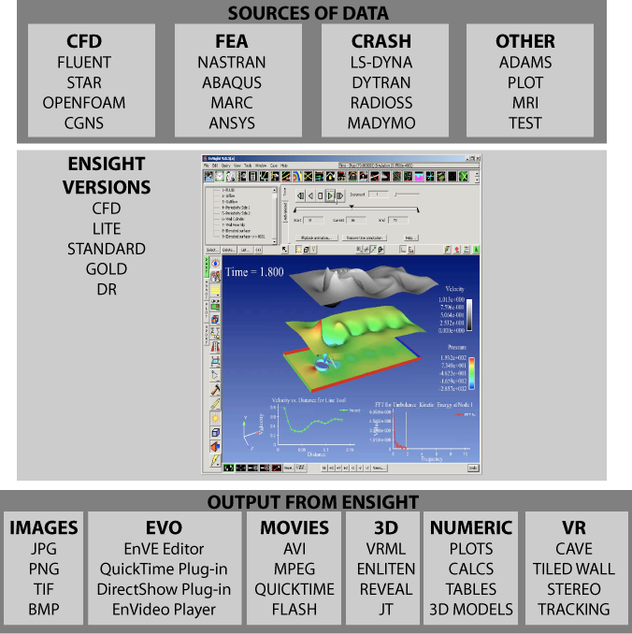

**4、支持格式**

见附件“Ensight解决方案支持文件格式”。

**5、二次开发API**

Command language able to run scripts, macros and batch operation;

**6、其它功能特点**

**为什么选择EnSight来做CAE后处理?**

EnSight的许多功能使之远胜于同行。它是业内更新率最高的软件之一。以下清单列举了成千上万的用户连年来继续使用EnSight的最常见原因。点击这里查看更完整详细的列表。

EnSight是当今CAE后处理器中功能最多最强大的，因此，它有能力让你的数据向你展示你所需要看到的。下列只是使用EnSight的很多好处中的一部分：

轻松把握大型，暂态模型

从不同的求解器加载多个数据集。结合计算流体力学，有限元分析，计算机辅助设计，多体动力学的结果到同一个视图中。相比较从其他求解器运行，在流体结构相互作用方面，或者在计算机辅助设计模型上显示计算流体力学结果上，都非常卓越。

强大的计算流体力学和流体结构相互作用功能；

优秀的图形质量和输出选择；

广泛的动画功能；

具备成为整个组织标准的后处理工具的能力；

卓越的免费三维浏览器，轻松分享；

慷慨和灵活的许可证发布——没有每个CPU收费，可以与多个站点共享一个许可证；

几乎不受限制的脚本，批处理模式，自定义选项；

其虚拟现实的功能，非常适合演示。

**7、系统要求：**

Windows, Linux and Macintosh(32-bit and 64-bit)；

**8、备注：**

* EnLiten

Enliten is a 3D geometry viewer used to display, manipulate and analyze complex visualization scenarios generated by EnSight. EnLiten enables collaboration and communication of high-end visualizations for CFD, FEA, crash analysis, aerodynamics, scientific visualizations and other applications. This product is easy to use and runs on Windows, Unix, Linux and Macintosh computers.

* EnVideo

EnVideo is a simple-to-use, cross-platform, video player.

* EnVe

EnVe is a general purpose animation post-processing too used to create animation files from collections of individual image and movie files. Functions are provided to crop and resize video sequences, as well as perform simple fades and pauses. The editor can be run in interactive mode or scripted using an enhanced Python command language. EnVe allows users to convert imagery between various movie and image file formats on all platforms. EnVe provides multi-tile support for cluster-based display of high-resolution animations using EnVideo Gold and support for stereoscopic animation conversions.

* Reveal

Reveal is a 3D geometry player for viewing, analyzing and manipulating complex visualization scenarios created in EnSight or in other applications. Reveal enables communication of complex 3D simulations and models in fields such as CFD, FEA, crash analysis, aerodynamics, and scientific visualizations. Reveal runs on Windows, Unix, Linux, and Mac OS.

### 3D XML

**1、产品简介**

3D XML是一种完全建立在XML基础上的Web 3D图形格式标准，它是一种轻量级的，使用多层图像表示(multi-representational)方法建构的3D数据结构、对复杂精密的几何数据有较好的压缩能力，而且生成的3D图形精度非常高，转换后的模型可以保持原有CAD模型的各种描述如产品结构、材质、尺寸、特征草图信息和特征等。

**2、模块构成**

* 3D XML Player

3D XML Player is a 3D visualization tool for quick and easy sharing of 3D data.

* 3DVIA PrintScreen3DVIA

PrintScreen lets you save in 3D XML and share easily 3D models coming from any application based on OpenGL or DirectX.

**3、主要解决方案**

PrintScreen生成对应文件格式后，用3D XML Player进行展示；

**4、支持格式**

见附件“3D XML解决方案支持文件格式”。

**5、二次开发API**

3DXML PLAYER提供浏览控件（3DForAllOCXViewer.ocx），方便其它程序集成；

**6、其它功能特点**

**无**

**7、系统要求：**

Some applications need to be installed prior to installing 3D XML Player:

On 32-bit you need:

Microsoft Visual C++ 2005 SP1 Redistributable Package (x86).

Microsoft XML parser needs to be installed (Microsoft XML Core Services 6.0).

On 64-bit you need:

Microsoft Visual C++ 2005 SP1 Redistributable Package (x64).

Microsoft XML parser needs to be installed (Microsoft Core XML Services 6.0 - x64 version on 64-bit).

End users must have a computer with:

Windows XP with Service Pack 2 (SP2), Windows Server 2003 with Service Pack 2, or Windows Vista （不支持windows2000）

The 3D XML Player is available in 32-bit and 64-bit

Windows Internet Explorer version 6 or 7, or Mozilla Firefox version 2.0 (for Internet Explorer, you must modify your Internet Security options to authorize ActiveX execution when using it in Internet Explorer web browser).

250 MB or more of hard disk space

A 1.0 GHz processor (2.8 GHz or faster recommended)

512 MB of system memory (1 GB recommended)

64 MB video card (256 MB recommended) that supports OpenGL 1.1 (OpenGL 1.5 recommended) with OpenGL 3D hardware acceleration enabled

3-button mouse recommended

Notes:

S3 and XGI graphics cards are not supported.

On Windows Vista, we recommend turning off the Windows Aero user interface.

**8、备注：**

可嵌入到Web中，office中；

支持脚本，3D XML Player can be embedded as an ActiveX or Mozilla Plugin in third parties applications. The provided API lets you control the 3D XML Player.

3D XML Player can interact with its container (Web browser or Office document). Communication between the the 3D XML Player and its container is enabled thanks to:

the use of an exposed API in the controlled application (the 3D XML Player)

the use of a language, used by the controlling application (i.e. the web browser) to send the commands to the controlled application (the 3D XML Player). This language mostly depends upon the user choice and the limitations of the controlling application (i.e. the web browser). It could be: VBScript or Java Script.

Controlling Application can be any application in which the 3D XML Player can be embedded that also supports Java Script or VB Script like languages. It is then possible to launch actions in the 3D XML Player from an hosting application and to receive interaction from the Player.

### CreoView

**1、产品简介**

通过ProductView我们可以直接浏览proe的文件，以及 200 多种其他文档类型，与Windchill集成，非proe的使用者都可以很方便的查看、剖面、分解、标记各种形式的数字化产品数据，并与它们进行交互和基于它们进行协同。

使所有团队成员能够在以 Web 为中心的可伸缩环境中访问产品信息

无需安装创作应用程序就能查看各种产品数据（例如 MCAD/ECAD 文件和 MS Office 文档）；

精确测量 3D 模型、绘制 3D 模型剖面、比较 3D 模型以及装配零件和复杂的产品结构；

通过标记和实时协同，在集中组织的数字化产品信息的基础上开展协同；

通过使用户在整个企业中轻松共享可视化信息提高生产效率；

**2、模块构成**

* Creo View Express

查看 Creo 2D 和 3D MCAD 设计；

查看标准绘图格式（CGM、DWG、DWF、HPGL）；

浏览大型组件；

通过剖面进行查看；

* Creo View Lite

Creo View Lite 使所有用户都能轻松简单地访问 3D 模型、绘图和图像，消除了有效分发数字化产品数据的障碍。

Creo View Lite 作为浏览器插件会在初次需要时自动安装并自我管理。

* Creo View MCAD

查看、标记、协作处理和分发机械 CAD 模型。

* Creo View ECAD

集成的参数化 3D CAD/CAM/CAE 软件。

**3、主要解决方案**

本身软件集成生成对应的中间格式，使用模块Creo View MCAD、Creo View ECAD和Creo View Lite进行相应操作和查看；

**4、支持格式**

见附件“CreoView解决方案支持文件格式”。

**5、二次开发API**

无；

**6、其它功能特点**

* Creo View Toolkit

可以使Creo View集成到office、网页和Java应用程序中；

**7、系统要求：**

Windows 7 32 位和 64 位

Windows Vista 32 位和 64 位

Windows XP 32 位和 64 位

**8、备注：**

无；

### AutoVue

**1、产品简介**

Oracle AutoVue解决方案旨在满足机构文档可视化的所有要求。它们可以作为跨所有企业管理软件的可视化窗口，甚至还能满足个人桌面的基本查看需求。通过允许用户查看、打印来自任何系统的任何数字信息资产并基于其进行协作，企业能够实现真正的企业可视化和确保项目取得成功。

无论是简单的PDF文件还是复杂的CAD图，共享这些信息对于所有行业,特别是产品和资产密集型行业来说至关重要。企业工程设计和资产信息通常只有核心工程设计团队才能访问。但是，企业其他人员也需要这些信息以高效且安全地执行操作，如维护和维修、项目计划和执行以及变更管理。通过提供一个能使资产和产品信息在整个企业自由流动的框架，AutoVue使用户能够利用所有企业系统中包含的现有信息资产，从而显著改进业务流程和提高员工生产力。

AutoVue企业可视化解决方案有助于加快产品上市的速度，制定更好的业务决策，提高收入和盈利能力。

**2、模块构成**

* AutoVue Office

Delivers support for Office, PDF, and graphical formats—providing viewing,

printing, and annotation capabilities.

* AutoVue 2D Professional

Delivers visualization of 2-D CAD designs such as AutoCAD and MicroStation, as well as Office document types. Comprehensive markup and annotation tools including text, color fills, hyperlinks, vector lines, and pointers are also included.

* AutoVue 3D Professional Advanced.

Supports 3-D CAD models, in addition to including the core functionality of AutoVue 2D Professional. AutoVue 3D Professional Advanced displays parts-and-assemblies models from essential solid modeling applications (such as CATIA, SolidWorks, Inventor, Pro/E, and UG) and includes comprehensive markup capabilities—delivering the ability to add text and precise 3-D markup measurements to points on a part or assembly. It also includes a compelling 3D walkthrough which allows users to perform detailed reviews of 3D facilitiets.

* AutoVue EDA Professional.

Provides native document viewing for the major EDA software packages, such as Mentor, Cadence, and Zuken, and delivers a comprehensive solution for multiformat design review, annotation, cross-probing, design verification and real-time collaboration.

* AutoVue Electro-Mechanical Professional

AutoVue Electro-Mechanical Professional is the most complete AutoVue solution. It features native document viewing, markup, cross-probing, and electro-mechanical digital mockup capabilities for the widest range of document types, including printed circuit board (PCB) layouts and schematics, 3-D parts and assemblies, 2-D CAD drawings, and Office documents.. With support for MCD and EDA documents, this solution bridges the gap between MCAD and EDA teams and enables cross functional design collaboration and reviews.

* AutoVue Mobile

Oracle's AutoVue Mobile complements AutoVue's powerful native document viewing, digital annotation and real-time collaboration capabilities, enabling global organizations to extend the reach of product and asset information to partners and external collaborators. Through the sharing of Mobile Packs, AutoVue Mobile significantly improves how teams share information, increasing everyone's visibility of key technical data, and providing insight into the context surrounding engineering and product documents. Teams can collaborate more effectively and securely with global supply chain partners, allowing them to meet the rigorous demands of product development and achieve competitive advantage.

**3、主要解决方案**

通过各种View适配器支持原始模型的统一界面查看；

**4、支持格式**

见附件“AutoVue解决方案支持文件格式”。

**5、二次开发API**

* AutoVue VueLink Integrations

VueLinks are Oracle developed pre-integrated solutions, which connect AutoVue to popular Product Lifecycle Management (PLM) and Content Management systems. The VueLink integration serves as a "bridge" that securely streams documents from an enterprise system's repository to AutoVue for viewing, digital markup and real-time collaboration. Digital markups are saved back in the content repository and associated with the base file for easy tracking and traceability. AutoVue VueLink Integrations are available for Oracle Universal Content Management (UCM), Oracle Agile PLM, EMC Documentum, and Microsoft SharePoint.

* AutoVue Integration Software Development Kit (iSDK)

The AutoVue iSDK allows users to go one step further in their integration projects to consistently render information from disparate systems and visually enable any enterprise application (PLM, ERP, Project Management, etc). AutoVue's Web Services based iSDK allows customers and Systems Integrators to build and customize their own integrations in any deployment environment. Customers and SIs can easily develop AutoVue integrations in deployment environments, such as .NET, and C++, in addition to Java, allowing them to take advantage of AutoVue's open and extensible integration framework. Alternatively, the AutoVue iSDK also provides an integration skeleton, which customers and partners can leverage when developing their own integrations.

* AutoVue Web Services

To support integrations within a Service Oriented Architecture (SOA) framework, AutoVue provides a comprehensive set of Web Services capabilities. Through Web Services, organizations can ensure a consistent, flexible, and repeatable approach for augmenting existing business applications with enterprise visualization services, creating visual composite applications and taking workflow automation one step further. Customers can leverage the power of AutoVue, in whole or in part, and capitalize on functions like the ability to generate document thumbnails in a Web portal, feed information contained in CAD files into search engines or process high volume printing operations to name a few. AutoVue Web Services are reusable, insulated from changes in systems providers, and enable IT to optimize process flows with enterprise visualization capabilities as non intrusively as possible.

* AutoVue VueBeans

VueBeans are Java APIs, which can be used to extend and customize AutoVue functionality to an organization's specific requirements. IT departments can leverage these APIs to create new markup entities, automate the creation of stamps or hyperlinks, dynamically watermark for printing, etc., increasing process automation, reducing human capital expenditures and improving organizational efficiency.

**6、其它功能特点**

* AutoVue Document Print Services

AutoVue enterprise visualization solutions enable users to view, print, and collaborate on any digital information asset stored in enterprise applications. As part of its Service Oriented Architecture (SOA) strategy, AutoVue delivers a series of Web Services which ensure a consistent, flexible and repeatable approach for deploying AutoVue capabilities throughout an organization.

AutoVue Document Print Services deliver a rich set of printing Web Services, which partners, system integrators, and third-party developers can leverage to complement their existing print server solutions with AutoVue’s format and platform agnostic document printing capabilities. By combining the power of AutoVue Document Print Services with applications such as Asset Lifecycle Management, partners can build robust printing solutions to automate and process high volume printing operations of both business and technical document types.

For many organizations, their printing processes are challenged by the fact that they can only print a small subset of the documents required by enterprise users. With AutoVue Document Print Services, partners can complement their existing print server solutions with powerful document printing capabilities that can be deployed in both Windows and Linux environments; thereby automating the printing of virtually any document type required in any business process. For example, during the planning and execution of maintenance and repair activities, maintenance planners can automate the printing of work orders and all corresponding attachments, including engineering and asset drawings, for use during repair operations, greatly improving business workforce productivity.

* AutoVue Web Visualization

AutoVue offers industrial strength viewing, markup and collaboration capabilities via the web. Geographically dispersed teams can come together to securely view, review and collaborate on documents through project extranets, intranets or the internet. People, information and processes are connected across the global enterprise in a secure, efficient and flexible manner. Communication, geographic and language barriers are eliminated in the collaboration and document review process.

**7、系统要求：**

Client/Server Deployment

Windows Server:

Windows Server 2003 32-bit

Windows Server 2003 64-bit (AutoVue running in 32-bit mode)

Windows Server 2008 32-bit

Windows Server 2008 64-bit (AutoVue running in 32-bit mode)

Windows Server 2008 R2 64-bit (AutoVue running in 32-bit mode)

The installation requires about 400MB of free space.

Linux Server:

Red Hat Enterprise Linux 5.4 (x86)—32-bit

Red Hat Enterprise Linux 5.4 (x86)—64-bit (AutoVue running in 32-bit mode)

Oracle Enterprise Linux 5.4 (x86)—32-bit

Oracle Enterprise Linux 5.4 (x86)- 64-bit (AutoVue running in 32-bit mode)

The installation requires about 400MB of free space.

Client:

Clients running the following 32-bit Java Virtual Machines:

J2SE 6.0 update 21

J2SE 5.0 update 22

The following OSes and browsers:

Windows Oses (XP, Vista, and 7) - 32 bit and 64 bit

Internet Explorer 7 - 32-bit only

Internet Explorer 8 - 32-bit only

Firefox 3.5 - 32-bit only

MAC OS X 10.6

Safari 5.0

Firefox 3.5

RedHat Enterprise Linux 5

Firefox 3.5

Ubuntu 10.04 LTS

Firefox 3.5

Solaris 10 (Sparc)

Firefox 3.5

Web Servers

The AutoVue client Web page is certified on the following Web servers:

Windows IIS

UNIX, Apache v2

Oracle HTTP Server

Application Servers:

The VueServlet has been certified on the following application servers:

Tomcat 6.X and up

WebSphere 6.1 and up

WebLogic 9.X and up

Oracle Application Server 10g R3 and up

Jetty 6.0 and up

Desktop Deployment

System Requirements

Windows XP 32-bit

Windows Vista 32-bit and 64-bit (AutoVue running in 32-bit)

Windows 7, 32-bit and 64-bit (AutoVue running in 32-bit)

The installation requires about 400MB of free space.

Desktop Version

System Requirements

Windows XP 32-bit

Windows Vista 32-bit

**8、备注：**

无；

### eDrawings

**1、产品简介**

eDrawings software is a product design communication tool for sharing representations of both 2D drawings and 3D models. The electronic data format of eDrawings files is highly compressed to enable easily transmission via email. When viewed with the eDrawings Viewer, these files provide intelligent interpretation tools (3D Pointer, Virtual Folding, Animated Drawing Views) that help the recipient easily understand and navigate the data they receive. eDrawings files are created through the use of the eDrawings Publisher add-in, which works as a plug-in to many popular CAD products. Once created, an eDrawings file may be sent to anyone via email. To eliminate the frustrations normally associated with 2D and 3D design data, the viewer may be embedded directly in an eDrawings file. These files can immediately be viewed by anyone with a Windows operating system. No additional CAD software or viewers are required.

**2、模块构成**

* eDrawings Viewer

Download free eDrawings Viewer software to view, print, and review all types of eDrawings files. In addition, eDrawings Viewer allows convenient viewing of supported AutoCAD&reg; DWG and DXF files and native SolidWorks&reg; parts, assemblies, and drawings. The eDrawings Viewer is intended primarily for people who do not use CAD software and thus do not need to publish eDrawings files themselves.

* eDrawings Publisher

Download free eDrawings Publisher software to publish eDrawings files directly from SolidWorks, AutoCAD, Inventor&reg;, Pro/ENGINEER&reg;,CATIA&reg; V5, Unigraphics/NX&reg;, Solid Edge&reg;, CoCreate&reg; OneSpace software, Google SketchUp&reg; and eDrawings RapidFire Lite (View IGES, STEP & STL files). You can reduce bandwidth requirements more than 95% by publishing and emailing eDrawings files instead of CAD files. Each of the four free eDrawings Publisher products also includes the free eDrawings Viewer. eDrawings Publisher products are intended for CAD users who need to share products designs more effectively

* eDrawings Professional

eDrawings Professional lets you create review-enabled eDrawings files that allow an unlimited number of recipients to mark up and provide feedback on product designs. eDrawings Professional is intended primarily for CAD users who need to both share product designs and coordinate design reviews.

**3、主要解决方案**

eDrawings Publisher发布edrawings格式，eDrawings Viewer进行对应查看；

**4、支持格式**

见附件“eDrawings解决方案支持文件格式”。

**5、二次开发API**

* eDrawings API

Download instructions to take advantage of the free eDrawings API (Application Programming Interface), which allow customization of the software to meet the specific requirements of your organization. As an email-enabled application, eDrawings software offers capabilities that can support a variety of engineering and business processes, including product data management, and automated manufacturing. The eDrawings API and instructions are intended for application programmers and CAD users and administrators with programming skills.

eDrawings API is a comprehensive API that allows you to save eDrawings files in multiple file formats.

* Archive Product Designs Automatically

Seamlessly create and archive product design information for reference purposes using eDrawings files.

* Share and View Lists of Product Design Components

Share design component information via your company's web site, within custom applications, or inside Microsoft PowerPoint presentations.

* Share and View Configurations

Share multiple variations of a product design within a single eDrawings file.

* Share and View Mass Properties

Allow eDrawings file recipients to view dimensions, mass, volume, density, and surface area of either parts or assemblies shown within an eDrawings file.

* Create Tool Tips to Associate with Components

Quickly create tool tips to associate with components and display these within eDrawings files to help make interpretation faster and easier.

**6、其它功能特点**

* Enable Markup

Create, edit, and save reviews by redlining 2D or 3D data and adding written comments.

* Enable Measure

Measure geometry in part, assembly, and drawing files when dimensions are omitted from an eDrawings file. To protect sensitive design data, simply disable the measurement feature.

* Password Protection

Password-protect your eDrawings files, encouraging users to more fully share design data.

* Dynamic Cross-section

Visualize designs more effectively by moving a dynamic cross-sectioning plane through parts and assemblies to see design details typically hidden from view.

* Move Components

Understand assembly structure more quickly – simply drag and drop components with your cursor to view an exploded assembly. Return components to their normal position by double-clicking on the component.

**7、系统要求：**

Microsoft Windows XP Professional, Windows 2000, Windows NT 4.0 with Service Pack 6 or later, Windows Me, Windows 98 2nd Edition.

**Mac OS X 10.4 and above.**

**8、备注：**

可以嵌入PowerPoint和word中。

采用邮件发送；

### Design Review

**1、产品简介**

Design Review enables your entire project or product team to view, print, measure, and markup DWF, DWG, DXF, PDF and raster files containing 2D and 3D content. Fully integrated with AutoCAD, Inventor, and Revit, Design Review helps you easily share drawings, models, maps, and design data with team members, clients, consultants, contractors, partners, suppliers, and other reviewers who may not own or know how to use design software.

You can share designs for use with Design Review by email, websites, intranets, and physical media, such as DVDs.

**2、模块构成**

* Design Review

AutodeskDesign Review is a free program used for creating and reviewing DWF files. An open, published, and secure file format developed by Autodesk, DWF enables you to combine and publish rich 2D- and 3D-design data and share it with others.

* DWF Writer

DWF publishing helps you enhance collaboration and easily exchange project information with extended teams. Download the free* Autodesk DWF Writer to securely share 2D and 3D data as DWF files—no matter what design application you’re using.

**3、主要解决方案**

A DWF file can be used to organize sheet sets, models, animations, finite element analyses (FEA), and map information, as well as other project-related files, into a single, highly compressed file. Together with Design Review, DWF files help you enhance collaboration by clearly communicating information, such as design changes or corrections, all while reducing the printing and shipping costs associated with distributing paper copies to your extended team.

Much like Adobe PDF files, DWF files are no more alterable than printed paper copies. Unlike PDF files, however, DWF files retain detailed design information and scale, and are therefore more suitable for architects, engineers, and designers.

The newest version of the DWF file format, DWFx, is based on the XML Paper Specification (XPS) from Microsoft. DWFx makes it easier to share design data with reviewers who cannot install software.

DWFx files can be opened and printed instantly using the free Microsoft XPS Viewer, which comes pre-installed on computers using the Microsoft Windows Vista operating system. (For the Windows XP operating system, the Microsoft XPS Viewer can be downloaded directly from Microsoft.) Unlike DWF files, DWFx files include additional information to display design data in the Microsoft XPS Viewer. As such, DWFx files are larger than corresponding DWF files.

**4、支持格式**

见附件“DesignReview解决方案支持文件格式”。

**5、二次开发API**

The Autodesk Design Review 2012 API (Application Program Interface) Reference enables you to customize the Design Review and DWF Viewer user interfaces, thereby controlling what users see and the actions they can perform in shared DWF files. For instance, you might want to hide a toolbar, so that users cannot access certain tools, or you may want to display a certain sheet in a DWF file so users see exactly what you want them to see when they load the DWF file.

**6、其它功能特点**

强大的状态追踪功能，用于管理项目变简单；

与 Autodesk 设计软件集成的往返标记功能，使设计人员可以覆盖原始计算

机辅助设计（CAD）文件的变更和备注；

**7、系统要求：**

Microsoft Windows 7 (Professional), Windows Vista (Enterprise, Business, Ultimate or Home Premium SP1), Windows XP (Professional or Home Edition SP2) operating systems

Microsoft .NET Framework 4

800 MHz 32-bit (x86) or 64-bit (x64) processor (faster processor recommended)

1 GB RAM (2 GB RAM or more recommended)

170 MB free disk space for installation (supporting components including .NET and DirectX may require more than 1 GB free disk space)

Tablet PC running Microsoft Windows 7 (Enterprise), Windows Vista SP1, or Windows XP SP2

Citrix XenApp 4.5 (32-bit) on Microsoft Windows Server 2003 with Windows 7, Windows Vista, or XP clients

Microsoft Internet Explorer 7 or later, Mozilla Firefox 3 or later, or Google Chrome 7 or later.

**8、备注：**

无；

### JT2go

**1、产品简介**

JT2Go is a no-charge, personal 2D/3D viewer that enables anyone to view .jt, .cgm, and .tif files for collaboration between product development teams. Based on Siemens PLM Software’s Teamcenter's lifecycle visualization products, it is easy to deploy.

JT2Go is designed to connect suppliers with their customer’s lifecycle processes such as design reviews, request for quotes, and any other process that requires 3D. Support for the .vfz collaboration format enables you to view the contents of work sessions authored in Teamcenter's lifecycle visualization professional or mockup. .vfz collaboration files preserve the visible contents of the active Viewing window or all open Viewing windows, including externally referenced files and attachments. JT2Go also supports visualizing the product assembly structure and model attributes.

**2、模块构成**

无；

**3、主要解决方案**

主要是JT文件查看；

JT files can be exported from all major CAD systems and translators are available from Siemens PLM Software and 3rd party developers (visit JT Open Member Products for more information). JT is a standard output format for Siemens PLM Software's CAD products Solid Edge and NX and can be automatically created whenever you save a file or even check a file into Teamcenter. See your Siemens PLM Software sales representative or call 800-498 5351 to learn how to purchase JT translators products.

JT2Go may not be used in a webpage or as part of any 3rd party product.

**4、支持格式**

见附件“JT2go解决方案支持文件格式”。

**5、二次开发API**

无；

**6、其它功能特点**

Microsoft Office documents with JTs embedded for in-page 3D viewing

Able to load JT from a URL

Merge PLM XML snapshots

Create/View snapshots during session

Lightweight surface representation (ULP) support

Support for Teamcenter .VFZ package files which can include JTs as well as other files such as MS Office files

**7、系统要求：**

Windows XP Pro Service Pack 3 (32bit only)

Windows Vista Ultimate, Business, and Enterprise Service Pack 1 (32bit). JT2Go is a 32 bit application so although it will run on Windows Vista 64 bit, it will still be limited to the RAM limit (3GB) of 32 bit.

**8、备注：**

无；

### SpinFire

**1、产品简介**

Actify诞生于1996年，是世界上第一款CAD设计信息轻量化、可视化、高效、安全交流和共享软件。Actify特有的.3D轻量化标准格式和高性价比的解决方案，能够有效提升制造企业设计沟通能力和供应链协同效率，降低企业CAD软件和IT购置成本，促进企业知识积累和保护，并大幅缩短产品上市周期。如今，Actify在世界范围内取得了巨大成功其应用已经深入汽车航空航天模具电子医疗动力等众多领域在全球45个国家拥有超过25万名用户和超过9000家客户。

SpinFire 系列产品让设计和生产组织或他们的供应链可以容易的读取并与他们的零件数据、相关档案或设计文件进行互动；大多数主流的 3D + 2D CAD 数据图档格式是兼容于 SpinFire 平台 - 因此单一解决方案确实可以处理所有的的需求。

**2、模块构成**

* SpinFire Professional ：强大的CAD压缩、交流、可视化工具；
* SpinFire Lite ： SpinFire Professional 的 "精简" 版本，它是以没有 CAD Importers 架构但包含 Professional版本所有功能；
* SpinFire Markup ：提供查看 CAD 模型的装配和标记批注功能；
* SpinFire Reader：免费的.3D轻量化阅读器；
* SpinFire Publisher：全自动的模型压缩和发布系统；
* SpinFire Plug-ins：供 plug-ins 以扩充 SpinFire Professional 的功能，第三方开发者也可以基于这个架构开发新的插件；
* Actify CAD Importers：Importers 提供 SpinFire Pro 直接开启和读取多数主流的 CAD 格式文件，并可把这些主要的 CAD 图档另存为.3D 格式。
* DesignShare：支持多用户在线CAD信息交流共享协作平台，各部门人员可通过Web门户快速在线查找中心零件库中的轻量化CAD模型和数据，直接通过Web浏览2D/3D CAD模型，在线批注、尺寸测量、浏览装配体零件树、生成剖面图、在线交流；

**3、主要解决方案**

通过[SpinFire Publisher](http://www.actify.asia/products/spinfire-publisher/)或者Actify CAD Importers的模型转换功能，将各种远程的CAD文档转换成.3D文件格式。由[SpinFire Professional](http://www.actify.asia/products/spinfire-professional/2d-3d-cad-system-viewer-file-converter-download)、SpinFire Markup、[SpinFire Reader](http://www.actify.asia/products/spinfire-reader/)或[SpinFire Lite](http://www.actify.asia/products/spinfire-lite/2d-3d-cad-system-viewer)进行查看或者其他操作。如下图所示。

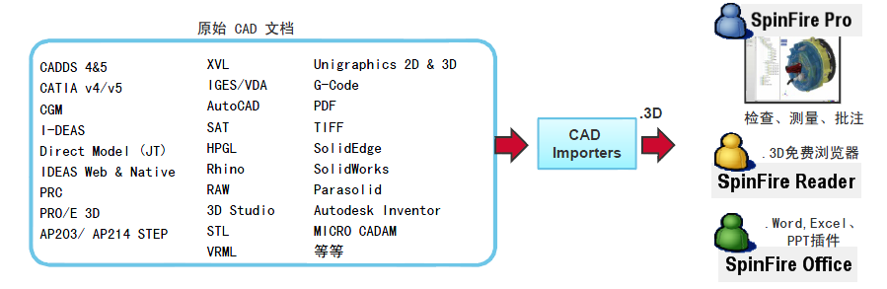

图

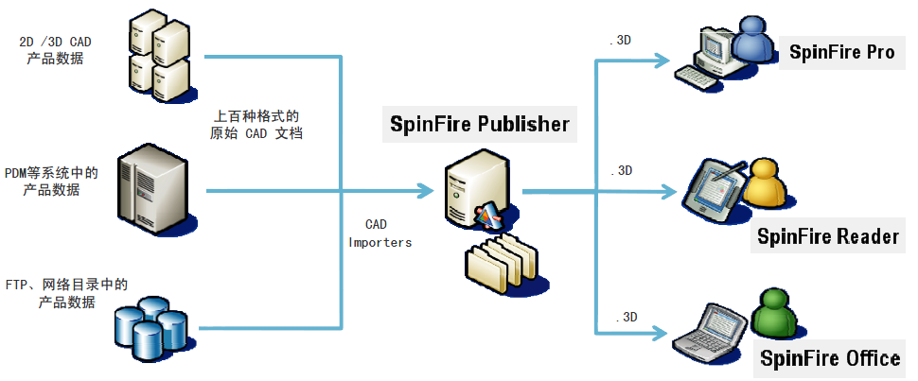

图

**4、支持格式**

见附件“SpinFire解决方案支持文件格式”。

**5、二次开发API**

提供扩展开发新的插件的功能，转换和批处理执行的API应该也有（官网上没有查到，但是其代理公司说明书里有）。

**6、其它功能特点**

DesignShare VDS：Actify 结合所有可用的产品数据、并与设计信息连结一起为做出优质的决定提供一个解决方案，让在您产品数据资产的导览和呈现具有完全的灵活性。主要就是一些决策支持；使用强大的 SharePoint，DesignShareVDS从多样的如 PLM、ERP、ECM，和资产应用程序、及从您的 CAD 应用程序中具有真实相关信息的设计数据中实时的结合数据，让您透过所有的信息进行可视化导览并询问问题如：哪些零件隐藏于列表中？显示装配中零件的费用指针，但高于它们的重量指标。

**7、系统要求：**

Microsoft Windows: XP SP3 / XP SP2 64Bit Vista / Windows 7

Internet Explorer7.X or higher

**8、备注：**

可以集成到Web中，可以嵌入到Office中（新版本）；

## 可视化解决方案特点分析

### CAE领域

|  |  |  |  |  |  |  |  |  |  |  |  |  |
| --- | --- | --- | --- | --- | --- | --- | --- | --- | --- | --- | --- | --- |
| **解决方案**  **（厂商/领域）** | **支持方式** | **支持**  **操作系统** | **支持**  **浏览器类型** | **客户端大小（安装包）** | **支持软件**  **数量、种类是否丰富** | **中间格式**  **压缩比** | **中间格式是否通用** | **是否有API接口（包括）** | **与PLM、PDM等信息系统集成性是否好** | **是否可以元数据抽取** | **是否**  **支持与Office**  **集成** | **界面是否支持中文** |
| GLview  （Ceetron/CAE） | application/Web | WindowsXP/Vista  ( 32-bit and 64-bit); Linux | Internet Explorer | 13.1M | 20+ | 10% | × | √ | 一般 | × | √ | × |
| Vcollab  (VCTI/CAE) | application/Web | Window XP/7 | Internet Explorer、FireFox | 75.4M | 20+ | 10% | × | √ | 一般 | √ | √ | × |
| **Ensight**  (CEI/ CAD、CAE  CAM、OTHER) | application | Windows, Linux 、Macintosh、AIX  (32-bit and 64-bit) | —— | 681M | 100+ | 无中间格式，未压缩 | 无中间格式 | √ | 一般 | √ | × | × |

表 CAE

### CAD领域

|  |  |  |  |  |  |  |  |  |  |  |  |  |
| --- | --- | --- | --- | --- | --- | --- | --- | --- | --- | --- | --- | --- |
| **解决方案**  **（厂商/领域）** | **支持方式** | **支持**  **操作系统** | **支持**  **浏览器类型** | **客户端大小（安装包）** | **支持软件**  **种类** | **中间格式压缩比** | **中间格式是否通用** | **是否有API接口（脚本调）** | **与PLM、PDM等信息系统集成性是否好** | **是否可以元数据抽取** | **是否**  **支持与Office**  **集成** | **界面是否支持中文** |
| 3D XML  （达索系统/ CAD、Other） | application /Web | Windows XP, Server 2003、Vista(32-bit and 64-bit) | Internet Explorer、Firefox | 50M | 100+ | 10% | ×（XSD 参考架构） | √ | 一般 | × | √ | × |
| CreoView  （PTC/CAD） | application /Web | Windows7、Vista、XP(32-bit and 64-bit) | Internet Explorer 、Firefox | 111M | 200+ | 未有具体说明 | × | √ | 好，主要是与WindChill集成 | × | √ | √ |
| AutoVue  （ORACLE/CAD, Other） | application /Web | Windows Oses、Linux、MAC OS、Ubuntu、Solaris | Internet Explorer 、Firefox | 180M | 500+ | 无中间格式，未压缩 | 无中间格式 | √，很丰富 | 很好 | × | √（office模块） | × |
| eDrawings  (Solidworks/CAD) | application /Web | Windows Oses;  Mac OS X | Internet Explorer | 38.2M | 约30+ | 5% | × | √ | 很好 | √ | √ | √ |
| Design Review  (Autodesk/CAD) | application | Windows7 , XP | Internet Explorer 、Firefox 、 Chrome | 约100M | 20+ | 较高，未有具体说明 | ×（XSD 参考架构） | √ | 较好 | × | × | √ |
| JT2go  (Siemens PLM/CAD) | application | Windows XP ,Vista (32bit only) | × | 30.2M | CGM, TIF, DWG UG NX、SolidEdge、Catia和Pro/E等主流CAD软件的文件结果文件格式 | 较高，未有具体说明 | √ | × | 较好，主要是与Teamcenter集成 | × | √ | √ |
| SpinFire  (Actify/CAD) | application /Web | Windows XP SP3 / XP SP2 64Bit Vista / 7 | Internet Explorer | 310M | 100+ | 10% | × | √ | 较好 | × | √ | √ |

表 CAD

## 可视化解决方案解析

从以上的说明及分析可以得出可视化解决方案策略如下表所示：

|  |  |  |  |  |  |  |  |  |  |  |
| --- | --- | --- | --- | --- | --- | --- | --- | --- | --- | --- |
| **解决方案** | **原始模型转换** | **原始**  **模型**  **处理** | | | **最终模型**  **展现** | **集成性** | **功能延伸** | **代表厂商/产品** | **优点** | **缺点** |
| 1 | 无中间格式 | 内置各种类型解析器 | | | 应用/  浏览器 | (1)与Office集成  (2)与PDM，PLM集成  (3)与其它应用集成，例如Java应用等 | (1)API操作；  (2)元数据抽取；  (3)Email集成；  (4)标记，批注，审批，传递；  (5)协同；  (6)可视化支持决策；  (7)导出图片、音频，视频 | Oracle/AutoVue  CEI/Ensight | 统一视图、操作 | 对文件没有压缩 |
| 2 | 有中间格式 | 非通用中间格式 | 有中间格式生成器 | 单一生成器 | Ceetron /GLview  VCTI /Vcollab | 统一生成，对文件有压缩 | 非通用标准 |
| 针对性多生成器 | Solidworks/eDrawings | 针对性强，对文件有压缩 | 操作较复杂，非通用标准 |
| 无中间格式生成器 | 内部软件集成，同时可以直接打开其它类型 | PTC/CreoView | 与自身软件集成度高，提供统一视图，对文件有压缩 | 开放性不够，非通用标准 |
| 通用中间格式 | 有中间格式生成器 | 单一生成器 | 达索/3D XML;  Autodesk/Design Review | 支持通用转换，对文件有压缩 |  |
| 针对性多生成器 | —— | —— | —— |
| 无中间格式生成器 | 行业通用格式 | Siemens /JT2go | 行业统一性，利于普遍使用，对文件有压缩； |  |

表 可视化解决方案

注：一些可视化工具还支持以下格式进行查看：

（1）支持通用中间格式，例如JT；

（2）非通用中间但普遍应用格式，例如edrawings格式。

# 可视化技术在协同研发平台中的应用

早期的可视化解决方案的应用集中在设计和分析模型的浏览功能上，在信息化水平不高的企业环境中，主要解决了模型的轻量化及脱离原始的软件工具的可视化问题。但是随着企业研发信息化的不断发展，平台体系建设的不断成熟，人们逐步认识到可视化技术及其解决方案在企业协同研发平台中的重要作用，即如何将可视化的解决方案及其扩展功能有机地集成到企业的协同研发平台中，充分发挥其“轻量可视化”、“决策支持”、“模型共享协同”等特色功能。

本文提出了一个在典型的研发企业的协同研发平台中集成可视化解决方案的整体架构。如下图所示。



图 研发企业的协同研发平台中集成可视化解决方案的整体架构

设计工程和仿真分析工程师在应用设计或者仿真分析工具软件的工作过程中，将生成的结果乃至中间过程文件提交到企业的协同研发平台或资源服务器中（如Ftp服务器、文件服务器、PDM系统中），如果提交到资源服务器中，也可以通过协同研发平台与资源服务器的接口实现文件的双向传输。

通过调用可视化解决方案框架中的模型转换器将各种格式的文件转换为统一可视化格式文件（Uniform Visualization Format File），同时也可以将文件中的元数据、参数信息等通过元数据抽取器（Metadata Extractor）抽取出来。统一可视化格式文件和元数据信息都可以存储到存储空间中供服务端和前端应用。

在客户端，各种角色的用户包括工程师、专家和管理者都可通过Web浏览器或者集成了可视化工具的CS客户端程序进行各种业务工作，这些工作包括可视化浏览及操作、决策支持中的模型对比，报告生成和远程可视化等。其中远程可视化功能通过调用可视化解决方案框架中的可视化服务接口实现。

# 总结与展望

从前述章节的分析我们得到，众多的“原生”和第三方厂家，在围绕自身的产品体系，都提出了不同的解决方案，很难有一个厂家的解决方案能够解决“足够多”文件的可视化问题。所以这里有两个问题值得我们关注，

（1）企业的三维可视化方案选型时候，能够基于现实情况和未来若干年企业的发展情况选择一个相对完善的解决方案；

（2）对于可视化技术方案提供商而言，需要软件厂家能够尽可能多得支持各种文件格式并提供不断可扩展的架构，同时能够支持多种平台及操作系统，以满足不断发展的文件可视化需求。

本文中提到三维可视化的终端用户主要是在产品研发阶段的工程技术人员，但事实远非如此，在整个大的制造业背景下，所有参与管理、研发、制造、销售等角色都属于这种市场行为参与者。基于模型轻量化的解决方案，通过构建企业的协同研发及沟通平台，能使得销售人员、最终用户、企业领导、制造人员和这些非技术人员在能前期参与到研发活动中，通过共享轻量化的三维模型，能够提升企业的市场反应能力，提高产品工程设计的效率和满意率。而对于技术人员，三维可视化解决方案能够在很大程度上减少产品设计时间、让其更专注于产品本身的工程设计中，从而提高其产品的设计分析能力。

# 参考文献

[http://www.glview.com/](http://www.glview.com/glview-inova.aspx)

<http://www.e-works.net.cn/report/Three-dimensional/Three-dimensional.htm>

<http://www.vcollab.com/>

Oracle AutoVue 20.0.0 User’s Guide

<http://www/soyotec.com>

<http://www.actify.asia/>

<http://www.3ds.com/>

<http://www.siemens.com.cn/>

<http://www.ptc.com/>products/creo/

<http://www.ensight.com.cn/>

<http://www.solidworks.com.cn/>

<http://www.autodesk.com.cn/>

<http://www.oracle.com>

<http://www.edrawingsviewer.com>

<http://www.plm.automation.siemens.com/en_us/products/teamcenter/solutions_by_product/lifecycle_visualization/jt2go/index.shtml>

ActifySpinFirePro_CN

<http://www.ensight.com/>

<http://www.3ds.com/products/3dvia/3d-xml/1/>

<http://www.actify.com/>

# 附件

## GLview解决方案支持文件格式

### File import

* Support for multiple result databases
* Support for geometry and results in separate files
* GLview VTF format (open ASCII, open binary, encrypted binary for GLview Express)
* GLview VTFx format (XML, zip and ASCII or binary)
* In-house formats (customized import filter required)

### Direct file readers

* ABAQUS: Binary post file (.fil, .odb)
* ANSYS: Binary results files (.rst,. rth and .rfl), and input files (.cdb)
* FEMAP: Neutral file (.neu)
* I-DEAS: ASCII universal file (.unv)
* MSC.Marc ASCII (.t19) & binary (.t16)
* MSC.Nastran: Binary output 2 files (.op2), input bulk data
* NE/Nastran: Binary output 2 files (.op2), input bulk data
* NX Nastran: Binary output 2 files (.op2), input bulk data
* RADIOSS: Binary ModAnim file
* PAMCRASH: Binary results database (.dsy)
* CGNS: Binary output (.cgn)
* FLUENT: Binary output (.cas, .dat)

### File export

* Export to VTF and [VTFx](http://www.ceetron.com/vtfx-format.aspx) file format for viewing with [GLview Express](http://www.ceetron.com/glview-express.aspx) and the [GLview 3D Plugin](http://www.ceetron.com/glview-3d-plugin.aspx).
* I-DEAS: ASCII universal file (.unv)
* STL
* VRML
* Still image formats (BMP (Windows), JPG, PNG, EPS, GIF and TIFF and others).
* Export of all visible views to one image
* Video: Animated GIF, AVI and MPEG.
* Model and result information: HTML export
* Plot: Separated text files, VTF plot files

## Vcollab解决方案支持文件格式

|  |  |  |
| --- | --- | --- |
| **Natively Supported CAE Software** | **Formats Supported** | **Remarks** |
| MSC.NASTRAN, NX.NASTRAN | OP2, BDF | Supports Complex  Eigen Vectors |
| ABAQUS | ODB, FIL, INP | Supports V6.9 |
| MSC.MARC | T16 and t17 plot files |  |
| ANSYS | RST, RTH, RFL |  |
| LS-DYNA | D3PLOT files, key Files |  |
| FLUENT | Binary Output (.CAS and .DAT files) |  |
| PRO MECHANICA Design Study Files | .NEU |  |
| IDEAS | .UNV |  |
| ENSIGHT GOLD | .CASE, .ENCASE |  |
| PATRAN | .PAT, .OUT files |  |
| Star-CD (Star-CCM) | .CCM |  |

## Ensignt解决方案支持文件格式

CATIA；

Pro/ENGINEER (Pro/E) Pro/ENGINEER (Pro/E)；

IGES；

STEP；

ACIS；

Unigraphics (UGS NX)；

SolidWorks；

Parasolid (PS)；

CFD系列格式；

FEA系列格式；

## 3D XML解决方案支持文件格式

基于OpenGL或DirectX应用都可以进行解析；

## Creo View解决方案支持文件格式

ED files；

EDZ files；

PVS files；

PVZ files；

OL files；

Drawing formats (CGM, DWG, DWF, HPGL)；

Image formats (BMP,JPG, GIF)；

PDF Documents；

DWF, DWFx；

Native reading of Pro/ENGINEER parts, assemblies and drawings

Native import of JT, STEP, STL, VRML, DGN, GBF, IGES.

## AutoVue解决方案支持文件格式

3D CAD, 2D CAD, EDA and Office document types such as Office, PDF, TIFF；

CATIA

SolidWorks,

AutoCAD,

Pro/ENGINEER

DirectModel

Unigraphics/NX,

Solid Edge,

IGES，STL

Altium Designer

EDIF

PDF，Office

JPG，BMP等

## eDrawings解决方案支持文件格式

SolidWorks,

AutoCAD,

Inventor,

Pro/ENGINEER

CATIA V5,

Unigraphics/NX,

Solid Edge,

CoCreate's OneSpace software,

Google SketchUp and eDrawings RapidFire Lite (View IGES, STEP & STL files).

You can reduce bandwidth requirements more than 95% by publishing and emailing eDrawings files instead of CAD files.

## Design Review解决方案支持文件格式

Autodesk design applications, including AutoCAD-based products, Autodesk Inventor, Revit-based products, Autodesk VIZ, and Autodesk 3ds Max software.

SolidWorks, Pro/ENGINEER, ESRI, Bentley MicroStation, or ESRI ArcGIS software.

## JT2go解决方案支持文件格式

Supported file formats

**2D file formats**

| **Abbreviation** | **Extension** | **Description** | **Type** | **Prerequisites** |
| --- | --- | --- | --- | --- |
| **Raster** | | | | |
| TG4 | .tg4 | CCITT Group 4 Type II tiled image format | Raster | None |
| TIFF | .tif, .tiff | Tagged Image File Format | Raster | None |
| **Vector** | | | | |
| CGM | .cgm | Binary Computer Graphics Metafile MIL-D-28003 ANSI X3.122 | Vector | None |
| DWG (up to AutoCAD 2010) | .dwg | AutoCAD Internal file format | Vector | None |

**3D file formats**

| **Abbreviation** | **Extension** | **Description** |
| --- | --- | --- |
| JT | .jt | DirectModel file format |
| PLM XML | .plmxml | XML format that supports product view and product structure data |

**Mixed format**

| **Abbreviation** | **Extension** | **Description** |
| --- | --- | --- |
| VFZ | .vfz | .vfz collaboration format |

## SpinFire解决方案支持文件格式

|  |  |  |  |  |
| --- | --- | --- | --- | --- |
| **Format** | **Description** | **Extension** | **Versions** | **PMI Support** |
| Autodesk DWF format | DWF (Drawing Web Format) drawing files from AutoCAD and Inventor. | *.dwf | Up to DWF 7.0 | N/A |
| Autodesk DWG format | DWG drawing and models from Autodesk products and compatible CAD systems. | *.dwg | AutoCAD compliant DWG. Up to AutoCAD 2010 | N/A |
| Autodesk DXF format | DXF (Drawing Exchange Format) drawing files from virtually any CAD system. | *.dxf | Autodesk compliant DXF. Up to AutoCAD 2010 | N/A |
| Autodesk Inventor | Native Autodesk Inventor parts, assemblies and drawings. | *.ipt, *.iam, *.idw | Inventor R8 - 2010 | N/A |
| Autodesk Mechanical Desktop | Native Autodesk Mechanical Desktop files from Autodesk Mechanical Desktop. | *.dwg | Up to v6 | N/A |
| Computer Graphics Metafile (CGM) | CGM drawing files from many CAD systems. | *.cgm | Any | N/A |
| Dassault Systemes CATIA V4 3D & 2D | Native CATIA 3D and 2D entities from all CATIA platforms. | *.model, *.exp, user-def., *.session | Export: from v3.2.5 to v4.X.X Model: from v4.1.1 to v4.2.5 Session: v4.X.X | N/A |
| Dassault Systemes CATIA V5 3D & 2D | Native CATIA V5 part files and assemblies and Native CATIA V5 Drawings | *.catpart, *.catproduct, *.cgr | 2D:V5 up to R20 3D: V5 up to R20 | YES |
| Dassault Systemes SolidWorks | Native SolidWorks parts, assemblies, drawings and sheet metal models. | *.sldprt, *.sldasm, *.sldlfp, *.slddrw | From v97+ to v2010 | N/A |
| Siemens Direct Model (.JT) | .JT files from EDS PLM Solutions, including parts and assemblies. | *.jt | Up to v9.3 | N/A |
| Siemens Parasolid | Parasolid X_T files as exported by NX, Solid Edge, SolidWorks, PTC Pro/DESKTOP, and several other CAD/CAM systems. | *.x_t, *.xmt_txt, *.x_b | Up to v19.1 | N/A |
| Siemens Solid Edge | Native Solid Edge parts, sheet metal, assemblies and drawings. | *.par, *.asm, *.psm, *.dft | Up to v20 | N/A |
| Siemens NX 2D & 3D | Native NX parts and assemblies and NX 2D drawings. | *.prt | NX 2D: NX 1 to NX7 NX 3D: From v13 to NX7 | N/A |
| HPGL | All HPGL (Hewlett-Packard Graphics Language) and HPGL/2 files. | *.plt, *.hpgl | Any | N/A |
| IGES 2D & 3D | (Initial Graphics Exchange Specifications) All IGES 2D & 3D entities. | *.igs, *.iges | Up to 5.3 | N/A |
| PTC Pro/ENGINEER | Native PTC Pro/ENGINEER parts and assembly files. | *.prt, *.asm | Parts and assemblies from rel.18 through Wildfire 5 | N/A |
| STEP | STEP files compliant with AP203 and AP214. | *.stp, *.step | AP203, AP214 | N/A |
| STL | STL files both binary and ASCII. | *.stl | Any | N/A |