**HO CHI MINH CITY UNIVERSITY OF TECHNOLOGY AND EDUCATION**

FACULTY FOR HIGH QUALITY TRAINING

**WEB PROGRAMMING**

---------------o0o---------------



**THE WEB PROGRAMMING PROJECT REPORT**

**Content: Online Shop Management**

**Lecturer: Nguyen Duc Khoan**

**Group:**

**Nguyễn Tuấn Anh - 17110004**

**Đặng Trọng Quốc Huy - 17110069**

**Nguyễn Đình Thi - 17110075**

**Ho Chi Minh, December, 2019**

Table of Contents

CHAPTER 1: PROJECT CHARACTERISTICS 5

1.1. Project target 5

1.2. Project range 5

1.3. Technology used 5

CHAPTER 3: SUMMARY 10

3.1. The advantages and disadvantages of the project 10

PLANNING TABLE 10

REFERENCES 12

**PREFACE**

To make any project, essential requirement is able guidance and references without which project is incomplete. We are very much thankful to Mr. Nguyen Duc Khoan who has provided us an opportunity and motivation to gain knowledge through this type of project. We will get practical knowledge from this project and this will help us a lot in our career.

The present is not free of limitation. There might have problem regarding lack of limitation in some aspects and also some minor mistakes such as typing mistakes. I apologize if any error is found which was deliberately made. Please feel free to contact me if any question arises.

Thank you!

***COMMENT OF THE INSTRUCTOR***

................................................................................................................................................. ................................................................................................................................................. ................................................................................................................................................. ................................................................................................................................................. ..................................................................................................................................................................... ................................................................................................................................................. ................................................................................................................................................. ................................................................................................................................................. ..................................................................................................................................................................... ................................................................................................................................................. ................................................................................................................................................. ................................................................................................................................................. ..................................................................................................................................................................... ................................................................................................................................................. ................................................................................................................................................. ................................................................................................................................................. ..................................................................................................................................................................... ................................................................................................................................................. ................................................................................................................................................. ................................................................................................................................................. ..................................................................................................................................................................... ................................................................................................................................................. ................................................................................................................................................. ................................................................................................................................................. .................…

# CHAPTER 1: PROJECT CHARACTERISTICS

### 1.1. Project target

Develop a program to manage and sell stuff. There are features such as edit product, edit category, add product,...

### 1.2. Project range

Given a web project which for selling and manage product to sell.

### 1.3. Technology used

We use Entity Framework which is an object-relational mapper (O/RM) that enables .NET developers to work with a database using .NET objects. It eliminates the need for most of the data-access code that developers usually need to write.

Model–view–controller (usually known as MVC) is a [software design pattern](https://en.wikipedia.org/wiki/Software_design" \o "Software design) commonly used for developing [user interfaces](https://en.wikipedia.org/wiki/User_interface" \o "User interface) which divides the related program logic into three interconnected elements. This is done to separate internal representations of information from the ways information is presented to and accepted from the user. Following the MVC architectural pattern decouples these major components allowing for [code reuse](https://en.wikipedia.org/wiki/Code_reuse" \o "Code reuse) and parallel development.

• Describe by words

When user want to turn on Online shop application, they have to input username and password.

**Diagram**

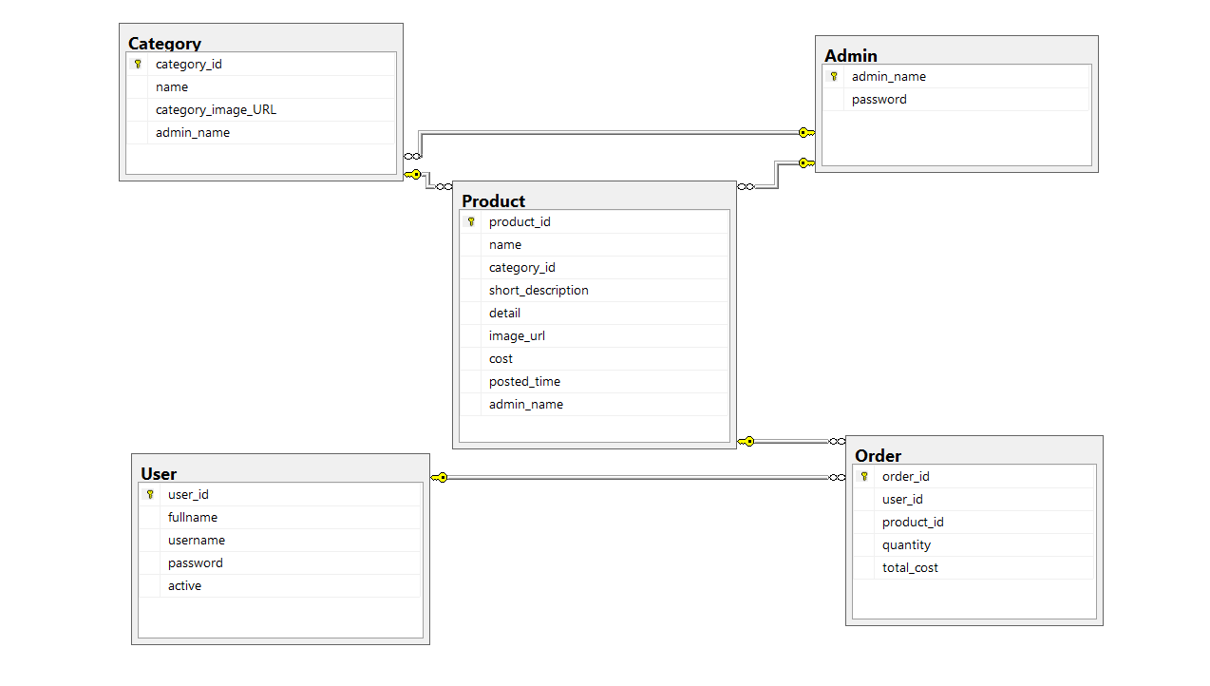

**Entity Relationship Diagram**

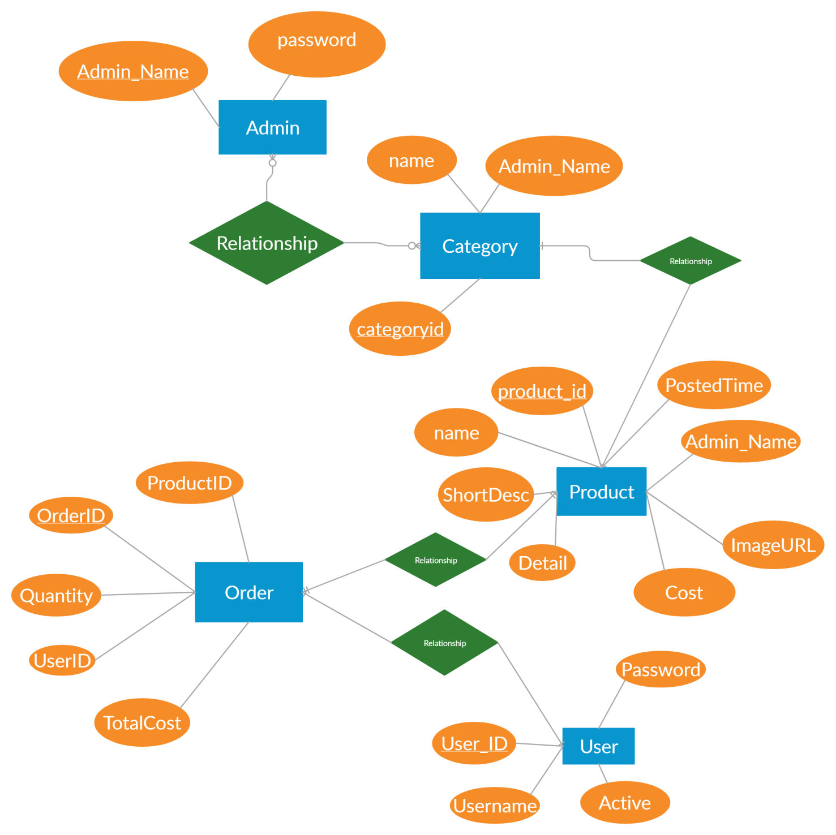

**CHAPTER 2 : USER INTERFACE**

**2.1 Welcome UI**

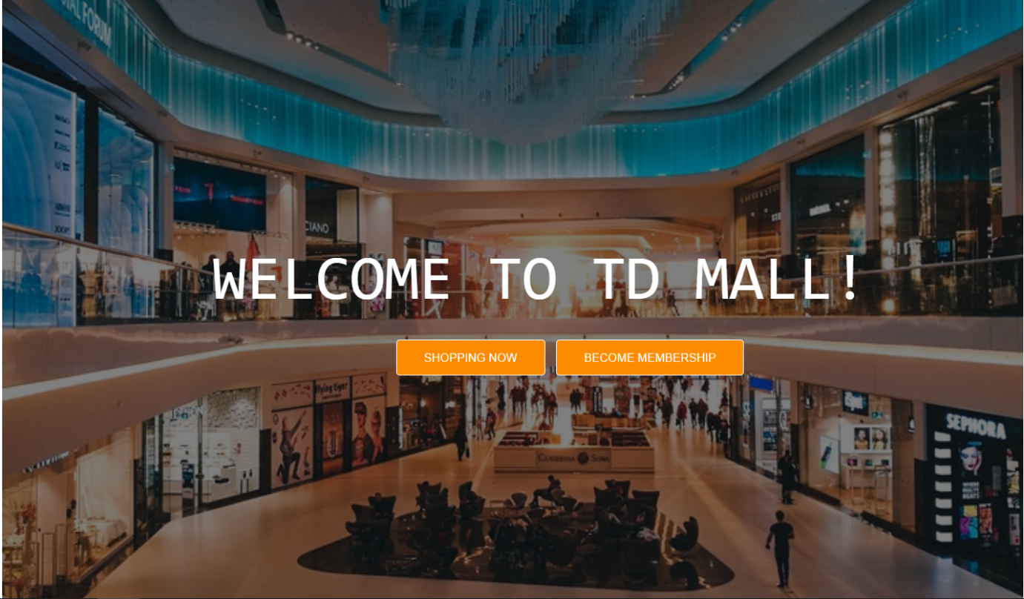

This is the homepage, which is first sight you will see when get into our web, if you don’t have the account, you can make the new one by Register.

In our web, you must have an account or you can not buy thing on our Website.

**2.2 List of categories**

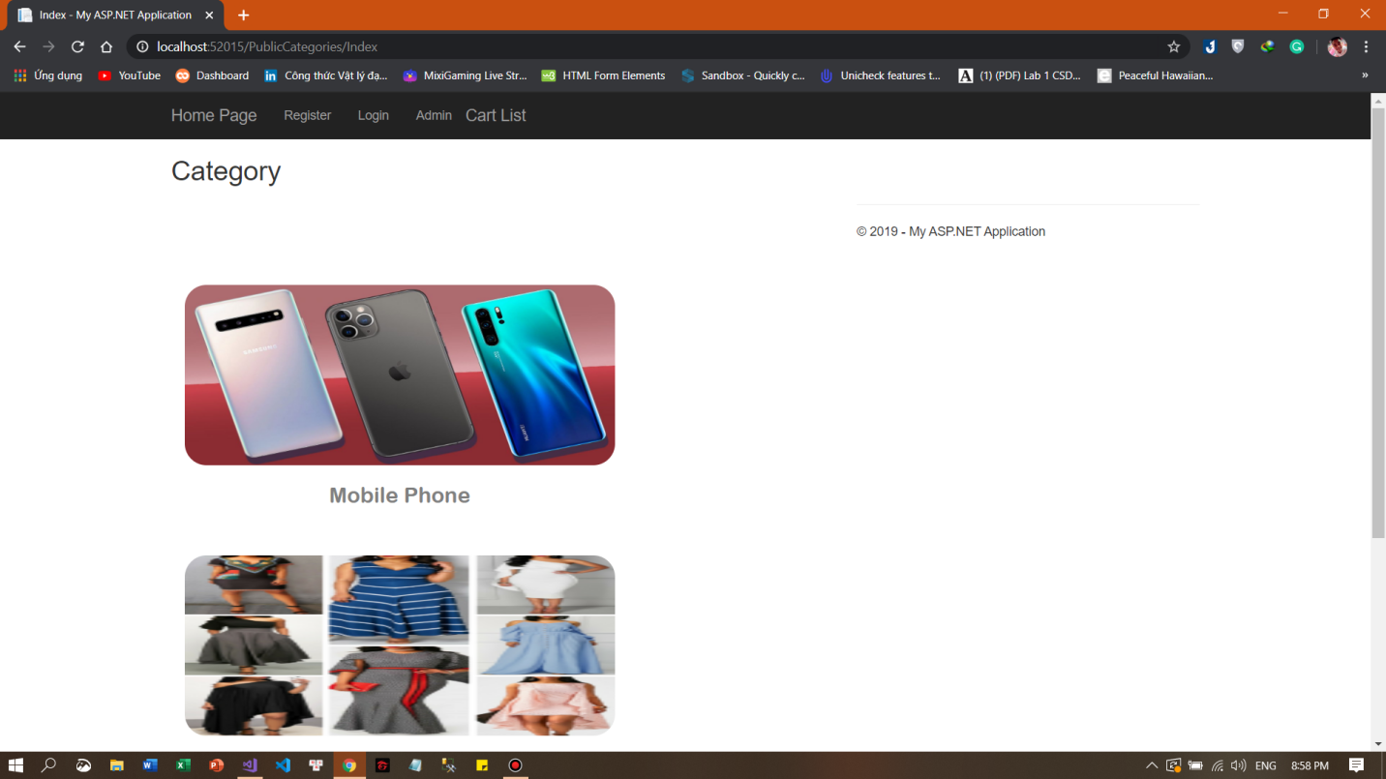

**2.3 List of Product in one category**

For example : Phone

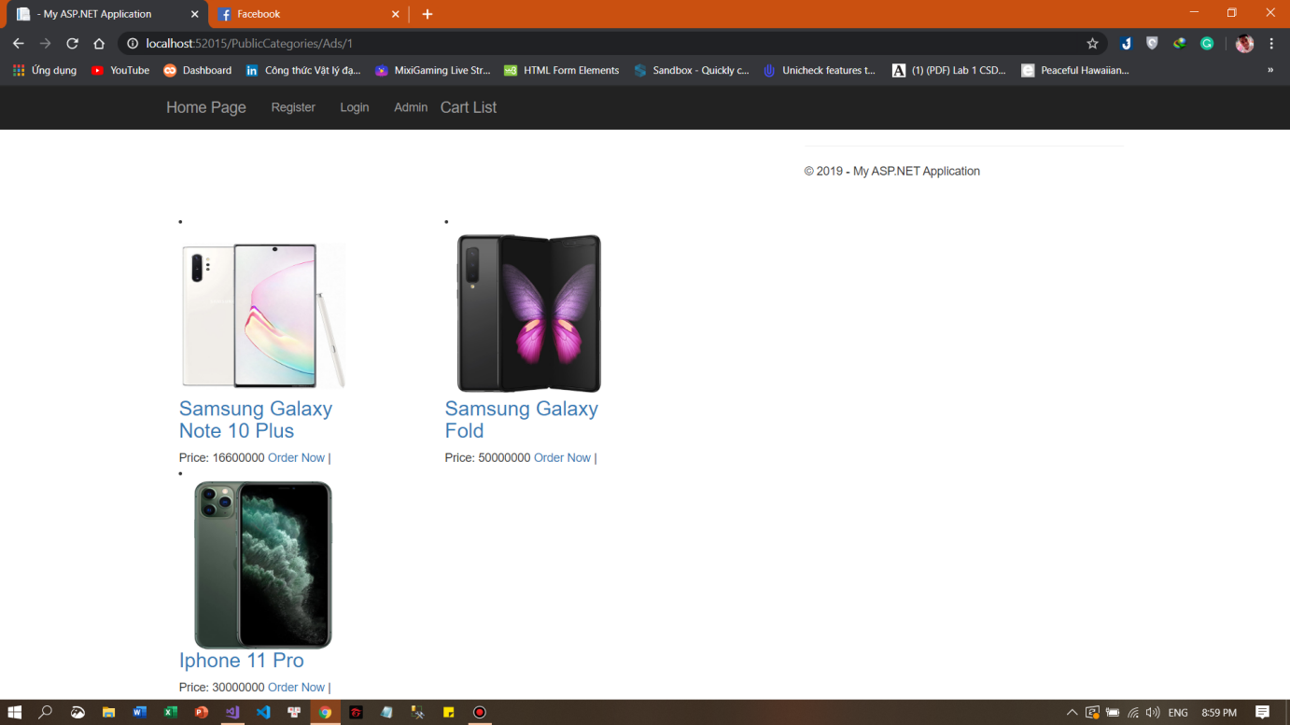

# CHAPTER 3: SUMMARY

### 3.1. The advantages and disadvantages of the project

#### 3.1.1. The advantages

We have made a project that had an easy-to-use UI so the users will face no obstacles to use this program. Besides that, the code is quite clean and clear.

The program also cost a little capacity.

#### 3.1.2. The disadvantages

The algorithms are not completely optimized. Some bugs still occur when we run the program in some specific test cases. We plan to build this program to be more efficient.

# PLANNING TABLE

|  |  |  |  |  |  |  |
| --- | --- | --- | --- | --- | --- | --- |
| **Week** | **Job** | **Time** | **Product** | **Attendee** | **Completion day** | **Rate** |
| 1  From  28/11/2019 To  03/12/2019 | 1. Find references | 28/11 | - Planning tasks | All  members | 29/10 | 100% |
| 2.  Planning | 29/11 |  | All  members | 29/10 | 100% |
| 3. Work assignment | 29/11 |  | Leader:  Đặng Trọng Quốc Huy | 29/10 | 100% |
| 4. First part of the  report | 29/11  – 1/12 | - Complete  the first part of the report | - Nguyễn Tuấn Anh | 1/11 | 100% |
| 5. Design  UI | 1/12 –  3/12 | - Complete the User Interface of the  Program | - All members | 3/11 | 100% |
| 2  From  4/12/2019  To  10/12/2019 | 1.  Complete general UI,  Menu, | 4/12 -  6/12 | - General UI | - Nguyễn Đình Thi | 6/11 | 100% |

|  |  |  |  |  |  |  |
| --- | --- | --- | --- | --- | --- | --- |
|  | Buttons,  Logo, Icon |  |  | - All members |  |  |
| 2.  Generate necessary properties, build Class | 7/12-  9/12 | - Main  Class | - Đặng Trọng Quốc Huy | 9/11 | 100% |
| 3. Build first controller | 10/12 |  | - All members | 10/11 | 100% |
| 3  From  10/12/2019 To  17/12/2019 | 1. Testing | 11/12-  15/12 | - Try some test cases | All members | 15/11 | 100% |
| 2. Make report for the main contents (P1) | 16/12-  17/12 | - Report for first part | - Nguyễn Tuấn Anh | 17/11 | 100% |
| 4  From  18/12/2019 To  20/12/2019 | 1.  Complete remaining parts | 18/11-  20/11 |  | - All  members | 20/11 | 100% |
| 2. Make report for the main contents (P1) | 23/11-  24/11 |  | - Nguyễn Đình Thi | 24/11 | 100% |
| 3. Testing | 24/11 |  | - All  members | 24/11 | 100% |
| 5  From  20/12/2019  To  21/12/2019 | 1. Adding some sub functions | 25/11  –  26/11 |  | - Đặng Trọng Quốc Huy |  | 100% |
| 2. Do the last part of the report | 25/11  -26/11 |  | - Nguyễn Tuấn Anh |  | 100% |
| 4.  Complete program, review the report | 27/11  -28/11 |  | - All  members |  | 100% |

# 

# REFERENCES

<https://www.w3schools.com/>

<https://docs.microsoft.com/en-us/ef/>

<https://docs.microsoft.com/en-us/aspnet/mvc/overview/getting-started/introduction/getting-started>

THE END