**HO CHI MINH UNIVERSITY OF TECHNOLOGY AND EDUCATION**

**FALCUTY FOR HIGH QUALITY TRANING**



**Lecturer: Ph.D Le Van Vinh**

**FINAL PROJECT**

**TOPIC: Tank Game In Unity Platform**

**ATTENDEES:**

**NGUYEN TUAN ANH - 17110002**

**DANG TRONG QUOC HUY - 17110035**

**SEMESTER: 2 – SCHOOL YEAR: 2019 – 2020**

**HO CHI MINH CITY – 07.2020**

**Lecturer’s comment:** ……………………………………………………

….…………………………………………………………………………

….…………………………………………………………………………

….…………………………………………………………………………

….…………………………………………………………………………

….…………………………………………………………………………

….…………………………………………………………………………

….…………………………………………………………………………

….…………………………………………………………………………

….…………………………………………………………………………

….…………………………………………………………………………

….…………………………………………………………………………

….…………………………………………………………………………

….…………………………………………………………………………

….…………………………………………………………………………

….…………………………………………………………………………

….…………………………………………………………………………

….…………………………………………………………………………

….…………………………………………………………………………

….…………………………………………………………………………

Thanks

In order to successfully complete this topic and report, we would like to express our sincere thanks to PhD. Le Van Vinh, who directly supported us throughout the class and topic-building process. We thank you for guiding us through the topic selection process, giving advice from our practical experience to guide us in the right direction of the chosen topic, he has always been watching. We throughout the process of implementing the topic, always answer questions and provide suggestions and corrections in time to help us overcome weaknesses and complete well the selected topic. Once again, we would like to thank you.

The topics and reports that we make in a short time, is a limited time with limited knowledge and many other surprises. Therefore, in the process of making the project, there are shortcomings that are inevitable, so we are looking forward to receiving your comments so that our knowledge will be more complete and we can do it. better in the next times. We sincerely thank you.

In the end, we wish her always good health and more success in human cultivation. Once again we would like to sincerely thank.

Ho Chi Minh City, July 25,2020

Group of student

1. **Overview:**
2. **Introduction**:

Tank game is very popular with us over many years. In this project we tried to make this game in 3D game with Unity platform. The rule of this game is very simple. We have 2 player playing at the same computer, each player will control one tank. They will try to take down another player. And the last player standing will be a winner.

1. **Software technique:**

* Programming platform: Unity 3D Platform.
* Programming language: C#, C++.

1. **Programming and explain source code:**
2. **Some picture of the project – Tank game:**
3. Main interface of Unity platform:

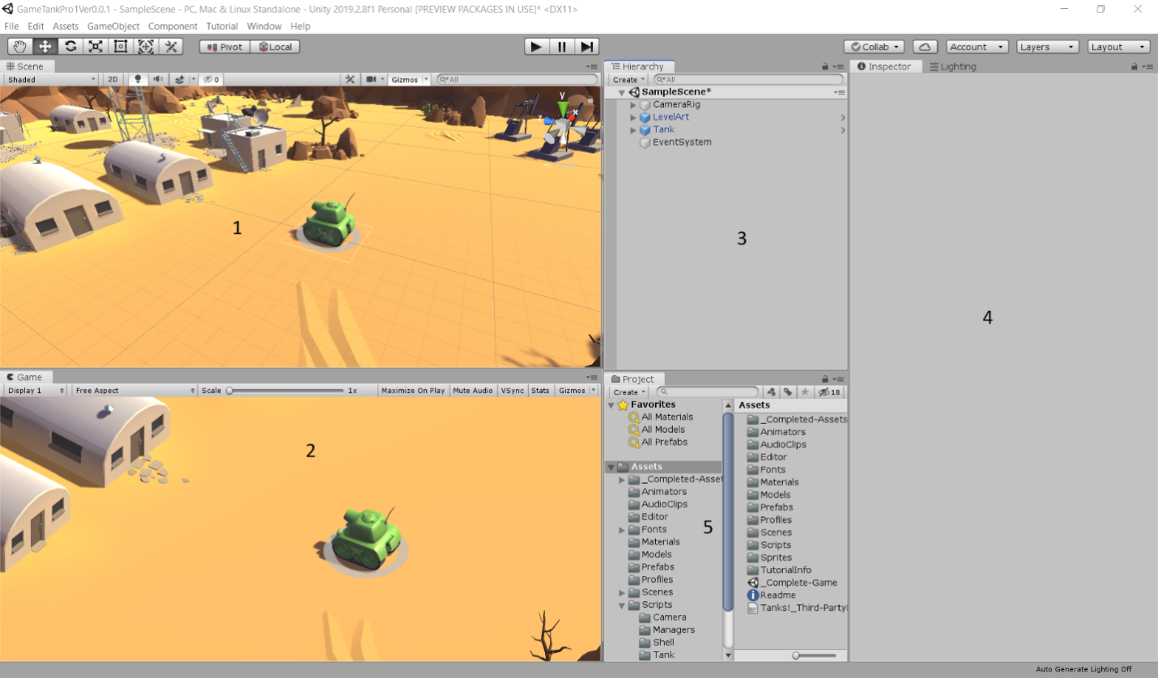

Note: This is a main interface of unity platform.

(1). This is a main work place in unity, in this screen we can do anything(add new component, camera, move a component, background,….)for our project.

(2). This is a demonstration screen of our project. When we run the project, the game will be run in this screen.

(3). This is a hierarchy window, all of the component will be stored in this window. We can easier control all of the component, model or anything we added into the project scene.

(4). This is an inspector window, all of the attribute and script of each component will be displayed in this window.

(5). This is a project folder, all of the file such as Assets or Packages will be stored and displayed in this window.

1. Map environment:

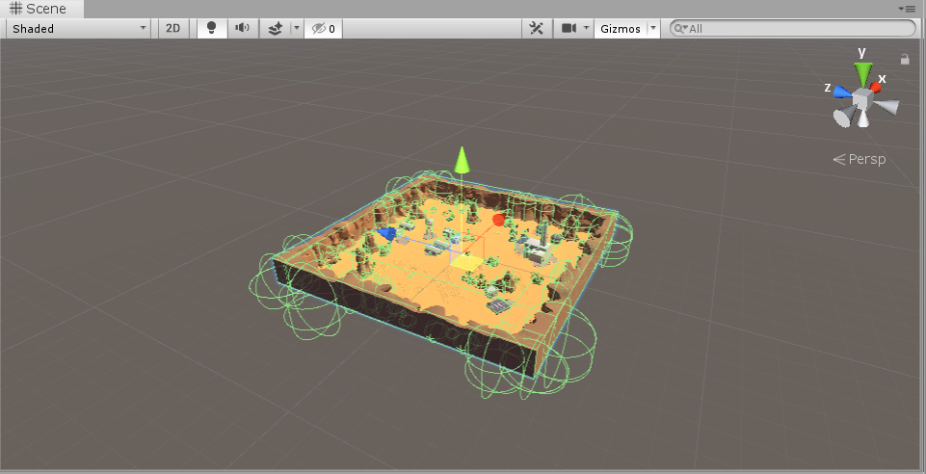

Note: This is also a Model or a Prefabs in Unity. In this project we called this Model is a Level Art. In this Level Art, we added some trees, companies, stones,…in order to create a map for player playing a game.

1. Tank model:

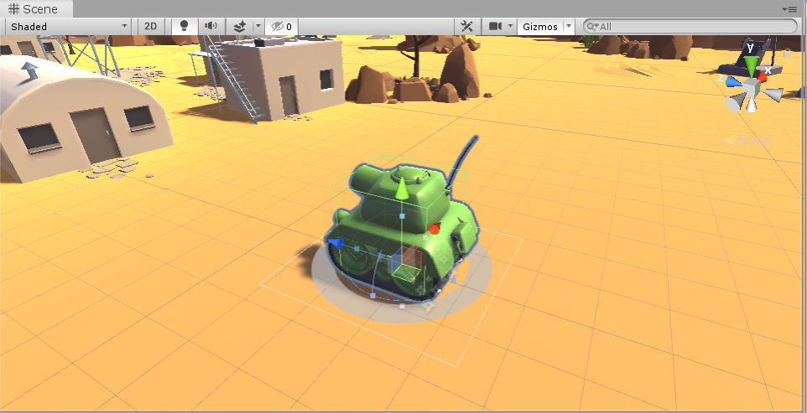

Note: This is a main character of this project – a Tank. The tank is also a model in unity so, therefore, it will have an interaction with another model in this project such as Level Art or the second tank.

1. Health bar of the tank:

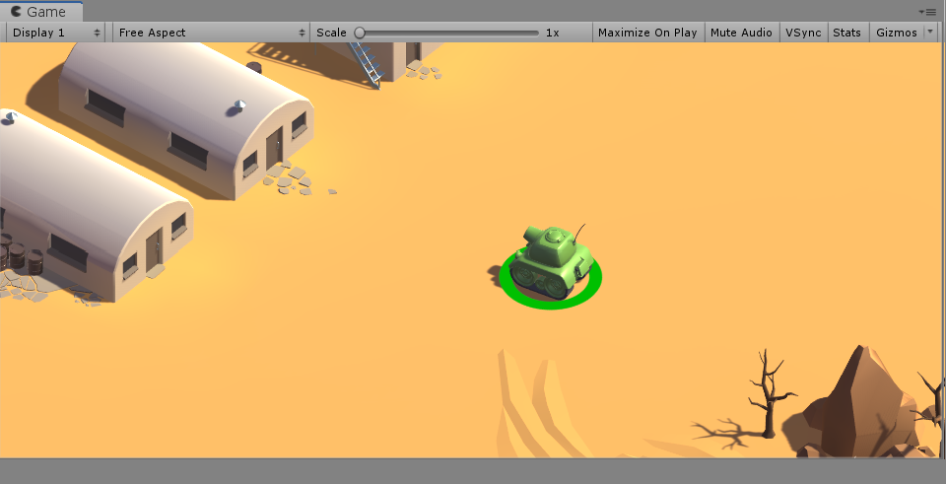

Note: According you can see, in the bottom of a tank, we have a circle health bar. This is a bar that will display the health of a tank.

1. Tank Shell

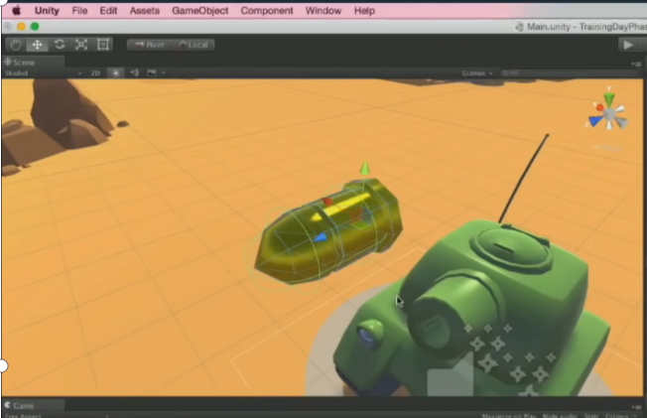

1. Screen of game

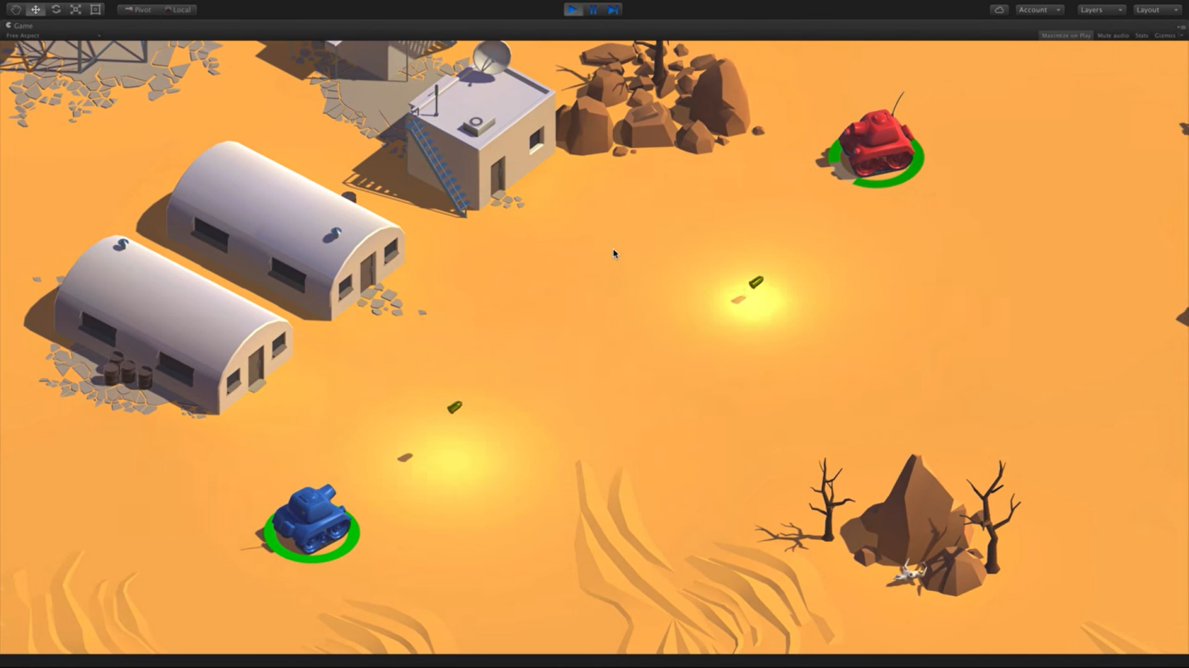

1. **Script and explain source code:**
2. **Script for tank model:**
3. **Tank Movement**

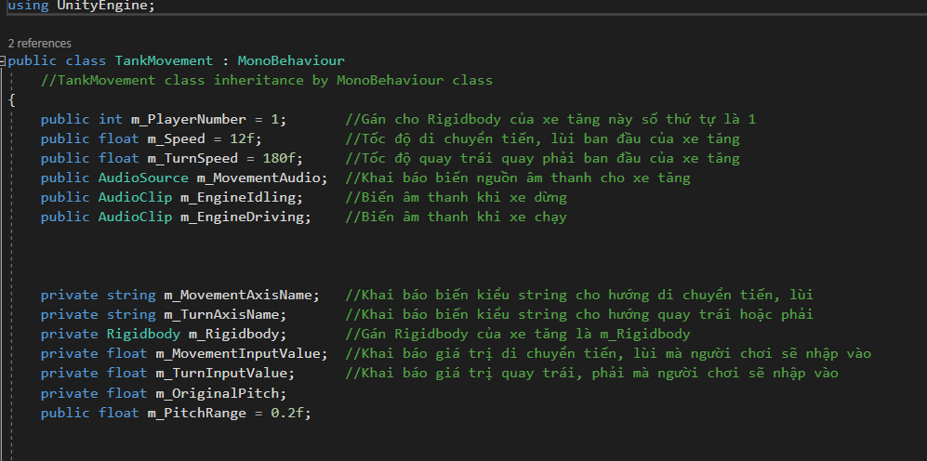

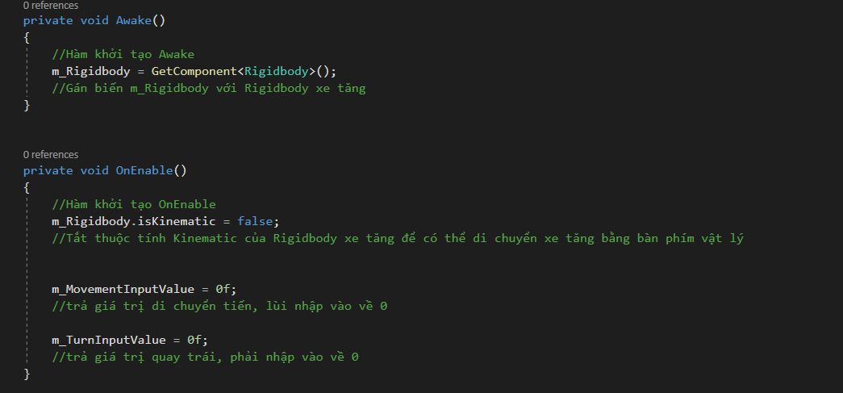

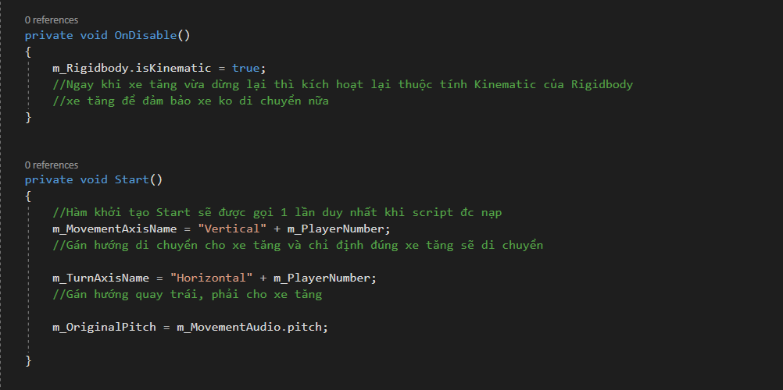

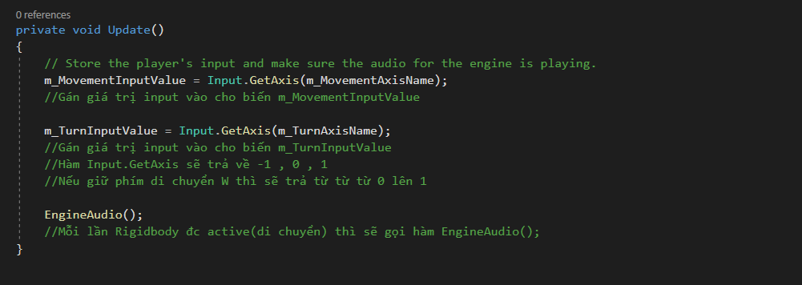

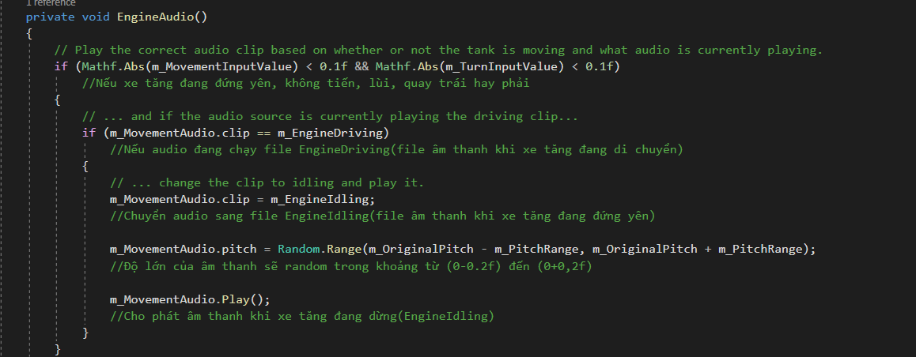

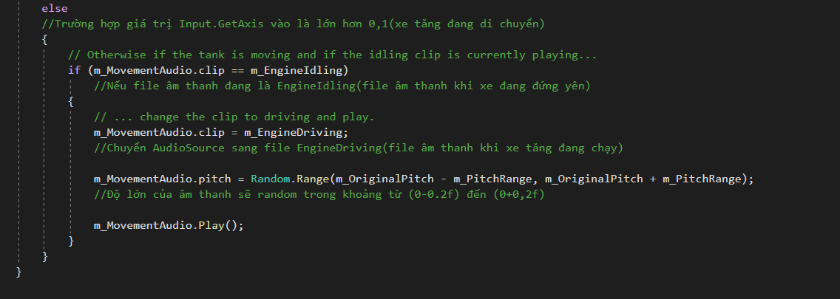

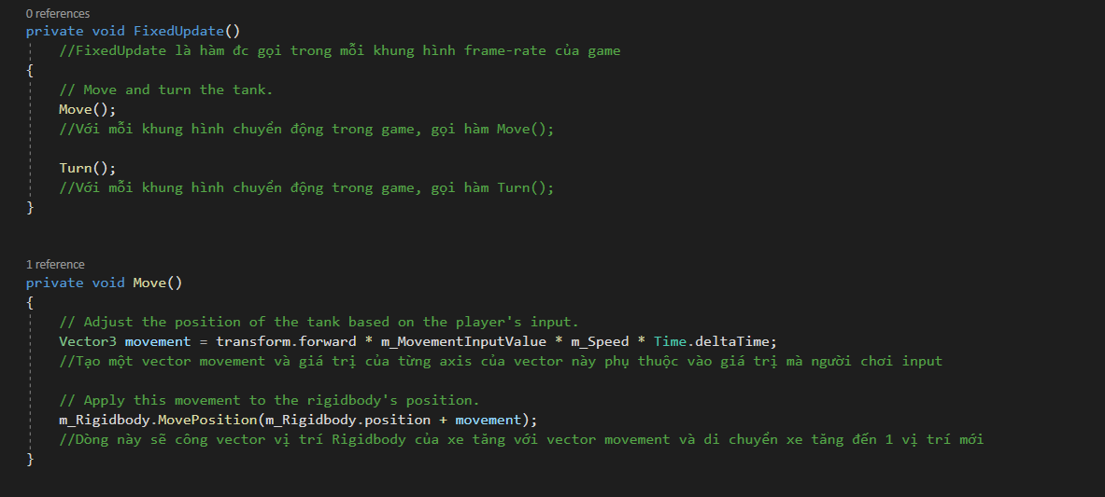

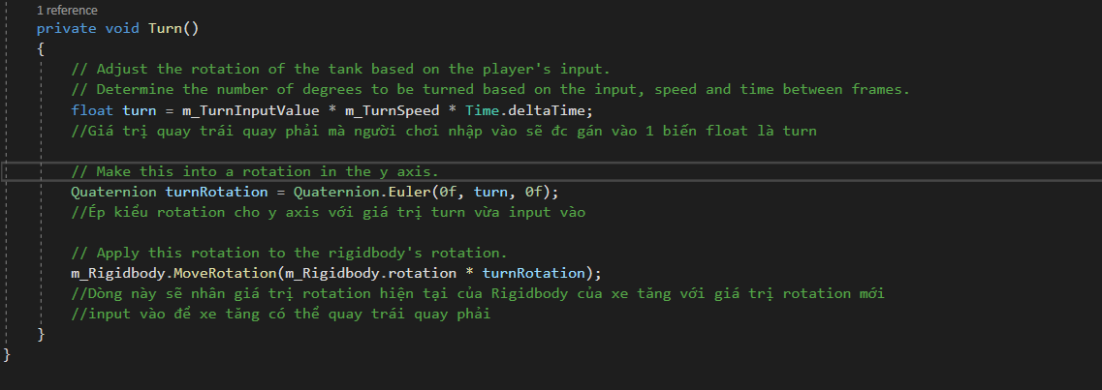

1. **Shell Explosion**

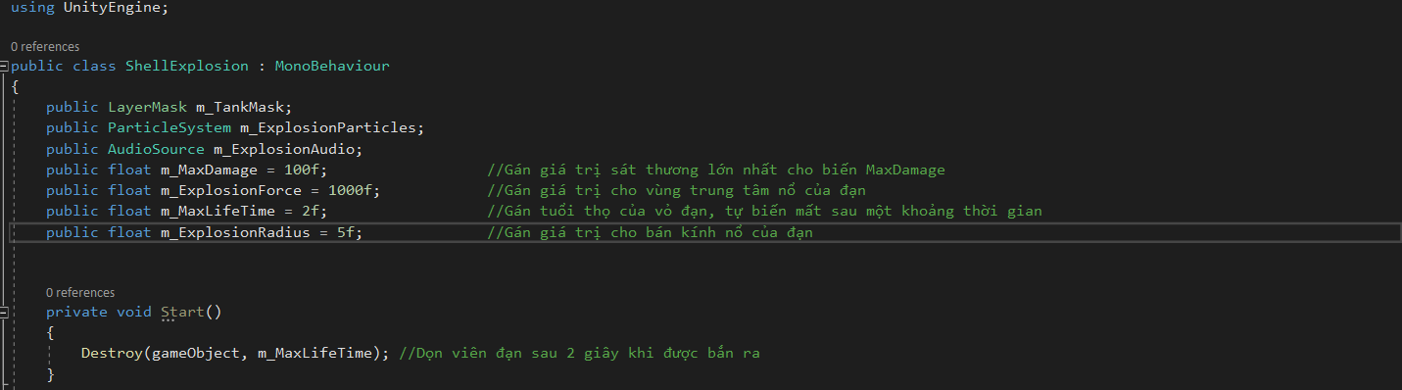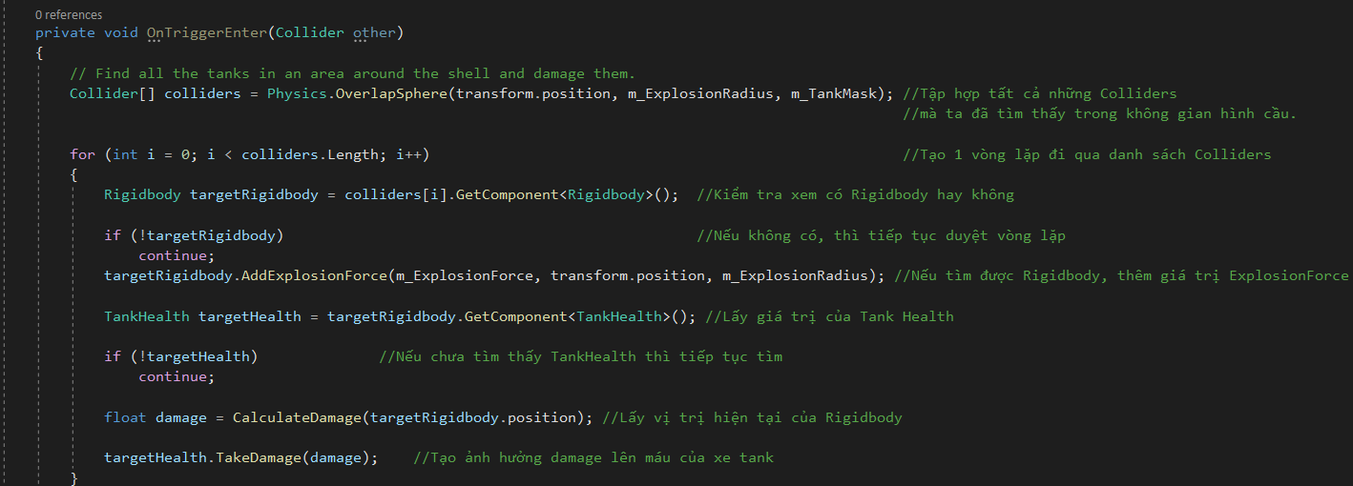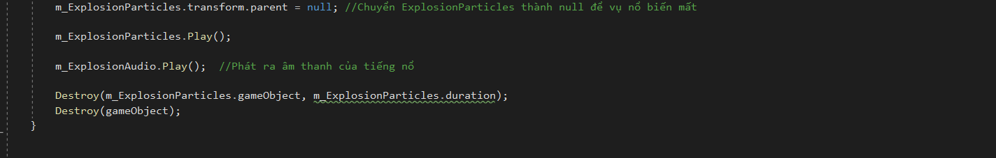

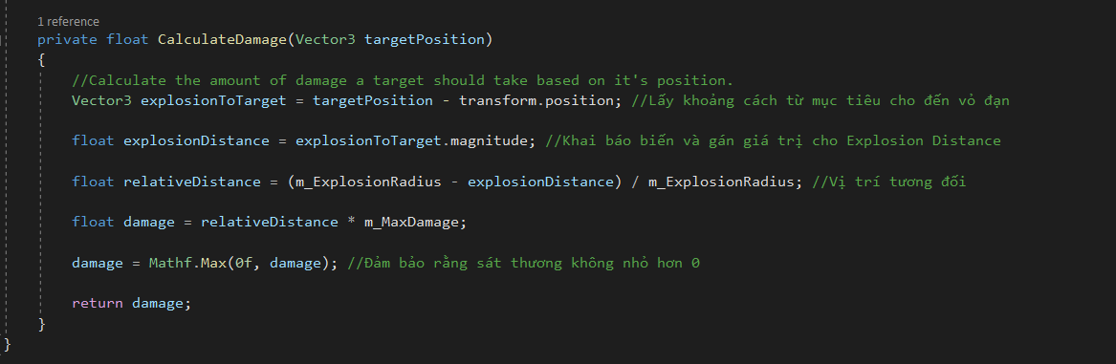

1. **Script for Game Manager**

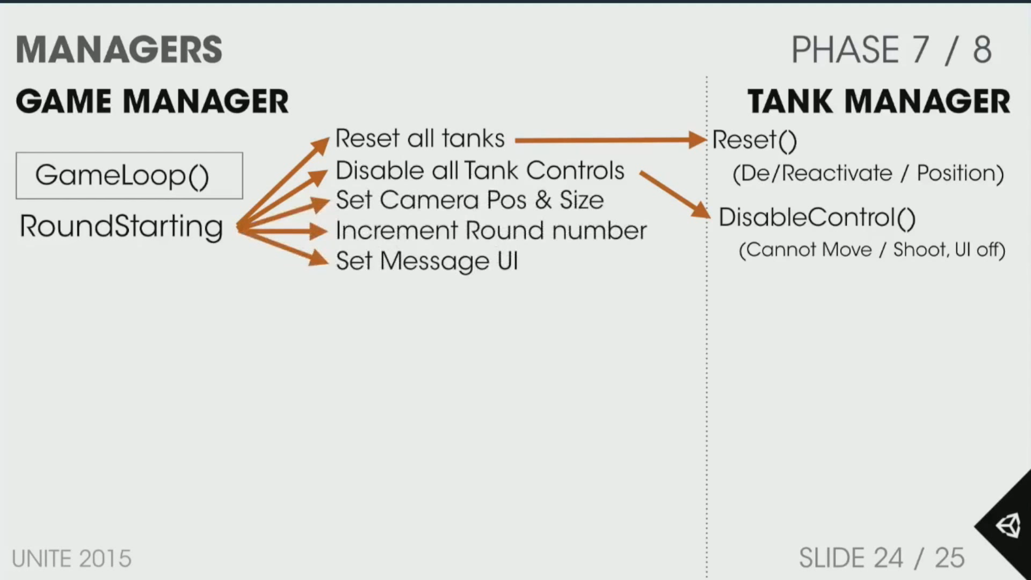

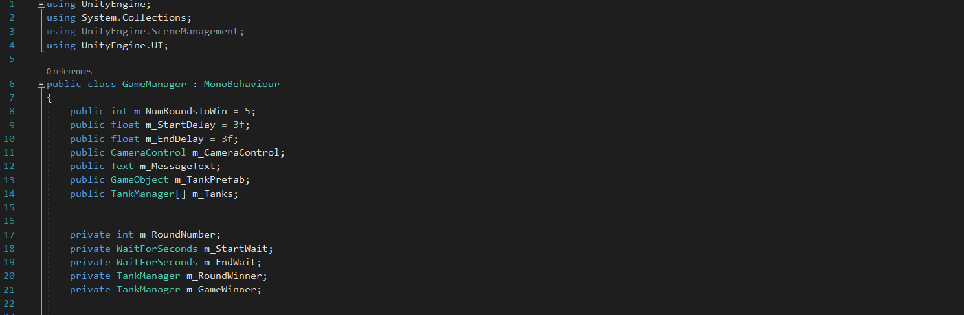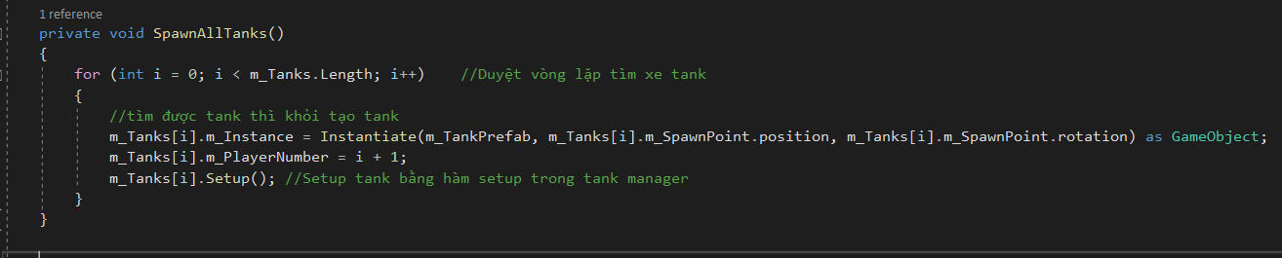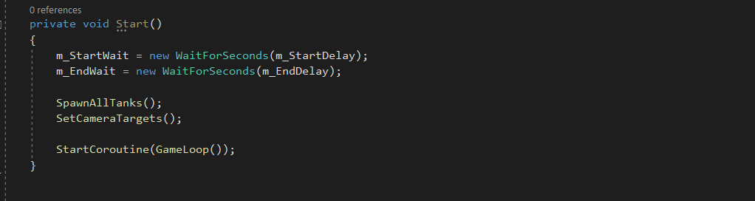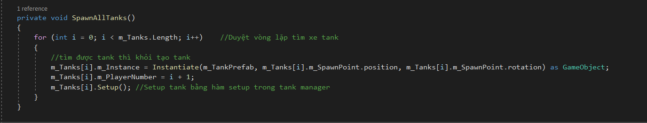

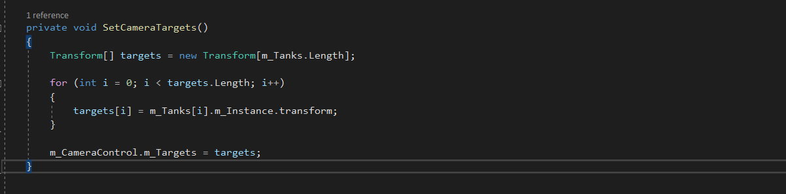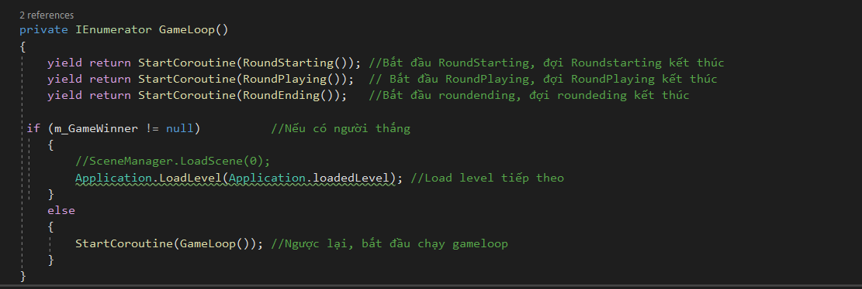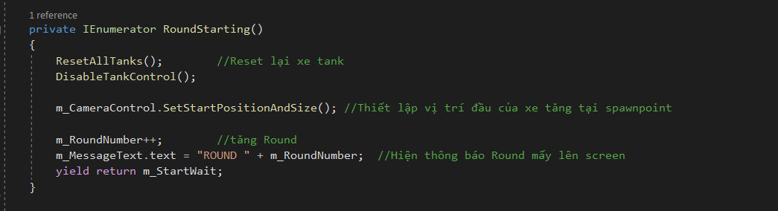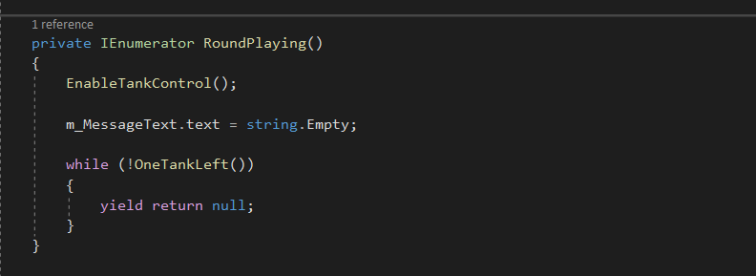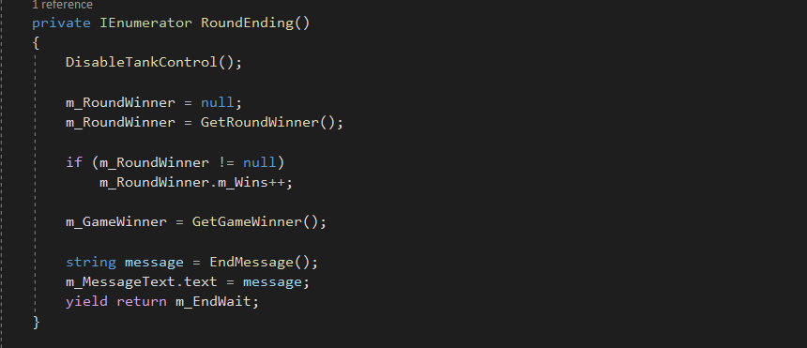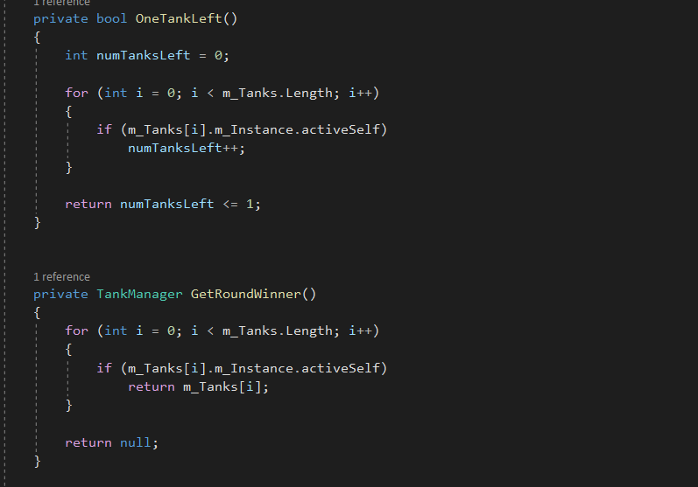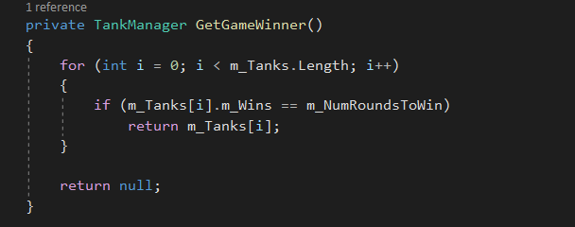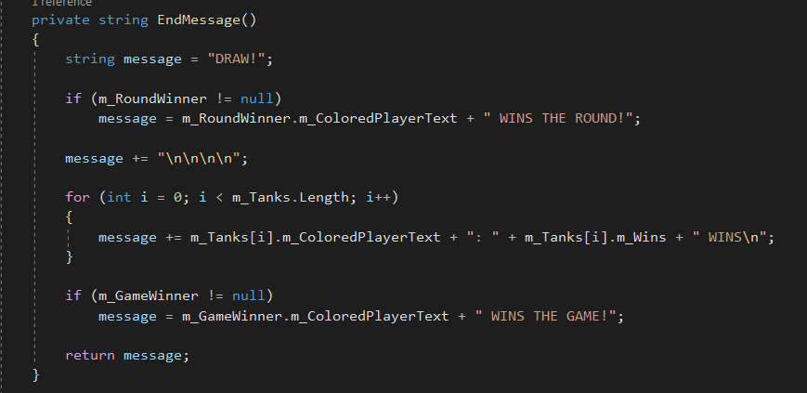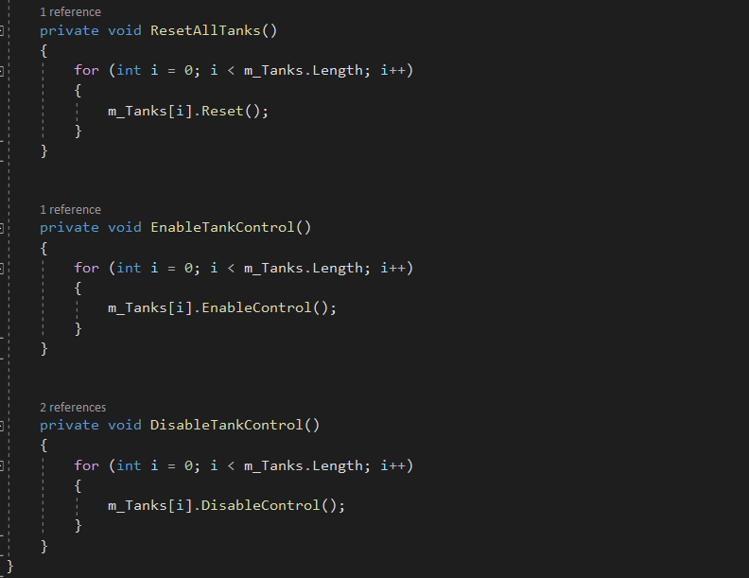

THE END