**1、题目**

**题目：设有一数据库，包括四个表：学生表（Student）、课程表（Course）、成绩表（Score）以及教师信息表（Teacher）。四个表的结构分别如表1-1的表（一）~表（四）所示，数据如表1-2的表（一）~表（四）所示。用SQL语句创建四个表并完成相关题目。**

**2、数据库的表结构**

**2.1、表1：Student (学生表)**

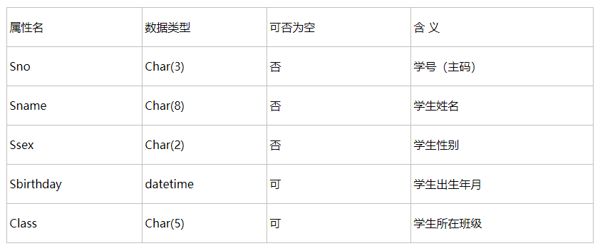

[复制代码](javascript:void(0);)

1 create table student

2 (

3 sno varchar(**20**) not null primary key,

4 sname varchar(**20**) not null,

5 ssex varchar(**20**) not null,

6 sbirthday datetime,

7 class varchar(**20**)

8 );

[复制代码](javascript:void(0);)

**2.2、表2：Teacher(教师表)**

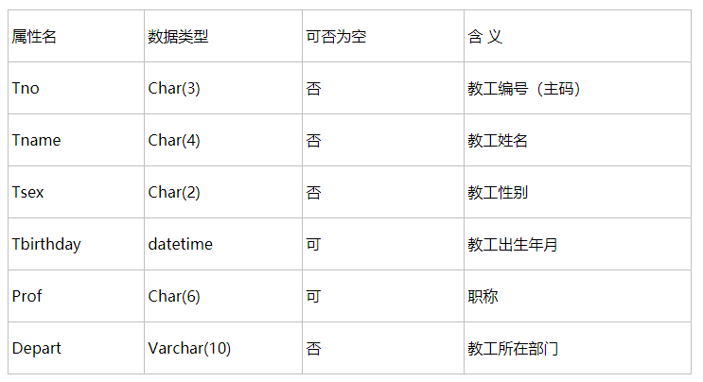

[复制代码](javascript:void(0);)

1 create table teacher

2 (

3 tno varchar(**20**) not null primary key,

4 tname varchar(**20**) not null,

5 tsex varchar(**20**) not null,

6 tbirthday datetime,

7 prof varchar(**20**),

8 depart varchar(**20**) not null

9 );

[复制代码](javascript:void(0);)

**2.3、表3：Course（课程表）**

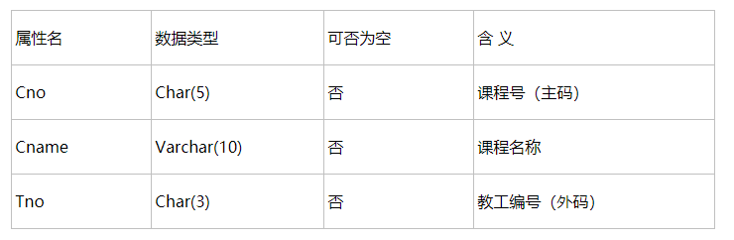

[复制代码](javascript:void(0);)

1 create table course

2 (

3 cno varchar(**20**) not null primary key,

4 cname varchar(**20**) not null,

5 tno varchar(**20**) not null,

6 foreign key(tno) references teacher(tno)

7 );

[复制代码](javascript:void(0);)

**2.4、表4：Score(成绩表)**

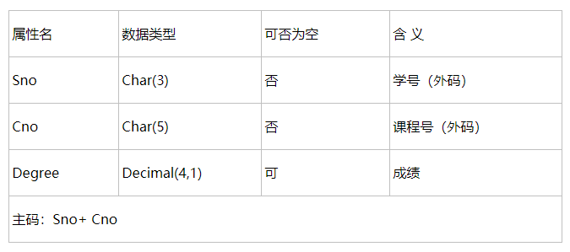

[复制代码](javascript:void(0);)

1 create table score

2 (

3 sno varchar(**20**) not null,

4 foreign key(sno) references student(sno),

5 cno varchar(**20**) not null,

6 foreign key(cno) references course(cno),

7 degree decimal

8 );

[复制代码](javascript:void(0);)

**3、数据库中的数据**

**3.1、Student(学生表)**

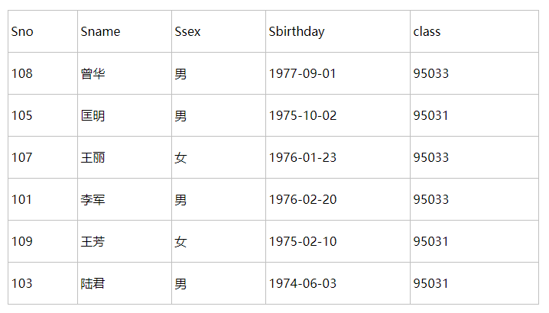

1 insert into student values('108','曾华','男','1977-09-01','95033');

2 insert into student values('105','匡明','男','1975-10-02','95031');

3 insert into student values('107','王丽','女','1976-01-23','95033');

4 insert into student values('101','李军','男','1976-02-20','95033');

5 insert into student values('109','王芳','女','1975-02-10','95031');

6 insert into student values('103','陆君','男','1974-06-03','95031');

**3.2、Teacher(教师表)**

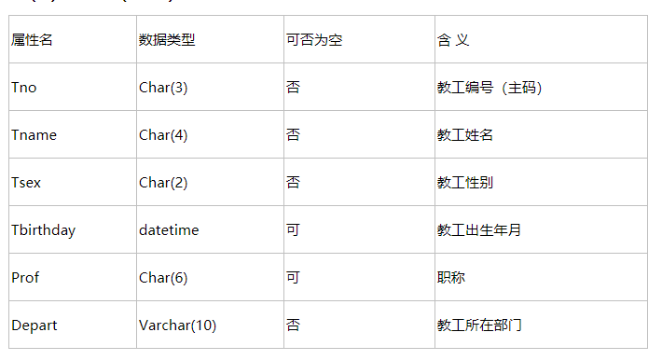

insert into teacher values (**804**,'李成','男','1958-12-2','副教授','计算机系');

insert into teacher values (**856**,'张旭','男','1969-3-12','讲师','电子工程系');

insert into teacher values (**825**,'王萍','女','1972-5-5','助教','计算机系');   
insert into teacher values (**831**,'刘冰','女','1977-8-14','助教','电子工程系');

**3.3、Course(课程表)**

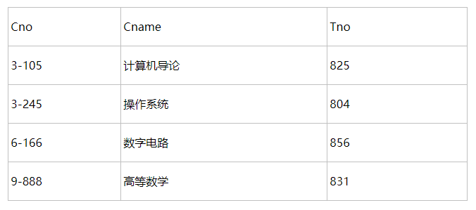

1 insert into course values('3-105','计算机导论','825');

2 insert into course values('3-245','操作系统','804');

3 insert into course values('6-166','数字电路','856');

4 insert into course values('9-888','高等数学','831');

**3.4、Score(成绩表)**

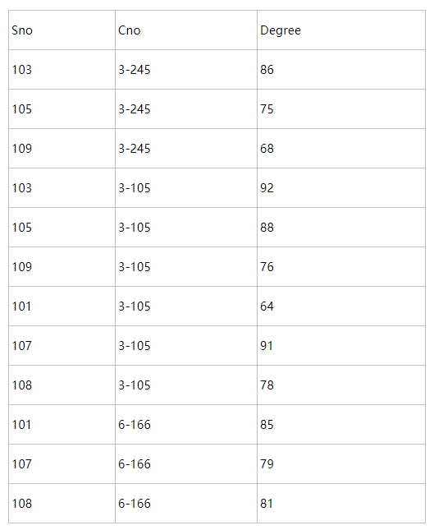

[复制代码](javascript:void(0);)

1 insert into score values('103','3-245','86');

2 insert into score values('105','3-245','75');

3 insert into score values('109','3-245','68');

4 insert into score values('103','3-105','92');

5 insert into score values('105','3-105','88');

6 insert into score values('109','3-105','76');

7 insert into score values('103','3-105','64');

8 insert into score values('105','3-105','91');

9 insert into score values('109','3-105','78');

10 insert into score values('103','6-166','85');

11 insert into score values('105','6-166','79');

12 insert into score values('109','6-166','81');

[复制代码](javascript:void(0);)

**4、45小题答案**

1、 查询Student表中的所有记录的Sname、Ssex和Class列。

select Sname,Ssex,Class from student

2、 查询教师所有的单位即不重复的Depart列。

select distinct Depart from teacher

3、查询Student表的所有记录。

select * from student

4、查询Score表中成绩在60到80之间的所有记录。

select * from Score where Degree between **60** and **80**

5、查询Score表中成绩为85，86或88的记录。

select * from Score where Degree in(**85**,**86**,**88**)

6、查询Student表中“95031”班或性别为“女”的同学记录。

select * from Student where class='95031' or Ssex='女'

7、以Class降序查询Student表的所有记录。

select * from student order by class desc

8、以Cno升序、Degree降序查询Score表的所有记录。

select * from Score order by cno asc,degree desc

9、查询“95031”班的学生人数。

select count(*) from student where class='95031'

10、 查询Score表中的最高分的学生学号和课程号。（子查询或者排序）查询语句查询出一个或者一列结果，可以作为其他查询语句的参数来使用，就是子查询，就是查询的嵌套。

select Sno,Cno from Score where Degree=(select max(Degree) from Score)

select Sno,Cno from Score order by Degree desc limit **0**,**1**

11、查询每门课的平均成绩，要按照课程分组group by，然后求没门课平均avg

select Cno,avg(degree) from Score group by Cno

12、查询Score表中至少有5名学生选修的并以3开头的课程的平均分数。Like模糊查询 3%以3开头 having只能跟在group by 后面

SELECT AVG(Degree) FROM score where Cno LIKE '3%' GROUP BY Cno HAVING count(**1**)>**5**

13、查询分数大于70，小于90的Sno列。

select Sno from Score where degree>**70** and degree<**90**

14、查询所有学生的Sname、Cno和Degree列。

select Sname, Cno,Degree from Score , student where Score.Sno=student.Sno

15、查询所有学生的Sno、Cname和Degree列。

select Sno,Cname,Degree from Score , Course where Score.Cno=Course.Cno

16、查询所有学生的Sname、Cname和Degree列。

select Sname,Cname,Degree from student,course,score where student.Sno=score.Sno and course.Cno=score.Cno

select Sname,Cname,Degree from student join score on student.Sno=score.Sno join course on course.Cno=score.Cno

17、 查询“95033”班学生的平均分。

select avg(degree) as 'class=95033' from Score where Sno in (select Sno from Student where Class='95033' )

18、假设使用如下命令建立了一个grade表：

　　create table grade(low int(3),upp int(3),rank char(1));

　　insert into grade values(90,100,’A’);

　　insert into grade values(80,89,’B’);

　　insert into grade values(70,79,’C’);

　　insert into grade values(60,69,’D’);

　　insert into grade values(0,59,’E’)

　　现查询所有同学的Sno、Cno和rank列。

select Sno,Cno,rank from Score,grade where degree between low and upp

19、查询选修“3-105”课程的成绩高于“109”号同学成绩的所有同学的记录。

select * from score where Cno='3-105' and degree>(select max(degree ) from Score where Sno='109' and Cno='3-105' )

20、查询score中选学多门课程的同学中分数为非最高分成绩的记录。

select * from score a where Sno in (select Sno from score group by Sno having count(*)>**1**) and degree<( select max(degree ) from Score b where b.cno = a.cno)

21、查询成绩高于学号为“109”、课程号为“3-105”的成m绩的所有记录。

Select * from score where degree>(select degree from Score where Sno='109' and Cno='3-105' order by degree desc limit **1** )

22、查询和学号为108的同学同年出生的所有学生的Sno、Sname和Sbirthday列。

select sno,sname,sbirthday from student where year(sbirthday) = (select year(sbirthday) from student where sno='108')

select sno,sname,sbirthday from student where year(sbirthday) = (select year(sbirthday) from student where sno='101')

23、查询“张旭“教师任的学生成绩。

select Sno,degree from score,Course where score.Cno=Course.Cno and Course.Tno= (select Tno from Teacher where Tname='张旭' )

select degree from score where Cno in (select cno from course where Tno= (select Tno from Teacher where Tname='张旭' ) )

24、查询选修某课程的同学人数多于5人的教师姓名。

select Tname from Teacher, Course where Teacher.Tno=Course.Tno and Course.Cno =(select Cno from Score group by Cno having count(*)>**5**)

select Tname from Teacher where tno=( select Tno from Course where cno=( select Cno from Score group by Cno having count(*)>**5** ))

25、查询95033班和95031班全体学生的记录。

select * from student where class in ('95033','95031')

26、 查询存在有85分以上成绩的课程Cno.

select Cno from score where degree>**85**

27、查询出“计算机系“教师所教课程的成绩表。

select * from course where cno in (select cno from course where tno in (select tno from teacher where Depart='计算机系'))

28、查询“计算机系”与“电子工程系“不同职称的教师的Tname和Prof。

select Tname,Prof from Teacher where Depart ='计算机系' and Prof not in( select Prof from Teacher where Depart ='电子工程系')  
  
select Tname,Prof from Teacher where Depart ='电子工程系' and Prof not in( select Prof from Teacher where Depart ='计算机系')

29、查询选修编号为“3-105“课程且成绩至少高于选修编号为“3-245”的同

select Cno,Sno,Degree from score where cno='3-105' and degree >any(select degree from score where cno='3-245' ) order by degree desc

30、查询选修编号为“3-105”且成绩高于选修编号为“3-245”课程的同学的Cno、Sno和Degree. ?

select Cno,Sno,Degree from score where cno='3-105' and degree >all(select degree from score where cno='3-245' ) order by degree desc

31、 查询所有教师和同学的name、sex和birthday.

select tname,tsex,tbirthday from Teacher union select sname,ssex,sbirthday from Student

32、查询所有“女”教师和“女”同学的name、sex和birthday.

select Tname,Tsex,Tbirthday from Teacher where Tsex='女' union select Sname,Ssex,Sbirthday from Student where Ssex='女'

33、 查询成绩比该课程平均成绩低的同学的成绩表。

select * from score a where degree < (select avg(degree) from score b where b.cno=a.cno)

34、查询所有任课教师的Tname和Depart.

select Tname,Depart from Teacher where tno in (select tno from course )

35 、查询所有未讲课的教师的Tname和Depart.

select Tname,Depart from Teacher where Tno not in (select Tno from Course where cno in (select cno from score ))

36、查询至少有2名男生的班号。

select class from student where ssex='男' group by class having count(*)>**1**

37.查询不姓王的同学信息

select * from Student where Sname not like '王%'

38、查询Student表中每个学生的姓名和年龄。

select Sname, year(now())-year(sbirthday) from Student

39、查询Student表中最大和最小的Sbirthday日期值。

select Max(Sbirthday ),Min(Sbirthday ) from Student

40、以班号和年龄从大到小的顺序查询Student表中的全部记录。

select * from Student order by class desc, Sbirthday

41、查询“男”教师及其所上的课程。

select Tname,Cname from course,teacher where course.tno= teacher.tno and teacher.Tsex='男'

42、查询最高分同学的Sno、Cno和Degree列。

select Sno,Cno,Degree from score where degree=(select max(degree) from score)

排序写法：select Sno,Cno,Degree from score order by degree desc limit **0**,**1**

43、查询所有选修“计算机导论”课程的“男”同学的成绩表。

SELECT * from score JOIN course ON course.Cno=score.Cno AND Cname='计算机导论' join student ON student.Sno=score.Sno AND Ssex='男'

44、查询和“李军”同性别的所有同学的Sname.

select Sname from Student where Ssex = (select Ssex from Student where Sname='李军')

45、查询和“李军”同性别并同班的同学Sname.

select Sname from Student where Ssex = (select Ssex from Student where Sname='李军' ) and class=( select class from student where Sname='李军')

46、查询所有选修“计算机导论”课程的“男”同学的成绩表。

select Sno,Cno,degree from score where Cno=( select Cno from course where Cname='计算机导论') and Sno in (select Sno from student where Ssex='男')