CPE301 – SPRING 2019

Design Assignment DA1A

Student Name: Gabriela Cuicas

Student #: 5002960022

Student Email: cuicas@unlv.nevada.edu

Primary Github address: https://github.com/cuicattack

Directory: https://github.com/cuicattack/cat1.git

1. **DEVELOPED CODE OF TASK 1**

The first task was to perform multiplication on a 16 bit number by an 8 bit number without using the instruction MUL. Multiplication is just the summation of the number over a finite period.

The instructions asked to set R25 and R24 to hold the 16 bit multiplicand, R22 to hold the 8 bit multiplier, and R20-R18 to hold the answer.

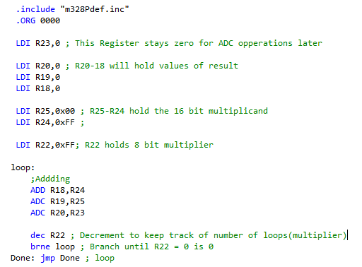

1. **DEVELOPED CODE OF TASK 2**

The second task was to verify the answer from task 1 using the MUL operation.

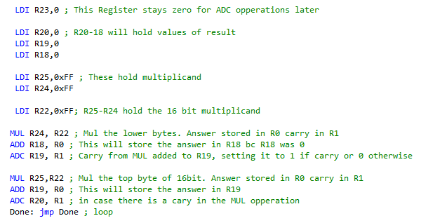

1. **SCREENSHOTS OF EACH TASK 1 OUTPUT**

The image below displays the results for the code, which are loaded in R20-R18. R18 is the low byte.



The image below displays the execution time for the code.

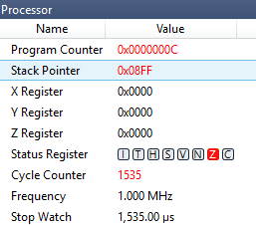

1. **SCREENSHOTS OF EACH TASK 2 OUTPUT**

The image below displays the results for the verification code, which are loaded in R20-R18. R18 is the low byte.



The image below displays the execution time for the verification code.

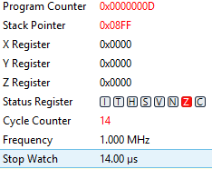

1. **GITHUB LINK OF THIS DA**

**Student Academic Misconduct Policy**

<http://studentconduct.unlv.edu/misconduct/policy.html>

“This assignment submission is my own, original work”.

NAME OF THE STUDENT