CPE301 – SPRING 2019

Design Assignment Midterm

Student Name: Gabriela Cuicas

Student #: 5002960022

Student Email: cuicas@unlv.nevada.edu

Primary Github address: https://github.com/cuicattack/cat1

Directory: https://github.com/cuicattack/cat/Cat1Assn11_DA_5

Submit the following for all Labs:

1. In the document, for each task submit the modified or included code (only) with highlights and justifications of the modifications. Also, include the comments.
2. Use the previously create a Github repository with a random name (no CPE/301, Lastname, Firstname). Place all labs under the root folder ESD301/DA, sub-folder named LABXX, with one document and one video link file for each lab, place modified asm/c files named as LabXX-TYY.asm/c.
3. If multiple asm/c files or other libraries are used, create a folder LabXX-TYY and place these files inside the folder.
4. The folder should have a) Word document (see template), b) source code file(s) and other include files, c) text file with youtube video links (see template).

1. **COMPONENTS LIST AND CONNECTION BLOCK DIAGRAM w/ PINS**

List of Components used

nRF24L01

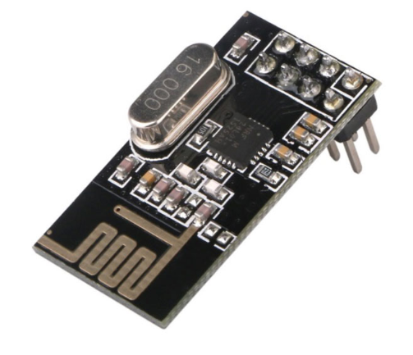

Block diagram

PORTD – rec

nRF24L01- trans

nRF24L01 - rec

PORTD – trans

1. **DEVELOPED C CODE OF TASK 1**

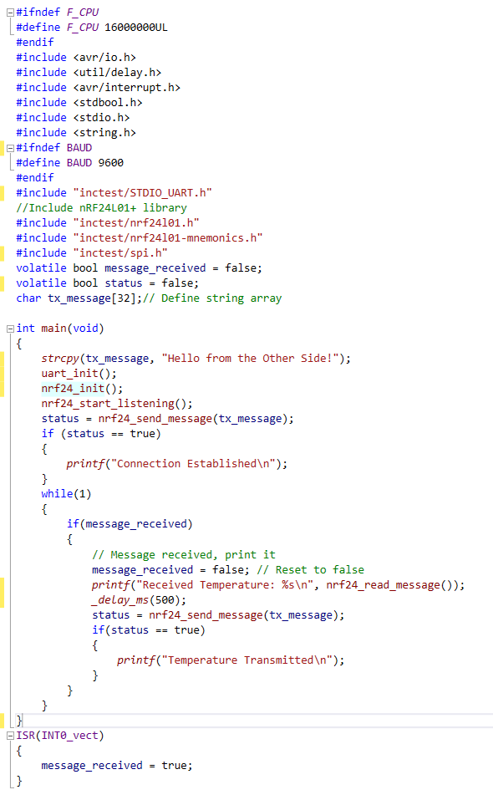

1. **SCHEMATICS**

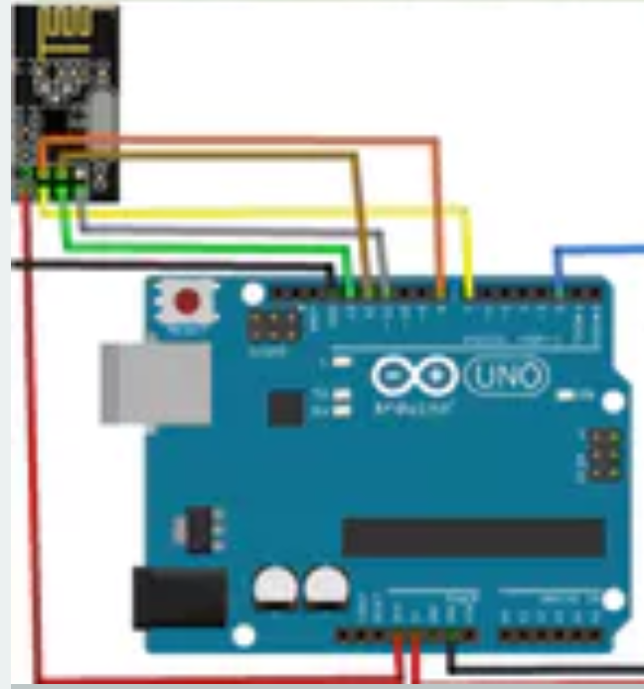

1. **SCREENSHOT OF EACH DEMO (BOARD SETUP)**

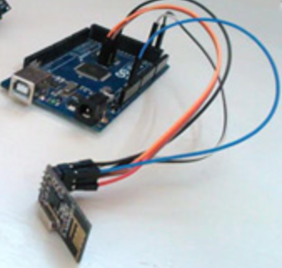

1. **VIDEO LINKS OF EACH DEMO**

<https://www.youtube.com/watch?v=7Hg786karNk&list=PL5KkHOalGXZ71iIBIr32ij3e1gJDyAUsu&index=10&t=0s>

1. **GITHUB LINK OF THIS DA**

https://github.com/cuicattack/cat/Cat1Assn11_DA_5

**Student Academic Misconduct Policy**

<http://studentconduct.unlv.edu/misconduct/policy.html>

“This assignment submission is my own, original work”.

NAME OF THE STUDENT