CPE301 – SPRING 2019

Design Assignment-Midterm II

Student Name: Gabriela Cuicas

Student #: 5002960022

Student Email: cuicas@unlv.nevada.edu

Primary Github address: https://github.com/cuicattack/cat1

Directory: https://github.com/cuicattack/cat/Cat1Assn13_DA_MidtermII

Submit the following for all Labs:

1. In the document, for each task submit the modified or included code (only) with highlights and justifications of the modifications. Also, include the comments.
2. Use the previously create a Github repository with a random name (no CPE/301, Lastname, Firstname). Place all labs under the root folder ESD301/DA, sub-folder named LABXX, with one document and one video link file for each lab, place modified asm/c files named as LabXX-TYY.asm/c.
3. If multiple asm/c files or other libraries are used, create a folder LabXX-TYY and place these files inside the folder.
4. The folder should have a) Word document (see template), b) source code file(s) and other include files, c) text file with youtube video links (see template).

1. **COMPONENTS LIST AND CONNECTION BLOCK DIAGRAM w/ PINS**

List of Components used

APDS 9960

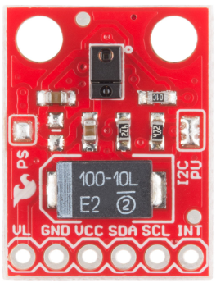

ESP32 – wifi module

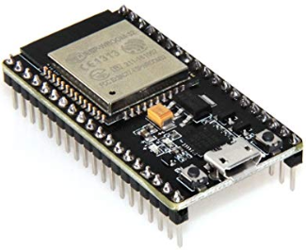

Block diagram

PORTC – –PC4 ADC4

APDS 9960

SDA

APDS 9960

SCL

PORTC – –PC5 ADC5

PORTD – –PD0 RXD

ESP 32

TXD

ESP 32

RXD

PORTD – –PD1 TXD

1. **DEVELOPED C CODE OF TASK 1**

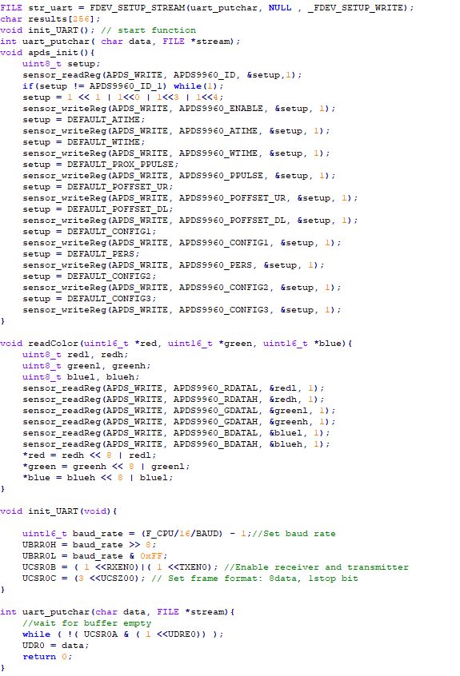

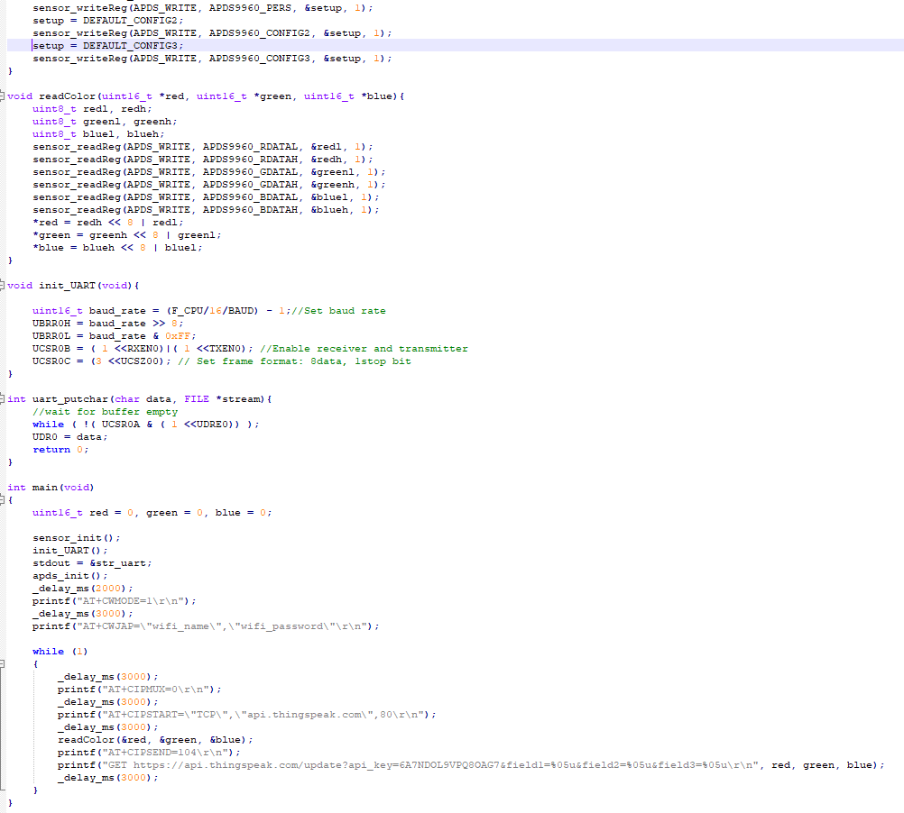

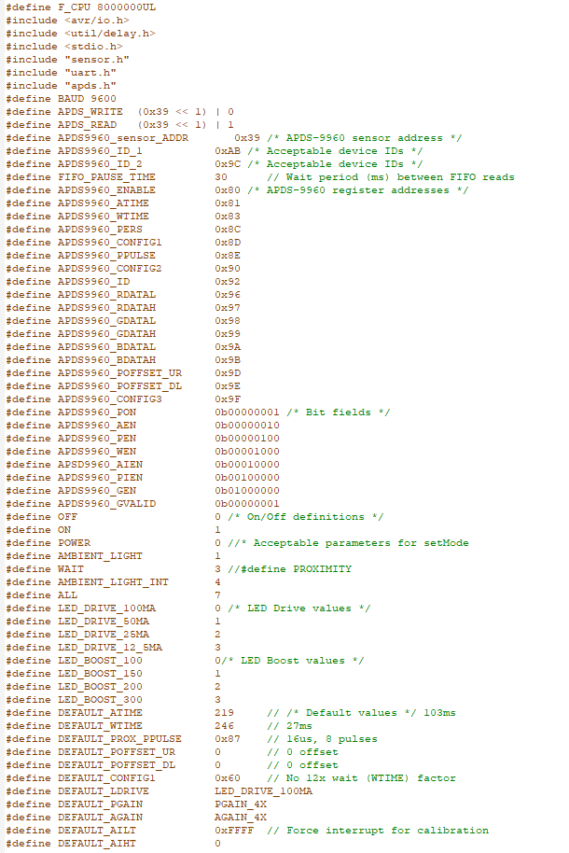

Sensor.c

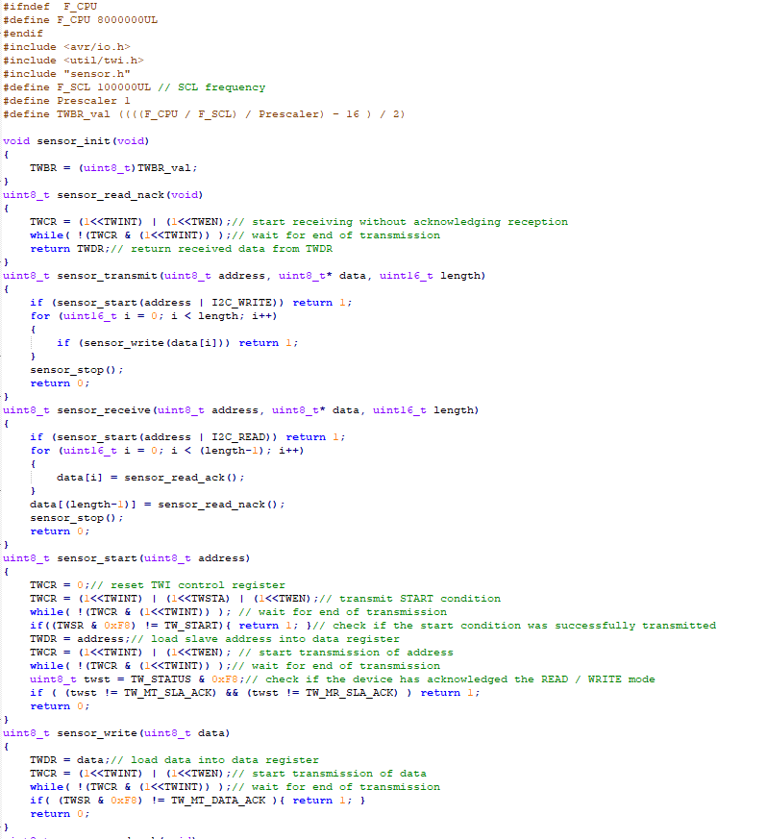

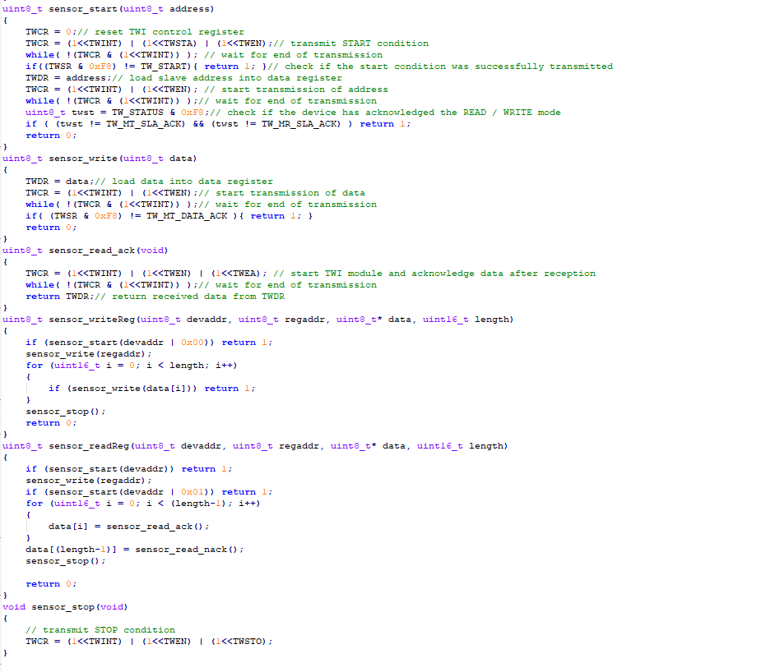

Apds.c

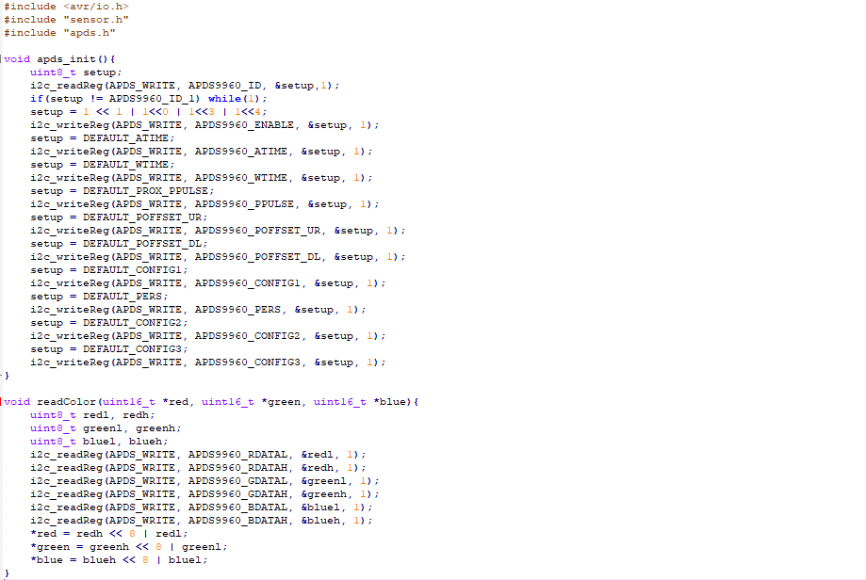

1. **SCHEMATICS**

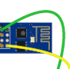

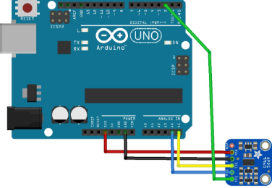

1. **SCREENSHOT OF EACH DEMO (BOARD SETUP)**
2. **VIDEO LINKS OF EACH DEMO**

<https://www.youtube.com/watch?v=QdFwAvv_HFM&list=PL5KkHOalGXZ71iIBIr32ij3e1gJDyAUsu&index=12&t=0s>

1. **GITHUB LINK OF THIS DA**

https://github.com/cuicattack/cat/ Cat1Assn13_DA_MidtermII

**Student Academic Misconduct Policy**

<http://studentconduct.unlv.edu/misconduct/policy.html>

“This assignment submission is my own, original work”.

NAME OF THE STUDENT