CPE301 – SPRING 2019

Design Assignment 2A

Student Name: Gabriela Cuicas

Student #: 5002960022

Student Email: cuicas@unlv.nevada.edu

Primary Github address: https://github.com/cuicattack/cat1

Directory: https://github.com/cuicattack/cat1/Cat1Assn3_DA_2A

Submit the following for all Labs:

1. In the document, for each task submit the modified or included code (only) with highlights and justifications of the modifications. Also, include the comments.
2. Use the previously create a Github repository with a random name (no CPE/301, Lastname, Firstname). Place all labs under the root folder ESD301/DA, sub-folder named LABXX, with one document and one video link file for each lab, place modified asm/c files named as LabXX-TYY.asm/c.
3. If multiple asm/c files or other libraries are used, create a folder LabXX-TYY and place these files inside the folder.
4. The folder should have a) Word document (see template), b) source code file(s) and other include files, c) text file with youtube video links (see template).

1. **COMPONENTS LIST AND CONNECTION BLOCK DIAGRAM w/ PINS**

List of Components used

* LED
* Button

Block diagram with pins used in the Atmega328P

Part 1: Port B pin 1 wired to an LED.



Pin 1: and an internal resistor

PORT B

Part 2: Port C pin 2 wired to button, Port B wired to LED

PORT C





Pin 1: and an internal resistor

PORT B

1. **DEVELOPED CODE OF TASK 1**



To calculate on time:

To calculate off time:

TCNT calculation:

Code in C:

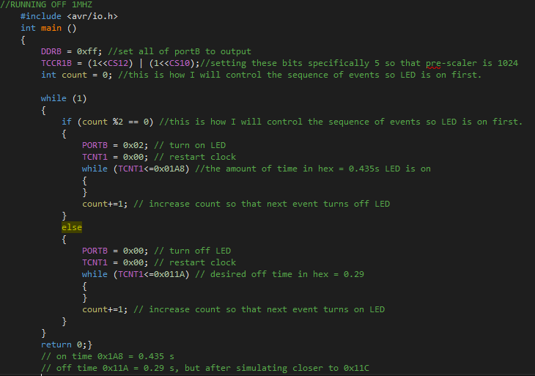

Code in Assembly:

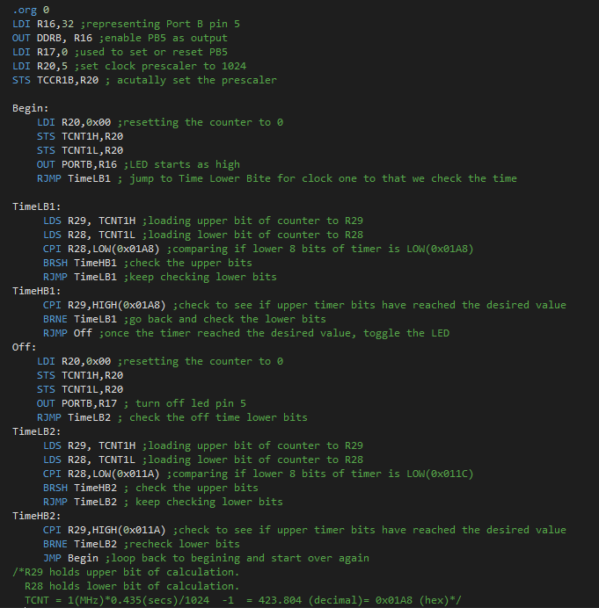

1. **MODIFIED CODE OF TASK 2**



TCNT calculation:

Code in C:

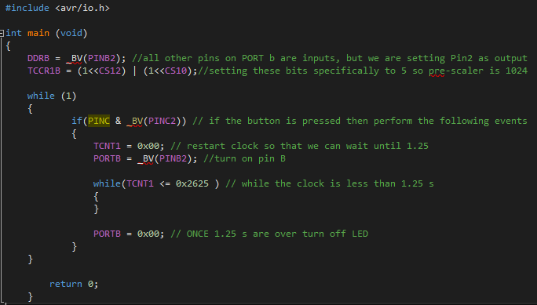

Code in Assembly:

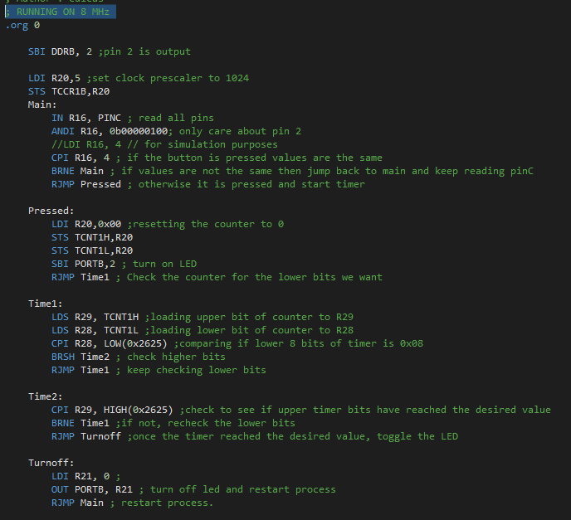

1. **SCHEMATICS**

Part 1: Port B pin 1 wired to an LED.

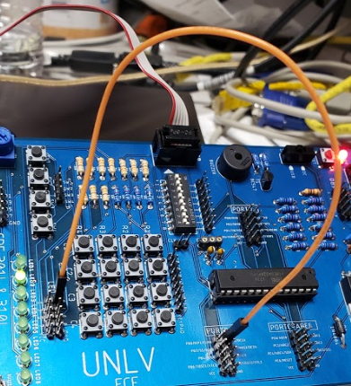

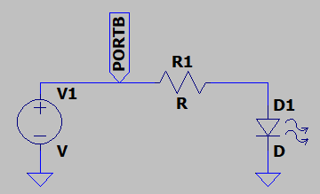

Part 2: Port C pin 2 wired to button, Port B wired to LED

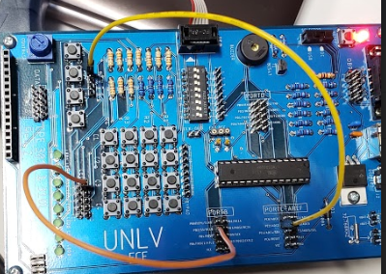

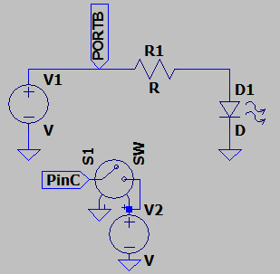

1. **SCREENSHOTS OF TASK 1 Delay Time: C Code**

This is the delay time of for when the LED should be turned on which I simulated and verified that it should be 0.435 s.

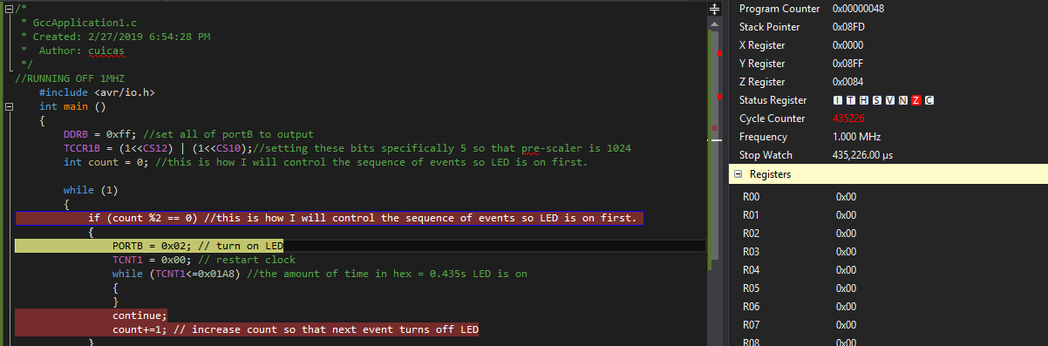

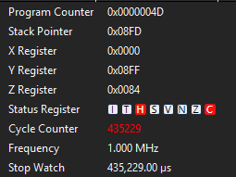

This is the delay time of for when the LED should be turned OFF which I simulated and verified that it should be approximately 0.29 s.

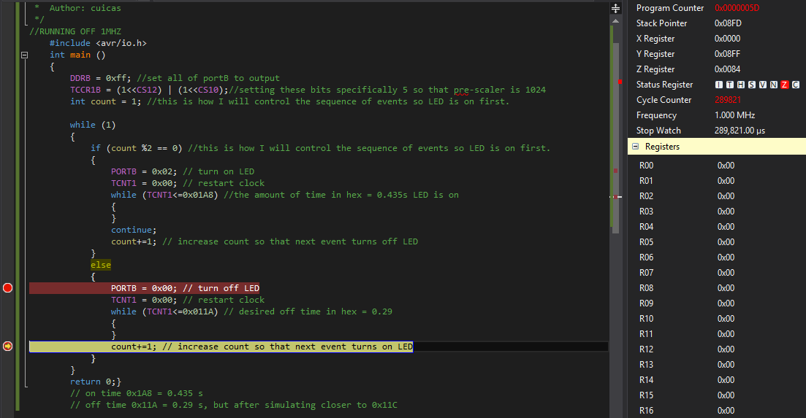

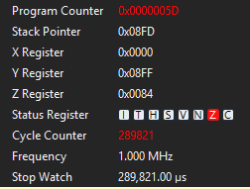

1. **SCREENSHOTS OF TASK 1 Delay Time: Assembly Code**

This is the delay time of for when the LED should be turned on which I simulated and verified that it should be 0.435 s.

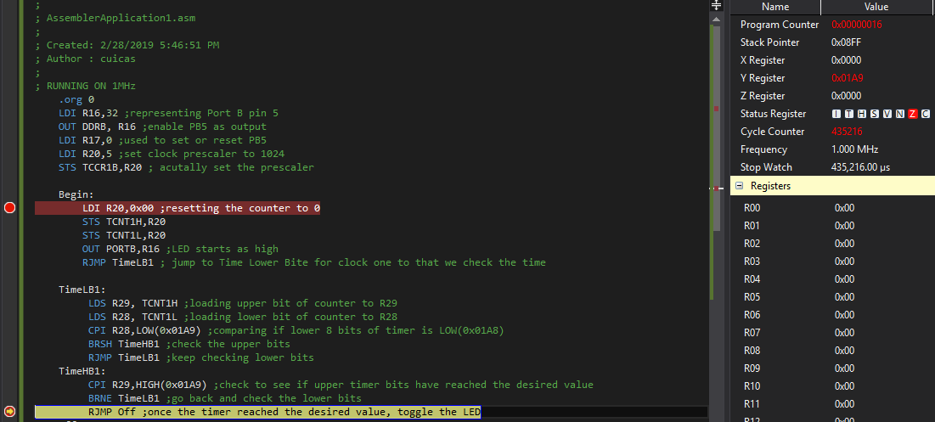

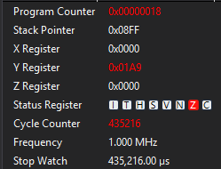

This is the total period of the LED which I simulated and verified that it should be 0.725 s.

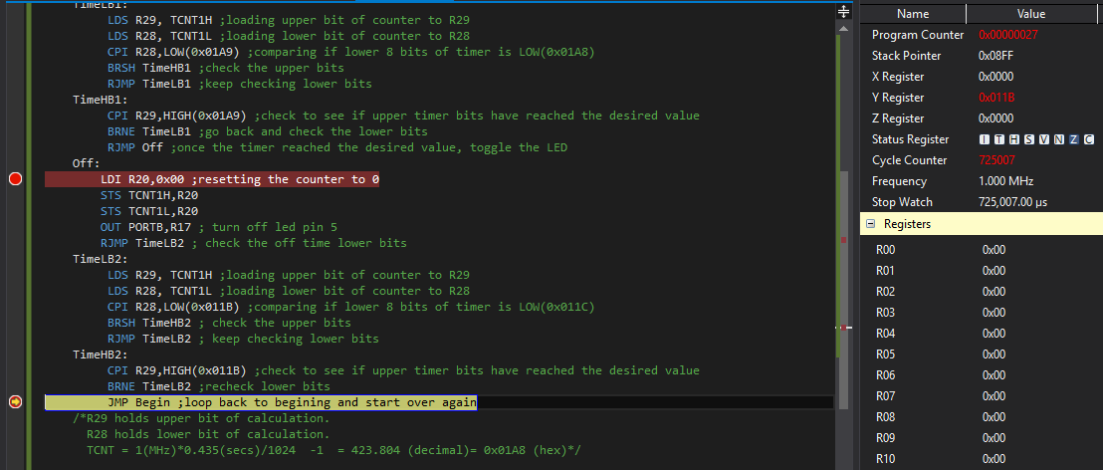

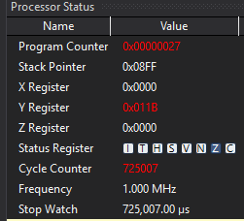

1. **SCREENSHOTS OF TASK 2 Delay Time: C Code**

This is the delay time of for when the LED should be turned on which I simulated and verified that it should be 1.25 s.

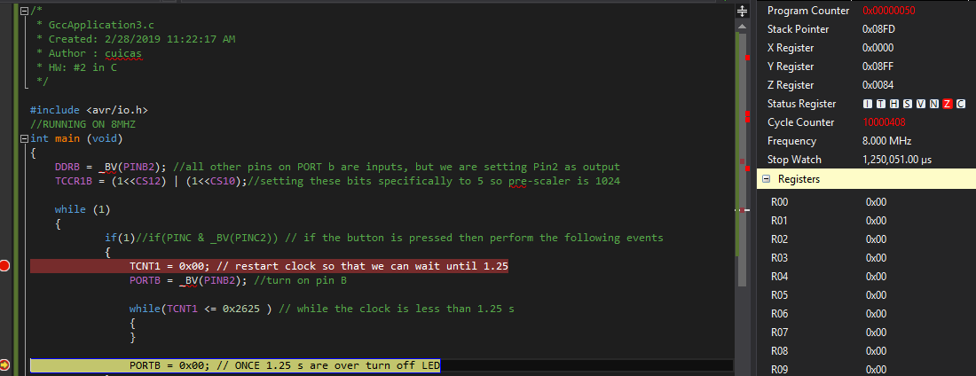

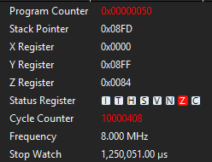

1. **SCREENSHOTS OF TASK 2 Delay Time: Assembly Code**

This is the delay time of for when the LED should be turned on which I simulated and verified that it should be 1.25 s.

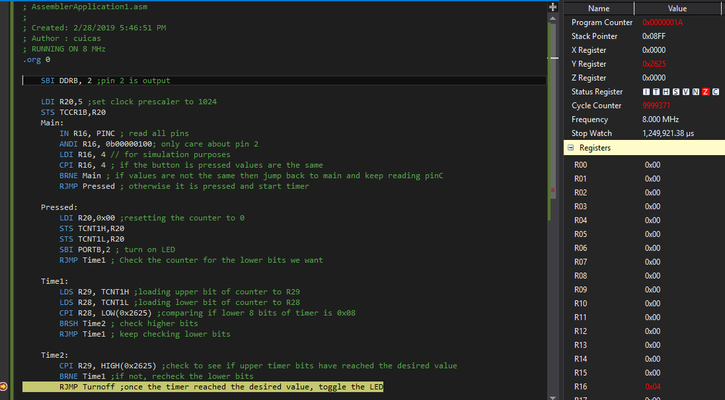

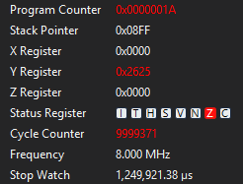

1. **SCREENSHOT OF EACH DEMO and BOARD SETUP**

Task 1: C Code

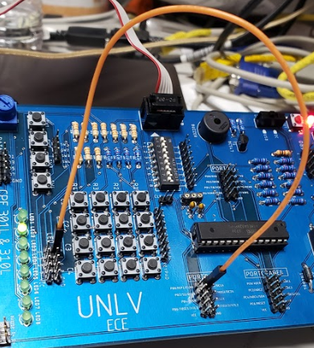

Task 1: Assembly Code

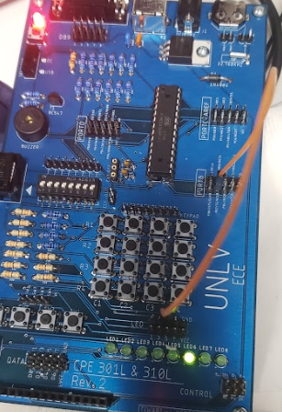

Task 2: C Code

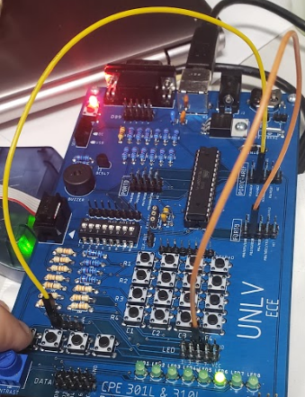

Task 2: Assembly Code

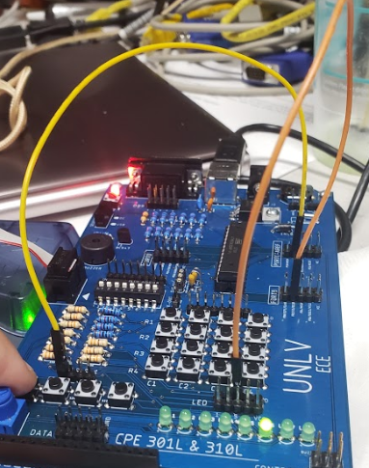

1. **VIDEO LINKS OF EACH DEMO**

https://youtu.be/j53OXKRMhyc

1. **GITHUB LINK OF THIS DA**

https://github.com/cuicattack/cat1/Cat1Assn3_DA_2A

**Student Academic Misconduct Policy**

<http://studentconduct.unlv.edu/misconduct/policy.html>

“This assignment submission is my own, original work”.

NAME OF THE STUDENT