CPE301 – SPRING 2019

Design Assignment 3B

Student Name: Gabriela Cuicas

Student #: 5002960022

Student Email: cuicas@unlv.nevada.edu

Primary Github address: https://github.com/cuicattack/cat1

Directory: https://github.com/cuicattack/cat/Cat1Assn7_DA_3B

Submit the following for all Labs:

1. In the document, for each task submit the modified or included code (only) with highlights and justifications of the modifications. Also, include the comments.
2. Use the previously create a Github repository with a random name (no CPE/301, Lastname, Firstname). Place all labs under the root folder ESD301/DA, sub-folder named LABXX, with one document and one video link file for each lab, place modified asm/c files named as LabXX-TYY.asm/c.
3. If multiple asm/c files or other libraries are used, create a folder LabXX-TYY and place these files inside the folder.
4. The folder should have a) Word document (see template), b) source code file(s) and other include files, c) text file with youtube video links (see template).

1. **COMPONENTS LIST AND CONNECTION BLOCK DIAGRAM w/ PINS**

List of Components used

FT232RL FTDI Mini USB to TTL Serial Converter

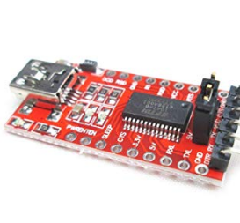

LM35 – Temperature sensor

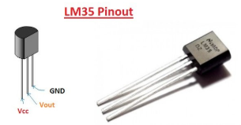

Block diagram

PORTD – Transmit –PD1

FTDI – Receive

PORTC – ADC5

LM35 - Vout

1. **DEVELOPED C CODE OF TASK 1**

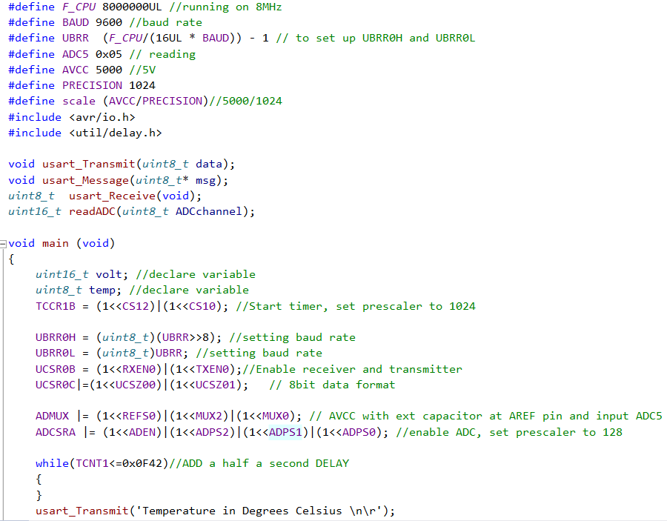

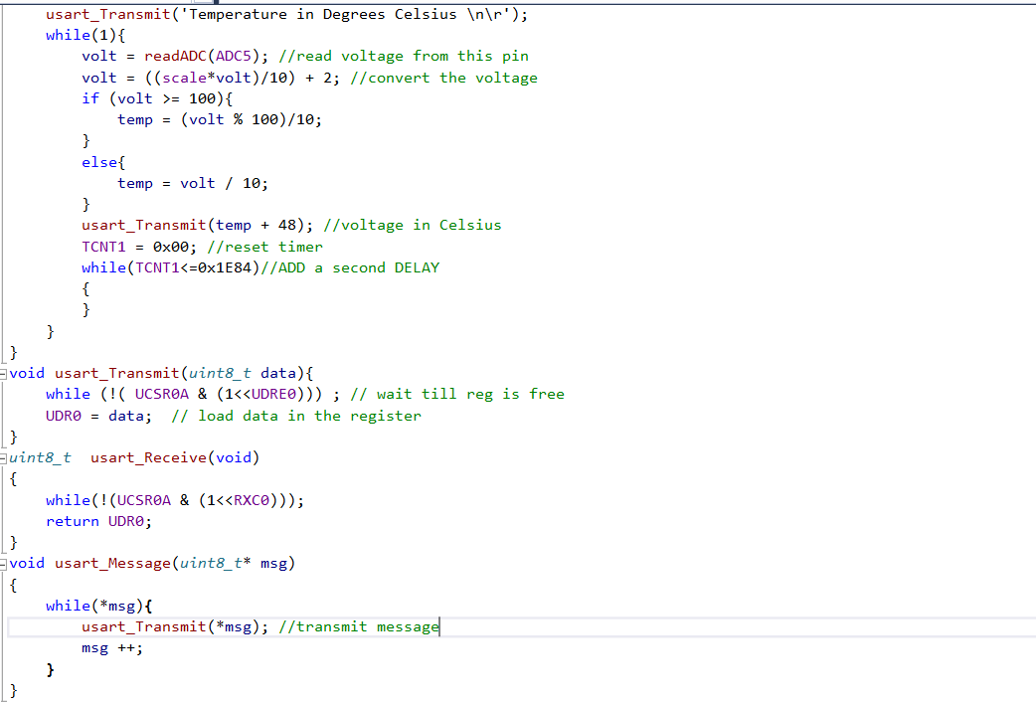

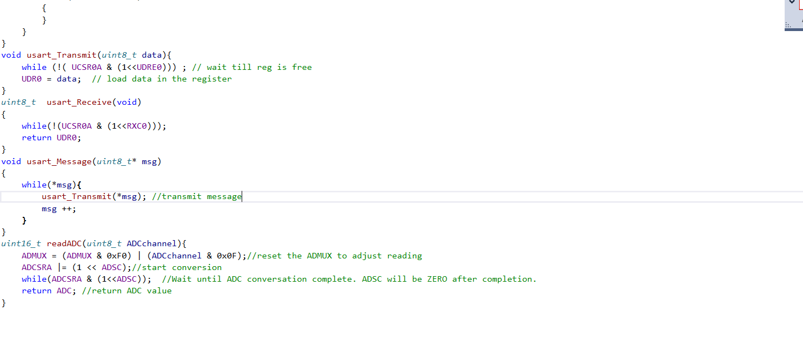

1. **SCHEMATICS**

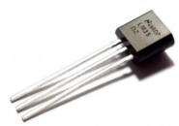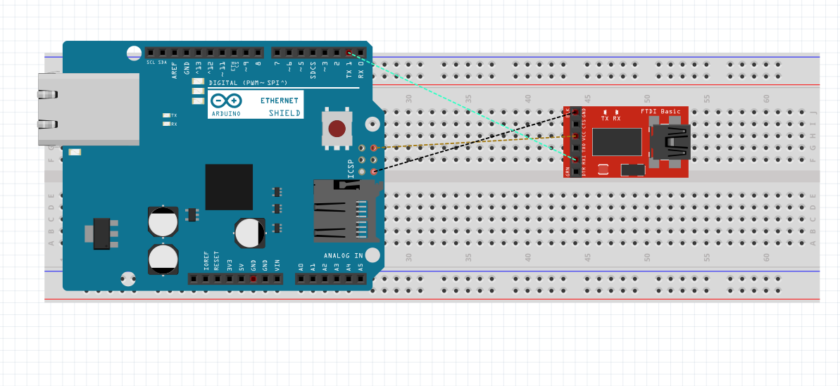

1. **SCREENSHOTS OF EACH TASK OUTPUT (ATMEL STUDIO OUTPUT)**

Screenshot of time delay for the c code

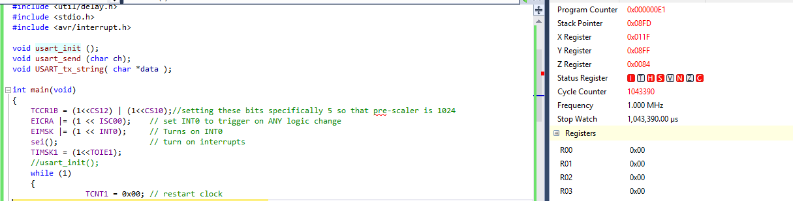

1. **SCREENSHOT OF EACH DEMO (BOARD SETUP)**

Terminal screen

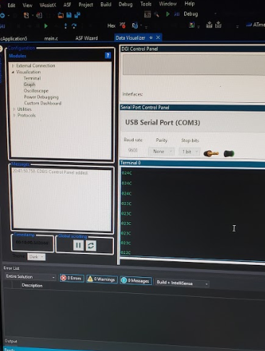

Hello, I could not get the graph feature to hook up because Atmel did not detect my device on DGI, I showed this in my video. But I am still made to graph my temperature over time because I know the rate it the messages were being transmitted.

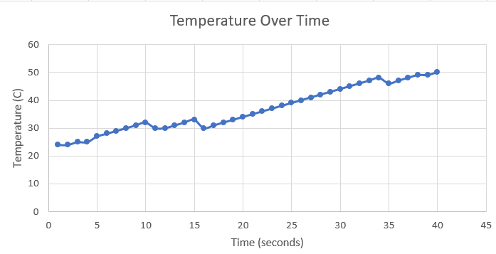

Board Setup

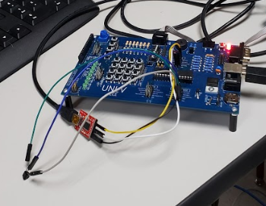

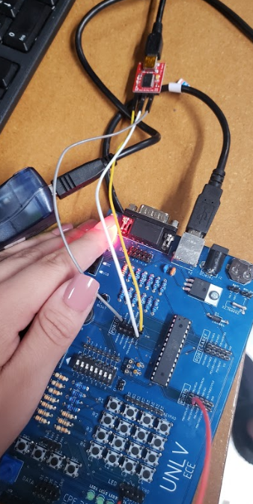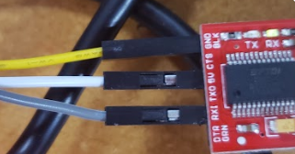

1. **VIDEO LINKS OF EACH DEMO**

<https://www.youtube.com/watch?v=E2wfXY3ct2k&index=6&t=0s&list=PL5KkHOalGXZ71iIBIr32ij3e1gJDyAUsu>

1. **GITHUB LINK OF THIS DA**

https://github.com/cuicattack/cat/Cat1Assn7_DA_3B

**Student Academic Misconduct Policy**

<http://studentconduct.unlv.edu/misconduct/policy.html>

“This assignment submission is my own, original work”.

NAME OF THE STUDENT