CPE301 – SPRING 2019

Design Assignment Midterm

Student Name: Gabriela Cuicas

Student #: 5002960022

Student Email: cuicas@unlv.nevada.edu

Primary Github address: https://github.com/cuicattack/cat1

Directory: https://github.com/cuicattack/cat/Cat1Assn8_DA_Midterm

Submit the following for all Labs:

1. In the document, for each task submit the modified or included code (only) with highlights and justifications of the modifications. Also, include the comments.
2. Use the previously create a Github repository with a random name (no CPE/301, Lastname, Firstname). Place all labs under the root folder ESD301/DA, sub-folder named LABXX, with one document and one video link file for each lab, place modified asm/c files named as LabXX-TYY.asm/c.
3. If multiple asm/c files or other libraries are used, create a folder LabXX-TYY and place these files inside the folder.
4. The folder should have a) Word document (see template), b) source code file(s) and other include files, c) text file with youtube video links (see template).

1. **COMPONENTS LIST AND CONNECTION BLOCK DIAGRAM w/ PINS**

List of Components used

FT232RL FTDI Mini USB to TTL Serial Converter

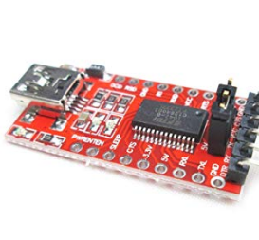

LM 35

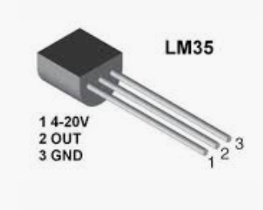

ESP-01

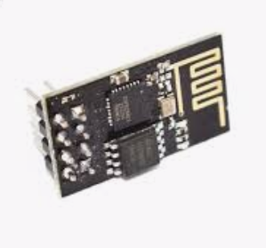

Block diagram

FTDI – Receive

PORTD – Transmit –PD1

FTDI – Transmit

PORTD – Receive

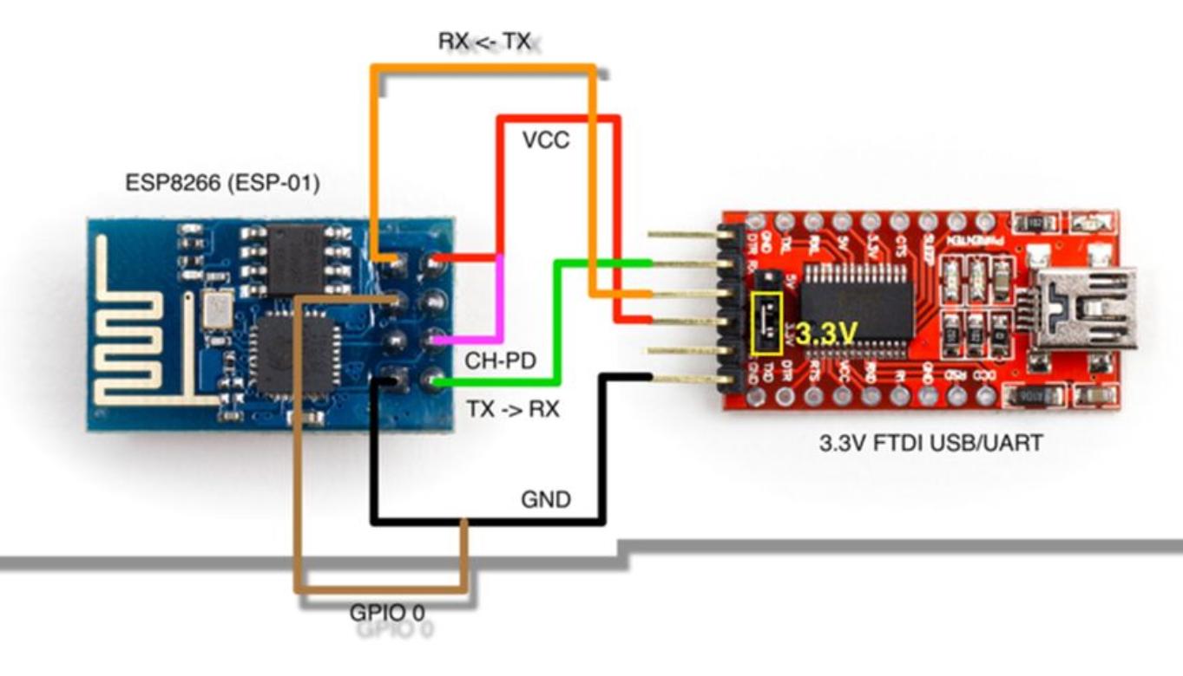

1. **DEVELOPED C CODE OF TASK 1**

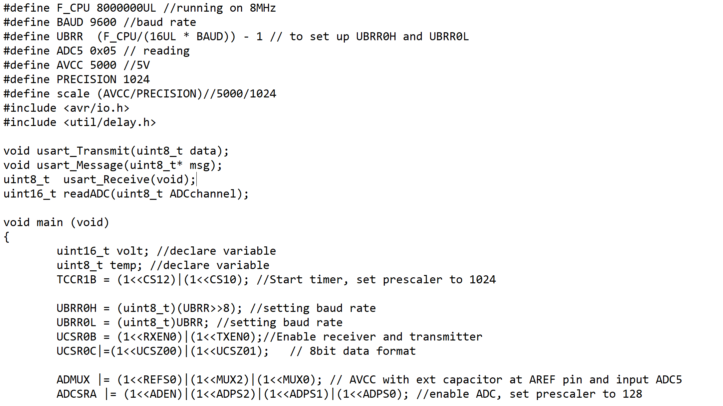

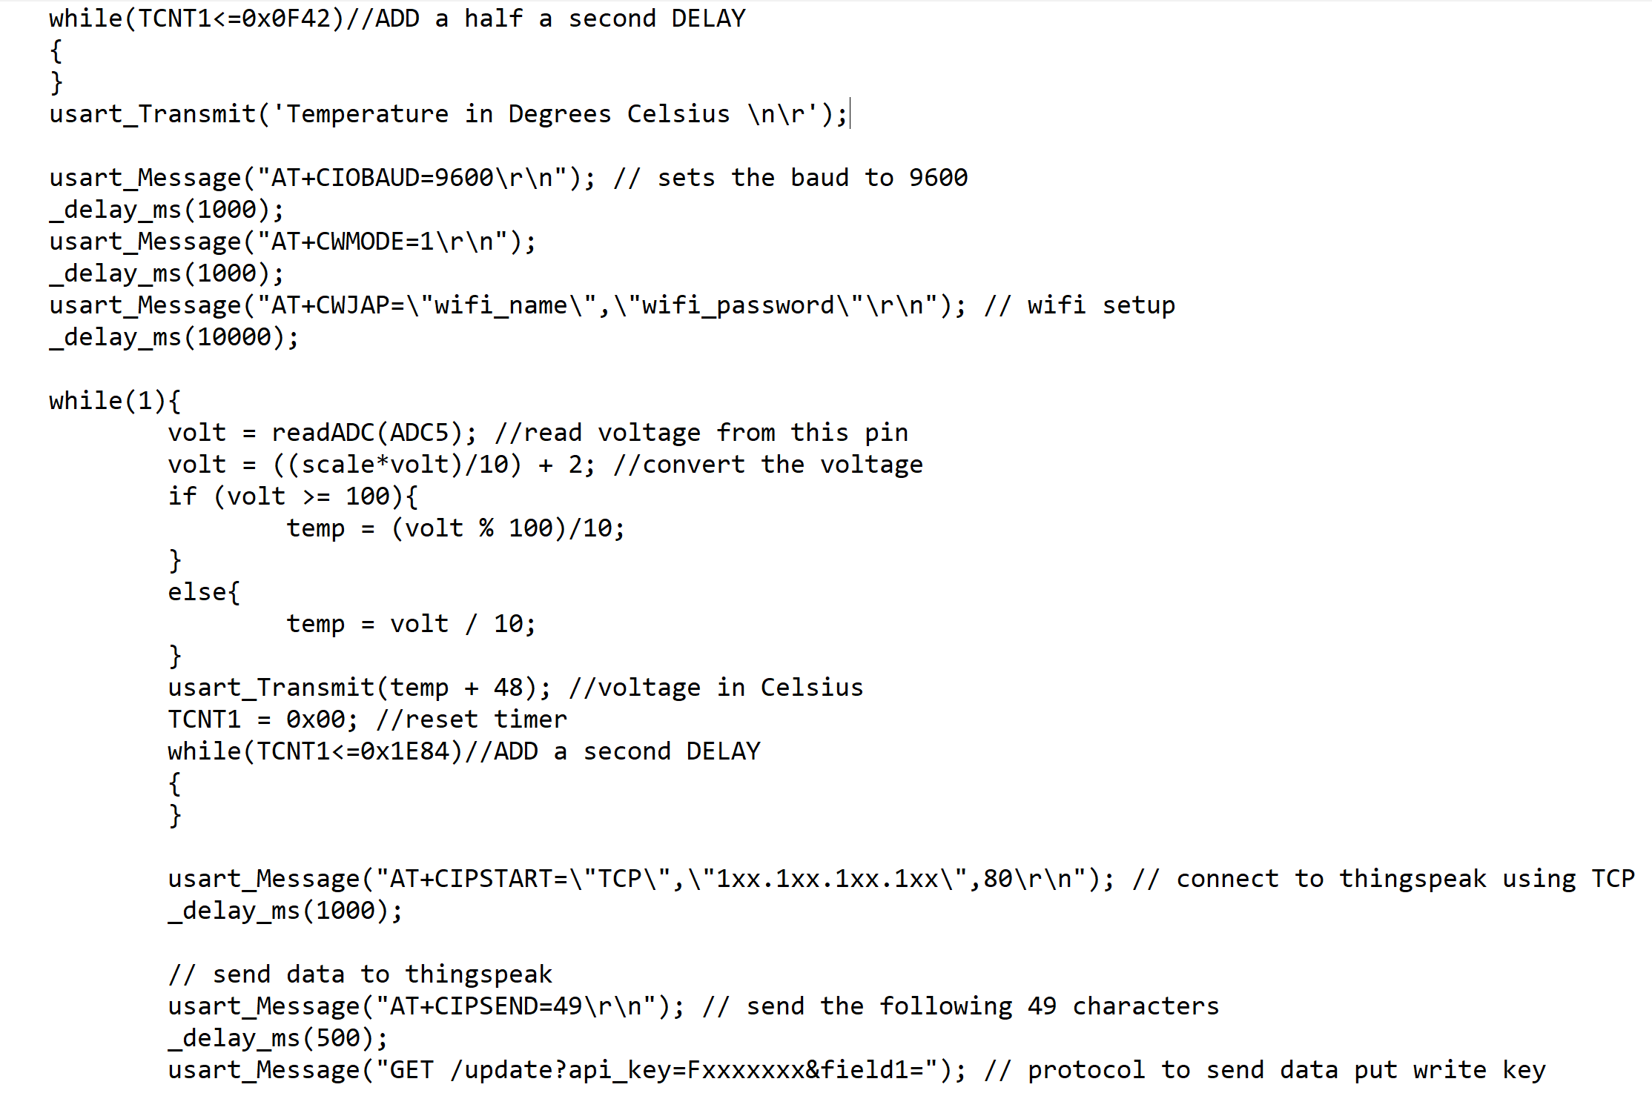

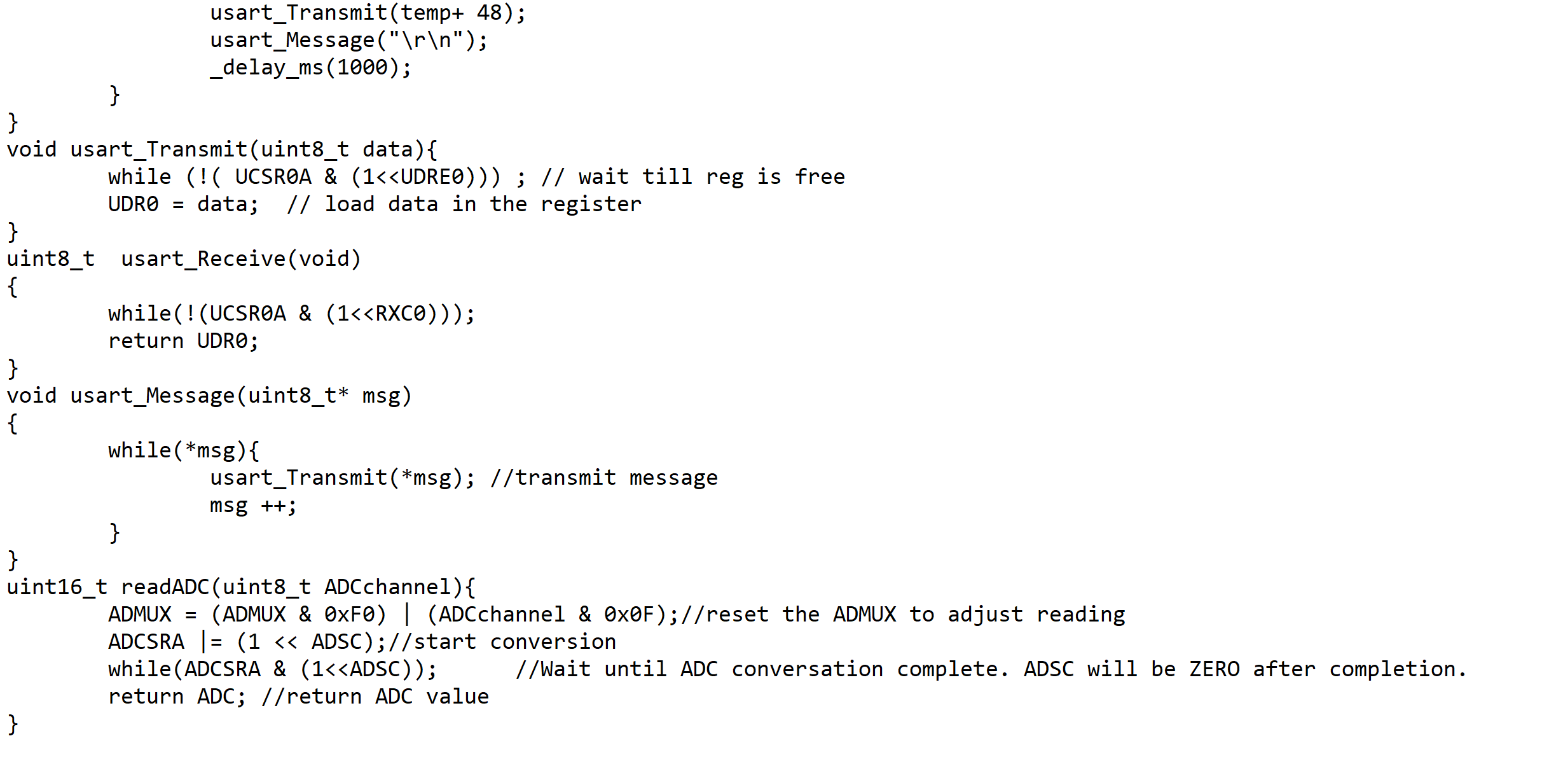

1. **SCHEMATICS**

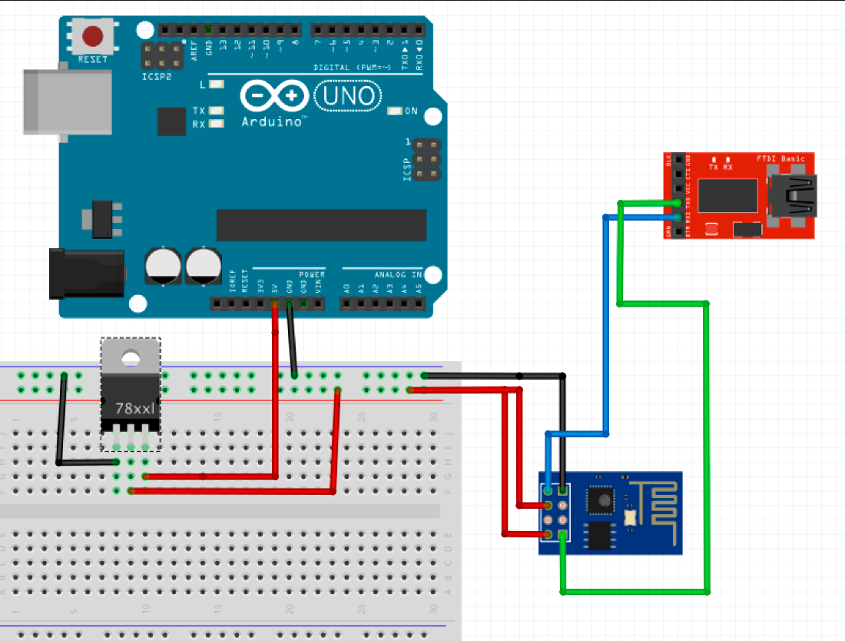

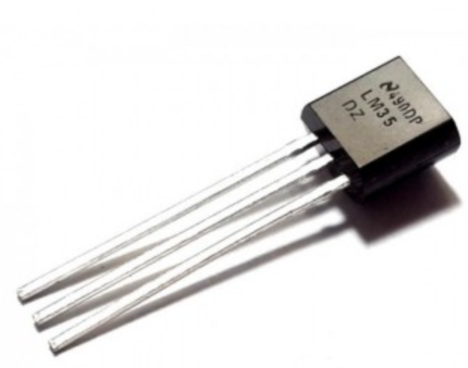

1. **SCREENSHOTS OF EACH TASK OUTPUT (ATMEL STUDIO OUTPUT)**

Screenshot of time delay for the c code

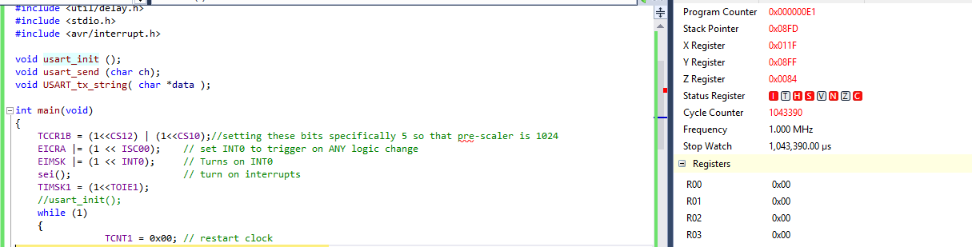

1. **SCREENSHOT OF EACH DEMO (BOARD SETUP)**

Thinkspeak screen

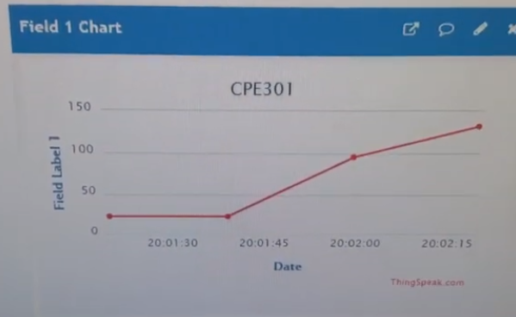

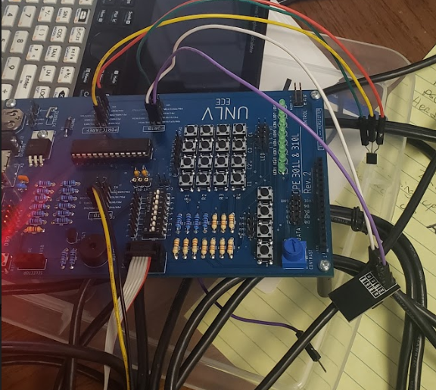

1. **VIDEO LINKS OF EACH DEMO**

<https://www.youtube.com/watch?v=j1BGUEkOzAI&list=PL5KkHOalGXZ71iIBIr32ij3e1gJDyAUsu&index=7&t=0s>

1. **GITHUB LINK OF THIS DA**

https://github.com/cuicattack/cat/Cat1Assn8_DA_Midterm

**Student Academic Misconduct Policy**

<http://studentconduct.unlv.edu/misconduct/policy.html>

“This assignment submission is my own, original work”.

NAME OF THE STUDENT