<https://www.zhihu.com/question/314879954>

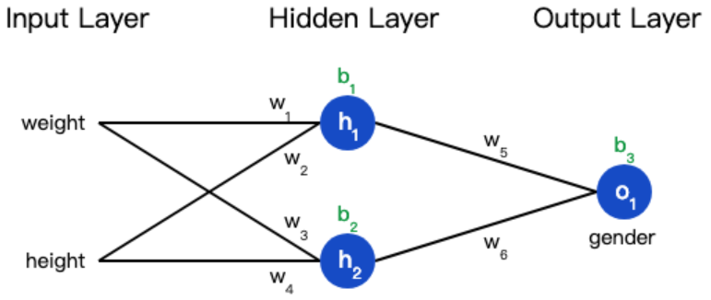

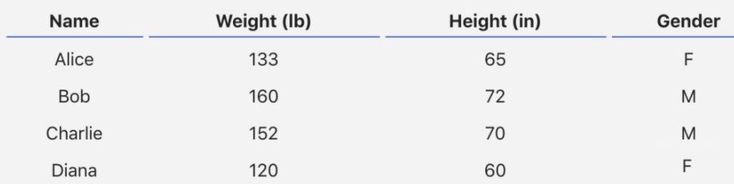

import numpy as np

def sigmoid(x):

# Sigmoid activation function: f(x) = 1 / (1 + e^(-x))

return 1 / (1 + np.exp(-x))

def deriv_sigmoid(x):

# Derivative of sigmoid: f'(x) = f(x) * (1 - f(x))

fx = sigmoid(x)

return fx * (1 - fx)

def mse_loss(y_true, y_pred):

# y_true and y_pred are numpy arrays of the same length.

return ((y_true - y_pred) ** 2).mean()

class OurNeuralNetwork:

'''

A neural network with:

- 2 inputs

- a hidden layer with 2 neurons (h1, h2)

- an output layer with 1 neuron (o1)

*** DISCLAIMER ***:

The code below is intended to be simple and educational, NOT optimal.

Real neural net code looks nothing like this. DO NOT use this code.

Instead, read/run it to understand how this specific network works.

'''

def __init__(self):

# Weights

self.w1 = np.random.normal()

self.w2 = np.random.normal()

self.w3 = np.random.normal()

self.w4 = np.random.normal()

self.w5 = np.random.normal()

self.w6 = np.random.normal()

# Biases

self.b1 = np.random.normal()

self.b2 = np.random.normal()

self.b3 = np.random.normal()

def feedforward(self, x):

# x is a numpy array with 2 elements.

h1 = sigmoid(self.w1 * x[0] + self.w2 * x[1] + self.b1)

h2 = sigmoid(self.w3 * x[0] + self.w4 * x[1] + self.b2)

o1 = sigmoid(self.w5 * h1 + self.w6 * h2 + self.b3)

return o1

def train(self, data, all_y_trues):

'''

- data is a (n x 2) numpy array, n = # of samples in the dataset.

- all_y_trues is a numpy array with n elements.

Elements in all_y_trues correspond to those in data.

'''

learn_rate = 0.1

epochs = 1000 # number of times to loop through the entire dataset

for epoch in range(epochs):

for x, y_true in zip(data, all_y_trues):

# --- Do a feedforward (we'll need these values later)

sum_h1 = self.w1 * x[0] + self.w2 * x[1] + self.b1

h1 = sigmoid(sum_h1)

sum_h2 = self.w3 * x[0] + self.w4 * x[1] + self.b2

h2 = sigmoid(sum_h2)

sum_o1 = self.w5 * h1 + self.w6 * h2 + self.b3

o1 = sigmoid(sum_o1)

y_pred = o1

# --- Calculate partial derivatives.

# --- Naming: d_L_d_w1 represents "partial L / partial w1"

d_L_d_ypred = -2 * (y_true - y_pred)

# Neuron o1

d_ypred_d_w5 = h1 * deriv_sigmoid(sum_o1)

d_ypred_d_w6 = h2 * deriv_sigmoid(sum_o1)

d_ypred_d_b3 = deriv_sigmoid(sum_o1)

d_ypred_d_h1 = self.w5 * deriv_sigmoid(sum_o1)

d_ypred_d_h2 = self.w6 * deriv_sigmoid(sum_o1)

# Neuron h1

d_h1_d_w1 = x[0] * deriv_sigmoid(sum_h1)

d_h1_d_w2 = x[1] * deriv_sigmoid(sum_h1)

d_h1_d_b1 = deriv_sigmoid(sum_h1)

# Neuron h2

d_h2_d_w3 = x[0] * deriv_sigmoid(sum_h2)

d_h2_d_w4 = x[1] * deriv_sigmoid(sum_h2)

d_h2_d_b2 = deriv_sigmoid(sum_h2)

# --- Update weights and biases

# Neuron h1

self.w1 -= learn_rate * d_L_d_ypred * d_ypred_d_h1 * d_h1_d_w1

self.w2 -= learn_rate * d_L_d_ypred * d_ypred_d_h1 * d_h1_d_w2

self.b1 -= learn_rate * d_L_d_ypred * d_ypred_d_h1 * d_h1_d_b1

# Neuron h2

self.w3 -= learn_rate * d_L_d_ypred * d_ypred_d_h2 * d_h2_d_w3

self.w4 -= learn_rate * d_L_d_ypred * d_ypred_d_h2 * d_h2_d_w4

self.b2 -= learn_rate * d_L_d_ypred * d_ypred_d_h2 * d_h2_d_b2

# Neuron o1

self.w5 -= learn_rate * d_L_d_ypred * d_ypred_d_w5

self.w6 -= learn_rate * d_L_d_ypred * d_ypred_d_w6

self.b3 -= learn_rate * d_L_d_ypred * d_ypred_d_b3

# --- Calculate total loss at the end of each epoch

if epoch % 10 == 0:

y_preds = np.apply_along_axis(self.feedforward, 1, data)

loss = mse_loss(all_y_trues, y_preds)

print("Epoch %d loss: %.3f" % (epoch, loss))

# Define dataset

data = np.array([

[-2, -1], # Alice

[25, 6], # Bob

[17, 4], # Charlie

[-15, -6], # Diana

])

all_y_trues = np.array([

1, # Alice

0, # Bob

0, # Charlie

1, # Diana

])

# Train our neural network!

network = OurNeuralNetwork()

network.train(data, all_y_trues)