青 岛 理 工 大 学
课程实验报告
课程名称 | JSP开发技术 | 班级 | 软件171 | 实验日期 | 2020.6.11
姓名 | 崔繁坚 | 学号 | 201707150 | 实验成绩
实验名称 | 实验3 基于SSM项目开发
实验目的  及要求 | 使用MyBatis、Spring和Spring MVC编写运行项目，综合应用各种技术。
实验环境 | Windows 10，IDEA,Mysql
实验内容 | 依据教材第20章的内容，完成Chapter20Maven项目，实现后台商品的增删改查功能。
算法描述及实验步骤 | - 创建SSM项目及其配置  - 根据上课视频完成SSM项目，实现后台商品的增删改查功能
调试过程及实验结果 | 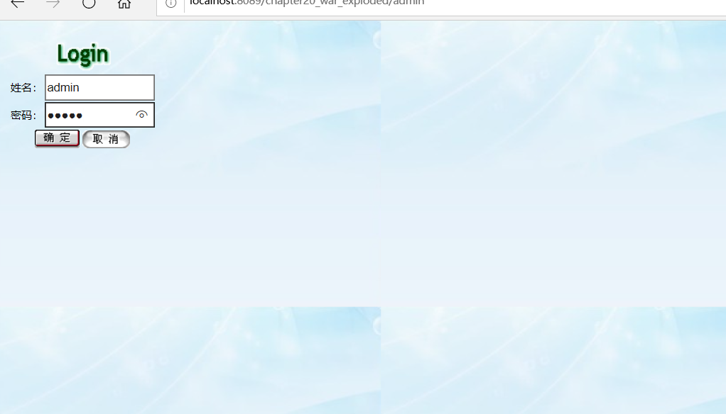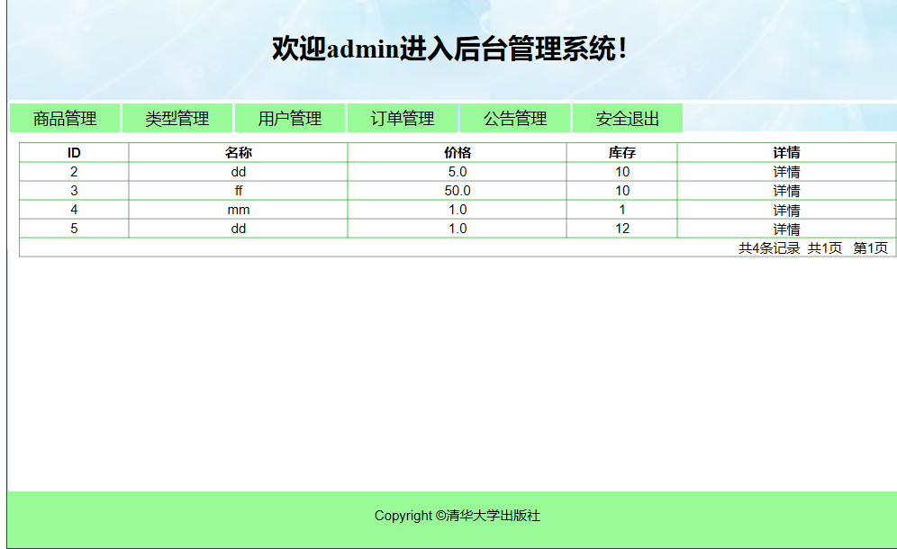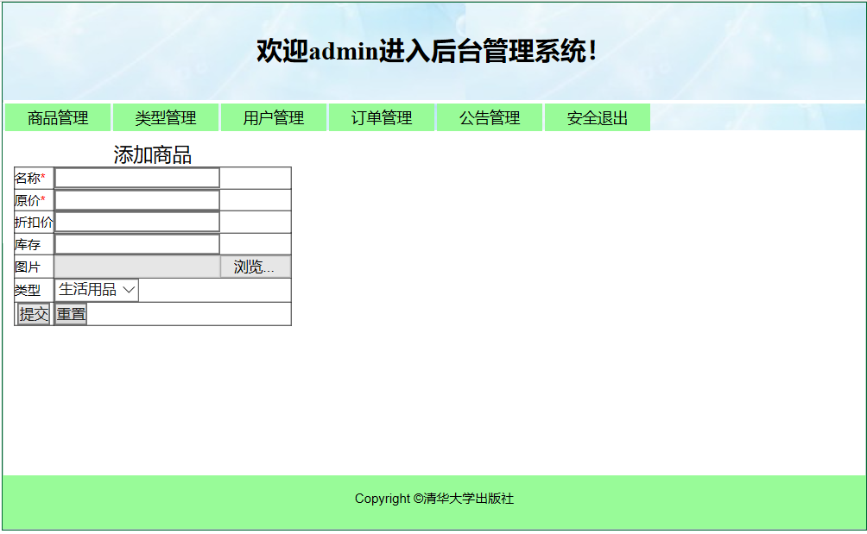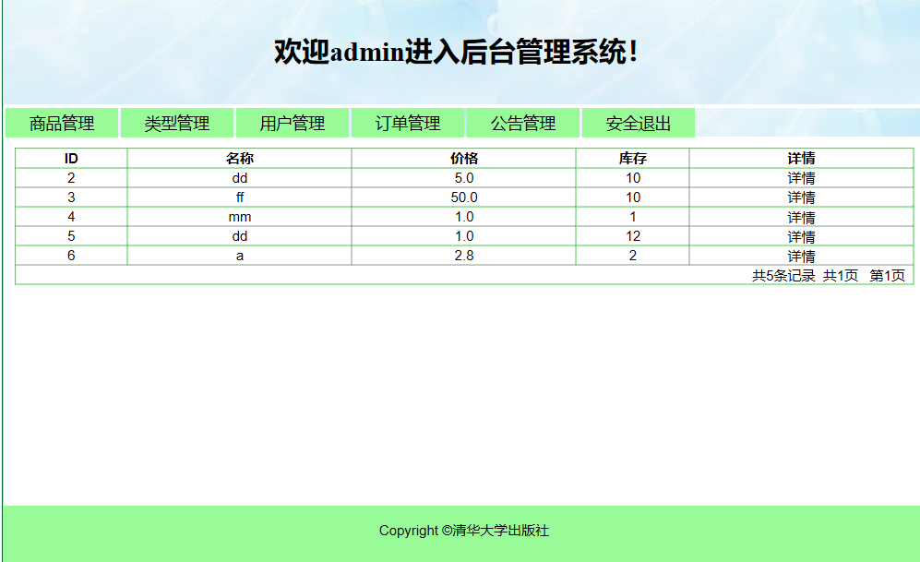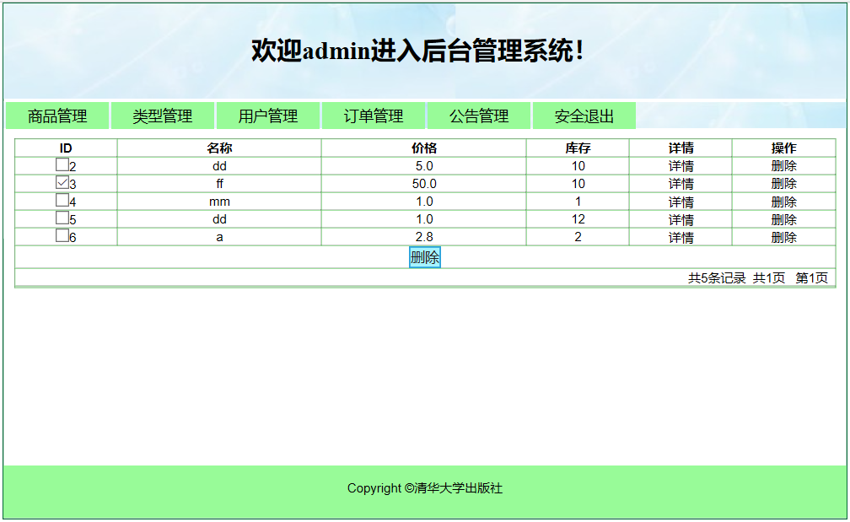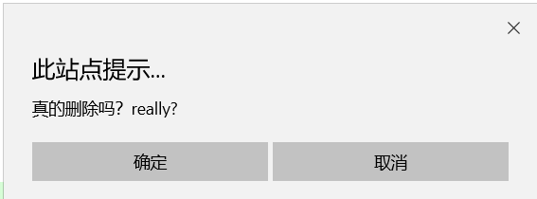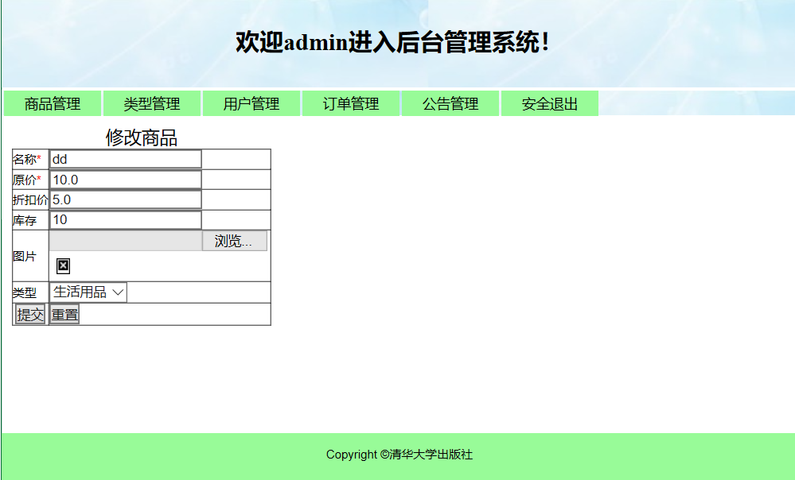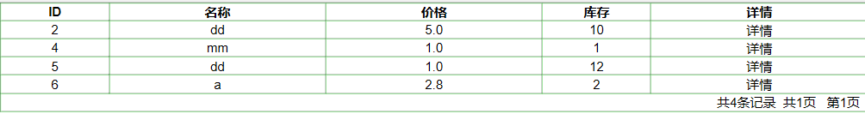
总结 | 实验过程中遇见了好多问题，例如：刚开始文件上传以及数据库配置出现了一些问题，导致出现了各种错误。  还有就是ssm整合开发不太熟悉，使用过程不太熟练。
附  录 | - AdminGoodsController.java  @Controller  @RequestMapping("/adminGoods")  public class AdminGoodsController extends BaseController {  @Autowired  AdminGoodsTypeService adminGoodsTypeService;  @Autowired  AdminGoodsService adminGoodsService;  @RequestMapping("/selectGoods")  public String findAllGoodsByPage(Model model,Integer pageCur,String act){  if(pageCur==null)  pageCur=1;  int pageRows=10;  List<Goods> goodslist=adminGoodsService.findAllGoodsByPage(pageCur,pageRows);  Integer totalCount =adminGoodsService.findGoodsTotalCount();  Integer totalpage=totalCount/pageRows+1;  model.addAttribute("totalCount",totalCount);  model.addAttribute("totalPage",totalpage);  model.addAttribute("allGoods",goodslist);  model.addAttribute("pageCur",pageCur);  if(act !=null&&act.equals("deleteSelect")){  return "admin/deleteSelectGoods";  }  else if(act !=null&&act.equals("updateSelect")){  return "admin/updateSelectGoods";  }  return "admin/selectGoods";  }  @RequestMapping("/toAddGoods")  public String toAddGoods(@ModelAttribute Goods goods,Model model){  List<GoodsType> goodsTypeList=adminGoodsTypeService.findAllGoodsTypes();  model.addAttribute("goodsType",goodsTypeList);  return "admin/addGoods";  }  @InitBinder("goods")  public void init(WebDataBinder binder){  binder.setFieldDefaultPrefix("goods.");  }  @RequestMapping("/addGoods")  public String addGoods(Goods goods, Integer goodstype_id, MultipartFile logoImage, String updateAct,HttpServletRequest request){  String realpath=request.getServletContext().getRealPath("legos");  String originalFileName=logoImage.getOriginalFilename();  String fileype=originalFileName.substring(originalFileName.indexOf("."),originalFileName.length());  String newName= MyUtil.getStringID()+fileype;  File targetFile=new File(realpath,newName);  if(!targetFile.exists()){  targetFile.mkdir();  }  try{  logoImage.transferTo(targetFile);  goods.setGpicture(newName);  }  catch (IOException e){  e.printStackTrace();  }  if(updateAct!=null&&updateAct.equals("update")){  GoodsType goodsType=adminGoodsTypeService.findTypeById(goodstype_id);  goods.setGtype(goodsType);  adminGoodsService.modifygoods(goods);  return "forward:/adminGoods/selectGoods";  }  GoodsType goodsType=adminGoodsTypeService.findTypeById(goodstype_id);  goods.setGtype(goodsType);  adminGoodsService.saveGoods(goods);  return "forward:/adminGoods/selectGoods";  }  @RequestMapping("/deleteGoods")  public String deleteGoods(String ids[]){  adminGoodsService.deleteGoodsByIds(ids);  return "forward:/adminGoods/selectGoods";  }  @RequestMapping("/selectAGoods")  public String selectAGoods(String id, String act, Model model){  if(act !=null&&act.equals("updateAgoods")){  Goods goods= adminGoodsService.findGoodsById(Integer.parseInt(id));  List<GoodsType> goodsTypeList=adminGoodsTypeService.findAllGoodsTypes();  model.addAttribute("goodsType",goodsTypeList);  model.addAttribute("goods",goods);  return "admin/updateAgoods";  }  return "forward:/adminGoods/selectGoods";  }  }  - AdminGoodsMapper.xml  <?xml version="1.0" encoding="UTF-8" ?>  <!DOCTYPE mapper  PUBLIC "-//mybatis.org//DTD Mapper 3.0//EN"  "http://mybatis.org/dtd/mybatis-3-mapper.dtd">  <mapper namespace="com.dao.admin.AdminGoodsDao">  <select id="findAllGoodsByPage" resultType="Goods" parameterType="map">  SELECT * FROM goodstable limit #{begin},#{pageRows}  </select>  <select id="findGoodsTotalCount" resultType="Integer" >  SELECT COUNT(*) FROM goodstable  </select>  <insert id="saveGoods" parameterType="Goods">  INSERT Into goodstable values (null,#{gname},#{goprice},#{grprice},#{gstore},#{gpicture},#{gtype.id})  </insert>  <delete id="deleteGoodsByIds">  DELETE FROM goodstable WHERE id in  <foreach collection="array" item="oneId" open="(" separator="," close=")">  #{oneId}  </foreach>  </delete>  <select id="findGoodsById" resultType="Goods" parameterType="Integer">  SELECT * FROM goodstable WHERE id=#{id}  </select>  <update id="modify" parameterType="Goods">  update goodstable set gname=#{gname},goprice=#{goprice},grprice=#{grprice},gstore=#{gstore},gpicture=#{gpicture},goodstype_id=#{gtype.id} where id=#{id}  </update>  </mapper>  - AdminGoodsServiceImpl.java  @Service("adminGoodsService")  public class AdminGoodsServiceImpl implements AdminGoodsService {  @Resource(name="adminGoodsDao")  AdminGoodsDao adminGoodsDao;  @Override  public List<Goods> findAllGoodsByPage(int pageCur, int pageRows) {  Map<String,Object> param=new HashMap<>();  param.put("begin",(pageCur-1)*pageRows);  param.put("pageRows",pageRows);  return adminGoodsDao.findAllGoodsByPage(param);  }  @Override  public Integer findGoodsTotalCount() {  return adminGoodsDao.findGoodsTotalCount();  }  @Override  public void saveGoods(Goods goods) {  adminGoodsDao.saveGoods(goods);  }  @Override  public void deleteGoodsByIds(String[] ids) {  adminGoodsDao.deleteGoodsByIds(ids);  }  @Override  public Goods findGoodsById(int id) {  return adminGoodsDao.findGoodsById(id);  }  @Override  public void modifygoods(Goods goods) {  adminGoodsDao.modify(goods);  }  }

