青 岛 理 工 大 学
课程实验报告
课程名称 | JSP开发技术 | 班级 | 软件171 | 实验日期 | 2020.4.30
姓名 | 崔繁坚 | 学号 | 201707150 | 实验成绩
实验名称 | 实验2 基于MyBatis和Spring的Shopping项目开发
实验目的  及要求 | 使用MyBatis和Spring编写运行Shopping项目，综合应用各种技术。
实验环境 | Windows 10，IDEA,Mysql
实验内容 | 依据提供的SpringShoppingMaven项目，改写发布一个MybatisSpringShoppingMaven项目，完成用户登录，查看商品列表，将商品添加到购物车以及提交订单等功能。
算法描述及实验步骤 | - 修改Maven配置文件pom.xml，添加MyBatis库，在Spring配置文件中添加MyBatis配置  - 添加GoodsDAO的映射器文件，删除GoodsDaoImpl.java并修改以MyBatis方式实现  3. 修改Item为持久化类(Item为购物车中的一条记录，Item与GoodsVo是1:1关联)，完成该领域对象对应的dao、service接口及实现类。在商品列表界面添加查看购物车链接，修改servlet层相关代码实现Item的存储以实现购物车中购物条目的持久化增删改查  4. 添加表示订单的Order持久化类(数据库表名不能为order，Order与Item之间的关联关系为1对多，购物车页面执行“提交订单”按钮后生成一个订单，订单类中包含购物车中所有Item条目和提交时间信息)，完成该领域对象对应的dao、service接口及实现类。完成OrderServlet类，该类可实现订单的添加，列表显示和删除功能。在商品列表页面添加查看订单链接并实现  5. 在商品列表页面添加商品的商品销量显示列显示该种商品所有售出的数量（GoodsVo和Item是1：N关联）  最终项目完成的效果如下视频所示：
调试过程及实验结果 | 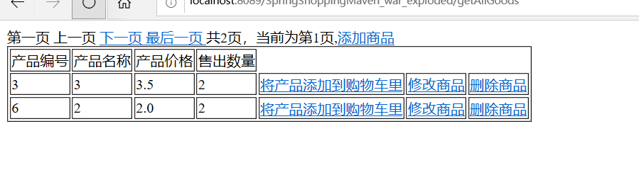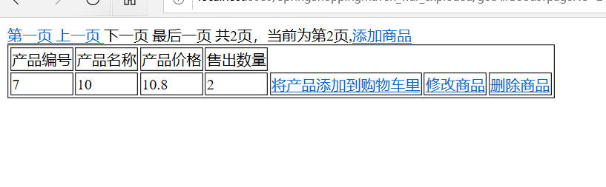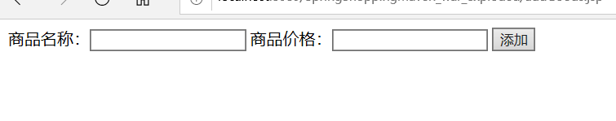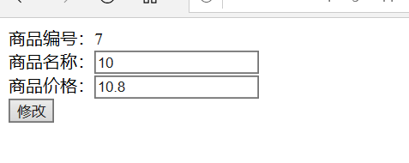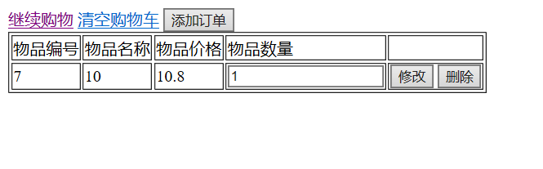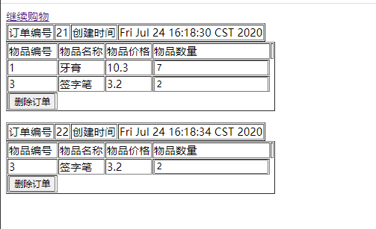
总结 | 实验过程中遇见了好多问题，例如：刚开始对mybatis框架和maven并不太熟悉，导致出现了各种错误。  还有就是配置文件不太熟悉，数据库连接出现一些错误。
附  录 | GoodsVo.java  public class GoodsVo {  Integer goodsId;  String goodsName;  Float price;  }  Item.java,Order.java  public class Order {  Integer id;  Date creattime;  ArrayList<Item> orderitems;  }  GoodsMapper.xml  <?xml version="1.0" encoding="UTF-8" ?>  <!DOCTYPE mapper  PUBLIC "-//mybatis.org//DTD Mapper 3.0//EN"  "http://mybatis.org/dtd/mybatis-3-mapper.dtd">  <mapper namespace="dao.GoodsDAO">  <!-- 查询商品 -->  <select id="getGoodsByPage" parameterType="map" resultType="bean.vo.GoodsVo">  select * from goods limit #{startIndex}, #{perPageSize}  </select>  <!-- 分页查询商品 -->  <select id="getGoodsById" resultType="bean.vo.GoodsVo" parameterType="Integer">  select * from goods where goodsid = #{id}  </select>  <!-- 添加商品 -->  <select id="getPageCount" resultType="Integer">  select (count(*)+0.5)/${pagesize} from goods  </select>  <!-- 根据id查询一个商品 -->  <insert id="saveGoods" parameterType="bean.vo.GoodsVo">  insert into goods values(null,#{goodsName},#{price})  </insert>  <!-- 删除单个商品 -->  <delete id="deleteGoods" parameterType="Integer">  delete from goods where goodsid=#{goodsId}  </delete>  <!-- 修改一个商品 -->  <update id="modifyGoods" parameterType="bean.vo.GoodsVo">  update goods set goodsname=#{goodsName},price=#{price} where goodsid=#{goodsId}  </update>  </mapper>  ItemMapper.xml  <?xml version="1.0" encoding="UTF-8" ?>  <!DOCTYPE mapper  PUBLIC "-//mybatis.org//DTD Mapper 3.0//EN"  "http://mybatis.org/dtd/mybatis-3-mapper.dtd">  <mapper namespace="dao.ItemDao">  <select id="getItemById" resultType="bean.vo.Item" parameterType="Integer">  select * from items where itemsid = #{id}  </select>  <insert id="saveItem" parameterType="bean.vo.Item">  insert into items values(null,#{goods.goodsId},#{quantity})  </insert>  <resultMap id="itemWithGoodsVo" type="bean.vo.Item">  <id property="itemsid" column="itemsid"/>  <result property="quantity" column="quantity"/>  <association property="goods" column="goodsid" javaType="bean.vo.GoodsVo" select="dao.GoodsDAO.getGoodsById"/>  </resultMap>  <!-- 找出还没有产生订单的清单，即购物车内容是没付费的-->  <select id="getCartItem" resultMap="itemWithGoodsVo">  select * from items where itemsid not in (select itemid from myorder_item)  </select>  <update id="modifyItems" parameterType="bean.vo.Item">  update items set quantity=#{quantity} where itemsid=#{itemsid}  </update>  <delete id="deleteItem" parameterType="Integer">  delete from items where itemsid=#{id}  </delete>  <delete id="deltetItemsInCart" parameterType="java.util.List">  delete from items where itemsid in  <foreach collection="list" open="(" close=")" separator="," item="item">  #{item.itemsid}  </foreach>  </delete>  <delete id="deleteItemsInOrder" parameterType="java.util.List" >  delete from items where itemsid in  <foreach collection="list" open="(" close=")" separator="," item="item">  #{item}  </foreach>  </delete>  </mapper>  OrderMapper.xml  <?xml version="1.0" encoding="UTF-8" ?>  <!DOCTYPE mapper  PUBLIC "-//mybatis.org//DTD Mapper 3.0//EN"  "http://mybatis.org/dtd/mybatis-3-mapper.dtd">  <mapper namespace="dao.OrdersDao">  <resultMap id="orderWithItems" type="bean.vo.Order">  <id property="id" column="myorderid"/>  <result property="creattime" column="creattime"/>  <collection property="orderitems" column="myorderid" ofType="bean.vo.Item" >  <id property="itemsid" column="itemsid" />  <result property="quantity" column="quantity"/>  <association property="goods" column="goodsid" javaType="bean.vo.GoodsVo" select="dao.GoodsDAO.getGoodsById"/>  </collection>  </resultMap>  <!-- 找出还没有产生订单的清单，即购物车内容是没付费的-->  <select id="getAllOrders" resultMap="orderWithItems">  select m.*,i.* from myorder as m,myorder_item as mi,items as i where m.myorderid=mi.orderid and mi.itemid=i.itemsid  </select>  <select id="getDeleteItemIds" parameterType="Integer" resultType="Integer">  select itemid from myorder_item where orderid=#{orderid}  </select>  <!-- 查询商品 -->  <insert id="saveOrders" parameterType="bean.vo.Order" keyProperty="id" keyColumn="myorderid" useGeneratedKeys="true" >  insert into myorder(myorderid,creattime) values(null,now())  </insert>  <insert id="saveOrderAndItems" parameterType="bean.vo.Order">  insert into myorder_item (id,orderid,itemid) values  <foreach collection="orderitems" item="oneitem" separator=",">  (null,#{id},#{oneitem.itemsid})  </foreach>  </insert>  <!-- 删除单个商品 -->  <delete id="deleteOrder" parameterType="Integer">  delete from myorder where myorderid=#{orderId}  </delete>  <delete id="deleteOrderItems" parameterType="Integer">  delete from myorder_item where orderid=#{orderId}  </delete>  </mapper>  ItemServiceImpl.java  @Service("itemService")  public class ItemServiceImpl implements ItemService {  @Autowired  ItemDao itemDao;  @Override  public Item getItemById(Integer id) {  return itemDao.getItemById(id);  }  @Override  public Integer saveItem(Item newItem) {  return itemDao.saveItem(newItem);  }  @Override  public ArrayList<Item> getCartItem() {  return itemDao.getCartItem();  }  @Override  public Integer modifyItems(Item modifiedItems) {  return itemDao.modifyItems(modifiedItems);  }  @Override  public Integer deleteItem(Integer id) {  return itemDao.deleteItem(id);  }  @Override  public Integer deltetItemsInCart(ArrayList<Item> xx) {  return itemDao.deltetItemsInCart(xx);  }  @Override  public Integer deleteItemsInOrder(List<Integer> itemids) {  return itemDao.deleteItemsInOrder(itemids);  }  }  OrderServiceImpl.java  import javax.annotation.Resource;  import java.util.List;  @Service("orderService")  public class OrderServiceImpl implements OrderService {  @Resource(name="ordersDao")  OrdersDao ordersDao;  @Resource(name="itemService")  ItemService itemService;  @Override  public List<Order> getAllOrders() {  return ordersDao.getAllOrders();  }  @Override  public Integer saveOrders(Order newOrders) {  ordersDao.saveOrders(newOrders);  return saveOrderAndItems(newOrders);  }  @Override  public Integer saveOrderAndItems(Order newOrders) {  return ordersDao.saveOrderAndItems(newOrders);  }  @Override  public Integer deleteOrders(Integer orderId) {  List<Integer> itemids=ordersDao.getDeleteItemIds(orderId);  ordersDao.deleteOrderItems(orderId);  itemService.deleteItemsInOrder(itemids);  return ordersDao.deleteOrder(orderId);  }  @Override  public List<Integer> getDeleteItemIds(Integer orderid) {  return ordersDao.getDeleteItemIds(orderid);  }  }  ShowCartServlet.java  @Controller  @WebServlet("/showCart")  public class showCartServlet extends HttpServlet {  @Autowired  CartService cartService;  @Autowired  ItemService itemService;  public void init(ServletConfig config) throws ServletException {  super.init(config);  WebApplicationContext wac = WebApplicationContextUtils.getWebApplicationContext(getServletContext());  AutowireCapableBeanFactory factory = wac.getAutowireCapableBeanFactory();  factory.autowireBean(this);  }  public void doGet(HttpServletRequest request, HttpServletResponse response)  throws ServletException, IOException {  response.setContentType("text/html;charset=utf-8");  ArrayList<Item> cart = itemService.getCartItem();  HttpSession session=request.getSession(true);  if(cart!=null)  session.setAttribute("cart", cart);  response.sendRedirect("cart.jsp");  }  /**  * The doPost method of the servlet. <br>  *  * This method is called when a form has its tag value method equals to post.  *  * @param request the request send by the client to the server  * @param response the response send by the server to the client  * @throws ServletException if an error occurred  * @throws IOException if an error occurred  */  public void doPost(HttpServletRequest request, HttpServletResponse response)  throws ServletException, IOException {  doGet(request,response);  }  /**  * Initialization of the servlet. <br>  *  * @throws ServletException if an error occurs  */  public void init() throws ServletException {  // Put your code here  }  }  AddOrderServlet.java  @Controller  @WebServlet("/addOrder")  public class AddOrderServlet extends HttpServlet {  @Autowired  OrderService orderService;  public void init(ServletConfig config) throws ServletException {  super.init(config);  WebApplicationContext wac = WebApplicationContextUtils.getWebApplicationContext(getServletContext());  AutowireCapableBeanFactory factory = wac.getAutowireCapableBeanFactory();  factory.autowireBean(this);  }  @Override  public void doGet(HttpServletRequest request, HttpServletResponse response) throws ServletException, IOException {  Order g = new Order();  HttpSession session = request.getSession(true);  ArrayList<Item> cart = (ArrayList<Item>)session.getAttribute("cart");  g.setOrderitems(cart);  int rst=orderService.saveOrders(g);  String rstPage = "cart.jsp";  if(rst<1){  String errorMessage = "添加订单出错!";  request.setAttribute("resultMessage",errorMessage);  }else{  String infoMessage = "添加订单成功!";  request.setAttribute("resultMessage",infoMessage);  }  request.getRequestDispatcher(rstPage).forward(request,response);  }  @Override  public void doPost(HttpServletRequest req, HttpServletResponse resp) throws ServletException, IOException {  doGet(req,resp);  }  }  applicationContext.xml  <?xml version="1.0" encoding="UTF-8"?>  <beans xmlns="http://www.springframework.org/schema/beans"  xmlns:xsi="http://www.w3.org/2001/XMLSchema-instance"  xmlns:context="http://www.springframework.org/schema/context"  xmlns:tx="http://www.springframework.org/schema/tx"  xsi:schemaLocation="http://www.springframework.org/schema/beans  http://www.springframework.org/schema/beans/spring-beans.xsd  http://www.springframework.org/schema/context  http://www.springframework.org/schema/context/spring-context.xsd  http://www.springframework.org/schema/tx  http://www.springframework.org/schema/tx/spring-tx.xsd">  <!-- 指定需要扫描的包（包括子包），使注解生效。dao包在mybatis-spring组件中已经扫描，这里不再需要扫描-->  <context:component-scan base-package="dao,service,bean"/>  <context:component-scan base-package="servlet"/>  <!-- 配置数据源 -->  <bean id="dataSource" class="org.apache.commons.dbcp2.BasicDataSource">  <property name="driverClassName" value="com.mysql.cj.jdbc.Driver" />  <property name="url" value="jdbc:mysql://localhost:3306/shopping?useSSL=false&amp;characterEncoding=utf8&amp;serverTimezone=UTC" />  <property name="username" value="root" />  <property name="password" value="123456" />  <!-- 最大连接数 -->  <property name="maxTotal" value="30"/>  <!-- 最大空闲连接数 -->  <property name="maxIdle" value="10"/>  <!-- 初始化连接数 -->  <property name="initialSize" value="5"/>  </bean>  <!-- 添加事务支持 -->  <bean id="txManager"  class="org.springframework.jdbc.datasource.DataSourceTransactionManager">  <property name="dataSource" ref="dataSource" />  </bean>  <!-- 开启事务注解-->  <tx:annotation-driven transaction-manager="txManager" />  <!-- 配置MyBatis工厂，同时指定数据源，并与MyBatis完美整合 -->  <bean id="sqlSessionFactory" class="org.mybatis.spring.SqlSessionFactoryBean">  <property name="dataSource" ref="dataSource" />  <!-- configLocation的属性值为MyBatis的核心配置文件 -->  <property name="configLocation" value="classpath:mybatis-config.xml"/>  </bean>  <!--Mapper代理开发，使用Spring自动扫描MyBatis的接口并装配  （Spring将指定包中所有被@Mapper注解标注的接口自动装配为MyBatis的映射接口） -->  <bean class="org.mybatis.spring.mapper.MapperScannerConfigurer">  <!-- mybatis-spring组件的扫描器 ，必须写全dao的包名，且只能扫描一个dao包-->  <property name="basePackage" value="dao"/>  <property name="sqlSessionFactoryBeanName" value="sqlSessionFactory"/>  </bean>  </beans>  OrderList.jsp  <%@ page language="java" import="java.util.*" pageEncoding="utf-8"%>  <%@ taglib uri="http://java.sun.com/jsp/jstl/core" prefix="c" %>  <%  String path = request.getContextPath();  String basePath = request.getScheme()+"://"+request.getServerName()+":"+request.getServerPort()+path+"/";  %>  <!DOCTYPE HTML PUBLIC "-//W3C//DTD HTML 4.01 Transitional//EN">  <html>  <head>  <base href="<%=basePath%>">  <title>My JSP 'cart.jsp' starting page</title>  <meta http-equiv="pragma" content="no-cache">  <meta http-equiv="cache-control" content="no-cache">  <meta http-equiv="expires" content="0">  <meta http-equiv="keywords" content="keyword1,keyword2,keyword3">  <meta http-equiv="description" content="This is my page">  <!--  <link rel="stylesheet" type="text/css" href="styles.css">  -->  </head>  <body>  <a href="getAllGoods">继续购物</a>  <c:if test="${!empty orderList}">  <c:forEach items="${orderList}" var="order">  <form action="deleteOrder">  <table border="1">  <input type="hidden" name="orderid" value="${order.id}">  <tr>  <td>订单编号</td>  <td>${order.id}</td>  <td>创建时间</td>  <td>${order.creattime}</td>  </tr>  </table>  <table border="1">  <tr>  <td>物品编号</td>  <td>物品名称</td>  <td>物品价格</td>  <td>物品数量</td>  <td></td>  </tr>  <c:forEach items="${order.orderitems}" var="item">  <tr>  <td>${item.goods.goodsId}</td>  <td>${item.goods.goodsName}</td>  <td>${item.goods.price}</td>  <td><input type="text" name="quantity" value="${item.quantity}"/></td>  </tr>  </c:forEach>  <tr><td><input type="submit" value="删除订单"></td></tr>  </table>  </form>  </c:forEach>  </c:if>  <c:if test="${empty orderList}">  订单数据为空，请直接购物！  </c:if>  </body>  </html>

