人工神经网络模型对几个函数的学习
崔鹤
（浙江大学，浙江省杭州市西湖区浙大路38号）

摘要：使用Python编写并使用简单人工神经网络学习函数sin（x）和|sin（x）|，使用两层隐含层的人工神经网络学习函数（sin（x1）/x1）*(sin(x2)/x2)。matlab画图比较理论值和学习结果。

引言 人工神经网络有许多模型，这里使用Back Propagation Neural Network。Back Propagation Neural Network是1986年由Rumelhart和McCelland为首的科学家小组提出，是一种按误差逆传播算法训练的多层前馈网络，是目前应用最广泛的神经网络模型之一。BP网络能学习和存贮大量的输入-输出模式映射关系，而无需事前揭示描述这种映射关系的数学方程。它的学习规则是使用最速下降法，通过反向传播来不断调整网络的权值和阈值，使网络的误差平方和最小。BP神经网络模型拓扑结构包括输入层（input）、隐层(hidden layer)和输出层(output layer)。

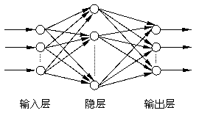
原理 人工神经网络模型概览

输入层的节点数量对应于输入数据数量，隐含层节点数量由经验取（本文涉及的三个神经网络前两个是只有一层隐含层，第三个包含了两层隐含层），输出层节点数由预期的结果数量决定（在本文中的三个函数均只有一个输出，所以三个网络的输出层均只有一个节点）。

对于每个隐含层节点，输入为前一层所有节点输出值的加权和，经过这个隐含层节点自身的函数处理，为输出后一层节点准备（如果有多层隐含层的话）。一般认为，自身的函数需要满足单调有界，有界是因为生理上每个神经元可以输出的刺激是有上限的，但是还不清楚单调的理由。在高级神经网络模型中增加一个数组用来记录隐含层节点和前一层哪些节点相连，而不是现在的全部相连。

对于一个样本的输入，网络的输出与样本的期望输出有误差。累加每个输出节点输出值与期望输出值的差的平方，得到的和乘一个系数0.5（这个系数没什么实际含义，系数变化也不会对神经网络的原理有什么影响，只是后面的计算可以简单点）。累加所有样本的误差为全局误差。

基于梯度下降法和上面得到的全局误差可以通过调整各个节点的连接权值来实现全局误差降低。
式中，△Wkj：权值从上层k点到当前层j权值的调整值
p：共P组样本
m：共m个输出节点
n：学习速率(后文可能会描述成N)
t：第pi个样本的第mi个输出节点的输出值（这个值是网络输出值）
y：第pi个样本的第mi个输出节点的期望输出值（这个值是样本给的）
f’：自身函数的导数
S：第mi个输出节点的总输入（从上层节点接收的加权和）
Z：上层第k个节点的输出
上述标准BP算法实质是一种简单的最速下降静态寻优方法，在修正权值时，只按照当前步的负梯度方向进行修正，而没有考虑到前一步的梯度方向，从而引发震荡，收敛缓慢。
本文使用下面的改进方式：
动量法权值调整的做法是将前一步的权值调整量的一部分叠加到本次计算所得的权值调整量上，和作为本次实际权值调整量。新增一个动量系数M

sin(x)的训练结果：
图中蓝色线是标准函数输出作为参考，红色线是神经网络训练结果。
下图相关参数：输入层-隐含层-输出层节点数为1-7-1，训练次数为2000000，学习速率为0.01，动量系数为0.01。
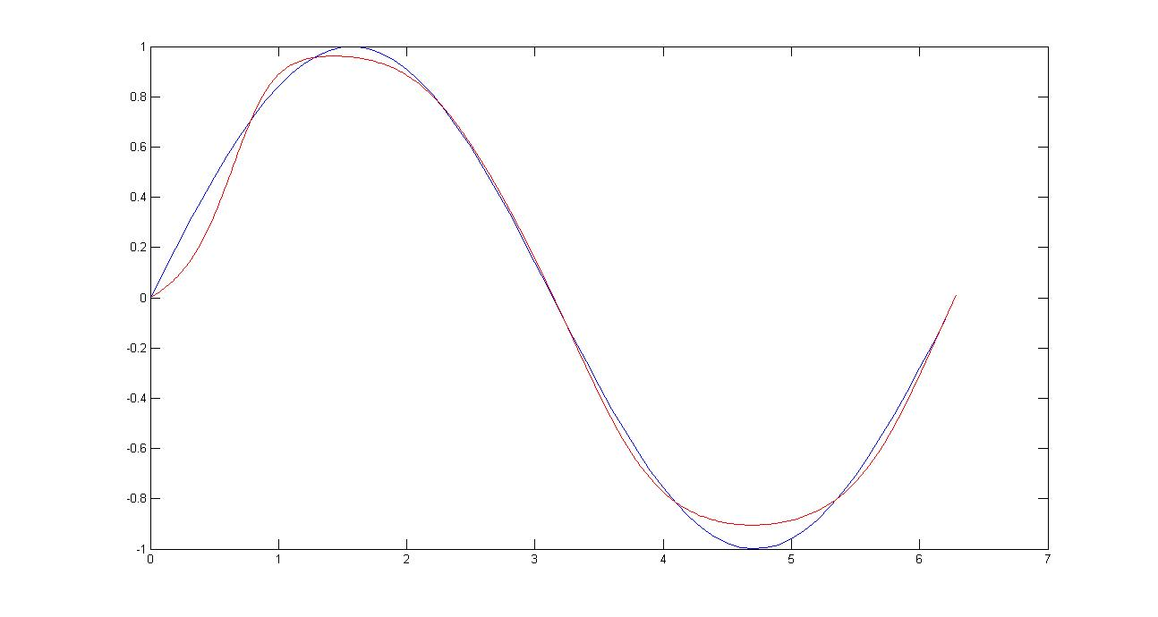
下图相关参数：输入层-隐含层-输出层节点数为1-5-1，训练次数为2000000，学习速率为0.01，动量系数为0.001。
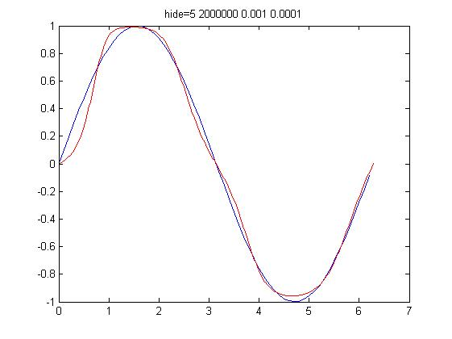
下图相关参数：输入层-隐含层-输出层节点数为1-5-1，训练次数为2000000，学习速率为0.01，动量系数为0.01。
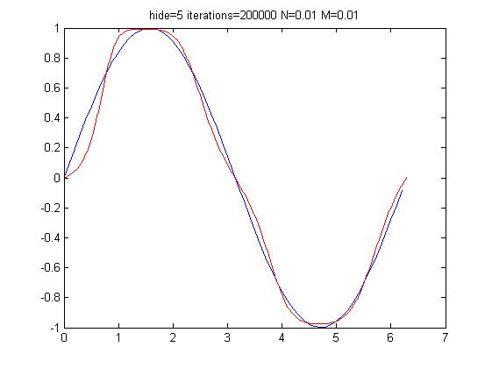

|sin(x)|的训练结果：
图中蓝色线是标准函数输出作为参考，红色线是神经网络训练结果。
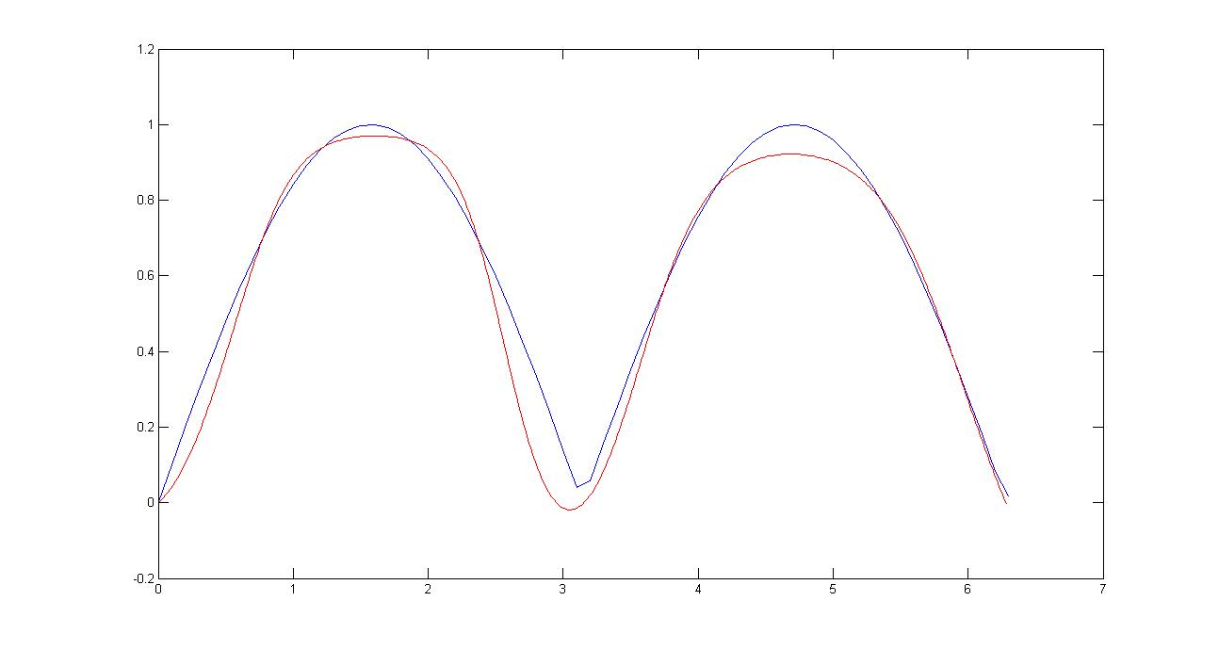
下图相关参数：输入层-隐含层-输出层节点数为1-5-1，训练次数为200000，学习速率为0.01，动量系数为0.01。
下图相关参数：输入层-隐含层-输出层节点数为1-6-1，训练次数为300000，学习速率为0.01，动量系数为0.01。
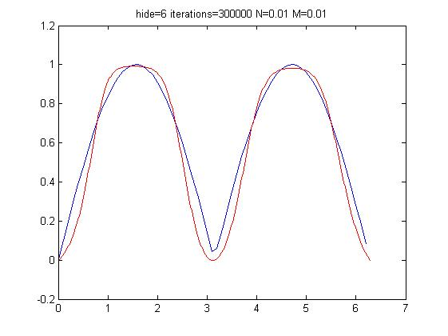
(sin(x1)/x1)*(sin(x2)/x2)的训练结果
下图相关参数：输入层-隐含层-输出层节点数为2-18-18-1，训练终止误差为0.165，学习速率为0.1，动量系数为0.1。
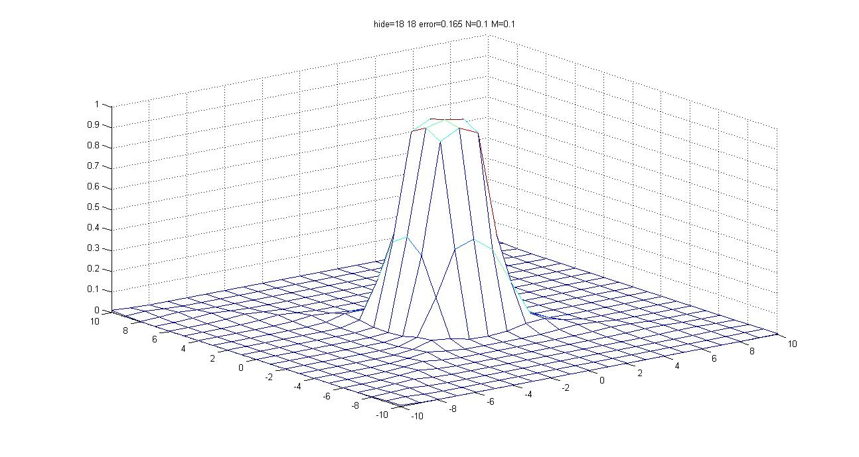
下图为标准函数图像，取值间隔0.1
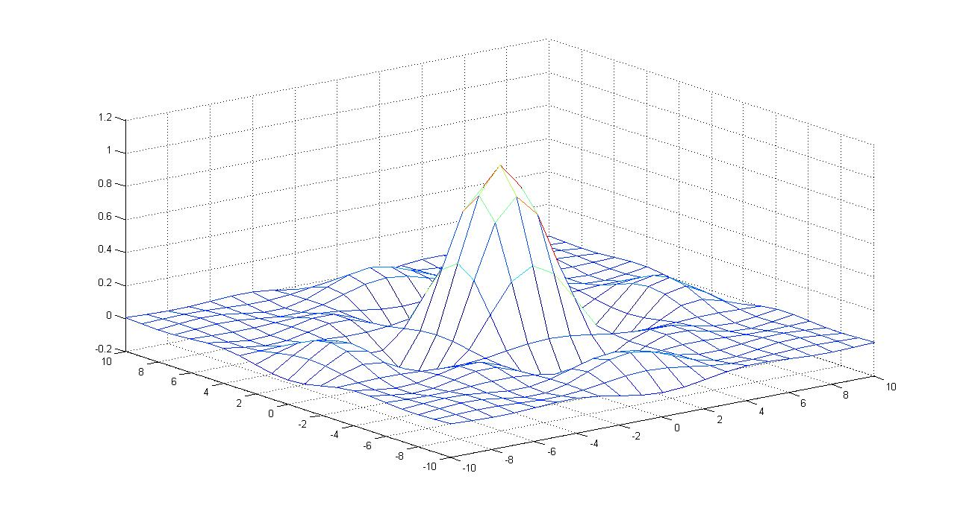
分析和讨论

Python程序清单：
sin函数数据生成
__author__ = 'cuihe'
# coding:utf-8

import math

def WriteFile(File, DisX=9, startX=0.0, endX=2*math.pi, OpenStlye='w'):
PerX = (endX-startX)/(DisX-1)
print('PerX=%f' %PerX )
f = open(File,OpenStlye)
for i in range(DisX):
temp = i*PerX
f.write("%.6f %.6f\n" %(temp, math.sin(temp)))
print('sin(temp)=%f' %math.sin(temp))
f.close()

def MakeFx_sinx():
FileName = 'sinx_InputData.txt'
WriteFile(FileName, 9, 0.0, 2*math.pi, 'w')
WriteFile(FileName, 361, 0.0, 2*math.pi, 'a')

if __name__ == '__main__':
MakeFx_sinx()
sin的神经网络
#__author__ = 'cuihe'
# coding:utf-8

import math
import random
import string

random.seed(0)

# calculate a random number where: a <= rand < b
def rand(a, b):
return (b-a)*random.random() + a

# Make a matrix I*J filled by fill, default=0.0
def makeMatrix(I, J, fill=0.0):
m = []
for i in range(I):
m.append([fill]*J)
return m

# sigmoid function, tanh is a little nicer than the standard 1/(1+e^-x)
def S_fy(x):
return math.tanh(x)

# derivative of our sigmoid function, in terms of the output (i.e. y)
def dsigmoid(y):
return 1.0 - y**2

class NN:
def __init__(self, ni, nh, no):
# number of input, hidden, and output nodes
self.ni = ni + 1 # +1 for bias node
self.nh = nh
self.no = no

# activations for nodes
self.ai = [1.0]*self.ni
self.ah = [1.0]*self.nh
self.ao = [1.0]*self.no

# create weights
self.wi = makeMatrix(self.ni, self.nh) #神经网络第一层 第二层的连接权值
self.wo = makeMatrix(self.nh, self.no) #神经网络第二层 第三层的连接权值
for i in range(self.ni):
for j in range(self.nh):
self.wi[i][j] = rand(-2.0, 2.0)
for j in range(self.nh):
for k in range(self.no):
self.wo[j][k] = rand(-1.0, 1.0)

# last change in weights for momentum
self.ci = makeMatrix(self.ni, self.nh)
self.co = makeMatrix(self.nh, self.no)

def update(self, inputs):
#按照已有的权值运算一遍，并非更新
if len(inputs) != self.ni-1:
raise ValueError('wrong number of inputs')

# input activations
for i in range(self.ni-1):
#self.ai[i] = S_fy(inputs[i])
self.ai[i] = inputs[i]

# hidden activations
for j in range(self.nh): #对隐含层的每一个神经元
sum = 0.0 #这个神经元初始化为0
for i in range(self.ni): #接受前一层所有的神经元信息
sum = sum + self.ai[i] * self.wi[i][j]
self.ah[j] = S_fy(sum) #S化后存入

# output activations
for k in range(self.no):
sum = 0.0
for j in range(self.nh):
sum = sum + self.ah[j] * self.wo[j][k]
self.ao[k] = S_fy(sum)

return self.ao[:]

def backPropagate(self, targets, N, M):
if len(targets) != self.no:
raise ValueError('wrong number of target values')

# calculate error terms for output
output_deltas = [0.0] * self.no
for k in range(self.no): #每一个输出
error = targets[k]-self.ao[k] # targets没有s化，ao是s化的，可以相减么
output_deltas[k] = dsigmoid(self.ao[k]) * error

# calculate error terms for hidden
hidden_deltas = [0.0] * self.nh
for j in range(self.nh):
error = 0.0
for k in range(self.no):
error = error + output_deltas[k]*self.wo[j][k]
hidden_deltas[j] = dsigmoid(self.ah[j]) * error

# update output weights
for j in range(self.nh):
for k in range(self.no):
change = output_deltas[k]*self.ah[j]
self.wo[j][k] = self.wo[j][k] + N*change + M*self.co[j][k]
self.co[j][k] = change
#print N*change, M*self.co[j][k]

# update input weights
for i in range(self.ni):
for j in range(self.nh):
change = hidden_deltas[j]*self.ai[i]
self.wi[i][j] = self.wi[i][j] + N*change + M*self.ci[i][j]
self.ci[i][j] = change

# calculate error
error = 0.0
for k in range(len(targets)):
error = error + 0.5*(targets[k]-self.ao[k])**2
return error

def test(self, patterns):
FOutput = open('sinx_Output.txt', 'w')
for p in patterns:
temp = self.update(p[0])
print(p[0], "->", temp) #update的参数是inputs
for item in p[0]:
FOutput.write(str(item)+' '),
for item in temp:
FOutput.write(str(item)+' '),
FOutput.write('\n')
FOutput.close()

def weights(self):
print('Input weights: '),
for i in range(self.ni):
print(self.wi[i] ),
print
print('Output weights: '),
for j in range(self.nh):
print(self.wo[j] ),
print

def train(self, patterns, iterations=150000, N=0.002, M=0.002):
# N: learning rate
# M: momentum factor
# change = hidden_deltas[j]*self.ai[i]
# self.wi[i][j] = self.wi[i][j] + N*change + M*self.ci[i][j]
# self.ci[i][j] = change

XLErrorList = []
olderror = 0

for i in range(iterations): #训练次数
error = 0.0 #本次误差
for p in patterns: #数据中每行
inputs = p[0] #每行的第一个数据是一个输入数组
targets = p[1] #每行的后一个数据是期望输出
self.update(inputs) #return self.ao[:]
error = error + self.backPropagate(targets, N, M) #这次训练的累加误差
if i % round(iterations*0.01) == 0: #每100次训练打印一次误差
print('error=%-.6f' % error),
XLErrorList.append(error)
if i % round(iterations*0.1) == 0:
print(' %3.2f %% delta=%3.9f\n' % (i*100.0/iterations, abs(error-olderror)))
olderror = error
print('\n')

XLErrorOutput = open('sinx-XLError.txt', 'w')
for item in XLErrorList:
XLErrorOutput.write(str(item)+' '),
XLErrorOutput.close()

def demo():
TestList2 = []
FilenameList = ['sinx_InputData.txt', '1sinx1_InputData.txt', 'x1x2_InputData.txt']
TestFileXL = [9, 9, 11]
FileNum = 0
TestFile = FilenameList[FileNum] #确保数据在这个文件
f = open(TestFile,'r')
for line in f: #对于每一行
TestList = [float(x) for x in line.split()] #读取这行的每一个实数，形成一行数据
TestList2.append([TestList]) #形成2维数组

traindata = []
for i in range(len(TestList2)):
#TestList2[i][0].append([TestList2[i][0][len(TestList2[i][0])]])
#TestList2[i] = [TestList2[i][0:len(TestList2)-1]]
#TestList2[i].insert(1,TestList2[i][len(TestList2[i][0])])
tempLa = TestList2[i]
tempLb = tempLa[0]
tempLc = tempLb[len(tempLb)-1]
tempLb = [tempLb[:len(tempLb)-1]]
tempLb.append([tempLc])
traindata.append(tempLb)

#traindata = TestList2[:]

datalen = len(traindata[0][0]) #输入层的数量

n = NN(datalen, datalen+4, 1)

n.train(traindata[0:TestFileXL[FileNum]], 200000, 0.01, 0.01)
n.test(traindata[TestFileXL[FileNum]:])

if __name__ == '__main__':
demo()

|sin|函数数据生成
__author__ = 'cuihe'
# coding:utf-8

import math

def WriteFile(File, DisX=9, startX=0.0, endX=2*math.pi, OpenStlye='w'):
PerX = (endX-startX)/(DisX-1)
f = open(File,OpenStlye)
for i in range(DisX):
temp = i*PerX
f.write("%.6f %.6f\n" %(temp, abs(math.sin(temp))) )
f.close()

def MakeFx_1sinx1():
FileName = '1sinx1_InputData.txt'
WriteFile(FileName, 9, 0.0, 2*math.pi, 'w')
WriteFile(FileName, 361, 0.0, 2*math.pi, 'a')

if __name__ == '__main__':
MakeFx_1sinx1()
|sin|的神经网络
#__author__ = 'cuihe'
# coding:utf-8

import math
import random
import string

random.seed(0)

# calculate a random number where: a <= rand < b
def rand(a, b):
return (b-a)*random.random() + a

# Make a matrix I*J filled by fill, default=0.0
def makeMatrix(I, J, fill=0.0):
m = []
for i in range(I):
m.append([fill]*J)
return m

# sigmoid function, tanh is a little nicer than the standard 1/(1+e^-x)
def S_fy(x):
return math.tanh(x)

# derivative of our sigmoid function, in terms of the output (i.e. y)
def dsigmoid(y):
return 1.0 - y**2

class NN:
def __init__(self, ni, nh, no):
# number of input, hidden, and output nodes
self.ni = ni + 1 # +1 for bias node
self.nh = nh
self.no = no

# activations for nodes
self.ai = [1.0]*self.ni
self.ah = [1.0]*self.nh
self.ao = [1.0]*self.no

# create weights
self.wi = makeMatrix(self.ni, self.nh) #神经网络第一层 第二层的连接权值
self.wo = makeMatrix(self.nh, self.no) #神经网络第二层 第三层的连接权值
for i in range(self.ni):
for j in range(self.nh):
self.wi[i][j] = rand(-2.0, 2.0)
for j in range(self.nh):
for k in range(self.no):
self.wo[j][k] = rand(-1.0, 1.0)

# last change in weights for momentum
self.ci = makeMatrix(self.ni, self.nh)
self.co = makeMatrix(self.nh, self.no)

def update(self, inputs):
#按照已有的权值运算一遍，并非更新
if len(inputs) != self.ni-1:
raise ValueError('wrong number of inputs')

# input activations
for i in range(self.ni-1):
#self.ai[i] = S_fy(inputs[i])
self.ai[i] = inputs[i]

# hidden activations
for j in range(self.nh): #对隐含层的每一个神经元
sum = 0.0 #这个神经元初始化为0
for i in range(self.ni): #接受前一层所有的神经元信息
sum = sum + self.ai[i] * self.wi[i][j]
self.ah[j] = S_fy(sum) #S化后存入

# output activations
for k in range(self.no):
sum = 0.0
for j in range(self.nh):
sum = sum + self.ah[j] * self.wo[j][k]
self.ao[k] = S_fy(sum)

return self.ao[:]

def backPropagate(self, targets, N, M):
if len(targets) != self.no:
raise ValueError('wrong number of target values')

# calculate error terms for output
output_deltas = [0.0] * self.no
for k in range(self.no): #每一个输出
error = targets[k]-self.ao[k]
output_deltas[k] = dsigmoid(self.ao[k]) * error

# calculate error terms for hidden
hidden_deltas = [0.0] * self.nh
for j in range(self.nh):
error = 0.0
for k in range(self.no):
error = error + output_deltas[k]*self.wo[j][k]
hidden_deltas[j] = dsigmoid(self.ah[j]) * error

# update output weights
for j in range(self.nh):
for k in range(self.no):
change = output_deltas[k]*self.ah[j]
self.wo[j][k] = self.wo[j][k] + N*change + M*self.co[j][k]
self.co[j][k] = change
#print N*change, M*self.co[j][k]

# update input weights
for i in range(self.ni):
for j in range(self.nh):
change = hidden_deltas[j]*self.ai[i]
self.wi[i][j] = self.wi[i][j] + N*change + M*self.ci[i][j]
self.ci[i][j] = change

# calculate error
error = 0.0
for k in range(len(targets)):
error = error + 0.5*(targets[k]-self.ao[k])**2
return error

def test(self, patterns):
FOutput = open('1sinx1_Output.txt', 'w')
for p in patterns:
temp = self.update(p[0])
print(p[0], "->", temp) #update的参数是inputs
for item in p[0]:
FOutput.write(str(item)+' '),
for item in temp:
FOutput.write(str(item)+' '),
FOutput.write('\n')
FOutput.close()

def weights(self):
print('Input weights: '),
for i in range(self.ni):
print(self.wi[i] ),
print
print('Output weights: '),
for j in range(self.nh):
print(self.wo[j] ),
print

def train(self, patterns, iterations=300000, N=0.0006, M=0.0006):
# N: learning rate
# M: momentum factor
# change = hidden_deltas[j]*self.ai[i]
# self.wi[i][j] = self.wi[i][j] + N*change + M*self.ci[i][j]
# self.ci[i][j] = change

XLErrorList = []
olderror = 0
for i in range(iterations): #训练次数
error = 0.0 #本次误差
for p in patterns: #数据中每行
inputs = p[0] #每行的第一个数据是一个输入数组
targets = p[1] #每行的后一个数据是期望输出
self.update(inputs) #return self.ao[:]
error = error + self.backPropagate(targets, N, M) #这次训练的累加误差
if i % 2000 == 0: #每100次训练打印一次误差
print('error=%-.6f' % error),
XLErrorList.append(error)
if i % 20000 == 0:
print(' [%3.2f %%] delta=%3.9f\n' % ((i*1.0/iterations)*100, abs(error-olderror)))
olderror = error
print('\n')

XLErrorOutput = open('1sinx1-XLError.txt', 'w')
for item in XLErrorList:
XLErrorOutput.write(str(item)+' '),
XLErrorOutput.close()

def demo():
TestList2 = []
TestFileList = ['sinx_InputData.txt', '1sinx1_InputData.txt', 'x1x2_InputData.txt']
TestFileXL = [9, 9, 11]
FileNum = 1 #<<<<==========================================这里有改动
TestFile = TestFileList[FileNum] #确保数据在这个文件
f = open(TestFile,'r')
for line in f: #对于每一行
TestList = [float(x) for x in line.split()] #读取这行的每一个实数，形成一行数据
TestList2.append([TestList]) #形成2维数组

traindata = []
for i in range(len(TestList2)):
tempLa = TestList2[i]
tempLb = tempLa[0]
tempLc = tempLb[len(tempLb)-1]
tempLb = [tempLb[:len(tempLb)-1]]
tempLb.append([tempLc])
traindata.append(tempLb)

#traindata = TestList2[:]

datalen = len(traindata[0][0]) #输入层的数量

n = NN(datalen, datalen+5, 1)

n.train(traindata[0:TestFileXL[FileNum]], 300000, 0.01, 0.01) #def train(self, patterns, iterations=500, N=0.02, M=0.01):
n.test(traindata[TestFileXL[FileNum]:])

if __name__ == '__main__':
demo()

(sin(x1)/x1)*(sin(x2)/x2)函数数据生成
__author__ = 'cuihe'
# coding:utf-8

import math

def WriteFile(File, DisX=11, startX=-10.0, endX=10.0, OpenStlye='w'):
PerX = (endX-startX)/(DisX-1)
f = open(File,OpenStlye)
for i in range(DisX):
for j in range(DisX):
X1 = startX+i*PerX
if X1==0:
ZX1=1
else:
ZX1 = math.sin(X1)/X1
X2 = startX+j*PerX
if X2==0:
YX2=1
else:
YX2 = math.sin(X2)/X2
resultZ_Y = ZX1 * YX2
f.write("%.6f %.6f %.6f \n" %(X1, X2, resultZ_Y) )#
f.close()

def MakeFx_x1x2():
FileName = 'x1x2_InputData.txt'
WriteFile(FileName, 11, -10.0, 10.0, 'w')
WriteFile(FileName, 21, -10.0, 10.0, 'a')

if __name__ == '__main__':
MakeFx_x1x2()
(sin(x1)/x1)*(sin(x2)/x2)的神经网络
#__author__ = 'cuihe'
# coding:utf-8

import math
import random
import BPNN

def demo():

TestList2 = []
TestFileList = ['sinx_InputData.txt', '1sinx1_InputData.txt', 'x1x2_InputData.txt']
TestFileXL = [9, 9, 121]
FileNum = 2
TestFile = TestFileList[FileNum] #确保数据在这个文件
f = open(TestFile,'r')
for line in f: #对于每一行
TestList = [float(x) for x in line.split()] #读取这行的每一个实数，形成一行数据
TestList2.append([TestList]) #形成2维数组

traindata = []
for i in range(len(TestList2)):
tempLa = TestList2[i]
tempLb = tempLa[0]
tempLc = tempLb[len(tempLb)-1]
tempLb = [tempLb[:len(tempLb)-1]]
tempLb.append([tempLc])
traindata.append(tempLb)

datalen = len(traindata[0][0]) #输入层的数量

example_list=traindata[:TestFileXL[FileNum]]
bpnn = BPNN.Bpnn(datalen, [datalen+16, datalen+16, 1])
bpnn.train(example_list, 0.165, 0.1, 0.1)
#bpnn.debug_train(example_list,2000)

FOutput = open('x1x2_Output.txt', 'w')
for line in traindata[TestFileXL[FileNum]:]:
bpnn.compute(line[0])
print(line[0][0], line[0][1],' -> ', bpnn.output()[0])
for item in line[0]:
FOutput.write(str(item)+' '),
for item in bpnn.output():
FOutput.write(str(item)+' \n')
FOutput.close()

if __name__ == '__main__':
demo()

其中的BPNN（修改之前的网络使之可以增加隐含层）
# coding:utf-8
import math
import random

class BpnnNode:
'''

'''
def __init__(self, input_num):
'''
:param input_num:
:return:None
'''
self.input = [1.0] * (input_num + 1)
self.weight = [0.0] * (input_num + 1)
self.old_weight = [0.0] * (input_num + 1)
for i in range(0, len(self.weight)):
self.weight[i] = self.rand(-0.5, 0.5)
self.delta = 0.0
self.output = 0.0

def rand(self,a, b):
'''
:param a:
:param b:
:return:
'''
return (b-a)*random.random() + a

def sigmoid(self, x):
'''

'''
return 1.0 / (1.0 + math.e ** -x)
# return math.tanh(x)

def dsigmoid(self, y):
'''

'''
return y * (1.0 - y)
# return 1.0 - y**2

def compute(self, data):
'''
ֵ
:param data:
:return:None
'''
if len(data) != len(self.input) - 1:
raise ValueError('wrong length of input for node!')
for i in range(len(self.input) - 1):
self.input[i] = data[i]
net = 0.0
for i in range(len(self.input)):
net += self.input[i] * self.weight[i]
self.output = self.sigmoid(net)

def update(self, weight_list, delta_list, eta, momentum):
'''

:param weight_list:
:param delta_list:
:param eta:
:param momentum:
:return:
'''
self.delta = 0.0
for i in range(len(weight_list)):
self.delta += weight_list[i] * delta_list[i]
self.delta *= self.dsigmoid(self.output)
for i in range(len(self.weight)):
change = eta * self.delta * self.input[i]+momentum*(self.weight[i]-self.old_weight[i])
# change= eta * self.delta * self.input[i]
self.old_weight[i]=self.weight[i]
self.weight[i] += change

class Bpnn:
def __init__(self, input_num, node_num_list):
'''

:param input_num:
:param node_num_list:
:return:
'''
self.bpnn = []
self.input_num = input_num
tmp_input_num = input_num
for node_num in node_num_list:
self.bpnn.append([BpnnNode(tmp_input_num) for i in range(node_num)])
tmp_input_num = node_num

def compute(self, input):
'''

:param input:
:return:
'''
if len(input) != self.input_num:
raise ValueError('wrong length of input for bpnn!')
tmp_input = input
for node_list in self.bpnn:
for node in node_list:
node.compute(tmp_input)
tmp_input = [node.output for node in node_list]

def output(self):
'''

:return:
'''
return [node.output for node in self.bpnn[-1]]

def error(self, example_list):
'''

:param example_list:
:return:
'''
error = []
for example in example_list:
self.compute(example[0])
output = self.output()
target = example[1]
e = 0.
for i in range(len(output)):
e += (target[i] - output[i]) ** 2
error.append(e / 2.)
return error

def update(self, target, eta, momentum):
'''

:param target:
:param eta:
:param momentum:
:return:
'''
if len(target) != len(self.bpnn[-1]):
raise ValueError('wrong length of target for bpnn!')
for i in range(len(self.bpnn[-1])):
self.bpnn[-1][i].update([1.0], [target[i] - self.bpnn[-1][i].output], eta, momentum)
tmp_list = range(len(self.bpnn) - 1)
tmp_list.reverse()
for i in tmp_list:
delta_list = [node.delta for node in self.bpnn[i + 1]]
for j in range(len(self.bpnn[i])):
weight_list = [node.old_weight[j] for node in self.bpnn[i + 1]]
self.bpnn[i][j].update(weight_list, delta_list, eta, momentum)

def train(self, example_list, error, eta=0.3, momentum=0.2):
'''

:param example_list:
:param error:
:param eta:
:param momentum:
:return:
'''
error_now=sum(self.error(example_list))
self.n = 0
while error_now> error:
self.n += 1
if self.n % 50 ==0:
print(' error_now = %f train_times_now = %d ' % (error_now, self.n))
# print '\n----------\n'
for example in example_list:
self.compute(example[0])
# print self.output()
self.update(example[1], eta, momentum)
error_now=sum(self.error(example_list))
# print error_now
print('error_n: %d' % self.n)

def debug_input(self):
'''

:return:
'''
print 'debug input'
for i in range(len(self.bpnn)):
print '\t', 'layer ', i # \t Tab
for node in self.bpnn[i]:
print '\t\t', node.input

def debug_output(self):
'''

:return:
'''
print 'debug output'
for i in range(len(self.bpnn)):
# print '\t', 'layer ', i
print '\t\t', [node.output for node in self.bpnn[i]]

def debug_delta(self):
'''

:return:
'''
print 'debug delta'
for i in range(len(self.bpnn)):
print '\t', 'layer ', i
for node in self.bpnn[i]:
print '\t\t', node.delta

def debug_weight(self):
'''

:return:
'''
print 'debug weight'
for i in range(len(self.bpnn)):
print '\t', 'layer ', i
for node in self.bpnn[i]:
print '\t\t', node.weight

def debug_train(self, example_list, times, eta=0.4, momentum=0.3):
'''

:param example_list:
:param times:
:param eta:
:param momentum:
:return:
'''
for i in range(times): #训练次数
error = 0.0 #本次误差
for example in example_list: #数据中每行
self.compute(example[0])
self.update(example[1], eta, momentum)
if i % 80 == 0:
print(' [%3.2f %%] ' % ((i*1.0/times)*100))

# example_list = [
# [[0, 0, 0],[0]],
# [[0, 1, 0],[0]],
# [[1, 0, 0],[0]],
# [[0, 1, 1],[1]],
# [[1, 0, 1],[1]],
# [[1, 1, 0],[1]]
# ]
# bpnn = Bpnn(3, [4 ,4,1])
# bpnn.train(example_list, 0.001)
# bpnn.debug_train(example_list,10000)
# bpnn.compute([0.9,0.9])
# print bpnn.output()
Matlab程序清单（用以打印结果）
sin
file_t = fopen('D:\!zju\!IntelligentSystem\HW#4\sinx_Output.txt','r');
[x fx] = fscanf(file_t,'%f %f');
for i=1:2:722
xx((i+1)/2)=x(i,1);
yy((i+1)/2)=x(i+1,1);
end
t=0:0.1:2*pi
yt=sin(t);
plot(t,yt);
hold;
plot(xx,yy,'r');
|sin|
file_t = fopen('D:\!zju\!IntelligentSystem\HW#4\1sinx1_Output.txt','r');
[x fx] = fscanf(file_t,'%f %f');
for i=1:2:722
xx((i+1)/2)=x(i,1);
yy((i+1)/2)=x(i+1,1);
end
t=0:0.1:2*pi
yt=abs(sin(t));
plot(t,yt);
hold;
plot(xx,yy,'r');
(sin(x1)/x1)*(sin(x2)/x2)
clear;
file_t = fopen('D:\!zju\!IntelligentSystem\HW#4\x1x2_Output.txt','r');
[x fx] = fscanf(file_t,'%f %f');
for i=1:3:fx
x1((i+2)/3)=x(i,1);
x2((i+2)/3)=x(i+1,1);
yy((i+2)/3)=x(i+2,1);
end
fclose(file_t);
x1=reshape(x1,21,21);
x2=reshape(x2,21,21);
yy=reshape(yy,21,21);

for i=1:21
for j=1:21
if x1(i,j)==0 temp1=1;
else temp1=sin(x1(i,j))/x1(i,j);end
if x2(i,j)==0 temp2=1;
else temp2=sin(x2(i,j))/x2(i,j);end
YY(i,j)=temp1*temp2;
end
end
%mesh(x1,x2,YY); %理论图
mesh(x1,x2,yy); %训练图

