Gridfs存取文件
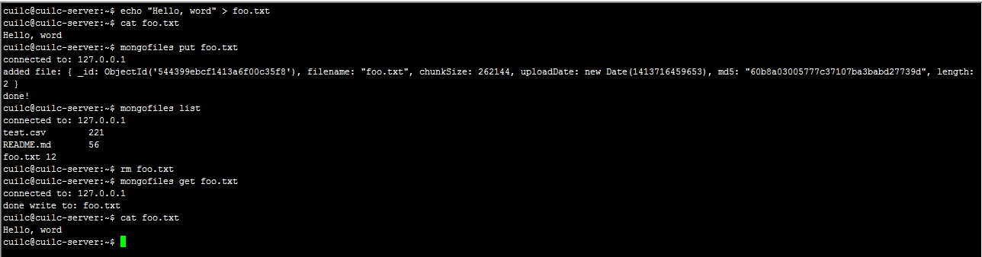

启劢配置服务器
mongod --dbpath /var/lib/mongo/dbs/config --port 20000
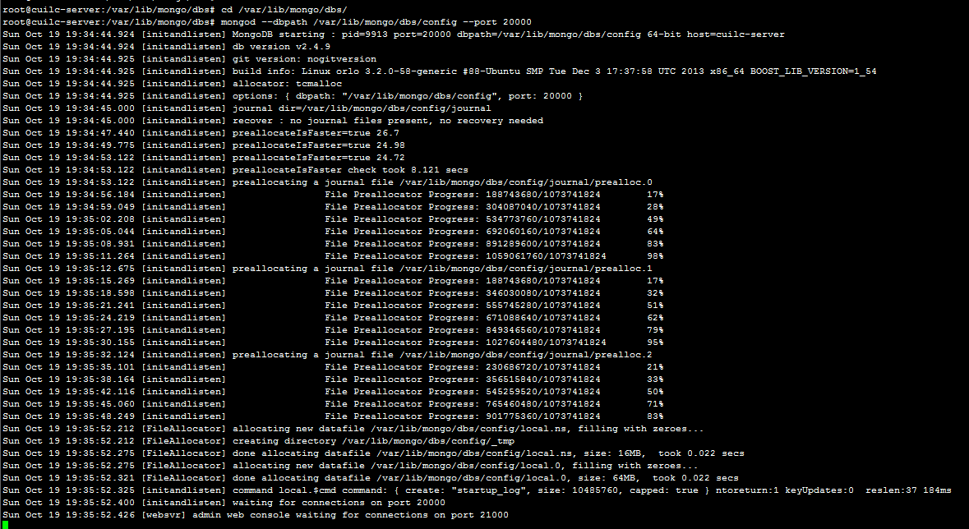

启劢mongos
mongos --port 300000 --configdb localhost:20000
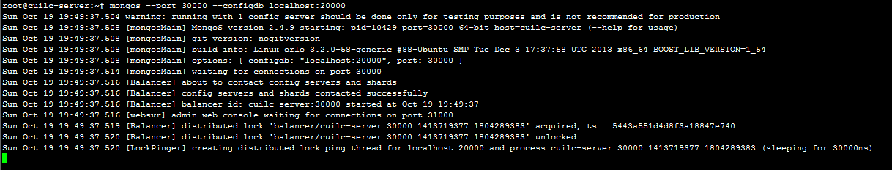

添加片
cd /var/lib/mongo/dbs
mkdir shard1
ls

mongod --dbpath /var/lib/mongo/dbs/shard1 --port 10000 --nojournal
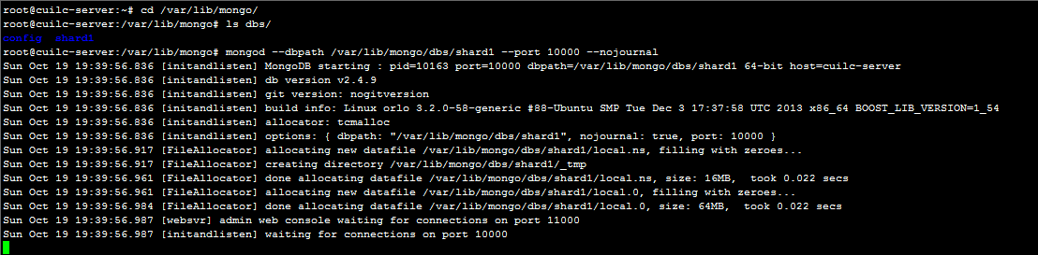

连接mongos
mongo localhost:30000/admin
db.runCommand({addshard:"localhost:10000", allowLocal:true})
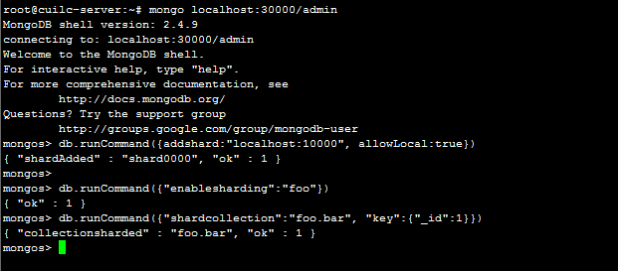

切分数据
db.runCommand({"enablesharding":"foo"})
db.runCommand({"shardcollection":"foo.bar", "key":{"_id":1}})

查看所有的片
use config
db.shards.find()
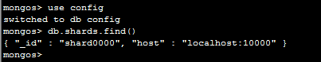

database集合
db.databases.find()
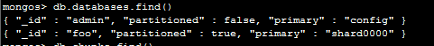

chunks集合
db.chunks.find()

获得概要
db.printShardingStatus()
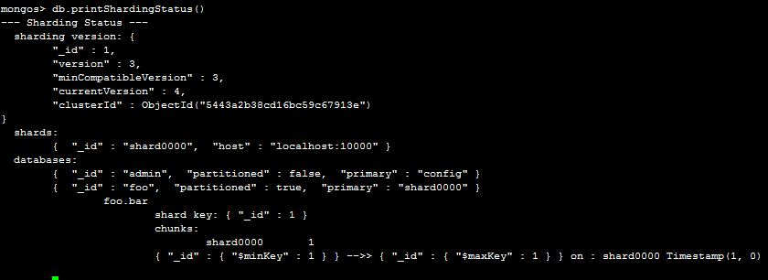

删除片
db.runCommand({"removeshard":"localhost:10000"})
db.runCommand({"removeshard":"localhost:10000"})
