1. 安装依赖包
下载uuid-devel uuid
ftp://rpmfind.net/linux/epel/5/i386/uuid-1.5.1-3.el5.i386.rpm

ftp://rpmfind.net/linux/epel/5/i386/uuid-devel-1.5.1-3.el5.i386.rpm
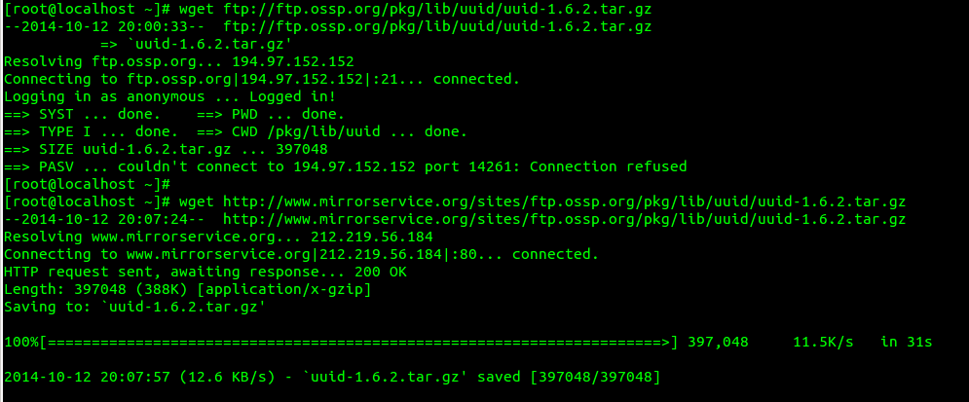

rpm -ivh uuid-devel-1.5.1-3.el5.i386.rpm uuid-1.5.1-3.el5.i386.rpm

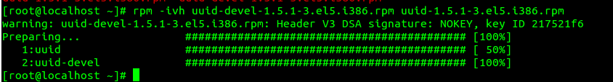

2. 配置源码
# cd /opt/pg
# ./configure --prefix=/home/ArteryDB –with-ossp-uuid
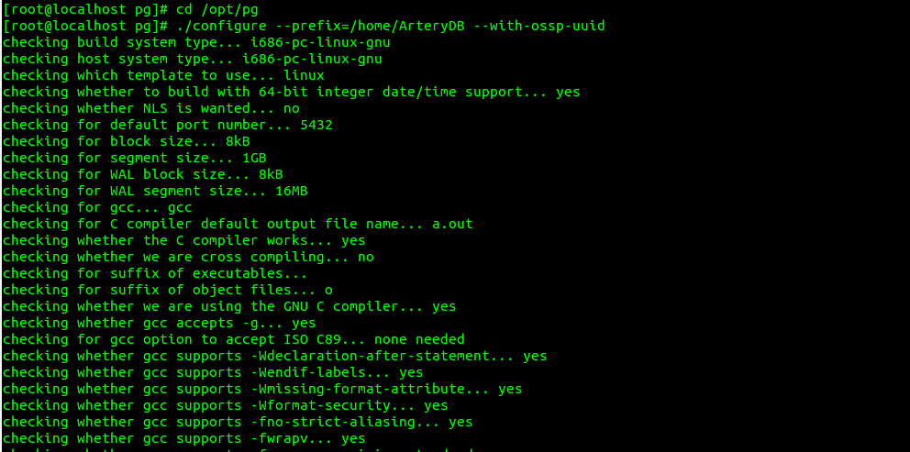

3. 编译
# cd contrib/uuid-ossp/
# make
# make install
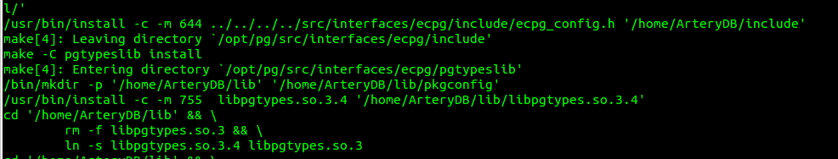

4. 安装
# cd /home/ArteryDB/
# mkdir /home/ArteryDB/data
# chown -R Postgresql:Postgresql /home/ArteryDB
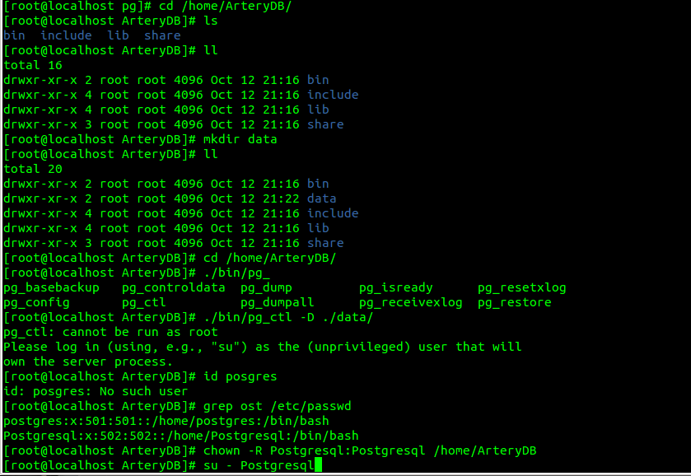
# create extension "uuid-ossp";
