postgres@cuilc-server:~$ mkdir /home/postgres/arch

postgres@cuilc-server:~$ ll /home/postgres/

编辑配置文件，$PGDATA/postgresql.conf
archive_mode = on
archive_command = 'DATE=`date +%Y%m%d`; DIR="/home/postgres/arch/$DATE"; (test -d $DIR || mkdir -p $DIR) && cp /usr/local/pgsql/data/%p $DIR/%f'
wal_level = hot_standby
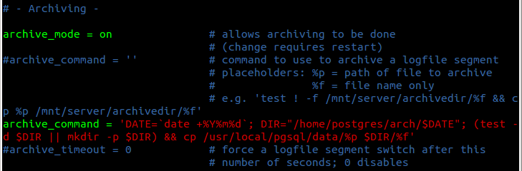
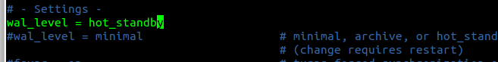

启动数据库，执行检查点，然后切换日志，多次重复执行这2条命令：
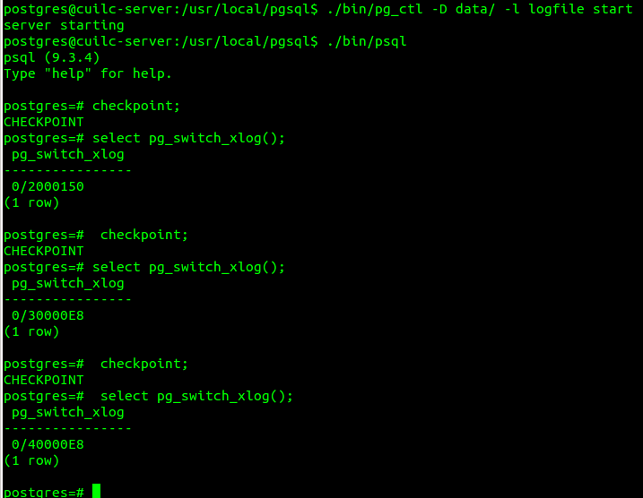

查看pg_xlog目录和备份目录：
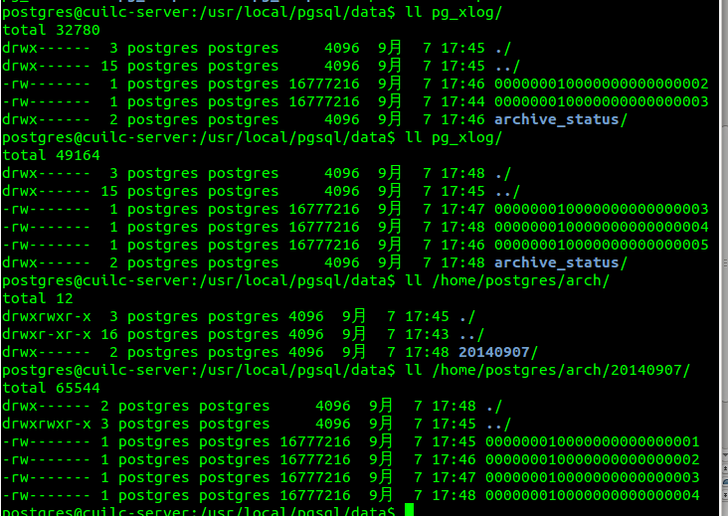

热备：
psql -c "select pg_start_backup('hot_backup');"
DATE=`date +%Y%m%d`
tar -cf /home/postgres/arch/$DATE.backup.tar /usr/local/pgsql/data/
psql -c "select pg_stop_backup();"
tar -rf /home/postgres/arch/$DATE.backup.tar /home/postgres/arch/$DATE/
