下载Apple，Microsoft，Oracle。Google公司2011-2012年交易行情数据，分别画出蜡烛图以及ADX子图
答：1 试对ADX指标进行技术分析，指出某段时间里根据ADX及相关指标研读出来的走势预测
library(quantmod)
## Loading required package: Defaults
## Loading required package: xts
## Loading required package: zoo
##
## Attaching package: 'zoo'
##
## The following objects are masked from 'package:base':
##
## as.Date, as.Date.numeric
##
## Loading required package: TTR
## Version 0.4-0 included new data defaults. See ?getSymbols.
getSymbols(c("AAPL", "MSFT", "ORCL", "GOOGL"), src = "yahoo", from = "2011-01-01",
to = "2012-12-31")
## As of 0.4-0, 'getSymbols' uses env=parent.frame() and
## auto.assign=TRUE by default.
##
## This behavior will be phased out in 0.5-0 when the call will
## default to use auto.assign=FALSE. getOption("getSymbols.env") and
## getOptions("getSymbols.auto.assign") are now checked for alternate defaults
##
## This message is shown once per session and may be disabled by setting
## options("getSymbols.warning4.0"=FALSE). See ?getSymbol for more details
## [1] "AAPL" "MSFT" "ORCL" "GOOGL"
chartSeries(AAPL, name = "AAPL CANDLECHART", type = "candlesticks")
addADX()
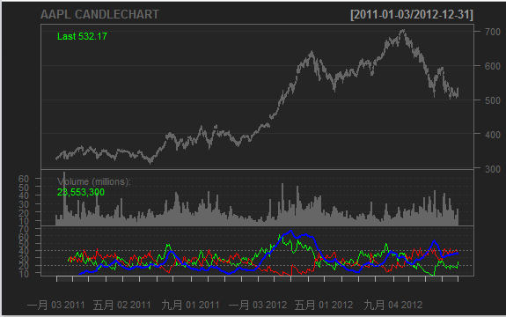

# 从2012年2月～4月这段期间的ADX指标来看，在2月到3月的时候指标达到了从近50到70,表示走势非常强劲。
# 参考蜡烛图可知当时的股价从450元左右开始一直飙升到530元左右。
chartSeries(MSFT, name = "MSFT CANDLECHART", type = "candlesticks")
addADX()
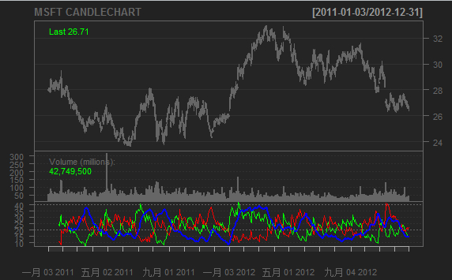
# 从2012年2月～4月这段期间的ADX指标来看，在2月到3月的时候指标达到了从近35到40.表示走势走强。
# 参考蜡烛图可知当时的股价从30元左右开始一直升到32元左右。
chartSeries(ORCL, name = "ROCL CANDLECHART", type = "candlesticks")
addADX()
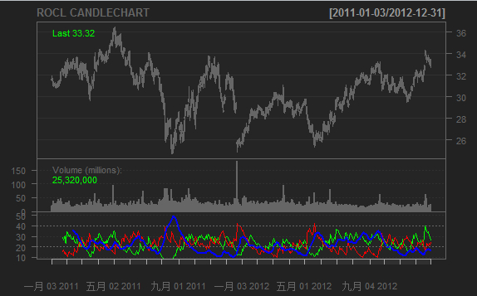
# 从2012年2月～4月这段期间的ADX指标来看，在2月到3月的时候指标从近20跌到15.表示走势走弱。#但参考蜡烛图可知当时的股价在29元左右徘徊。表示在ADX小于20时参考意义不大。
chartSeries(GOOGL, name = "GOOGL CANDLECHART", type = "candlesticks")
addADX()
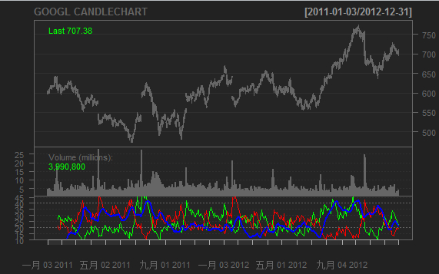
# 从2011年8月～10月这段期间的ADX指标来看，指标达到了从近41到16.表示走势走弱。
# 参考蜡烛图可知当时的股价从630元跌倒520左右。

2 求出每种股票在上述年份内ADX指标同时低于DI+和DI-的时间段
# AAPL股票
AAPL.ADX <- ADX(AAPL)
head(AAPL.ADX[which(AAPL.ADX[, 1] > AAPL.ADX[, 4] & AAPL.ADX[, 2] > AAPL.ADX[,
4])], 50)
## DIp DIn DX ADX
## 2011-02-22 57.03 48.84 7.736 48.39
## 2011-02-23 55.81 49.34 6.158 45.37
## 2011-02-24 60.17 44.13 15.378 43.23
## 2011-03-10 54.51 42.30 12.608 36.03
## 2011-03-11 54.05 41.94 12.608 34.36
## 2011-03-14 60.28 35.71 25.603 33.73
## 2011-03-15 56.44 49.27 6.783 31.81
## 2011-03-16 54.40 56.70 2.070 29.69
## 2011-03-17 44.72 52.32 7.833 28.12
## 2011-03-18 40.02 49.11 10.200 26.84
## 2011-03-21 36.23 44.46 10.200 25.66
## 2011-03-22 42.18 39.54 3.231 24.05
## 2011-03-23 42.08 43.35 1.492 22.44
## 2011-03-24 42.22 39.29 3.594 21.10
## 2011-03-25 45.67 33.94 14.733 20.64
## 2011-03-28 48.98 30.92 22.598 20.78
## 2011-03-29 48.98 36.17 15.039 20.37
## 2011-03-30 50.13 33.58 19.764 20.33
## 2011-03-31 50.13 35.40 17.220 20.11
## 2011-04-01 53.81 32.43 24.788 20.44
## 2011-04-04 52.85 44.13 8.996 19.62
## 2011-04-05 52.85 48.57 4.221 18.52
## 2011-04-06 55.56 43.91 11.718 18.04
## 2011-04-07 54.52 49.84 4.492 17.07
## 2011-04-08 53.94 46.08 7.859 16.41
## 2011-04-11 53.82 55.30 1.358 15.34
## 2011-04-12 53.26 59.03 5.138 14.61
## 2011-04-13 57.46 52.93 4.103 13.86
## 2011-04-14 54.59 50.59 3.800 13.14
## 2011-04-15 53.04 54.57 1.421 12.30
## 2011-04-18 53.04 58.05 4.510 11.75
## 2011-04-19 53.31 43.19 10.489 11.66
## 2011-04-20 60.32 34.51 27.219 12.77
## 2011-04-21 65.24 27.66 40.449 14.74
## 2011-04-25 63.41 29.01 37.222 16.35
## 2011-04-26 65.26 27.50 40.709 18.09
## 2011-04-27 62.22 30.47 34.246 19.24
## 2011-04-28 62.22 34.99 28.011 19.87
## 2011-04-29 61.86 34.18 28.819 20.51
## 2011-05-02 58.34 38.69 20.247 20.49
## 2011-05-03 55.57 37.96 18.828 20.37
## 2011-05-04 53.25 36.01 19.305 20.30
## 2011-05-05 51.60 36.69 16.892 20.05
## 2011-05-06 50.41 33.99 19.464 20.01
## 2011-05-09 48.66 34.49 17.045 19.80
## 2011-05-10 48.41 32.74 19.310 19.76
## 2011-05-11 46.18 31.04 19.609 19.75
## 2011-05-12 45.24 37.08 9.911 19.05
## 2011-05-13 41.71 36.19 7.086 18.20
## 2011-05-16 41.71 48.66 7.686 17.44
# MSFT股票
MSFT.ADX <- ADX(MSFT)
head(MSFT.ADX[which(MSFT.ADX[, 1] > MSFT.ADX[, 4] & MSFT.ADX[, 2] > MSFT.ADX[,
4])], 50)
## DIp DIn DX ADX
## 2011-02-10 44.36 56.39 11.936 18.14
## 2011-02-11 37.92 52.22 15.859 17.98
## 2011-02-14 36.23 67.06 29.840 18.83
## 2011-02-15 35.15 65.05 29.840 19.61
## 2011-02-16 33.94 71.78 35.797 20.77
## 2011-02-17 29.83 63.10 35.797 21.84
## 2011-02-18 27.69 58.57 35.797 22.84
## 2011-02-22 27.69 62.44 38.554 23.96
## 2011-02-23 27.58 71.26 44.185 25.41
## 2011-02-24 29.54 65.65 37.945 26.30
## 2011-02-25 34.69 56.34 23.784 26.12
## 2011-02-28 32.39 55.75 26.493 26.15
## 2011-03-01 31.34 56.83 28.912 26.35
## 2011-03-02 31.34 72.84 39.837 27.31
## 2011-03-03 34.46 66.67 31.853 27.63
## 2011-03-04 33.90 72.11 36.047 28.23
## 2011-03-07 29.61 62.98 36.047 28.79
## 2011-03-25 38.00 39.68 2.160 37.90
## 2011-03-28 37.06 46.80 11.618 36.03
## 2011-03-29 37.06 54.40 18.954 34.81
## 2011-03-30 42.48 48.45 6.570 32.79
## 2011-03-31 40.88 48.13 8.154 31.03
## 2011-04-01 37.95 50.34 14.040 29.82
## 2011-04-04 35.90 47.63 14.040 28.69
## 2011-04-05 43.79 40.72 3.629 26.90
## 2011-04-06 45.71 37.31 10.114 25.70
## 2011-04-07 47.69 33.19 17.922 25.14
## 2011-04-08 44.48 30.96 17.922 24.63
## 2011-04-11 41.06 29.58 16.249 24.03
## 2011-04-12 40.62 43.51 3.424 22.56
## 2011-04-13 39.12 41.90 3.424 21.19
## 2011-04-14 37.34 56.31 20.251 21.12
## 2011-04-15 33.86 48.91 18.188 20.91
## 2011-04-18 33.86 59.62 27.557 21.39
## 2011-04-19 30.36 57.52 30.904 22.07
## 2011-04-20 40.93 45.42 5.204 20.86
## 2011-04-21 45.11 41.49 4.176 19.67
## 2011-04-25 42.29 47.32 5.612 18.67
## 2011-04-26 42.61 41.72 1.062 17.41
## 2011-04-27 50.35 34.74 18.349 17.48
## 2011-04-28 50.19 31.74 22.515 17.84
## 2011-04-29 48.16 36.67 13.547 17.53
## 2011-05-02 41.21 47.30 6.880 16.77
## 2011-05-03 39.93 49.72 10.924 16.35
## 2011-05-04 42.63 45.17 2.902 15.39
## 2011-05-05 44.90 42.18 3.133 14.52
## 2011-05-06 41.05 38.09 3.741 13.75
## 2011-05-09 40.51 44.45 4.639 13.10
## 2011-05-10 40.51 47.58 8.024 12.73
## 2011-05-11 43.45 42.39 1.243 11.91
# ORCL股票
ORCL.ADX <- ADX(ORCL)
head(ORCL.ADX[which(ORCL.ADX[, 1] > ORCL.ADX[, 4] & ORCL.ADX[, 2] > ORCL.ADX[,
4])], 50)
## DIp DIn DX ADX
## 2011-02-10 49.96 34.09 18.883 24.18
## 2011-02-11 51.89 30.91 25.339 24.27
## 2011-02-14 53.85 29.06 29.898 24.67
## 2011-02-15 52.67 37.88 16.337 24.07
## 2011-02-16 49.57 35.89 16.003 23.50
## 2011-02-17 48.16 32.77 19.011 23.18
## 2011-02-18 46.32 30.70 20.292 22.97
## 2011-02-22 48.57 27.91 27.006 23.26
## 2011-02-23 48.20 53.45 5.172 21.97
## 2011-02-24 47.16 58.75 10.946 21.18
## 2011-02-25 44.32 49.45 5.471 20.06
## 2011-02-28 53.44 40.96 13.220 19.57
## 2011-03-01 49.51 41.20 9.161 18.83
## 2011-03-02 49.51 58.00 7.903 18.05
## 2011-03-03 58.38 47.11 10.683 17.52
## 2011-03-04 62.16 41.94 19.417 17.66
## 2011-03-07 53.67 36.95 18.458 17.71
## 2011-03-08 49.32 34.85 17.190 17.68
## 2011-03-09 50.62 32.11 22.378 18.01
## 2011-03-10 50.62 45.20 5.661 17.13
## 2011-03-11 48.42 44.42 4.308 16.21
## 2011-03-14 46.62 53.88 7.216 15.57
## 2011-03-15 46.62 66.28 17.406 15.70
## 2011-03-16 49.78 52.50 2.662 14.77
## 2011-03-17 40.88 43.29 2.855 13.92
## 2011-03-18 41.34 38.82 3.149 13.15
## 2011-03-21 43.20 33.87 12.104 13.08
## 2011-03-22 42.58 38.37 5.195 12.51
## 2011-03-23 41.43 37.33 5.195 11.99
## 2011-03-24 44.00 31.84 16.036 12.28
## 2011-03-25 55.84 23.18 41.326 14.35
## 2011-03-28 54.07 37.77 17.747 14.60
## 2011-03-29 54.07 37.77 17.747 14.82
## 2011-03-30 58.96 33.32 27.793 15.75
## 2011-03-31 58.96 33.32 27.793 16.61
## 2011-04-01 62.44 29.94 35.180 17.93
## 2011-04-04 63.67 27.99 38.929 19.43
## 2011-04-05 63.98 26.89 40.819 20.96
## 2011-04-06 61.29 28.66 36.277 22.06
## 2011-04-07 60.25 30.17 33.268 22.86
## 2011-04-08 59.20 27.53 36.519 23.83
## 2011-04-11 57.07 27.79 34.503 24.59
## 2011-04-12 56.78 31.34 28.866 24.90
## 2011-04-13 52.16 28.79 28.866 25.18
## 2011-04-14 52.16 30.40 26.353 25.27
## 2011-04-15 56.23 26.43 36.050 26.04
## 2011-04-18 56.23 35.81 22.189 25.76
## 2011-04-19 53.53 34.09 22.189 25.51
## 2011-04-20 58.17 29.92 32.068 25.98
## 2011-04-21 55.25 28.42 32.068 26.41
# GOOGL股票
GOOGL.ADX <- ADX(GOOGL)
head(GOOGL.ADX[which(GOOGL.ADX[, 1] > GOOGL.ADX[, 4] & GOOGL.ADX[, 2] > GOOGL.ADX[,
4])], 50)
## DIp DIn DX ADX
## 2011-02-10 52.44 39.16 14.5044 15.46
## 2011-02-11 50.81 37.94 14.5044 15.39
## 2011-02-14 56.39 32.85 26.3715 16.18
## 2011-02-15 56.23 29.82 30.6894 17.21
## 2011-02-16 54.35 33.56 23.6457 17.67
## 2011-02-17 54.35 33.56 23.6457 18.10
## 2011-02-18 56.66 30.86 29.4782 18.91
## 2011-02-22 56.66 40.33 16.8323 18.76
## 2011-02-23 54.39 54.74 0.3274 17.45
## 2011-02-24 48.36 51.09 2.7483 16.40
## 2011-02-25 41.99 43.67 1.9696 15.37
## 2011-02-28 41.68 43.35 1.9696 14.41
## 2011-03-01 46.78 37.52 10.9809 14.16
## 2011-03-02 46.44 56.70 9.9480 13.86
## 2011-03-03 48.30 48.16 0.1456 12.88
## 2011-03-04 46.07 49.41 3.4940 12.21
## 2011-03-07 45.84 56.99 10.8478 12.12
## 2011-03-08 41.88 60.39 18.1021 12.54
## 2011-03-09 41.36 65.02 22.2429 13.24
## 2011-03-10 41.36 78.19 30.8091 14.49
## 2011-03-11 41.36 90.09 37.0731 16.10
## 2011-03-14 41.36 93.40 38.6189 17.71
## 2011-03-15 41.36 108.59 44.8400 19.65
## 2011-03-16 50.71 84.78 25.1471 20.04
## 2011-03-17 40.59 69.06 25.9619 20.47
## 2011-03-18 38.06 66.29 27.0553 20.94
## 2011-03-21 40.29 56.55 16.7937 20.64
## 2011-03-22 45.29 50.29 5.2300 19.54
## 2011-03-23 43.60 48.41 5.2300 18.52
## 2011-03-24 49.07 40.30 9.8121 17.90
## 2011-03-25 44.26 38.15 7.4220 17.15
## 2011-03-28 42.69 39.21 4.2520 16.23
## 2011-03-29 41.95 42.66 0.8363 15.13
## 2011-03-30 46.41 36.68 11.7087 14.88
## 2011-03-31 44.96 35.54 11.7087 14.66
## 2011-04-01 48.25 32.39 19.6750 15.01
## 2011-04-04 51.07 30.62 25.0368 15.73
## 2011-04-05 49.96 47.90 2.1005 14.76
## 2011-04-06 45.63 52.19 6.7043 14.18
## 2011-04-07 45.66 46.98 1.4219 13.27
## 2011-04-08 50.84 40.89 10.8429 13.10
## 2011-04-11 50.84 49.74 1.0846 12.24
## 2011-04-12 49.45 50.01 0.5675 11.41
## 2011-04-13 45.23 45.07 0.1854 10.60
## 2011-04-14 43.12 42.96 0.1854 9.86
## 2011-04-15 31.10 66.62 36.3407 11.75
## 2011-04-18 30.28 84.89 47.4221 14.30
## 2011-04-19 30.50 75.08 42.2196 16.29
## 2011-04-20 28.86 75.41 44.6394 18.32
## 2011-04-21 28.68 70.43 42.1290 20.02

