# Machine Learning Echo Localization

## Principle

The aim is to be able to localize in a room a robot using echo. The localization is done in 2D. The room environment has to be previously learnt. Space is divided by zones. For each zone the robot makes echo scanner all around itself. This operation is repeated in order to get measurement diversity. These measurements are used by a logistic regression system to learn the environment. By doing so the robot is learning the environment.

Then it is possible to localize the robot in the room. The robot has to do a 360° scan. The measurement is used by the previously defined algorithm to localize the robot in a zone and find the orientation of the robot.

The robot is moving in 2D. The space to cover is divided in rectangular zones of the same shape. The space is oriented following 2 orthogonal axes X and Y.  Each zone is identified by a number that increase following X and then Y.

The 360° scan is done by rotating the echo sonar of a defined number of steps. The number of steps is the same for the learning and localization phase.

For instance a space of 90cm x 180 cm divided in 28 squares (30cm x 30xcm) form zones.

|  |  |  |  |  |  |
| --- | --- | --- | --- | --- | --- |
|  | 0 | 30 | 60 | 90 | X |
| 0 | 1 | 2 | 3 | 4 |  |
| 30 | 5 | 6 | 7 | 8 |  |
| 60 | 9 | 10 | 9 | 9 |  |
| 90 | 13 | 14 | 15 | 16 |  |
| 120 | 17 | 18 | 19 | 20 |  |
| 150 | 21 | 22 | 23 | 24 |  |
| 180 | 25 | 26 | 27 | 28 |  |
| Y |  |  |  |  |  |

## Details of implementation

## Learning phase

### Getting data

The robot has a servo-motor that can rotate of 180° and two echo sensors that are 180° oriented. One is oriented at the rest to the front and the other to the back of the robot.

For each scan the robot provides (angle, front echo distance, back echo distance) to the localization algorithm.

During the learning phase each scan is identified by a unique number.

The scan is done with 15 (nbStepsRotation) rotations of 12.857° that lead to a complete 360° rotation.  That gives 2x15 distances for a specific localization. The first and the last measurement of a scan are quite the same (measuring the same position with the opposite echo sensor).

During the learning phase the robot keep the same orientation.

Around 15 scans have been done for each zone during the learning phase in order to provide enough diversity to the learning system.

nbZones is the number of different zones. zonesXY.txt is a file that contains (x,y) coordinates order by zone number. See cartography for more details.

At the end of the learning scans 15 x nbStepsRotation x nbZones records; each records contains a scan identifier (idscan), the servo motor orientation, the front distance and back distance the X and Y position if the robot.

For the same idscan we have nbStepsRotation records.

### Learning system

The collected data extracted from mysql DB are used as input for the learning system. Use Excel and extractScanRobot sql procedure to extract and store data in extractScanRobot.txt file (dos txt format).

Only complete scan containing 15 records must be used. Use countRobotScan sql to identify and delete bad scanId.

Use AllocateScanZones.m to add the compute the zone number according to zonesXY.txt file and create the final input file (scanResults.txt) ro the learning phase.

### First case – Virtual rotation

During the first step (extendScanResult) of the learning system the data are extended by a virtual rotation of nbStepsRotation steps. By doing so we can simulate what would be the scan result if the robot has been differently oriented. The zone identifier is modified to introduce the angle point of view. These new identifier will become the feature values of the logistic regression calculation. The output is a matrix extScanResult.

During the second step (createMatrixTraining) of the learning system data are extrapolated in order to provide a 360° scan with one degree step. The outputs are 2 matrix trainMat(containing the measurements) and trainResult (containing the target values).

The third step (learnScanRobot) does the logistic regression calculation. learnScanRobot needs to input values (lambda, maxIter)  lambda to tune over/under fitting and maxIter to limit the number of iteration.

During the first experience we got that (100000,5000) were the best values.

The output is a matrix all_theta.

### Second case – Flat

Create matrix training with createMatrixTrainingFlat.m

Do the learning with learnScanRobotflat(lamdaMin,lambdaMax,maxIterarion)

For instance learnScanRobotflat(70,150,3000)

## Localization

***Getting data***

The robot makes a single 360° scan and sends data to the calculation system. The target is to do the same “nbStepsRotation” rotations than during the learning phase but the experience show that it could even work with a little less. The data are stored in scanToAnalyse.txt.

***Calculation***

The data are extrapolated in order to provide a 360° scan with one degree step, stored in a matrix analyseMat and then proceeded by predictOneVsAll (all_theta,analayseMat) in order to bet the predicted localization value. At the end this value is analyse to provide zone number and angle.

On top of that 2 graphs are provided. The first one shows the echograph to be determined and the second one the echographs of selected training set (containing all the measurement made at the same zone during the learning phase).

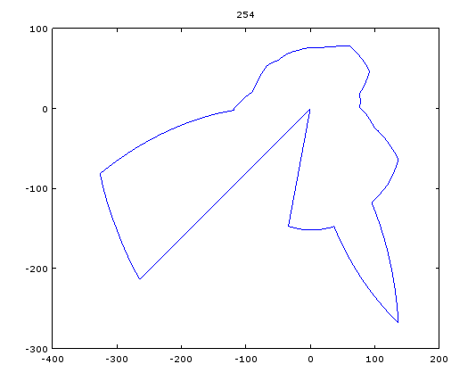 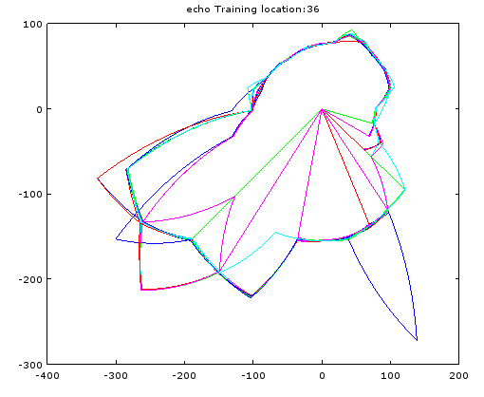

**Cartography**

Cartography is generated with Excel.

One sheet contains the zones used during the scan learning phase. It provides the (x,y) coordinates for each zone and will be stored in zonesXY.txt

Another sheet contains square (10x10cm must fit with the step size of AStarSearch.m) mapping of the room. For position (a,b) a value is set to describe the physical situation (0: free space, value from 1 to10 generates an increasing cost in order to avoid this square (used to find by the path search tool) , up to 10 means space not available). Export this sheet as cartoxx.txt (dos txt format)

Use createCartoMatrix(cartoxx) to create a 1cmx1cm extension of cartoxx.txt

Use createCartoImage(cartoxx) to create a 1cmx1cm image of cartoxx.txt