常见模板
第一段：总体描述图表，指明时间段，指出突出变化或不同
常用句型或短语：
As is clearly shown in the char/ table/graph, ___________
According to the figures given in the table/chart/graph, ____________
It can be seen from the table/chart/graph, _____________________.
The figures in the table/chart reflect that ________________.
especially, ________________（指出突出变化）
第二段：（分析原因）
There are several factors leading to this change / difference ……..
There are several reasons for _____________.(引出原因)
To begin with, _______(原因一)
In addition, ______________（原因二0
For example, _________（举例说明）
Last but not the least, __________（原因三）
To sum up——————————————（简要总结）
第三段：自己的观点
As for me, ____________
On the one hand, ________
on the other, ____
In brief，_____________________.
数据变化常用句型
表示逐句增长
The number of …. has grown steadily from … to…..in 2009.has risen from ….shows a tendency to increase /climbed /went sharply up/soared
/tends to go up b/ increase
There was a rapid / sharp / dramatic / gradual / slow increase / rise in the number of …. who…..
The number of …. is on the rise / increase.
The increase of …. has reached to ….
表示数据降低
The number of … dropped steadily from … to …in 2008./declined suddenly/fell/tends to go down/tendency to fall/shows a tendency to decrease
There was a sharp fall …. in the number of … in 2008./gradual decreas/sudden reduction/slow decline/drop
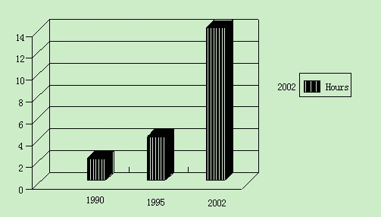
例文： Students Use of Computers
提纲： 1. 上图所示为某校大学生平均每周使用计算机的时间： 1990年（2 hours）, 1995年 (4 hours), 2002年 (14 hours)，请描述其变化；
2. 请说明发生这些变化的原因（可从计算机的用途、价格或社会发展等方面加以说明）；
3. 你认为目前大学生在计算机使用中有什么困难或问题。

Directions:
Study the following picture carefully and write an essay in which you should
1) describe the picture,
2) interpret its meaning, and
3) point out its implications in our life.
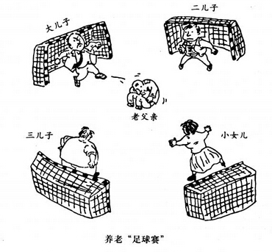
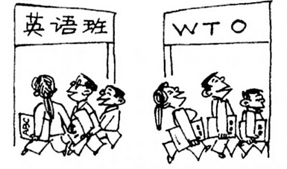
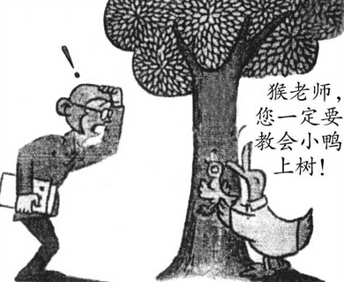

Student Use of Computers
As is clearly shown in the chart, the average number of hours a student spent on computers increased from two to four hours per week from 1990 to 1995. Especially, the number reached approximately 14 hour per week in 2002. Why are there such great changes during these days?
There are three factors leading to this phenomenon. Firstly, because of the sharp decline in the price of computers, most college students can afford oor surfing online is relaxing. To sum up, low price, easy ne. Secondly, the Internet provides access to various kinds of information students are interested in. Finally, playing computer games access to information and wide use make students use computers a lot.
As for me, computers do bring convenience to students; however, it is no good fro students to spend too much time chatting online or playing computer games. In brief, in spite of the problems concerning the use of computers, we can’t deny that computers are of more merits than defects.

Student Use of Computers
Using computers has become a common part of people’s life. And the tremendous growth of student use of computers has always aroused the greatest concern. What impresses us most is the number of hours students spend on computers. In 2002, they spend as many as 14 hours per week on computers.
The reasons why computers as widely used are varied. Among them, the decreasing price of PC plays an important part. What’s more, the Internet provides college students an amazing world to explore. For example, they can get the latest news and make friends conveniently around the world.
Whey talking about the disadvantages and problems existing in student use of computers, I think that their lack of skills and discipline is what should be paid attention to. On the one hand, the lack of skills fails students to make good use of the computer and the Internet. On the other hand, their lack of necessary discipline makes some students indulge in computer games and the net world, forgetting their major tasks as college students. In brief, there is still a lot to do to help students make good use of computers.
人生处处面临选择
This simple picture represents a situation that every person must face: when approaching a junction, which direction should one choose?
Most viewers can empathize with the sense of hesitation and uncertainty embodied in such an image. Without exception, everyone has to make choices in life, whether they concern school, career, or love. While some choices are simple, one cannot avoid the task of making difficult decisions.
Choices are often directly related to one's happiness. University students,for example, face a hard and crucial decision upon graduating. Many students have difficulty deciding whether to continue studying or begin developing a career. Every individual is different, and one must take the factors of one's personal life into consideration. In addition to an awareness of specific circumstances, however, making the right choice also depends on correct appraisal of oneself.
In order to choose correctly, therefore, one must be both realistic and self aware. Furthermore, once having made a decision, one should seriously accept and pursue the path one has chosen, and strive towards the realization of one's goal with spirit.
养老足球赛
As is depicted in the picture, a poor old man, rolling like a football, is kicked among his three sons and a daughter.Unwilling to be responsible for their father ,the daughter and sons spare no effort to kick the old man as far as possible.
We are irritated to see in the picture(建议放到句首或句末) the pathetic fact that these people go to any length to avoid surporting(拼写错误，改为supporting) their parents. Unfortunately, what we have seen in the picture isn't a rare phenomenon. However,what factor it is that results in this situation? (汉语式英语，改为what is the cause of this situation?)
For one thing, in my opinion, the decreased importance attached to the moral education contributes to the lack of ethnic conception,leading (建议改为定语从句，which leads)to the consequence that paople(拼写错误，改为people) don 't esteem and(改为or，肯定句中用and，否定句中用or) value their parents. For another, faced with the pressure of work and house installment, young people can hardly make ends meet, let alone taking good care of their old parents who is(改为are，定语从句的先行词为parents,从句中的谓语动词应用are) fragile to a sudden disease such as heart attack. There is no denying that further attention must be paid to the problem by the government. To handle this worsening situation, more money should be involed(拼写错误，改为involved) in the pension to guarantee the daily life of old people. In addition, instead of merely focusing on the scores, schools ought to put more stress on moral education.(结尾较为仓促，可适当添加总结性的话语)

充电学习
There is no doubt that the two cartoons vividly demonstrate a positive and ubiquitous scenario in modern society: increasing number of people go to miscellanelous(拼写错误，改为miscellaneous) training programs. A majority of people, with smile on faces, swarm into English classes and attend the lectures about WTO. What is conveyed(建议改为conveys) by the drawings is both inspiring and illuminating. What might account for this mushrooming phenomenon? Several points analyzed below may equip us with deeper comprehending of what we head for. First things first, the rapid development of economy has been accompanied with a corresponding of fierce competition. Therefore, many people prefer to attend some lectures about their careers, in the desire to(改为and want to,文中in the desire to表示“在欲望中建立”) keep abreast of the latest development of technology. In addition, the constant international communication stimulates people to endeavor themselves to learn something which is beyond their majors, thus subjecting the increasing challenges to their own minds(改为thus they may challenge themselves and broaden their knowledge). Last but not least, the desire for studying signifies the pursuit of individuality. From what has been mentioned above, we can safely conclude that if we are ever going to survive(加in) the harsh society, we must persist in learning new skills and knowledge. Only in this way can make us(改为we make ourselves to be) perfect candidates for a promising future.

