# Question 1:

Longest DASH Winner:  
bottommost

# Question 2:

Longest DOT Winner:  
mississippi  
mississippian

# Question 3

See my code;

# Question 4

233.4

# Question 5

"What hath God wrought!"

你造吗?

between Washington, D.C., and Baltimore, Maryland, about 41 miles…

$500,000

# Question 6

2333.3333km

# Question 7

眼睛不好使，反正就是1，2，3个0 和1，2，3个1的组合，最后再查书….

# Question 8

2100762118.9853

# Question 9

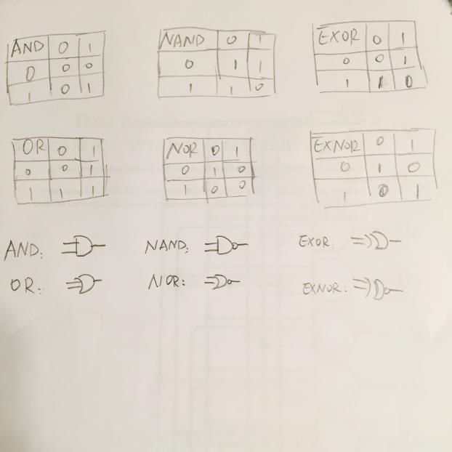

# Question 10

**B**

# Question 11

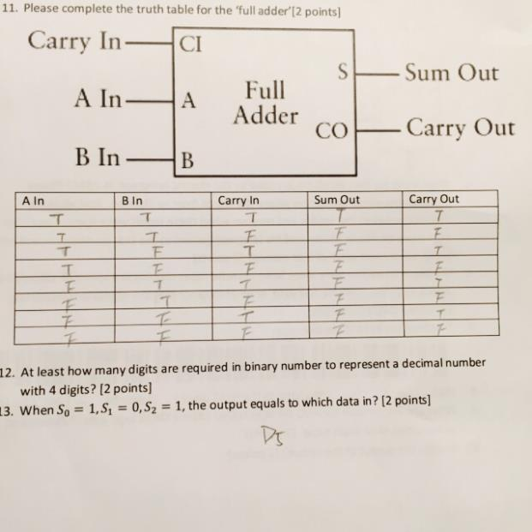

# Question 12

16

# Question 13

**D5**

# question 14

**O5**

# Question 15

**E**

# Question 16

�=l9�1�@�*

# Question 17

32-bit float: 23

64-bit double: 52

# Question 18

160Hz