算法设计与分析

寻找平面上距离最短的点实验报告

# 一、算法设计

## 1、O(n2)算法

遍历每个点与其他所有点的距离，选择最近的距离

|  |
| --- |
| for i := 0 to N-1  for j:=i to N-1  if distance(points[i], points[j]) < minDistance  minDistance := distance(points[i], points[j])  end  end |

## 2、O(nlgn)算法

使用分治法的思想，将平面分为两个部分，分解为两个子问题，在进行合并，算法的思路是：

1. 将所有点按照x值排序，并划分为（start,(start+end)/2）和（(start+end)/2,end）两个部分
2. 使用分治法计算这两个部分的最短距离，记为minHalf
3. 考虑最短的两个点分别在这两个区域的情况，以（1）中划分点的中线half为基础，分别取half-minHalf和half+minHalf两条边界，将中间部分的点存到临时空间。
4. 将临时空间的点按y轴排序，从小到大开始检查与临时空间其余每个点的距离，如果检查点数超过7或两点的y轴距离大于最小距离则终止。
5. 比较（4）中的最小距离minMiddleDistance与minHalf，选择min(minMiddleDistance, minHalf)为最终的最小距离。

|  |
| --- |
| sort(points, compareX)  function minDistance(start, end):  if end-start==0  return INF  else if end-start==1  return distance(points[start], points[end])  minLeft := minDistance(start, (start+end)/2)  minRigth := minDistance(start, (start+end)/2)  minHalf := min(minLeft, minRight)  for i:=start to end  if abs(points[i].x-points[half].x) < minHalf  then middlePoints.add(points[i])  end  sort(middlePoints, compareY)  for i := 0 to N-1  for j:=i+1 to i+7  if middlePoints[j].y-middlePoints[i].y > minHalf  then break  if distance(points[i], points[j]) < minDistance  then minDistance := distance(points[i], points[j])  end  end  return min(minDistance, minHalf) |

# 二、实验设计

## 1、实验环境

Java 1.8

Windows 10 64位， CPU i7-8700

## 2、实验界面

### 2.1 画布界面

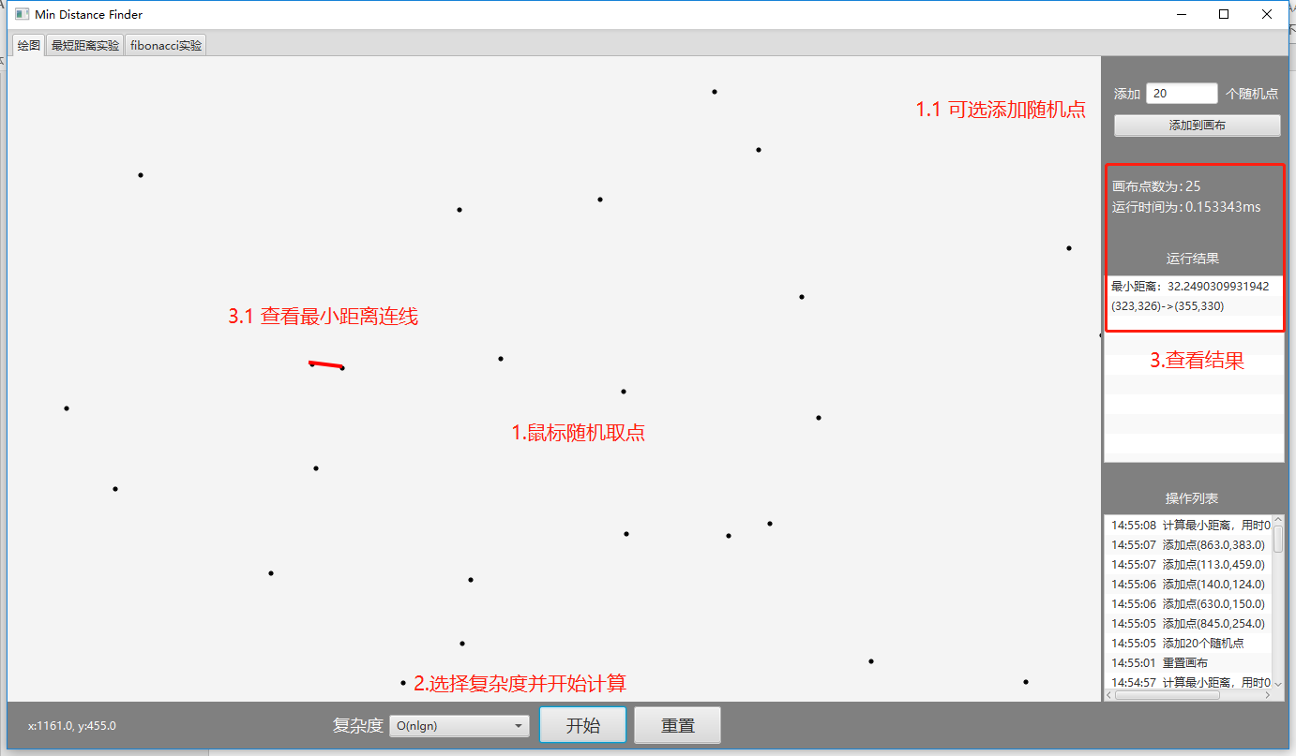

画布界面可以用鼠标在画布上选择随机点，也可选添加随机生成的点。选择复杂度并计算后会显示最小两点距离的连线。

生成随机点与鼠标画点可以以任意顺序进行

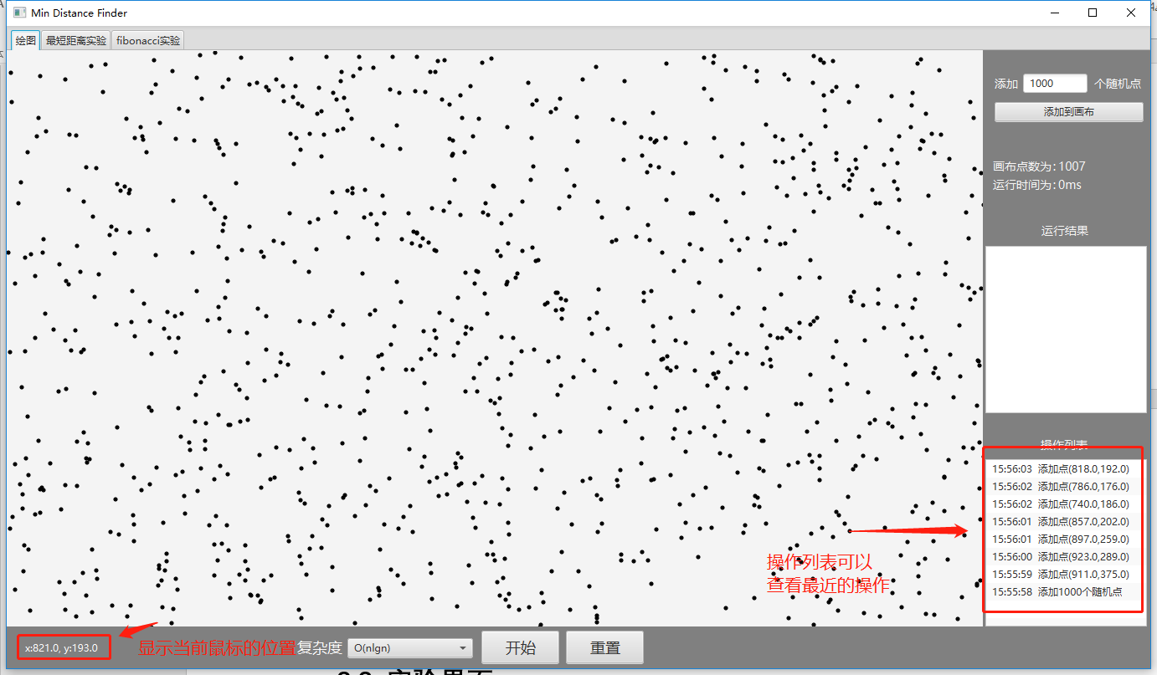

### 2.2 实验界面

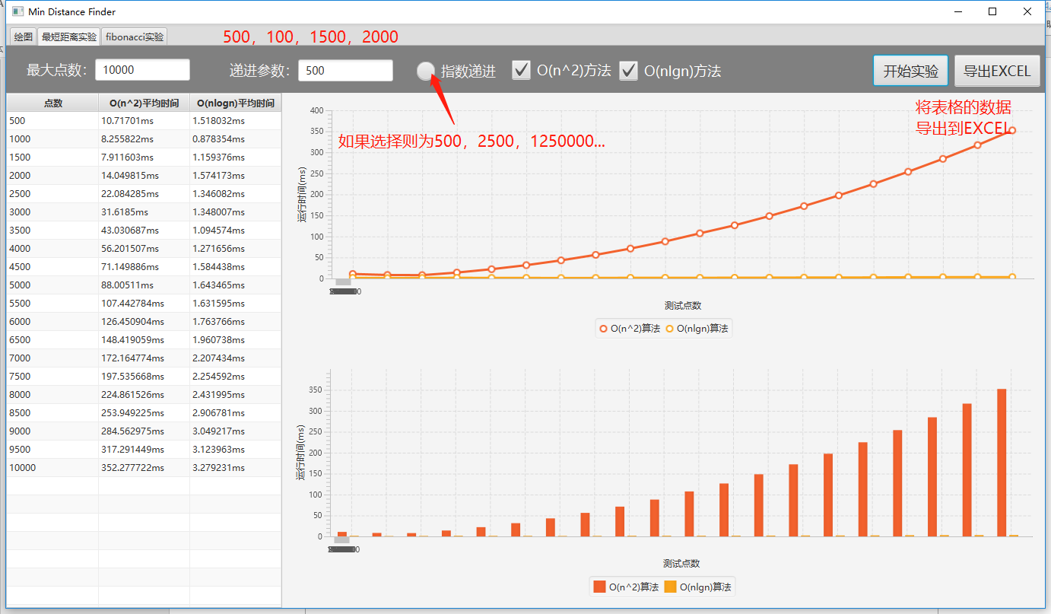

实验界面可以比较不同方法的执行时间，最大点数限制了递进的最大范围，选择指数递进则将递进方式由加法变为指数，由于O(n2)方法后期太慢影响实验，也可以只对O(nlgn)方法进行实验。

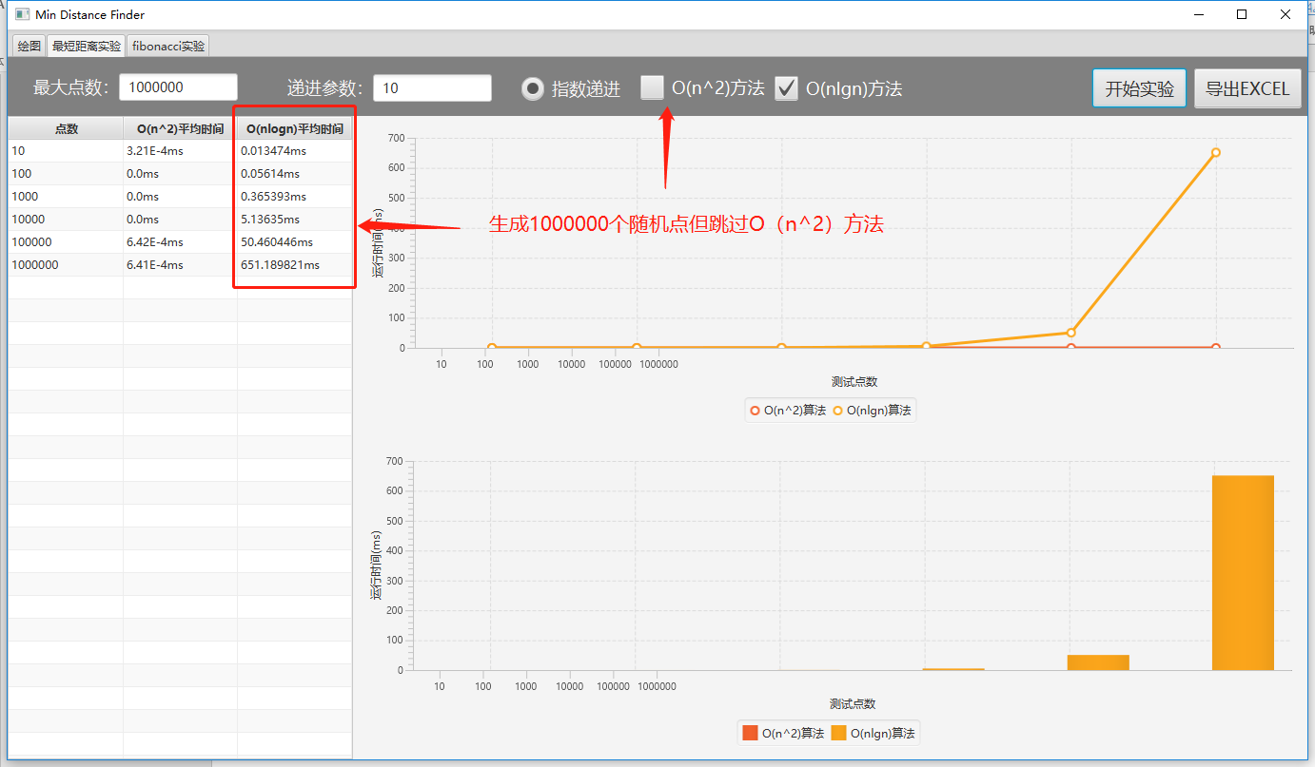

可以将实验的结果导出到Excel以备后续分析

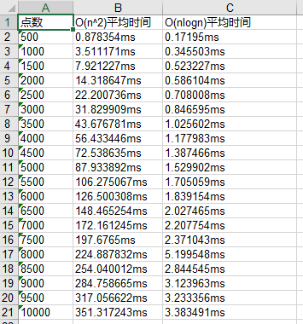

# 三、实验结果

## 1、运行时间的对比

|  |  |  |
| --- | --- | --- |
| 点数 | O(n^2)时间 | O(nlogn)时间 |
| 10 | 0.002567ms | 0.005453ms |
| 20 | 0.001924ms | 0.003529ms |
| 30 | 0.003208ms | 0.006095ms |
| 40 | 0.005774ms | 0.018607ms |
| 50 | 0.008983ms | 0.008982ms |
| 60 | 0.012512ms | 0.011228ms |
| 70 | 0.017003ms | 0.012832ms |
| 80 | 0.022456ms | 0.014757ms |
| 90 | 0.028551ms | 0.017002ms |
| 100 | 0.034967ms | 0.017965ms |
| 1000 | 3.529136ms | 0.26434ms |
| 2000 | 14.092802ms | 0.534455ms |
| 3000 | 31.672074ms | 0.854936ms |
| 4000 | 56.215301ms | 1.146223ms |
| 5000 | 87.843426ms | 1.528618ms |
| 6000 | 126.651405ms | 1.826964ms |
| 7000 | 173.072962ms | 2.169579ms |
| 8000 | 224.972524ms | 2.542029ms |
| 9000 | 284.700599ms | 2.960355ms |
| 10000 | 351.4924ms | 3.378038ms |
| 20000 | 1405.664839ms | 7.522149ms |
| 30000 | 3164.562103ms | 14.743388ms |
| 40000 | 5624.246037ms | 16.780156ms |
| 50000 | 8788.42799ms | 21.447815ms |
| 100000 | 35274.818314ms | 46.101718ms |
| 500000 |  | 302.246598ms |
| 1000000 |  | 704.853789ms |
| 5000000 |  | 6632.300716ms |

10到100的折线图为：

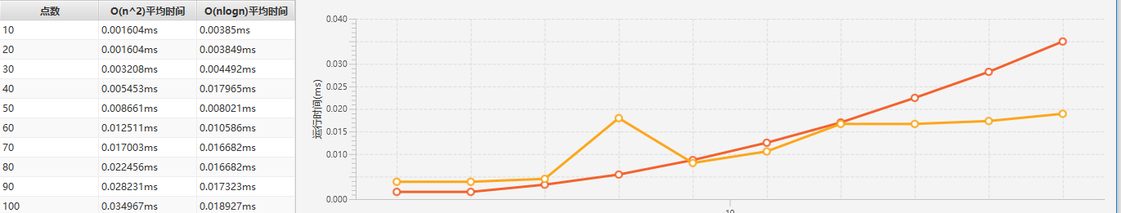

1000到10000的折线图为

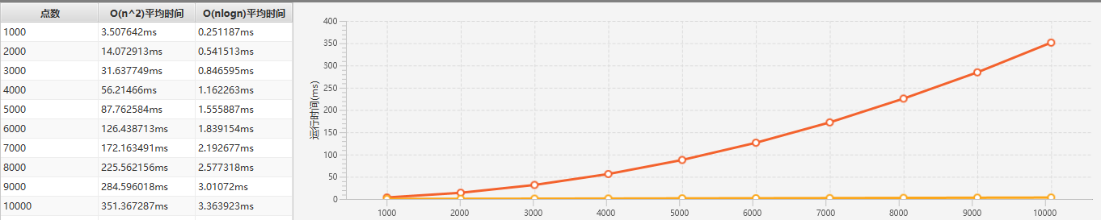

## 2、实验结果

在点数小于50时，O(nlgn)算法由于本身的代码复杂性，运行时间大于循环查找暴力求解的方法，在点数为50~70之间两种方法运行时长相似，但在这之后分治法方法的运行时间则小于暴力求解方法的时间，两者运行时间的差距不断扩大，在点数超过100000时包里求解的方法已经过长而没有统计必要，运行时间大约为35s，而此时分治法的运行时间只有46ms，在5000000个点的情况下分治法的运行时间为6632ms，仍然在可以接受的范围。

# 四、关键代码

分治法的核心代码如下：

|  |
| --- |
| //在分治开始之前对points所有点进行排序  private Comparator<Point> xCompare = Comparator.comparingInt(o -> o.x);  private DistanceResult divideDistance() {  long start = System.nanoTime();  points.sort(xCompare);  DistanceResult result = divideDistance(0, points.size()-1);  long end = System.nanoTime();  result.setTime(end-start);  return result;  }  //分治法主方法  private DistanceResult divideDistance(int start, int end) {  double minDistance = Double.MAX_VALUE;  List<Pair<Point,Point>> result = new ArrayList<>();  if (end - start == 0) {  return new DistanceResult(result, minDistance);  }  if (end - start == 1) {  result.add(new Pair<>(points.get(start),points.get(end)));  return new DistanceResult(result, distance(points.get(start),points.get(end)));  }  //划分左右  int half = (end+start)>>1;  DistanceResult resultLeft = divideDistance(start, half);  DistanceResult resultRight = divideDistance(half, end);  //划分中间分区  double minHalf = Math.min(resultLeft.getMinDistance(), resultRight.getMinDistance());  List<Point> middlePoints = new ArrayList<>();  for (int i = start; i < end; i++) {  if (Math.abs(points.get(i).x - points.get(half).x) < minHalf)  middlePoints.add(points.get(i));  }  //计算中间分区的距离最小值  double minMiddleDistance = Double.MAX_VALUE;  List<Pair<Point,Point>> middleResult = new ArrayList<>();  if (middlePoints.size() > 1 ) {  middlePoints.sort(yCompare);  for (int i = 0; i < middlePoints.size(); i++) {  for (int j = i+1; j < middlePoints.size() && j < i+8; j++) {  if (middlePoints.get(j).y-middlePoints.get(i).y>minHalf) break;  double distance = distance(middlePoints.get(i), middlePoints.get(j));  if (distance < minMiddleDistance) {  middleResult.clear();  middleResult.add(new Pair<>(middlePoints.get(i), middlePoints.get(j)));  minMiddleDistance = distance;  } else if (distance == minMiddleDistance) {  middleResult.add(new Pair<>(middlePoints.get(i), middlePoints.get(j)));  }  }  }  }  DistanceResult resultMiddle = new DistanceResult(middleResult, minMiddleDistance);  //合并结果  if (resultLeft.getMinDistance() < resultRight.getMinDistance()) {  minDistance = resultLeft.getMinDistance();  result = resultLeft.getPoints();  } else if (resultLeft.getMinDistance() == resultRight.getMinDistance()) {  minDistance = resultLeft.getMinDistance();  result = resultLeft.getPoints();  result.removeAll(resultRight.getPoints());  result.addAll(resultRight.getPoints());  } else {  minDistance = resultRight.getMinDistance();  result = resultRight.getPoints();  }  if (minDistance == resultMiddle.getMinDistance()) {  result.removeAll(resultMiddle.getPoints());  result.addAll(resultMiddle.getPoints());  } else if (minDistance > resultMiddle.getMinDistance()) {  minDistance = resultMiddle.getMinDistance();  result = resultMiddle.getPoints();  }  return new DistanceResult(result, minDistance);  } |