## 词法单元

ID, INT, DOUBLE, KEYWORD, OPERATOR, SEPARATOR

(注释？后面有空再试试)

## 正则表达式

<digit> -> 0|1|2|3|4|5|6|7|8|9

<letter>->a|b|c|d|e|f|g|h|i|j|k|l|m|n|o|p|q|r|s|t|u|v|w|x|y|z

定义：

ID -> <letter> (<letter> | <digit> ) *

INT -> <digit><digit>*

DOUBLE -> <digit><digit>* . <digit><digit>*

OPERATOR -> [ | ] | ~ | ( | ) | ? | ^ | % | * | / | . | ’| ”| : | + | - | < | > | = | ! | & | \| | += | -= | <= | >= | != | && | \|\| |<< | >> | ++ | --

SEPARATOR -> ; | { | }

## 合并NFA

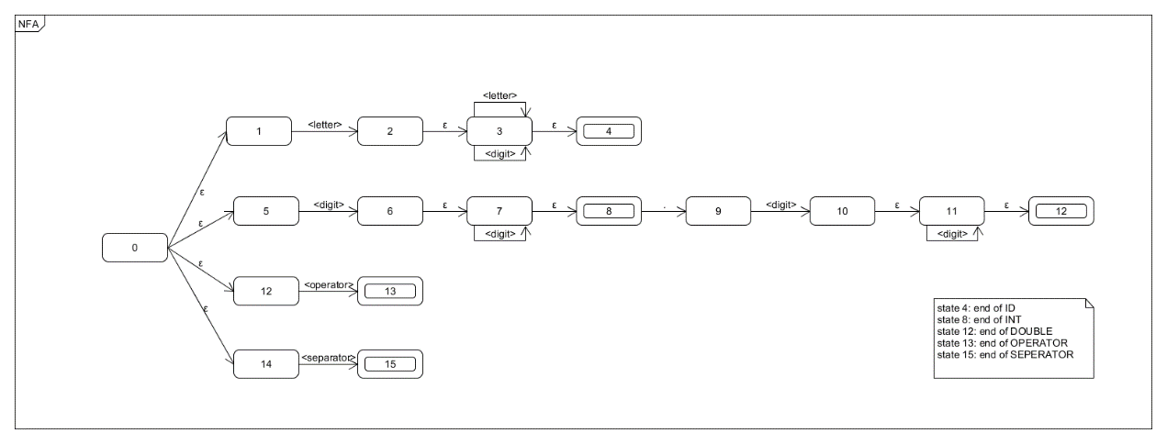

## NFA->DFA

|  |  |  |  |  |  |
| --- | --- | --- | --- | --- | --- |
| Ii | <letter> | <digit> | <operator> | <separator> | . |
| I0={0,1,5,12,14} | ε-c({2})=I1 | ε-c({6})=I2 | ε-c({13})=I3 | ε-c({15})=I4 | Ø |
| I1={2,3,4} | ε-c({3})=I5 | ε-c({3})=I5 | Ø | Ø | Ø |
| I2={6,7,8} | Ø | ε-c({7})=I6 | Ø | Ø | ε-c({9})=I7 |
| I3={13} | Ø | Ø | Ø | Ø | Ø |
| I4={15} | Ø | Ø | Ø | Ø | Ø |
| I5={3,4} | ε-c({3})=I5 | ε-c({3})=I5 | Ø | Ø | Ø |
| I6={7,8} | Ø | ε-c({7})=I6 | Ø | Ø | ε-c({9})=I7 |
| I7={9} | Ø | ε-c({10})=I8 | Ø | Ø | Ø |
| I8={10,11,12} | Ø | ε-c({11})=I9 | Ø | Ø | Ø |
| I9={11,12} | Ø | ε-c({11})=I9 | Ø | Ø | Ø |

## DFA优化

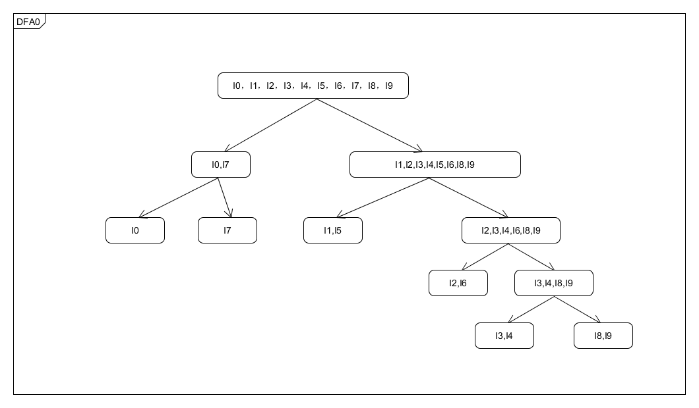

## DFA模型

