

语法分析实验报告

141250019 崔浩



2016-10-25

南京大学软件学院

目录

1. 实验目的 2

2. 内容概述 2

3. 思路方法 2

4. 语言定义 2

4.1 保留字 2

4.2 操作符 3

4.3 分隔符 3

4.4 标识符 4

4.5 数值 4

5. 相关FA描述 4

5.1 合并后的NFA 4

5.2 转换为DFA 4

5.3 优化DFA 5

5.4 DFA模型 6

6. 重要数据结构 6

7. 核心算法描述 7

8. 困难与解决方案 9

9. 测试用例 10

10. 总结 11

# 实验目的

本实验的目的是自己编写一个词法分析程序，对自定义的程序语言进行词法分析，并输出分析完成后的Token序列。

# 内容概述

本报告描述了编写词法分析程序的过程，包括语言词法的正则表达式定义，生成的NFA，转化的DFA及DFA优化。此外，报告描述了程序的主要数据结构和核心算法，以及最终产品的输入输出示例。

# 思路方法

1. 定义各个类别的正则表达式
2. 写出每个正则表达式对应的NFA
3. 合并NFA
4. 将合并的NFA转化为DFA
5. 优化DFA
6. 根据DFA生成词法分析程序

# 语言定义

## 保留字

|  |  |  |  |
| --- | --- | --- | --- |
| 类别 | 保留字 | 类别 | 保留字 |
| KEYWORD_0 | abstract | **KEYWORD_1** | assert |
| KEYWORD_2 | boolean | **KEYWORD_3** | break |
| KEYWORD_4 | byte | **KEYWORD_5** | case |
| KEYWORD_6 | catch | **KEYWORD_7** | char |
| KEYWORD_8 | class | **KEYWORD_9** | const |
| KEYWORD_10 | continue | **KEYWORD_11** | default |
| KEYWORD_12 | do | **KEYWORD_13** | double |
| KEYWORD_14 | else | **KEYWORD_15** | enum |
| KEYWORD_16 | extends | **KEYWORD_17** | final |
| KEYWORD_18 | finally | **KEYWORD_19** | float |
| KEYWORD_20 | for | **KEYWORD_21** | goto |
| KEYWORD_22 | if | **KEYWORD_23** | implements |
| KEYWORD_24 | import | **KEYWORD_25** | instanceof |
| KEYWORD_26 | int | **KEYWORD_27** | interface |
| KEYWORD_28 | long | **KEYWORD_29** | native |
| KEYWORD_30 | new | **KEYWORD_31** | package |
| KEYWORD_32 | private | **KEYWORD_33** | protected |
| KEYWORD_34 | public | **KEYWORD_35** | return |
| KEYWORD_36 | strictfp | **KEYWORD_37** | short |
| KEYWORD_38 | static | **KEYWORD_39** | super |
| KEYWORD_40 | switch | **KEYWORD_41** | synchronized |
| KEYWORD_42 | this | **KEYWORD_43** | throw |
| KEYWORD_44 | throws | **KEYWORD_45** | transient |
| KEYWORD_46 | try | **KEYWORD_47** | void |
| KEYWORD_48 | volatile | **KEYWORD_49** | while |

## 操作符

|  |  |  |  |
| --- | --- | --- | --- |
| 类别 | 操作符 | 类别 | 操作符 |
| OPERATOR_0 | = | **OPERATOR_1** | + |
| OPERATOR_2 | - | **OPERATOR_3** | * |
| OPERATOR_4 | / | **OPERATOR_5** | % |
| OPERATOR_6 | > | **OPERATOR_7** | < |
| OPERATOR_8 | & | **OPERATOR_9** | | |
| OPERATOR_10 | ! | **OPERATOR_11** | ? |
| OPERATOR_12 | : | **OPERATOR_13** | += |
| OPERATOR_14 | -= | **OPERATOR_15** | *= |
| OPERATOR_16 | /= | **OPERATOR_17** | != |
| OPERATOR_18 | >= | **OPERATOR_19** | <= |
| OPERATOR_20 | << | **OPERATOR_21** | >> |
| OPERATOR_22 | == | **OPERATOR_23** | && |
| OPERATOR_24 | || |  |  |

## 分隔符

|  |  |  |  |
| --- | --- | --- | --- |
| 类别 | 分隔符 | 类别 | 分隔符 |
| SEPARATOR_0 | ; | **SEPARATOR_1** | { |
| SEPARATOR_2 | } | **SEPARATOR_3** | [ |
| SEPARATOR_4 | ] | **SEPARATOR_5** | ( |
| SEPARATOR_6 | ) | **SEPARATOR_7** | , |

## 标识符

<digit> -> 0|1|2|3|4|5|6|7|8|9

<letter>->a |b |c |d |e |f |g |h |i |j |k |l |m |n |o | p |q |r |s |t |u |v |w | x |y |z

|  |  |
| --- | --- |
| 类别 | 正则表达式 |
| ID | <letter> (<letter> | <digit> ) * |

## 数值

|  |  |
| --- | --- |
| 类别 | 正则表达式 |
| INT | <digit><digit>* |
| DOUBLE | <digit><digit>*. <digit><digit>* |

# 相关FA描述

## 合并后的NFA

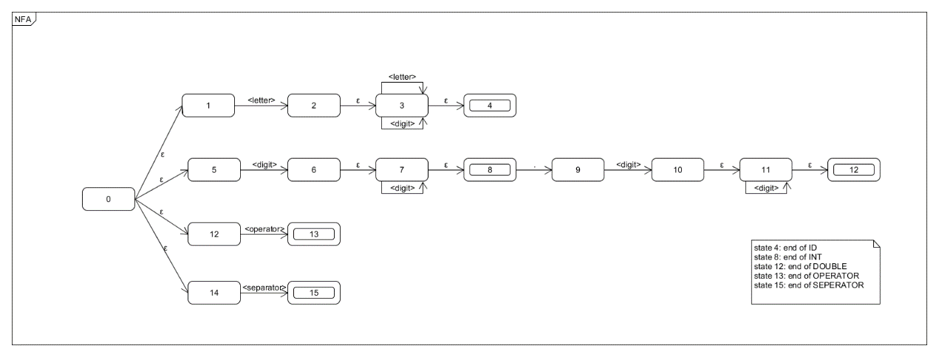

## 转换为DFA

|  |  |  |  |  |  |
| --- | --- | --- | --- | --- | --- |
| Ii | <letter> | <digit> | <operator> | <separator> | . |
| I0={0,1,5,12,14} | ε-c({2})=I1 | ε-c({6})=I2 | ε-c({13})=I3 | ε-c({15})=I4 | Ø |
| I1={2,3,4} | ε-c({3})=I5 | ε-c({3})=I5 | Ø | Ø | Ø |
| I2={6,7,8} | Ø | ε-c({7})=I6 | Ø | Ø | ε-c({9})=I7 |
| I3={13} | Ø | Ø | Ø | Ø | Ø |
| I4={15} | Ø | Ø | Ø | Ø | Ø |
| I5={3,4} | ε-c({3})=I5 | ε-c({3})=I5 | Ø | Ø | Ø |
| I6={7,8} | Ø | ε-c({7})=I6 | Ø | Ø | ε-c({9})=I7 |
| I7={9} | Ø | ε-c({10})=I8 | Ø | Ø | Ø |
| I8={10,11,12} | Ø | ε-c({11})=I9 | Ø | Ø | Ø |
| I9={11,12} | Ø | ε-c({11})=I9 | Ø | Ø | Ø |

## 优化DFA

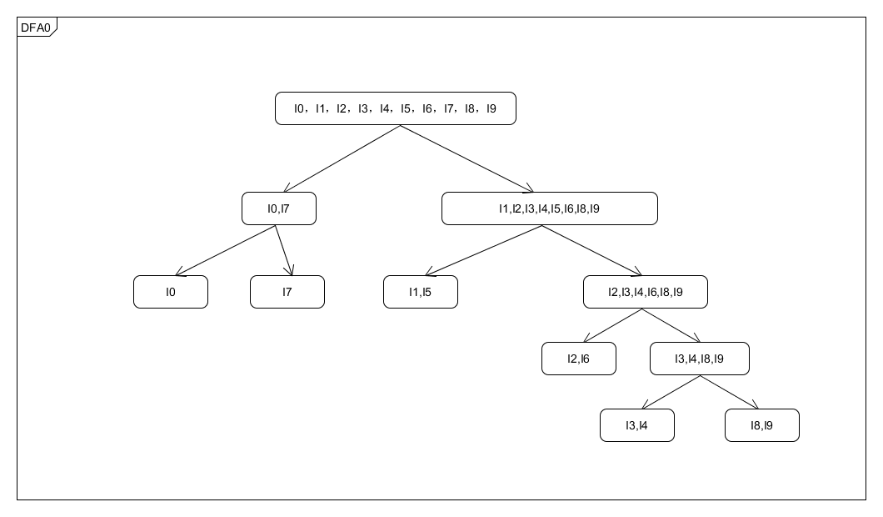

## DFA模型

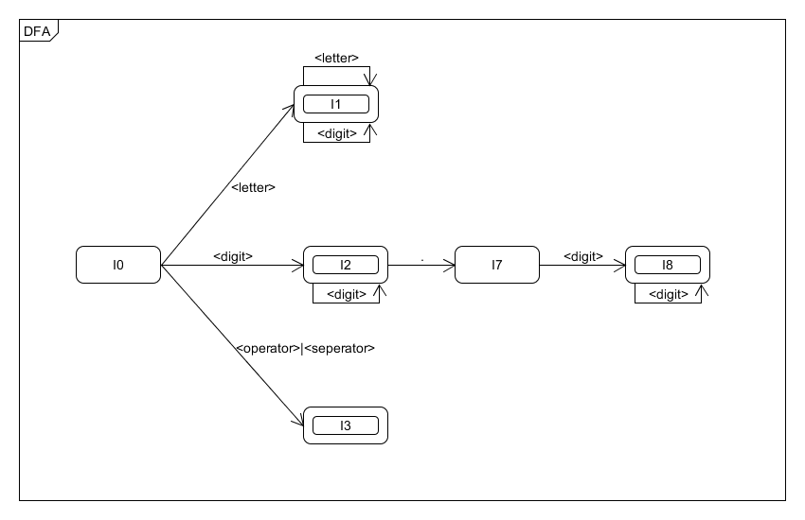

# 重要数据结构

用Catalog枚举表示大类。

|  |
| --- |
| **public enum** Catalog {  ***KEYWORD***,***ID***,***INT***,***DOUBLE***,***OPERATOR***,***SEPARATOR*** } |

用Token类描述生成的Token，并标注所属大类的具体类别。

|  |
| --- |
| **public class** Token {**private** Catalog **catalog**; **private** String **lexeme**;**private int index**;   **public** Token(Catalog catalog, String lexeme, **int** index) {  **this**.**catalog** = catalog;  **this**.**lexeme** = lexeme;  **this**.**index** = index;  }  **public** Catalog getCatalog() {  **return catalog**;  }  **public void** setCatalog(Catalog catalog) {  **this**.**catalog** = catalog;  }  **public** String getLexeme() {  **return lexeme**;  }  **public void** setLexeme(String lexeme) {  **this**.**lexeme** = lexeme;  } } |

State枚举类对应DFA中的状态。

|  |
| --- |
| **public enum** State {  ***STATE_0***,***STATE_1***,***STATE_2***,***STATE_3***,***STATE_4***,***STATE_5*** } |

# 核心算法描述

Analyzer类是本程序的核心算法，其中的lexicalAnalyze()方法是核心方法。程序每读入一个字符时会判断状态机当前所处的状态，根据不同的状态做状态转换、异常识别或输出成立的Token。

|  |
| --- |
| **public void** lexicalAnalyze() {  String line = **""**;  **while** ((line = **ioHelper**.nextLine()) != **null**) {  **int** index = 0;  String tempWord = **""**;  State state = State.***STATE_0***;  **while** (index < line.length()) {  **char** current = line.charAt(index);  **switch** (state){  **case *STATE_0***:  **if** (Constant.*isDigit*(current)) {  state = State.***STATE_2***;  tempWord += current;  } **else if** (Constant.*isLetter*(current)) {  state = State.***STATE_1***;  tempWord += current;  } **else if** (Constant.*isOperator*(current+**""**)>=0) {  state = State.***STATE_3***;  tempWord += current;  } **else if** (Constant.*isSeparator*(current)>=0) {  state = State.***STATE_3***;  tempWord += current;  }  **break**;  **case *STATE_1***:  **if** (Constant.*isDigit*(current)) {  tempWord += current;  } **else if** (Constant.*isLetter*(current)) {  tempWord += current;  } **else** {  index--;  state = State.***STATE_0***;  **if** (Constant.*isKeyword*(tempWord)>=0) {  addToken(tempWord, Catalog.***KEYWORD***, Constant.*isKeyword*(tempWord));  } **else** {  addToken(tempWord, Catalog.***ID***, -1);  }  tempWord = **""**;  }  **break**;  **case *STATE_2***:  **if** (Constant.*isDigit*(current)) {  tempWord += current;  } **else if** (current==**'.'**) {  tempWord += current;  state = State.***STATE_4***;  } **else** {  index--;  state = State.***STATE_0***;  addToken(tempWord, Catalog.***INT***, -1);  tempWord = **""**;  }  **break**;  **case *STATE_3***:  **char** su = tempWord.charAt(0);  **if** (((su==**'+'**||su==**'-'**||su==**'*'**||su==**'/'**||su==**'<'**||su==**'>'**||su==**'!'**||su==**'='**) && current==**'='**)  || ((su==**'|'** && current==**'|'**)||(su==**'&'** && current==**'&'**)||(su==**'<'** && current==**'<'**)||(su==**'>'** && current==**'>'**))) {  addToken(tempWord+current, Catalog.***OPERATOR***, Constant.*isOperator*(tempWord+current));  }**else** {  index--;  **if** (Constant.*isOperator*(tempWord)>=0) {  addToken(tempWord, Catalog.***OPERATOR***, Constant.*isOperator*(tempWord));  } **else** {  addToken(tempWord, Catalog.***SEPARATOR***, Constant.*isSeparator*(tempWord.charAt(0)));  }  }  state = State.***STATE_0***;  tempWord = **""**;  **break**;  **case *STATE_4***:  **if** (Constant.*isDigit*(current)) {  state = State.***STATE_5***;  tempWord += current;  } **else** {  System.***out***.println(**"error: state 4"**);  }  **break**;  **case *STATE_5***:  **if** (Constant.*isDigit*(current)) {  tempWord += current;  } **else** {  index --;  state = State.***STATE_0***;  addToken(tempWord, Catalog.***DOUBLE***,-1);  tempWord=**""**;  }  **break**;  }  index++;  }  //这里的内容在后面说明 } |

# 困难与解决方案

1. **回退处理**

在当前状态无法继续，并且输入的字符并没有进入异常处理时，程序会将当前指针回退一个字符，代表当前状态终止，清空缓存的字符，并置状态为初始状态。

index--;  
state = State.***STATE_0***;

//根据不同的状态选择输出不同的Token  
tempWord = **""**;

1. **末尾处理**

在读取一行结束时，因为没有触发下一次的回退处理，可能会导致到一行的最后一个字符结束没有处理当前Token的问题，因此在每行循环的末尾都要判断一下状态，如果是终止状态则要处理当前缓存的字符。

**switch** (state) {  
 **case *STATE_1***:  
 **if** (Constant.*isKeyword*(tempWord)>=0) {  
 addToken(tempWord, Catalog.***KEYWORD***, Constant.*isKeyword*(tempWord));  
 } **else** {  
 addToken(tempWord, Catalog.***ID***, -1);  
 }  
 **break**;  
 **case *STATE_2***:  
 addToken(tempWord, Catalog.***INT***, -1);  
 **break**;  
 **case *STATE_3***:  
 **if** (tempWord.length()>0) {  
 **if** (Constant.*isOperator*(tempWord)>=0) {  
 addToken(tempWord, Catalog.***OPERATOR***, Constant.*isOperator*(tempWord));  
 } **else** {  
 addToken(tempWord, Catalog.***SEPARATOR***, Constant.*isSeparator*(tempWord.charAt(0)));  
 }  
 }  
 **break**;  
 **case *STATE_5***:  
 addToken(tempWord, Catalog.***DOUBLE***,-1);  
 **break**;  
}

# 测试用例

输入程序（在/source_code/testFile文件夹下）：

public class Main() {

public static void main (String[] args) {

int a = 10;

a += 10;

double b = 123.45;

if (a == 20) {

a >> 2;

}

System.out.println(10 * 123.45 + 12 - a * b);

}

}

输出截图：

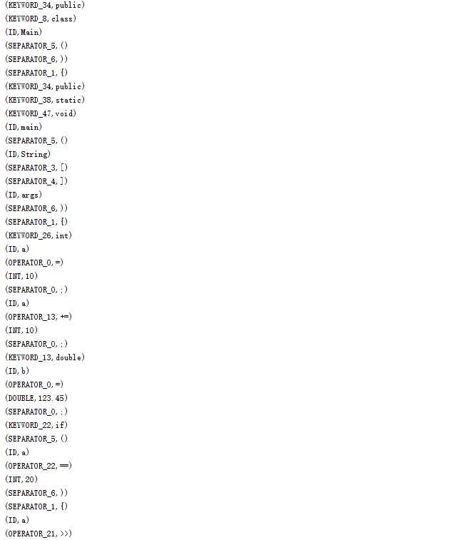

# 总结

通过这次实验，我对词法分析的过程有了更深入的认识，通过自己看书和查阅资料，我锻炼了自己分析问题和解决问题的能力，为今后语法分析打下基础。