Hotel Booking Customer Retention and Dynamic Pricing Analysis
Week 3 Report
Power BI Dashboard Development
Prepared by:
Ishwarya A
Tools Used:
- Power BI Desktop
- Python
- SQL
- Git & GitHub

1. Introduction
The third phase of the Hotel Booking Customer Retention and Dynamic Pricing Analysis project focused on developing an interactive Power BI dashboard. The objective was to transform the cleaned dataset into meaningful visualizations that enable stakeholders to monitor booking performance, customer behavior, cancellation trends, and pricing metrics.
The dashboard was designed to provide a single-page executive view that supports data-driven decision-making through interactive filtering and clear business insights.

2. Objectives
The primary objectives of the dashboard development phase were to:
- Develop an interactive executive dashboard using Power BI.
- Present key hotel booking metrics through KPI cards.
- Visualize booking trends across different months.
- Compare performance between City Hotels and Resort Hotels.
- Analyze cancellation behavior.
- Support business decision-making through visual insights.

3. Dashboard Development Process
The dashboard development followed a structured approach to ensure accuracy, usability, and business relevance.
Data Preparation
The cleaned hotel booking dataset was imported into Power BI Desktop. Data types were validated, calculated columns were reviewed, and relationships between tables were established where necessary.
Data Modeling
A separate Month Dimension table was created to correctly sort the arrival month names in chronological order. This resolved the default alphabetical sorting issue and ensured that monthly trend visualizations displayed January through December correctly.
Dashboard Design
The dashboard was designed using a clean executive layout with KPI cards at the top, analytical charts in the center, slicers for user interaction, and a Business Insights section to summarize key findings.

4. Dashboard Components
The dashboard includes the following analytical components:
KPI Cards
Five KPI cards provide a quick summary of key business metrics:
- Total Bookings
- Total Revenue
- Average Daily Rate (ADR)
- Total Guests
- Cancellation Rate
These indicators provide management with an immediate overview of hotel performance.
Visualizations
The dashboard includes:
- Monthly Booking Trend (Line Chart)
- Hotel Type Comparison (Bar Chart)
- Cancellation Distribution (Donut Chart)
Each visualization was selected to communicate information clearly while supporting interactive analysis.
Interactive Slicers
Three slicers allow users to dynamically filter dashboard results based on different booking dimensions, enabling customized exploration of the data.

5. Dashboard Design Decisions
Several design considerations were implemented to improve usability:
- Consistent color scheme across all visuals.
- Executive-style layout for easy interpretation.
- Proper alignment of charts and KPI cards.
- Chronological month sorting using a Month Dimension table.
- Business Insights section for management-focused interpretation.
These improvements enhance readability and support faster decision-making.

6. Dashboard Preview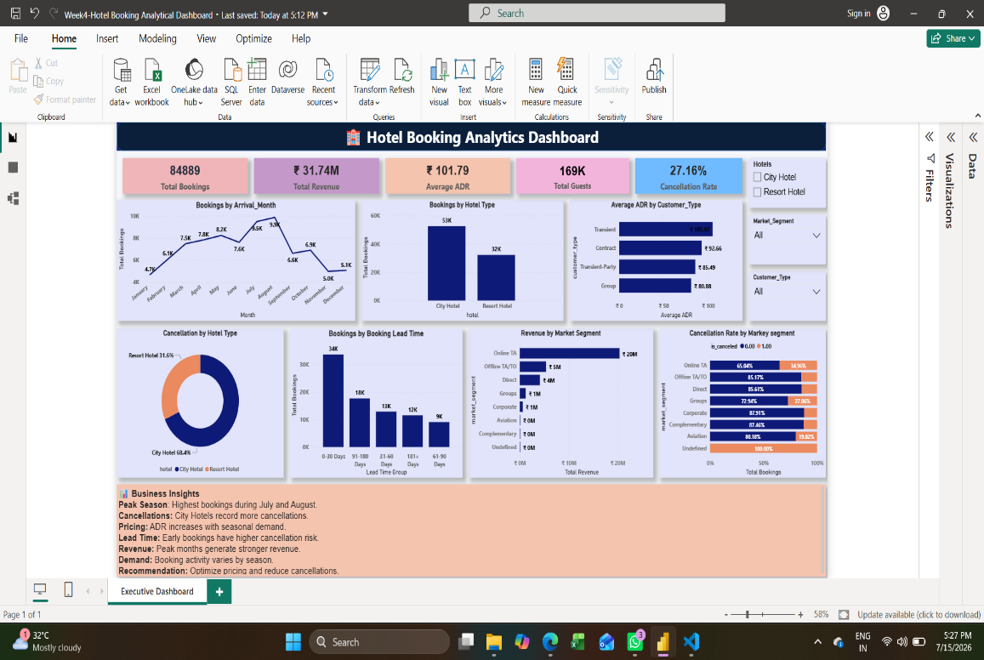
Hotel Booking Executive Dashboard

7. Conclusion
The Week 3 dashboard successfully transformed hotel booking data into an interactive business intelligence solution. The use of KPI cards, analytical charts, slicers, and business-focused design principles enables stakeholders to monitor booking trends, evaluate cancellation behavior, and assess hotel performance efficiently.
The dashboard serves as a foundation for generating strategic business insights and recommendations, which are presented in the Week 4 report.

