FOURHAND
TENNIS CLUB

Booking Web App
Development Plan & Product Documentation
Version | 1.0 · Draft for review
Date | 16 June 2026
Product | Court booking + events platform (custom build)
Status | Planning / pre-development

Contents

1. Introduction & Purpose
This document is the single source of truth for the Fourhand Tennis Club web application. It defines the product vision, the landing experience, the booking system and its interactive court visualisation, the events module, the notification/mailing service, the admin controls, the design and motion language, the technical approach, and a phased development plan.
It is written to be handed directly to a designer and a development team. Each section pairs intent ("why") with concrete specification ("what to build"), so the team can estimate, design, and implement without guesswork.
In one sentence: Fourhand Tennis Club is a visually rich, fast booking app where a player can go from landing page to a confirmed court in three taps, with classes and competitions available alongside court hire.

2. Vision & Goals

2.1 Primary goal
Make reserving a court effortless and visual. The booking flow is the product; everything else exists to funnel players into it with confidence and as little friction as possible.

2.2 Guiding principles
- Minimal steps. Three meaningful actions to a booked court: pick a court, pick a time, confirm. No mandatory account creation to book.
- Show, don’t tell. Photography of the courts and facility carries the page. Copy is short and supporting.
- Visual booking. Courts are represented as clickable tiles; tapping one instantly reveals which dates and times are taken — no separate search form.
- Seamless motion. Every state change is animated with intent. Transitions guide attention; they never block the user or feel decorative.
- Trustworthy. Clear availability, clear pricing, an instant confirmation email, and an easy cancellation path.

2.3 Success metrics
Metric | Target intent
Booking completion rate | High % of users who open the booking page leave with a confirmed slot
Time to book | Under ~60 seconds for a returning user
Steps to book | 3 primary interactions (court → time → confirm)
Mobile share | Designed mobile-first; majority of bookings expected on phones
Confirmation delivery | Booking email delivered within seconds, every time

3. Target Users
Four core users shape the product:
Persona | Needs | Key surfaces
Casual / first-time player | See the courts, trust the place, book once without an account | Landing page, guest booking
Regular / member | Book fast, rebook favourites, manage upcoming sessions | Court grid, My Account
Event participant | Find and sign up for competitions, classes, workshops | Events module
Staff / admin | See the day at a glance, manage courts, bookings, events, pricing | Admin panel

4. Information Architecture
A flat, shallow structure. Every primary destination is reachable from the landing page in one click, and "About" and "Contact" are always visible in the navigation and footer.
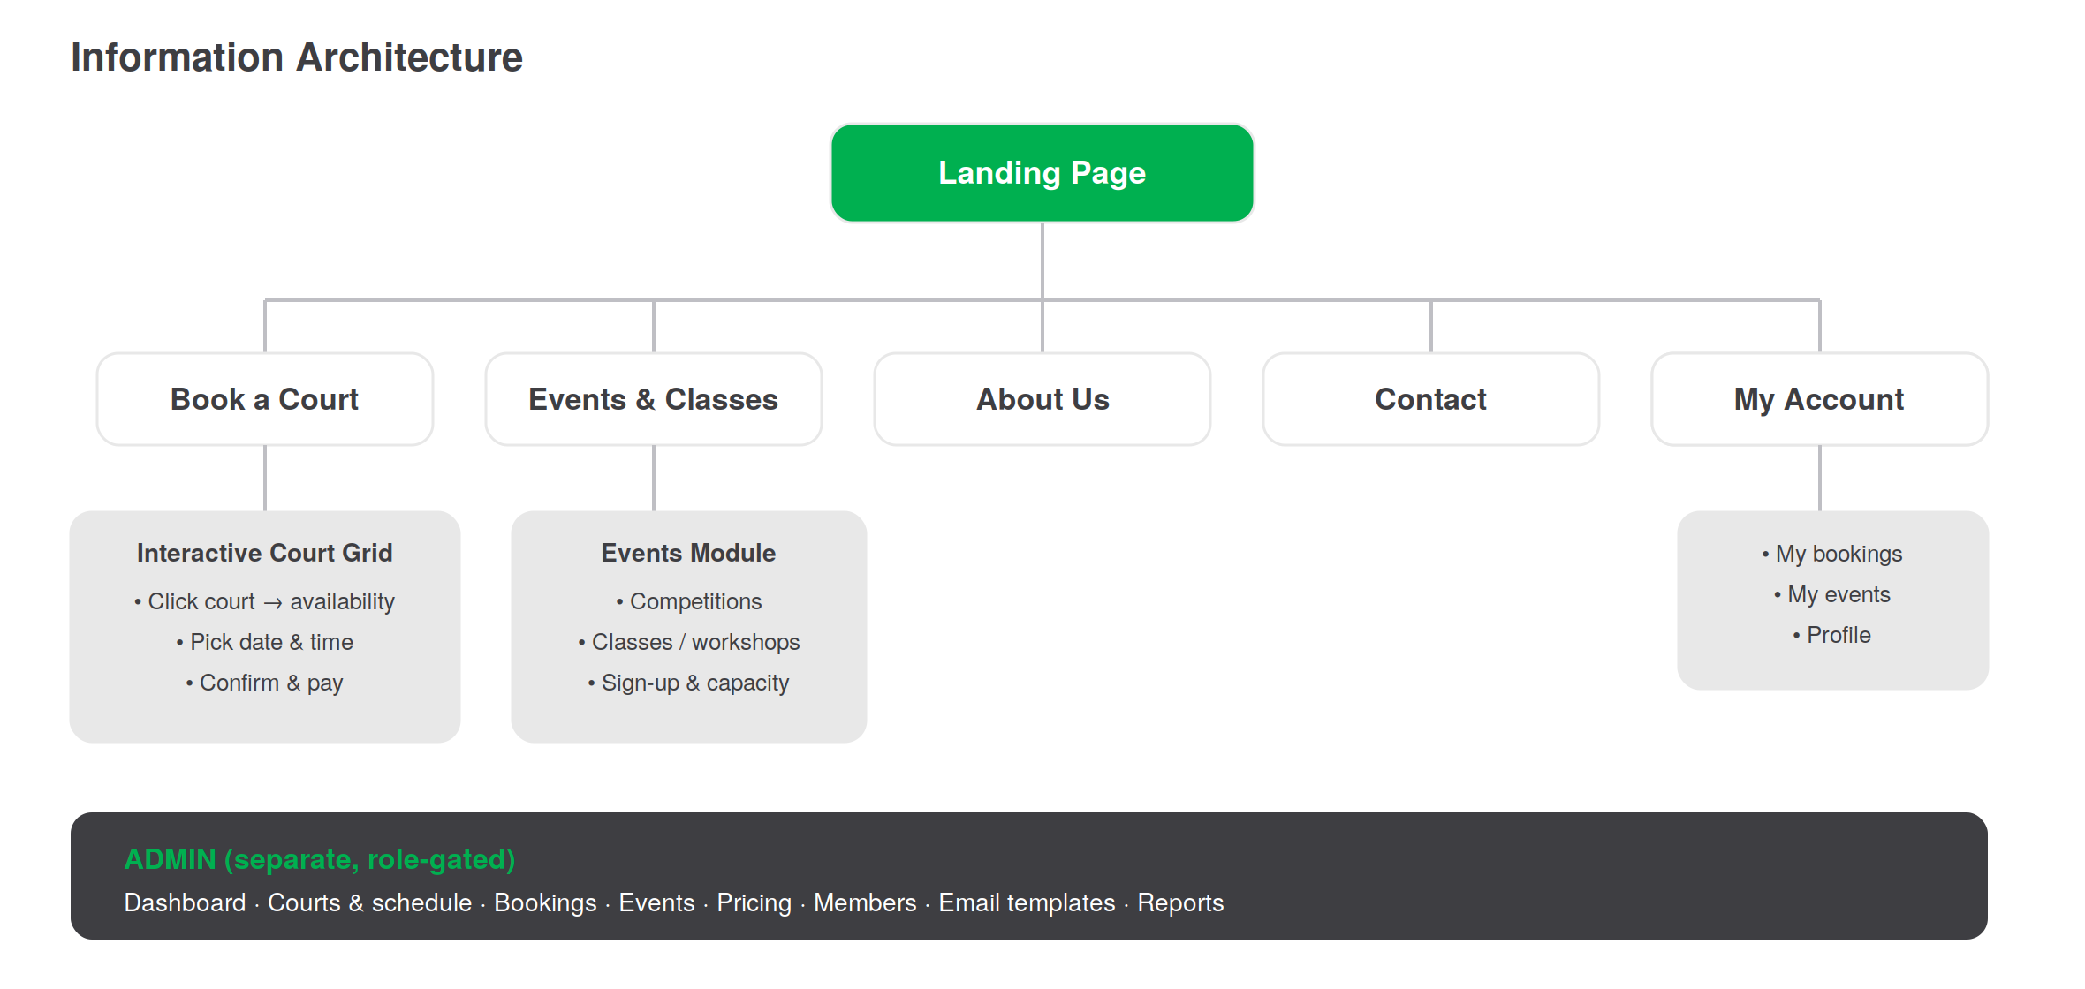
Figure 1 — Site map. The public site sits on the left; the role-gated admin is a separate surface.

4.1 Global navigation
A persistent top bar carries the logo, the primary destinations (Book, Events, About, Contact), and a high-contrast green "Book a Court" button. A sticky "Book a Court" call-to-action also follows the user as they scroll the landing page. On mobile the nav collapses to a slide-in menu, with the book button always visible.

5. Page Specifications

5.1 Landing page
The landing page must sell the club at a glance and push toward booking. Recommended section order, top to bottom:
- Hero. Full-bleed photograph of a Fourhand court in play. Club name, a one-line tagline, and a single primary action: "Book a Court". A soft secondary link points to events.
- Court showcase. A gallery of the courts — each with photos, surface type (hard/clay/grass), indoor/outdoor, and lighting. Large imagery; horizontal scroll or grid. This is the "lots of pictures" centrepiece of the landing page.
- Amenities. Pro shop, racket and ball hire, ball machine, changing rooms, parking, cafe — shown as iconographic cards with photos.
- Events & classes teaser. A preview of upcoming competitions and workshops with a link into the events module.
- About snapshot. A short, warm paragraph and an image, linking to the full About page.
- Contact & location. Address, hours, an embedded map, phone, email — visible without leaving the page.
- Footer. Repeats navigation, contact, socials, policies, and the book CTA.
Accessibility of key info: "About Us" and "Contact" appear in the top navigation, are echoed on the landing page, and live in the footer — so they are never more than one glance away, per the brief.

5.2 Booking page
The heart of the app. Instead of a search form, the user is shown the courts as clickable tiles. Selecting a court instantly opens a detail panel showing that court’s availability for the chosen date — which slots are free and which are taken. Choosing a free slot and confirming completes the booking. Section 7 specifies this interaction in full.
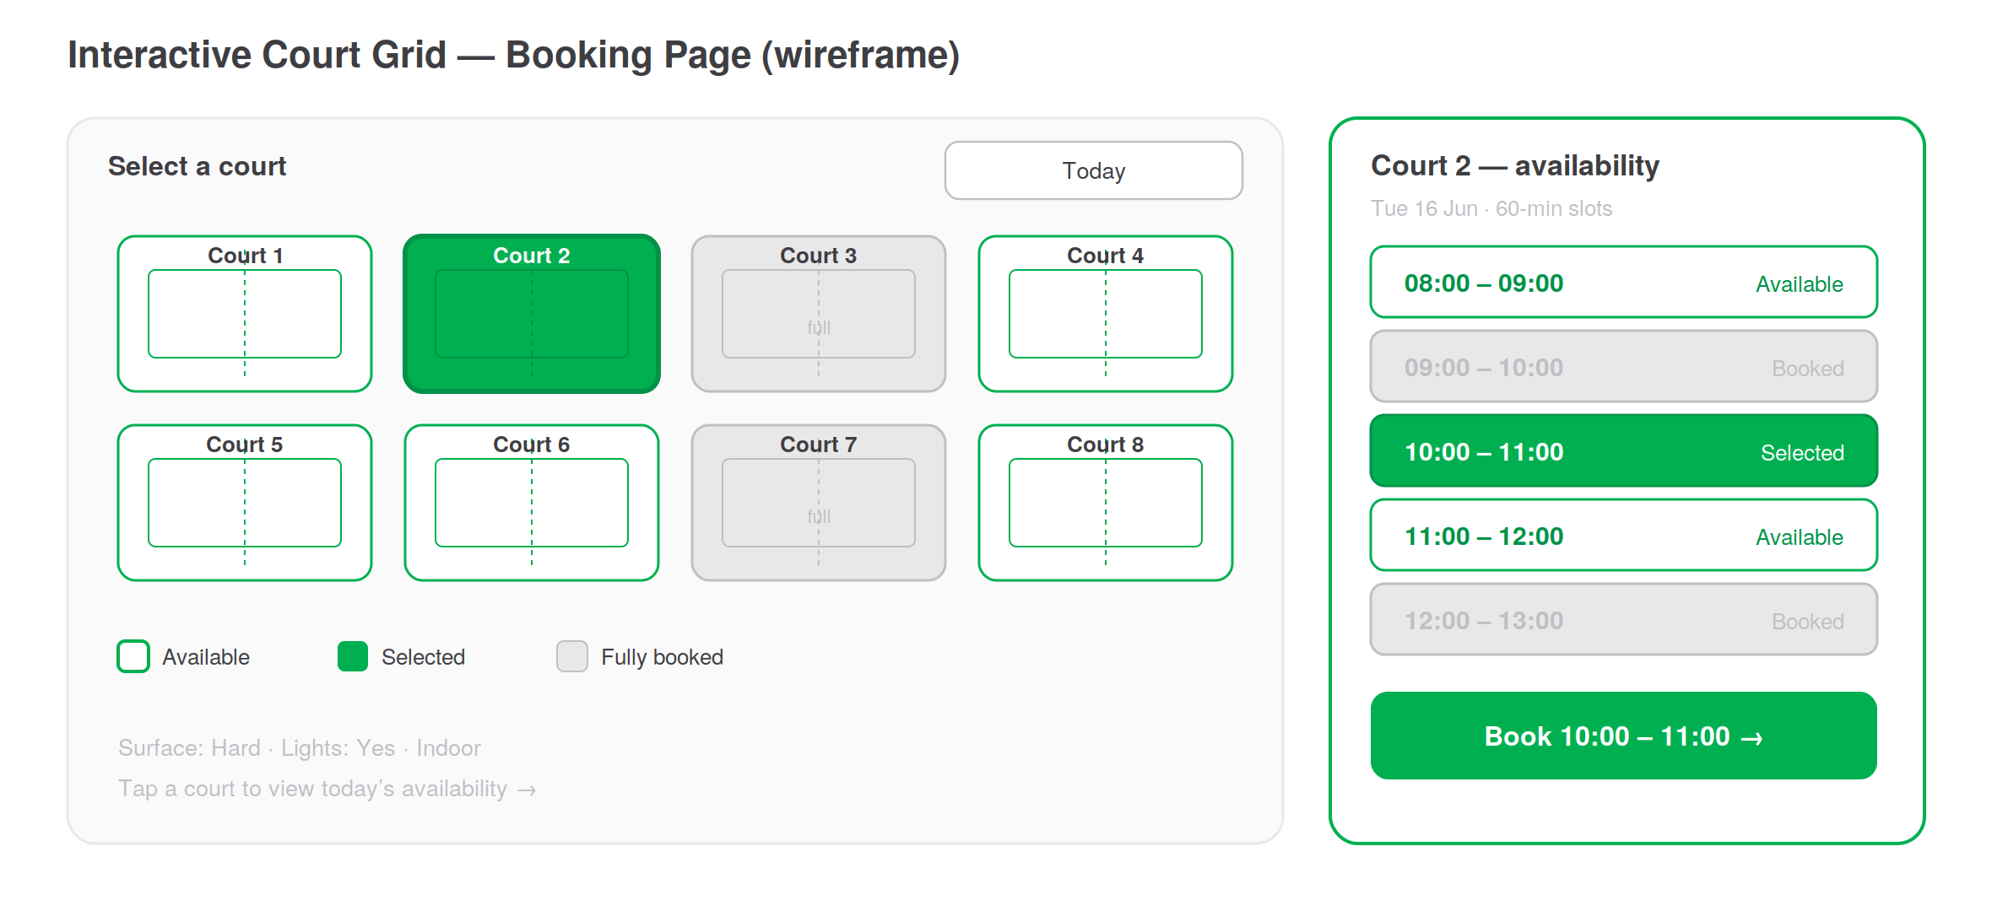
Figure 2 — Booking page wireframe: clickable court tiles (left) with an instant availability panel (right).

5.3 Events & classes
A browsable list of upcoming competitions, classes, and workshops. Each event has its own detail view with photos, description, date/time, coach or organiser, capacity, price, and a prominent sign-up action. Section 8 covers behaviour.

5.4 About Us
The club story, the team and coaches, the facility, and the values. Generous photography. Reachable from nav, landing page, and footer.

5.5 Contact
Address with an interactive map, opening hours, phone, email, social links, and a short contact form. Submissions are emailed to staff and acknowledged automatically.

5.6 My Account
For returning users: upcoming and past bookings, event sign-ups, saved details for one-tap rebooking, and cancellation/reschedule controls. Account creation is optional and never blocks a first booking — a guest booking can be claimed into an account afterwards.

6. The Booking Flow
The flow is deliberately three steps. Most users never see a fourth screen.
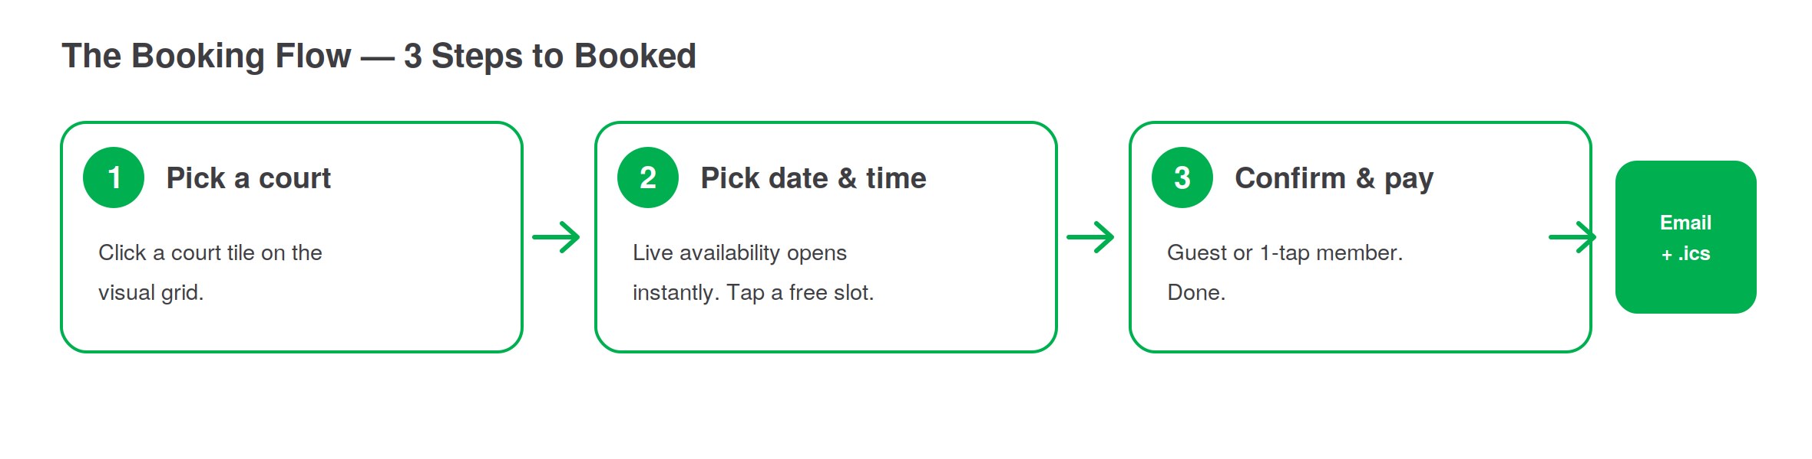
Figure 3 — Three steps from intent to a confirmed, emailed booking.

6.1 Step detail
- Pick a court. From the visual grid. Court metadata (surface, indoor/outdoor, lighting) is visible on each tile.
- Pick date & time. The availability panel opens instantly. A date control sits at the top; free slots are tappable, taken slots are clearly inert.
- Confirm & pay. Returning members confirm in one tap. Guests enter name, email, and phone. Payment (if enabled) happens here. A confirmation screen and email follow immediately.

6.2 Booking rules
- Slot locking. When a user opens checkout, the slot is held briefly so two people cannot book the same court-time. The hold expires if checkout is abandoned.
- Pricing. Support peak / off-peak rates, member vs non-member pricing, and duration-based pricing (e.g. 60/90 min).
- Cancellation. A configurable cancellation window (e.g. free cancellation up to N hours before). Cancel/reschedule links live in the confirmation email and in My Account.
- Add-ons. Optional racket/ball hire, ball machine, or a coach can be attached during checkout.
- Guest vs member. Guest checkout is always available; an account is offered, never forced.

7. Interactive Court Visualisation
This is the signature interaction described in the brief: "courts visualised as clickable UI elements that immediately show a detailed view of what dates and times are booked."

7.1 The court grid
Courts are rendered as tiles laid out to loosely echo the real facility. Each tile shows the court name and a compact status. Tile state is colour-coded against the brand palette:
State | Meaning | Visual treatment
Available | Has free slots on the selected date | White fill, green outline
Selected | Currently open in the detail panel | Solid green fill, white label
Fully booked | No free slots that date | Grey fill, muted, non-primary

7.2 The availability panel
Tapping a court opens a detail panel (a side panel on desktop, a bottom sheet on mobile) showing that court’s slots for the chosen date. Free slots are tappable; booked slots are visibly inert. A date control lets the user move across days without leaving the panel, and availability re-renders in place. Selecting a slot reveals a single confirm action.

7.3 Behaviour notes
- Availability is live: opening a court fetches current state so two users never see a stale picture.
- Changing the date updates both the tile states and the open panel together.
- The whole interaction stays on one screen — no full-page reloads between selecting a court, a date, and a slot.
- Deep links: a court+date URL can open the grid in that exact state (useful for sharing and for email links).

8. Events, Competitions & Classes
Beyond court hire, players can sign up to organised activities. These are capacity-based rather than slot-based.

8.1 Event types
- Competitions — tournaments and ladders with a roster and, optionally, an entry fee.
- Classes & workshops — coached sessions with a fixed capacity and a coach assigned.

8.2 Sign-up behaviour
- Each event shows remaining spots; sign-up closes automatically when full.
- A waitlist can be enabled — if a spot frees up, the next person is notified by email.
- Sign-up reuses the same lightweight identity step as booking (guest or member).
- Confirmation and reminder emails are sent exactly as for court bookings (Section 9).

9. Notifications & Mailing System
Email is split into two streams handled differently: transactional (triggered by an action, no opt-in needed) and marketing (opt-in, separate). The brief’s requirement — an email when someone books a court — is the first transactional trigger below.

9.1 Transactional triggers
Trigger | Email sent | Recipient
Court booked | Confirmation with details + calendar (.ics) + cancel/reschedule link | Player
Court booked | New-booking notification | Staff / admin
Before session | Reminder (e.g. 24h and ~1–2h before) | Player
Cancelled | Cancellation / refund confirmation | Player
Rescheduled | Updated booking confirmation | Player
Event sign-up | Sign-up confirmation + details | Participant
Waitlist opening | Spot-available notification | Next in line
Contact form | Enquiry forwarded + auto-acknowledgement | Staff + sender

9.2 Email content
The booking confirmation includes: court, date and time, duration, price, location with a map link, what to bring, an attached .ics calendar invite, and one-click cancel/reschedule links. Templates are branded with the palette and stored so an admin can edit copy without code.

9.3 Marketing email
Newsletters and promotions are a separate, opt-in stream with double opt-in and an unsubscribe link. It is never mixed into the transactional stream, both to respect the user and to keep deliverability high.

9.4 Delivery
Transactional mail is sent through a dedicated provider (e.g. Resend, Postmark, SendGrid, Mailgun, or Amazon SES) for reliability and speed. Sends are queued so a slow email never delays the booking confirmation screen, and failures are retried and logged.

10. Admin Panel
A separate, role-gated surface for staff. It is built in two stages: a minimum admin first — a secure login plus a read-only booked-courts overview — and a fuller operations surface later. The minimum is specified first because it is what the club needs on day one.

10.1 Minimum admin (first release)
Scope for the first release is deliberately small: an admin can sign in securely and see which courts are booked. That is enough for staff to keep an eye on the day, so nothing more is built yet.

Admin login
- Protected area. The admin lives at a separate, authenticated route and cannot be reached without signing in.
- Sign-in. Email and password for staff accounts. Accounts are created by the owner — there is no public sign-up.
- Security. Passwords are hashed, sign-in attempts are rate-limited, sessions expire, and "Sign out" is always available. Forgot-password resets are sent by email.
- One role for now. A single admin account type. The richer role model (front-desk, coach) arrives with the fuller admin.

Booked-courts overview
On sign-in, the admin lands on a single screen showing the booked courts:
- Day view. Defaults to today, with a date control to look at other days.
- Summary strip. The essentials at a glance — bookings today, courts occupied vs. free, and the next upcoming booking.
- Booking list. Each booking for the selected day: court, time slot, player name, and status.
- Live. A booking made on the website appears here without a manual refresh.
- Read-only for now. The admin can see the day but not yet edit, cancel, or create bookings — those are a later increment.
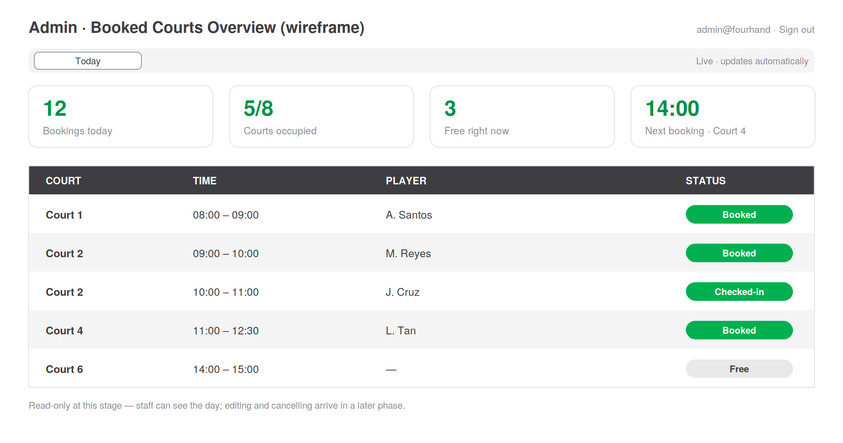
Figure 4 — Minimum admin: secure login lands on a read-only booked-courts overview.

10.2 Full admin (later phases)
Once the minimum is in place, the admin grows into the full operations surface below. These modules are the target, not the first release.
Module | Capabilities
Dashboard | Today’s bookings, court occupancy, and revenue at a glance
Courts & schedule | Add/edit courts, set surfaces and hours, block time for maintenance, calendar/grid view of all bookings
Bookings | Search, filter, create manual bookings (phone), cancel, refund, reassign
Events | Create competitions/classes, assign coaches, set capacity, manage rosters and waitlists
Pricing | Peak/off-peak rates, member rates, discounts, promo codes
Members | Profiles, membership status, credit balances, booking history
Email templates | Edit transactional copy, adjust reminder timing
Reports | Revenue, occupancy trends, exports
Settings | Business hours, cancellation policy, branding

10.3 Roles
Role | Access
Owner / admin | Everything, including pricing, refunds, and settings
Front-desk staff | Manage bookings and members; no pricing or refunds
Coach | Only their own sessions and rosters

11. Design System

11.1 Colour
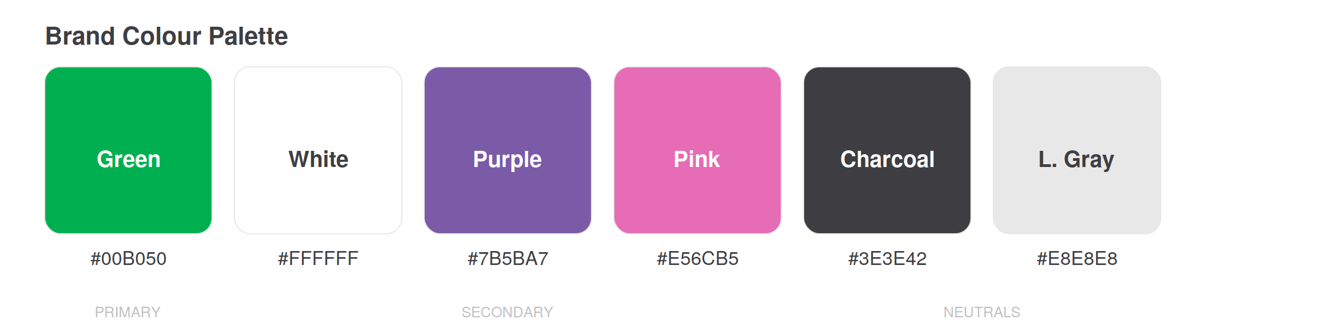
Figure 5 — Brand palette.
Role | Colour | Use
Primary | Green #00B050 | Primary actions, brand, "available" states, key CTAs
Base | White #FFFFFF | Page background, cards, breathing room
Text | Charcoal #3E3E42 | Body copy and headings
Accent | Purple #7B5BA7 | Membership tiers, secondary highlights (sparingly)
Accent | Pink #E56CB5 | Events / promotions accents (sparingly)
Surface | Light Gray #E8E8E8 | Section backgrounds, dividers, "booked/inert" states
Green dominates so the app reads as sporty and energetic; purple and pink stay as restrained accents so they never compete with the primary action.

11.2 Typography
A clean, modern sans-serif (e.g. Inter, Plus Jakarta Sans, or similar) used at a clear scale: a bold display size for hero, distinct heading steps, and a comfortable, readable body. Generous line height. Type is quiet so photography leads.

11.3 Photography
- Real photos of the actual Fourhand courts and facility — not generic stock — carry the landing page and showcase.
- Consistent treatment: bright, natural light, action and atmosphere over empty rooms.
- All images responsive and served in modern formats with lazy loading so the page stays fast despite being image-heavy.

11.4 Components
A small, consistent component library — buttons, cards, the court tile, the availability slot, the date control, the bottom sheet/side panel, form fields, and toasts — each with defined default, hover, focus, active, and disabled states. Rounded corners and soft shadows give a modern, friendly feel.

12. Motion & Animation Guidelines
The brief calls for seamless animation. Motion here is functional: it explains state changes and maintains spatial continuity, never decoration for its own sake.

12.1 Principles
- Purposeful. Every animation answers "what changed and where did it come from?"
- Fast and natural. Short durations (roughly 150–300ms) with easing that feels physical — quick to start, gentle to settle.
- Continuous. Elements transform between states rather than popping in and out; the availability panel expands from the tapped court, keeping context.
- Non-blocking. Animation never delays the user — they can act mid-transition.
- Respectful. Honour "reduced motion" preferences with simplified fades.

12.2 Signature moments
- Court tile → availability panel: a smooth expand that preserves the tile’s position as the anchor.
- Slot selection: a soft fill and lift, with the confirm button sliding up.
- Date change: availability cross-fades/slides in place rather than reloading.
- Page and section transitions: gentle fade-and-rise as content enters the viewport.
- Confirmation: a brief, satisfying success animation on booking complete.

12.3 Performance budget
Animate only cheap properties (transform and opacity) to hold 60fps. Avoid animating layout. Keep the image-heavy pages fast with lazy loading, modern formats, and skeleton loaders so motion never competes with content load.

13. UX Principles
A best-in-class bar, expressed as concrete rules the team can check work against:
- Mobile-first: the booking flow must be effortless one-handed on a phone.
- One primary action per screen — always obvious what to do next.
- No dead ends: every state (empty, loading, error, fully booked) has a clear next step.
- Instant feedback: taps respond immediately; network waits show skeletons, not spinners-on-blank.
- Forgiving: easy to change a date, court, or slot; easy to cancel.
- Accessible: keyboard navigable, screen-reader labelled, sufficient contrast, large tap targets.
- Honest availability and pricing — no surprises at the final step.

14. Technical Architecture
A pragmatic, modern stack chosen for fast iteration, great UI performance, and reliable booking logic. These are recommendations; the team may substitute equivalents.
Layer | Recommendation & rationale
Frontend | A modern React framework (e.g. Next.js) for fast, image-optimised, SEO-friendly pages and smooth client interactions
Animation | A declarative motion library (e.g. Framer Motion) for the seamless transitions in Section 12
Styling | A utility CSS system (e.g. Tailwind) with the brand palette as design tokens
Backend / API | A typed API service handling availability, slot locking, bookings, events, and pricing
Database | A relational database (e.g. PostgreSQL) — bookings are inherently relational and need transactional integrity
Auth | Lightweight accounts with guest checkout; social/passwordless optional
Payments | A hosted provider (e.g. Stripe) if paid bookings are enabled
Email | A transactional email provider (Section 9.4) with a queue
Media | A CDN/image service for responsive, lazy-loaded court photography
Hosting | A managed platform (e.g. Vercel) for the frontend; managed DB and queue
Concurrency note. Double-booking prevention is the hardest correctness requirement. Slot holds and database-level constraints/transactions must guarantee a court-time can be confirmed only once, even under simultaneous attempts.

15. Core Data Model
Entity | Key fields
Court | name, surface, indoor/outdoor, lighting, hours, status, photos
Slot / availability | court, date, start, end, status (free/held/booked)
Booking | court, slot, user/guest, price, add-ons, status, timestamps
User / member | name, email, phone, membership, credits, history
Event | type, title, datetime, coach, capacity, price, roster, waitlist
Event sign-up | event, user/guest, status, payment
Pricing rule | scope, peak window, member flag, rate, promo code
Email log | type, recipient, status, timestamp

16. Non-Functional Requirements
Area | Requirement
Performance | Fast first load despite heavy imagery; interactions feel instant; smooth 60fps motion
Responsive | Mobile-first; fully usable from small phones to desktop
Accessibility | WCAG AA: contrast, keyboard nav, screen-reader labels, large tap targets, reduced-motion support
SEO | Server-rendered marketing pages, semantic markup, fast Core Web Vitals
Reliability | No double-bookings; confirmation emails always delivered; graceful failure states
Security | Secure auth, protected admin, PCI-handled payments via provider, data privacy on personal info

17. Development Plan & Roadmap
A phased build that ships a usable booking experience early, then layers on events, payments, and polish. Durations are indicative and depend on team size.
# | Phase | Deliverables | Est.
0 | Discovery & design | Finalise scope, gather court photography, design system, hi-fi designs of landing + booking, prototype the court-grid interaction | 1–2 wk
1 | Landing page | Responsive landing with hero, court showcase, amenities, about/contact, sticky CTA, animations | 1–2 wk
2 | Booking core | Court grid, live availability panel, slot locking, guest booking, confirmation screen | 2–3 wk
3 | Mailing | Transactional emails (Section 9), .ics, reminders, admin notifications, queue | 1 wk
3b | Minimum admin | Secure admin login + read-only booked-courts overview (Section 10.1) | ½–1 wk
4 | Accounts | Optional accounts, My Account, rebooking, cancel/reschedule | 1–2 wk
5 | Events | Events module, sign-up, capacity, waitlist, event emails | 1–2 wk
6 | Full admin | Dashboard, courts/schedule, bookings, events, pricing, members, templates, reports, roles | 2–3 wk
7 | Payments | Paid bookings/memberships, refunds (if enabled) | 1 wk
8 | Polish & launch | Motion refinement, performance, accessibility audit, QA, soft launch | 1–2 wk
Suggested first release (MVP): Phases 0–3b — a beautiful landing page, a working visual court booking with confirmation emails, and a minimum admin (secure login plus a read-only booked-courts overview) so staff can see the day. That satisfies the core brief and can go live while accounts, events, the fuller admin, and payments follow.

18. Risks & Mitigations
Risk | Mitigation
Double-booking under concurrency | Slot holds + DB-level transactional constraints; load-test the confirm path
Image-heavy pages feel slow | CDN, modern formats, lazy loading, skeletons, performance budget
Animation hurting performance | Animate only transform/opacity; respect reduced motion; test on low-end phones
Email landing in spam | Reputable provider, proper domain auth, transactional/marketing separation
Scope creep delaying launch | Ship the Phase 0–3b MVP first; treat later phases as increments

19. Decisions Needed
A few choices will sharpen scope and estimates:
- Payments at launch — paid bookings, reserve-only (pay in person), or memberships/packages?
- Number and layout of courts, and whether the grid should mirror the real facility map.
- Slot length(s) — fixed 60-minute, 90-minute, or flexible durations.
- Membership model — tiers, member pricing, credits?
- Whether real court photography is available now (needed for the showcase) or to be commissioned.

Appendix A — Reference Sites Studied
The following sites informed this plan. Several run on a shared booking platform (rezerv.co / "rezeve"), confirming that a polished branded front-end over a solid booking engine is a proven pattern; this plan proposes a custom build to deliver the bespoke visual court grid the brief calls for.
Activity | Site | Relevance
Padel | padelku.com | Closest sport; court booking
Badminton | wyseactivehub.rezerv.co | Multi-court grid booking (32 courts)
Group PT | elvtesg.rezerv.co | Capacity/class sign-ups
Pilates | sofstudios.co | Class scheduling, clean brand
Spin | clubaloha.co | Class booking, brand-led
Bouldering | outpostclimbing.sg | Image-led custom site

