FOURHAND
TENNIS CLUB

Technical Stack & Architecture
Technology basis document for the booking web app
Version | 1.0 · Draft for review
Date | 16 June 2026
Proposed stack | Next.js · Vercel · Supabase (+ Resend, Stripe)
Companion to | Development Plan & Product Documentation v1.0

Contents

1. Purpose & Scope
This document is the technical basis for the Fourhand Tennis Club web app: it recommends the technologies to build on and explains why each one fits. It is the companion to the Development Plan & Product Documentation, and assumes that product scope (visual court booking, events, the mailing service, and the minimum admin).
Short answer to the proposed stack: Next.js + Vercel + Supabase is the right choice for this product. It is coherent, low-maintenance, and a proven pairing. Two additions complete it — a transactional email service (Resend) and, if you take payments, Stripe — and one thing must be done deliberately: booking concurrency (Section 7).

2. Recommended Stack at a Glance
Layer | Recommendation | Why it fits | Alternative
Framework | Next.js (App Router) | React with server rendering, image optimisation, and server actions — ideal for an image-heavy, fast, SEO-friendly site | Remix, Astro
Hosting | Vercel | First-class Next.js host; serverless, preview deploys per branch, built-in cron | Netlify, Cloudflare
Database + backend | Supabase | Managed Postgres with Auth, Realtime, and Storage in one place — minimal ops | Neon, Firebase
Auth | Supabase Auth | Integrated with the database and RLS; email/password for admin, optional accounts for players | Clerk, Auth.js
Live updates | Supabase Realtime | Live court availability and the live admin overview without polling | Pusher, Ably
Email | Resend + React Email | Transactional confirmations/reminders with branded React templates; pairs cleanly with Next.js | Postmark, SES
Payments | Stripe (if enabled) | Hosted checkout; PCI handled for you | —
Media | Supabase Storage + Next/Image | Court photos stored next to the data, served responsively | Cloudinary
Animation | Framer Motion | Declarative, layout-aware transitions for the court grid and panels | GSAP
Styling | Tailwind CSS | Brand palette as design tokens; fast, consistent UI | CSS Modules
Scheduled jobs | Vercel Cron or pg_cron | Reminders, hold expiry, waitlist promotion | Inngest, QStash
Monitoring | Sentry + Vercel Analytics | Error tracking and Core Web Vitals | Logflare

3. What the Stack Must Support
Every choice above traces back to a product requirement:
- Image-heavy, fast, animated UI — Next.js image optimisation + Framer Motion + Vercel’s edge network.
- Three-tap booking with live availability — server actions + Supabase Realtime.
- No double-bookings — Postgres transactions, row locking, and a unique constraint (Section 7).
- Email on booking + reminders — Resend, triggered by server actions and scheduled jobs.
- Admin login + live booked-courts overview — Supabase Auth + Realtime, protected by RLS.
- Event sign-ups with capacity — the same transactional pattern as bookings.
- Optional payments — Stripe, added without disrupting the rest.
- Small team, low ops — all three core platforms are managed/serverless with generous free tiers.

4. Architecture Overview
The browser talks to a Next.js app on Vercel. Server-side code (server components, server actions, route handlers) talks to Supabase for data, auth, realtime, and file storage, and to Resend and Stripe for email and payments. Secrets stay server-side; the browser only ever uses Supabase’s public key behind Row Level Security.
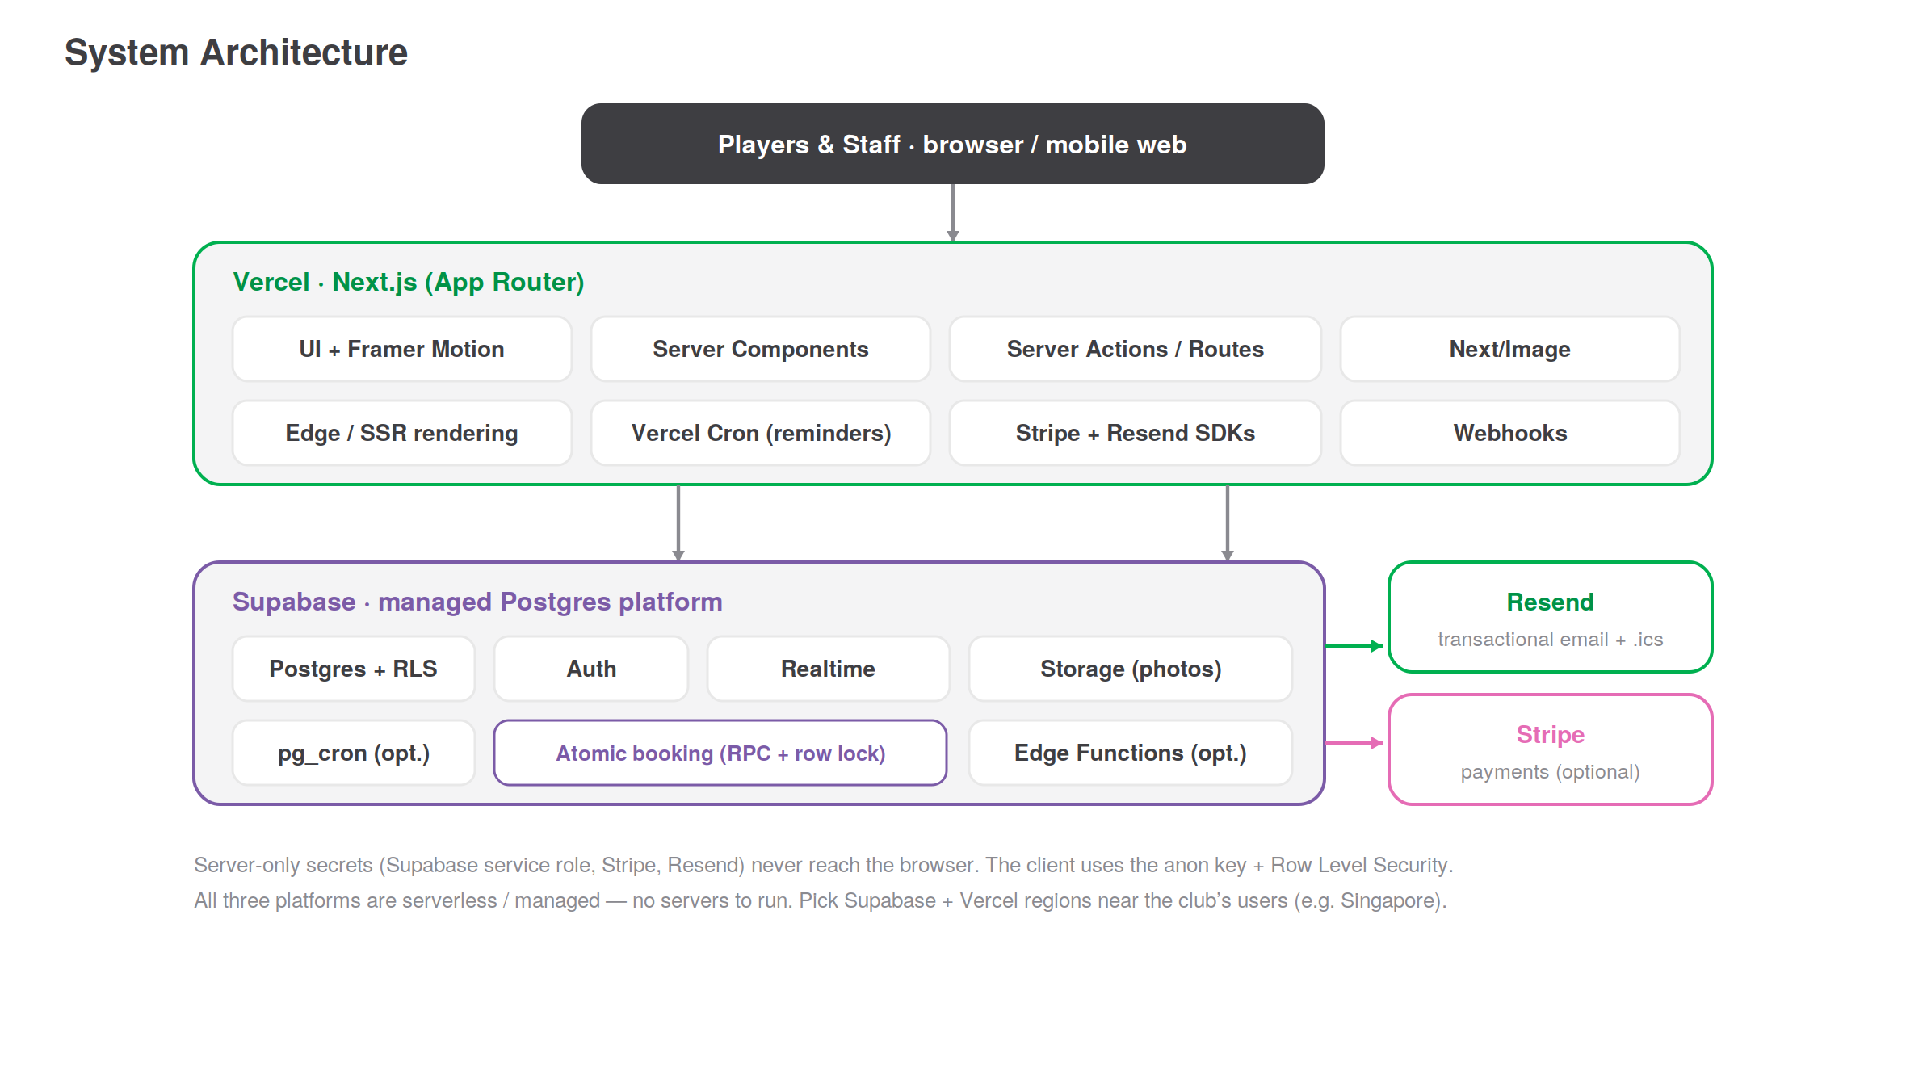
Figure 1 — System architecture. Three managed platforms, no servers to run.

5. Frontend — Next.js

5.1 Rendering strategy
Use the App Router. Marketing pages (landing, about, events list) are server-rendered or static for speed and SEO. The booking page is interactive: server components fetch initial availability, and client components handle the court grid, the availability panel, and live updates. Mutations (create booking, sign up for an event) run through server actions or route handlers so secrets and validation stay on the server.

5.2 UI & animation
Tailwind CSS carries the design system, with the brand palette defined as tokens so green/charcoal/accent usage stays consistent. Framer Motion drives the seamless transitions called for in the plan — its layout animations are a natural fit for expanding a court tile into the availability panel and cross-fading dates. Next/Image handles the heavy court photography with responsive sizes, modern formats, and lazy loading.

5.3 Accessibility & performance
Server rendering plus image optimisation keeps Core Web Vitals strong despite the imagery. Build to WCAG AA (keyboard, labels, contrast, reduced-motion), and animate only transform/opacity to hold 60fps, as specified in the product docs.

6. Backend & Data — Supabase
Supabase is managed Postgres with batteries included. The relational model from the product docs (courts, slots, bookings, users, events, sign-ups, pricing rules, email log) maps directly to Postgres tables.

6.1 Access model
- Anon key + Row Level Security (RLS): the browser uses Supabase’s public key; RLS policies decide what each user can read or write. RLS is enabled on every table from day one.
- Service role on the server only: privileged operations (admin reads, booking writes) run server-side with the service key, never exposed to the client.

6.2 Where logic lives
Simple reads can go straight from server components to Supabase. Anything that must be correct under concurrency — booking a slot, joining a full event — runs inside a Postgres function (RPC) so the database enforces the rules atomically. This keeps business-critical logic in one trustworthy place.

7. Booking Integrity & Concurrency
This is the one part that must be engineered deliberately. Two players tapping the same slot at the same moment must never both succeed. The guarantee lives in Postgres, not in the browser or in application memory.
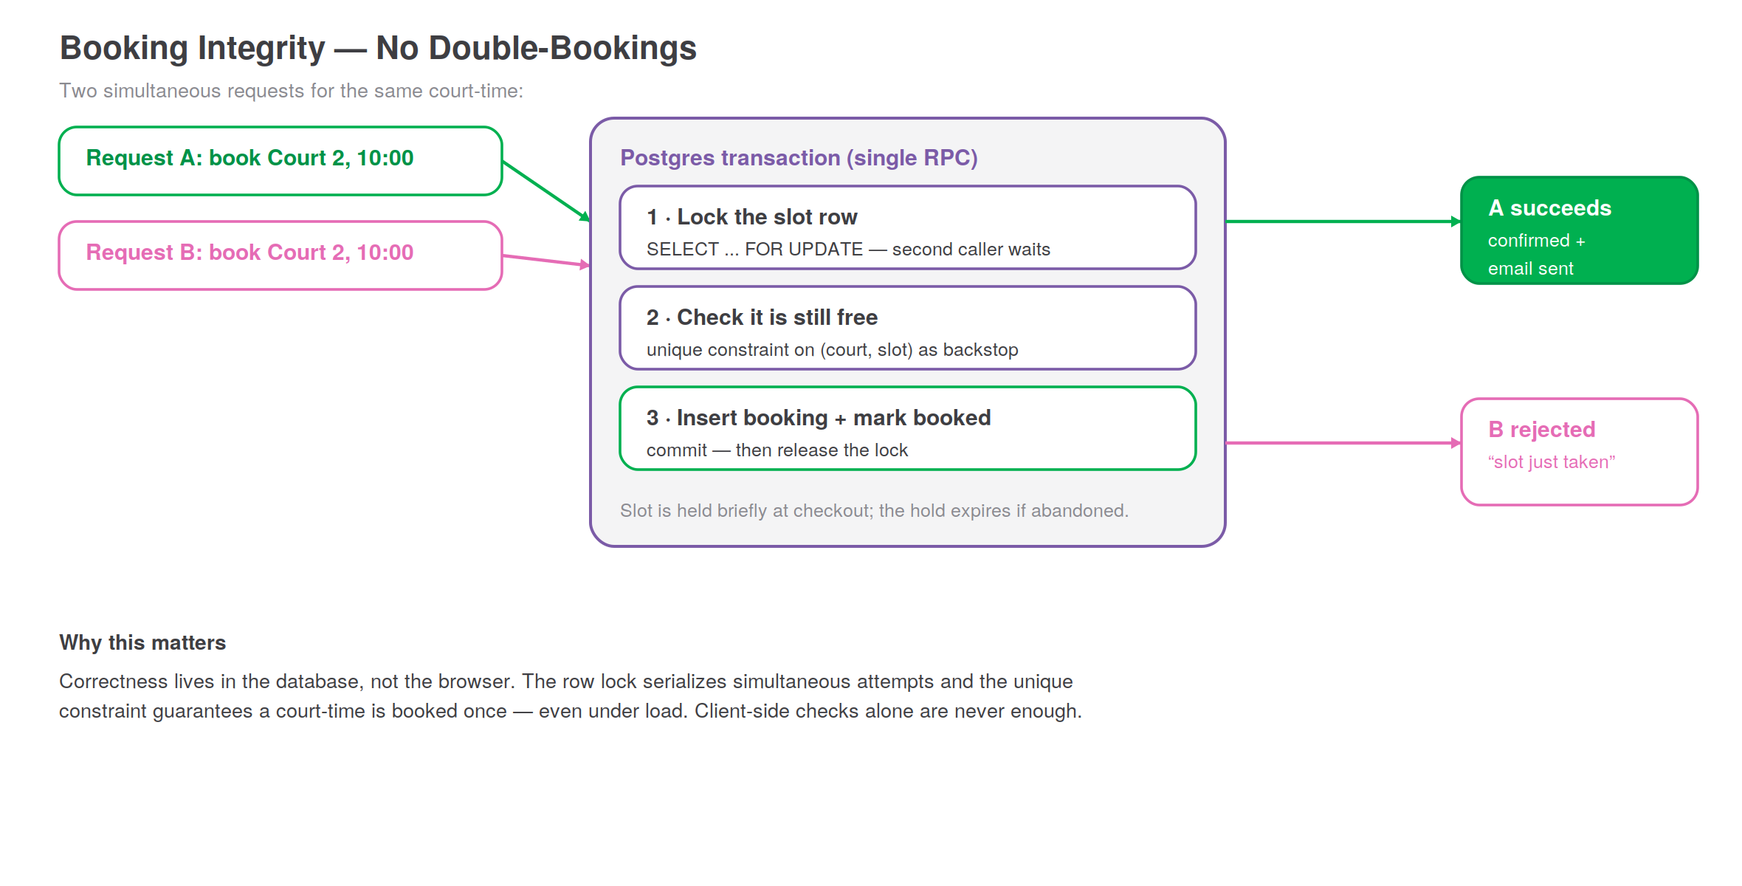
Figure 2 — Concurrent requests are serialised in the database; exactly one wins.

7.1 The approach
- Hold the slot at checkout with a short-lived hold so the UI reflects intent; the hold expires if abandoned.
- Confirm inside a single transaction (RPC): lock the slot row, verify it is still free, insert the booking, mark the slot booked, commit.
- Back it with a unique constraint on (court, slot/time) so even a logic bug cannot create a duplicate.
- Make it idempotent with a client-supplied key so a retried request never books twice.

7.2 Illustrative confirm function
A simplified shape of the atomic booking RPC:
begin;
-- 1. lock this exact slot so a second caller waits
select id from slots
where court_id = :court and starts_at = :start
for update;

-- 2. only insert if still free (unique constraint is the backstop)
insert into bookings (court_id, slot_id, user_id, ...)
values (:court, :slot, :user, ...);

update slots set status = 'booked' where id = :slot;
commit; -- lock releases; the loser gets a clear "slot taken" error
The same pattern guards event sign-ups: lock the event row, check remaining capacity, insert the sign-up, decrement — or send the player to the waitlist.

8. Realtime Updates
Supabase Realtime streams database changes to connected clients. Two places use it: the booking page (a slot another player just took greys out live, so availability never looks stale) and the admin booked-courts overview (new bookings appear without a refresh, as specified in the minimum admin). This avoids polling and keeps the experience feeling immediate.

9. Authentication
Supabase Auth covers both audiences with one system:
- Players — accounts are optional. Guest booking never requires sign-up; a guest booking can later be claimed into an account.
- Admin / staff — email + password sign-in to the protected admin area. Accounts are created by the owner; there is no public staff sign-up.
Roles are stored on the user and enforced by RLS, so the same policies that protect the API also protect the admin. The minimum admin needs only a single admin role; the richer roles (front-desk, coach) slot in later without changing the auth system.

10. Storage & Media
Court and facility photography — central to the landing page — lives in Supabase Storage, served through Next/Image for responsive, lazy-loaded delivery. If image traffic grows or heavier transformations are needed, a dedicated image CDN (e.g. Cloudinary) can sit in front without other changes. Public marketing images are world-readable; any private assets stay behind signed URLs.

11. Transactional Email
Supabase does not send product email, so this is the one clear gap in the proposed stack. Use Resend for transactional mail, with React Email for branded templates that share the app’s design tokens.

11.1 What it sends
Everything in the product docs’ mailing section: booking confirmation (with an attached .ics calendar invite and cancel/reschedule links), the staff new-booking notification, reminders, cancellation/refund confirmations, event sign-up confirmations, waitlist openings, and contact-form handling.

11.2 How it runs
- Triggered by the booking server action — the confirmation is queued the moment a booking commits, so a slow email never delays the success screen.
- Reminders run on a schedule — a scheduled job (Section 13) finds upcoming bookings and sends 24h / 1–2h reminders.
- Resilient — sends are retried on failure and recorded in the email log table for auditing.
- Deliverability — verify the sending domain (SPF/DKIM) and keep transactional and any future marketing streams separate. Supabase Auth emails can also be routed through Resend for one consistent sender.

12. Payments (Optional)
If paid bookings or memberships are enabled, use Stripe. Stripe-hosted checkout keeps card data off your systems (PCI handled by Stripe). A Stripe webhook confirms payment server-side before the booking is finalised, and refunds are issued through Stripe for cancellations within policy. Because payment sits at the confirm step, it can be added later without reworking the booking flow.

13. Scheduled Jobs
A few things happen on a timer rather than in response to a user:
Job | Purpose
Reminders | Find upcoming bookings/events and send reminder emails
Hold expiry | Release slot holds abandoned at checkout
Waitlist promotion | When a spot frees up, notify the next person
Run these with Vercel Cron (a scheduled route handler) or Supabase pg_cron. Vercel Cron keeps the logic alongside the app; pg_cron keeps it next to the data. Either is fine — pick one and be consistent.

14. Hosting, Regions & Environments
- Hosting — Next.js on Vercel; Supabase managed. No servers to patch or scale by hand.
- Region — since the club and its players are in the Philippines, provision Supabase in a nearby region (e.g. Singapore, ap-southeast-1) to keep database latency low; Vercel serves static and edge content from a global network.
- Environments — use Vercel preview deploys per branch and a separate Supabase project (or branch) for staging, so changes are tested before production.
- Secrets — Supabase service key, Stripe, and Resend keys live in Vercel environment variables, server-side only.

15. Security
- Row Level Security on every table from day one; the client never has more access than its policies allow.
- Service role and all third-party keys server-side only — never shipped to the browser.
- Payments via Stripe — no card data touches your systems.
- Admin hardening — protected routes, rate-limited sign-in, hashed passwords (handled by Supabase Auth), expiring sessions.
- Input validation on every server action; treat all client input as untrusted.

16. Observability & Analytics
Add Sentry for error and performance monitoring across frontend and server code, and Vercel Analytics for Core Web Vitals and traffic. Supabase’s logs and the email-log table give visibility into data and delivery. This is enough to catch booking failures, slow pages, or email problems early without standing up heavy infrastructure.

17. Recommendations & Decisions to Confirm
In short: keep your proposed stack, add Resend, and treat concurrency as a first-class concern. Specific recommendations:
- Keep Next.js + Vercel + Supabase. It is the right level of simplicity for this product and team.
- Add Resend for email. Supabase won’t cover the booking confirmations and reminders the brief requires.
- Do the booking RPC properly (Section 7) before launch, and load-test the confirm path. This is the highest-risk area.
- Turn on RLS immediately, not later — retrofitting security is painful.
- Pick a nearby Supabase region (Singapore) for latency.
Decisions to confirm:
- Payments at launch, or reserve-only for now? (Determines whether Stripe is in the first release.)
- Vercel Cron vs. Supabase pg_cron for scheduled jobs — a small preference, but decide once.
- Supabase Storage vs. a dedicated image CDN for photos — start with Storage; revisit if image needs grow.
- Player accounts at launch, or guest-only first with accounts in a later phase?

18. Stack Risks & Mitigations
Risk | Mitigation
Double-booking under load | Postgres row lock + unique constraint + idempotency; load-test (Section 7)
Misconfigured RLS exposing data | RLS on from day one; service role server-side only; review policies
Email in spam / not delivered | Verified sending domain (SPF/DKIM); reputable provider; transactional/marketing split
Latency for PH users | Supabase in a nearby region; Vercel edge/CDN; image optimisation
Vendor lock-in concern | Supabase is standard Postgres — portable; Next.js can host elsewhere if needed
Cost growth at scale | Generous free/low tiers cover launch; monitor usage; all three scale on managed plans

19. Phase 0 — Setup Checklist
- Create the Vercel project and connect the Git repository (preview deploys on).
- Create the Supabase project in a nearby region; define the schema; enable RLS on every table.
- Wire Supabase Auth; create the first admin account.
- Add the atomic booking RPC and the unique constraint; write a concurrency test.
- Set up Resend; verify the sending domain; build the confirmation + reminder templates.
- Configure environment variables (Supabase service key, Resend, later Stripe) in Vercel.
- Add Sentry and Vercel Analytics.
- Stand up Tailwind with the brand palette as tokens and Framer Motion.

Appendix A — Cost & Scaling Note
All three core platforms offer free or low-cost entry tiers that comfortably cover a launch and early traffic, then scale on predictable managed plans. Because Supabase is standard Postgres and Next.js is portable, none of these choices traps you: each layer can be moved independently if the club outgrows it. Exact pricing changes over time, so confirm current plans before committing budget.

Appendix B — Library Shortlist
Purpose | Library / service
Framework | next
Database client | @supabase/supabase-js, @supabase/ssr
Animation | framer-motion
Styling | tailwindcss
Email | resend, react-email
Calendar invite | an .ics generator (e.g. ics)
Payments | stripe (if enabled)
Validation | zod
Monitoring | @sentry/nextjs

