Android study

Android 的几种开发
SDK
NDK
HardWARE

Android application
Every application runs on its linux process.
Each application is assigned an unique User-id

Android Framework
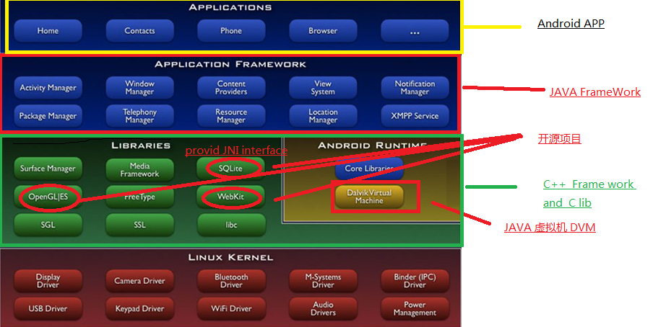

Frame work 组件，应用之间的联系
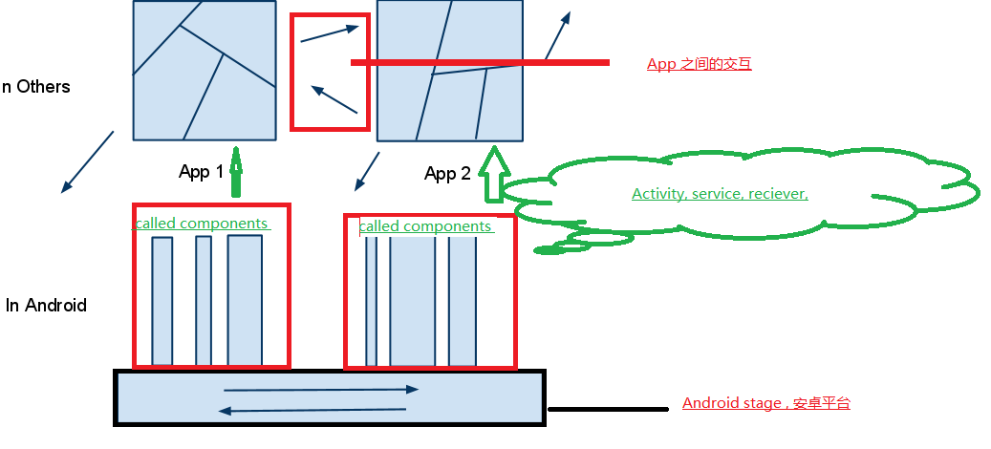

Android application components [like MVC]

Activity (most like the html page)
Root Super class:Context
Abstract class: Activity
- Target: presents a visual user interface for one focused endeavor the user can undertake
- Application, Activity , views and window
One application can contains many activities, but there will be only one activity once.
One activity is given a default window(fill the screen,or float on other window) to draw in.
One window has many hierarchy (分层的,leaf view, branch view) views as a visual，each view controls particular rectangular space within window.
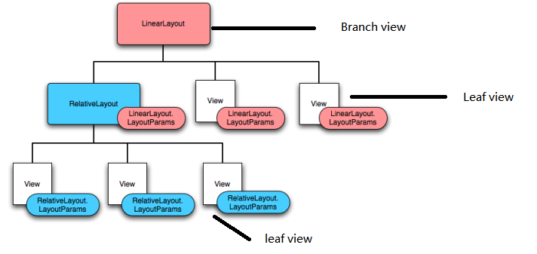
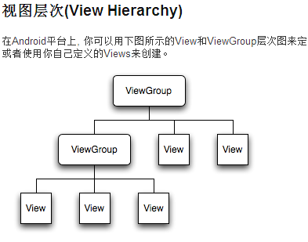
Set content view, this view is the root of the hierarchy。
所有子控件的事件，都是由父控件viewGroup 派发的
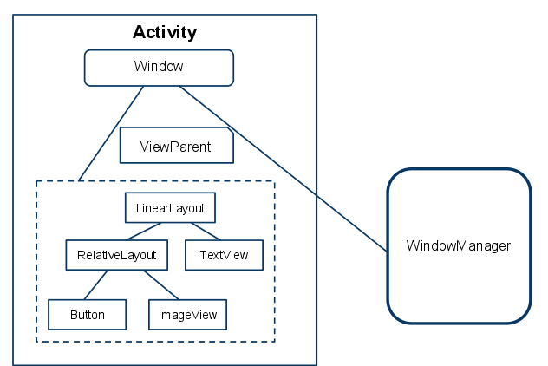

Services [后台长时间运行，接受上层指令，完成相关事务的模块,和 windows 的服务，web 后台服务一样]
Root Super class : Context
Abstract class: Service
Target: It can be run in background, when close the UI, independent from activity, Like music service
- The system would then keep the music playback service running even after the activity that started it leaves the screen.
It's possible to connect to the running service to control them, like stop, start,
Like other components like activity, it is run in the main thread of application process, other components are runs in other thread, there will be no blocking between components

Special features: service本身可以通过RPC和调用service的程序运行在不同的进程中，也可以再同一个进程中
Example:activity.getSystemService(Activity.WALLPAPER_SERVICE);

Broadcast receivers
Root super class: did’t extend context
Abstract class: BroadcastReceiver
Target: Do nothing but receive broadcast announcements like downloading notification,battery notification and so on.
Two ways to show the notification
- Start an activity
- User BroadcastReceiver to alart user
- 方式 像观察者模式一样可以写一个自己的reciever 然后注册在系统中，

Content providers
Root Super class: Did’t extend context,
Abstract class: ContentProvider
Target: provide data for applications, which has data stored on file system, SQL lite system, or others which make sense.
The way to access data:
Use ContentResolver to communicate with content provider
Act ivied by a request from ContentResolver

通过Url 访问所有应用共享 data content://com.xxxxx

Intent as a bridge among these components

What is Intent

Target：An asynchronous（异步的） message to hold the content message， which contains actions wrapped , like “convey(传输) a request for an activity to present an image to the user ”.
组件之间的通信协定，实现调用者与被调用者完全解耦. E.g Activity 组件的调用如下图

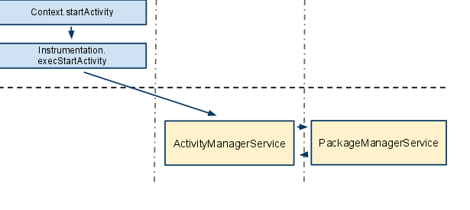
所有的外围组件，都只和系统的核心模块(e.g ActivityManagerService)发生联系，通过它进行中转，组件之间不直接勾搭。 【核心模块：Android一些关键事务的一组服务，和service 一样只是不漏面 】
Intent filter 一个组件在安装的时候可以设置Intent 过滤方式，过滤掉一下调用方式, 比如说 main Activity 中都配置了一个Intent filter

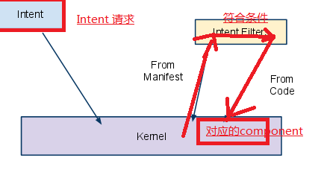

Intent structure
Action: e.g Intent.ACTION_VIEW,ACTION_PICK
Data: 表现为一个URL e.g content://xxxx tel://xxxx
Type
Category e.g Activity has a main activity <action android:name="android.intent.action.MAIN" />

<category android:name="android.intent.category.LAUNCHER" />
Component: e.g new Component (conm.xxxxx.xxapp)
Extras: 组件之间传递的参数
Flags: 指明运行模式 e.g FLAG_ACTIVITY_NEW_TASK

How to use intent in components
- Activity launched by passing an intent to “context.startActivity”,”context.startActivityForResult”, for “startActivityForResult” it will return the an Intent as a result.
- A service is started (or new instructions are given to an ongoing service) by passing an Intent object to Context.startService(). Android calls the service's onStart() method and passes it the Intent object., an intent can be passed to Context.bindService() to establish an ongoing connection between the calling component and a target service.
- An application can initiate a broadcast by passing an Intent object to methods like Context.sendBroadcast(), Context.sendOrderedBroadcast(), andContext.sendStickyBroadcast() in any of their variations. Android delivers the intent to all interested broadcast receivers by calling their onReceive() methods。

How android UI works in two ways

Android UI 布局文件 xml
- 每个元素 都是 一个view，或者一个viewGroup 的对象
- 参数含义
Layout_width/height: Wrap_content 让view 包裹其子视图，子视图有多大，view就会被撑多大
Layout_width/height fill_parent 填充父view的大小，父view有多大，子view就会有多大
Orientation
Padding
Gravity [控制空间的显示位置]
- <TextView
- android:layout_width="100dip"
- android:layout_height="100dip"
- android:layout_gravity="bottom|center_horizontal"
- android:gravity="center|bottom"
- android:background="#00FF00"
- android:text="@string/textview"
- />

- <Button
- android:layout_width="100dip"
- android:layout_height="100dip"
- android:layout_gravity="bottom|left"
- android:gravity="left|top"
- android:background="#FF0000"
- android:text="@string/button"
- />
位置参数：
丈量并设定控件的位置，是通过两步来进行的。
第一步是measure。它传入此控件的width/height信息，控件会根据自己的参数，计算出真实需要的width/height，然后调用setMeasuredDimension方法，缓存成成员变量，留作后用。
在计算出大小之后，会进行另一个步骤，layout。在这个过程中，父控件会计算其上各个子控件的位置，从而完成整个大小和位置的确定流程。整个measure和layout的流程，都是自上到下，从树顶往叶子来推进的。
当开发人员需要自定义控件的时候，可能需要关注这些内容，通过重载onMeasure和onLayout方法，可以定义自己控件的丈量方式。

Add view directly in code

The way to build complex windows on android

- Android Task , process and thread
Task定义：一组以栈的模式聚集在一起的Activity组件集合、新加的activity位于栈顶，只有栈顶的activity才能与用户交互，栈中没有activity 的时候，task 才结束
Task相当于一个android应用，在开发人的眼中，开发一个Android程序，是做一个个独门独户的组件，在用户角度看，就是一个android 应用，这整个android应用就是Task

Android 特色
只需要传递一个有意向的Intent，发送出去，系统会帮你照相相应的组件，组件当然包含一个应用（每一个应用时一个activity, 而Activity本身也是一个组件），所以应用之间可以相互调用

Tools
aapt tool
Reference
http://www.cnblogs.com/duguguiyu/archive/2010/02/22/1671547.html 深入android
http://api.apkbus.com/reference/android/widget/BaseAdapter.html Android 开发网

Android 进程被托管？
Android 文件私有化
Google Group？？论坛

基于组件的软件架构？？？
Web的Mash-Up概念？？

开发环境
Eclipse + ADT（Android Development Tool），是正牌的Android开发环境

Andriod 编写应用套路

网络词汇
想做绿叶, 衬托别人

