**Nova Electronic （Shanghai） GmbH**

***NOVA Radar Interface Technical Documentation***

Version 1.01

August 20, 2021

**Table of Contents**

1. Introduction 6

2. Operating Conditions 6

3. Safety Information 6

4. Interface 7

5. Description 8

6. Cluster List 10

6.1 Cluster list status (0x600) 11

6.2 Cluster general information (0x701) 12

6.3 Cluster quality information (0x702) 14

7. Object List 19

7.1 Object list status (0x60A) 20

7.2 Object general information (0x60B) 21

7.3 Object quality information (0x60C) 23

7.4 Object extended information (0x60D) 26

7.5 Object collision detection warning (0x60E) 28

8. Detect List 29

8.1 Detect list status (0x70A) 30

8.2 Detect general information (0x70B) 31

**History**

|  |  |  |  |
| --- | --- | --- | --- |
| **Version** | **Date** | **SW** | **Change description** |
| V 1.0 | 20.8.2021 |  | First released version |
|  |  |  |  |

**Table of Figures**

Figure 1: Nova Radar coordinate system for clusters and objects 9

Figure 2: Overview of cluster list messages that are sent cyclically by the radar 10

Figure 3: Cluster_0_Status - message layout (0x600) 11

Figure 4: Cluster_1_General - message layout (0x701) 12

Figure 5: Cluster_2_Quality - message layout (0x702) 14

Figure 6: Overview of object list messages that are sent cyclically by the radar 19

Figure 7: Object_0_Status - message layout (0x60A) 20

Figure 8: Object_1_General - message layout (0x60B) 21

Figure 9: Object_2_Quality - message layout (0x60C) 23

Figure 10: Object_3_Extended - message layout (0x60D) 26

Figure 11: Object_4_Warning - message layout (0x60E) 28

Figure 12: Overview of detect list messages that are sent cyclically by the radar 29

Figure 13: Detect_0_Status - message layout (0x70A) 30

Figure 14: Detect_1_General - message layout (0x70B) 31

**Table of Tables**

Table 1: Sensor CAN messages (exemplary for sensor ID 0) 7

Table 2: Cluster_0_Status - message content (0x600) 11

Table 3: Cluster_0_Status – signal description (0x600) 11

Table 4: Cluster_1_General - message content (0x701) 12

Table 5: Cluster_1_General - signal description (0x701) 13

Table 6: Cluster_2_Quality - message content (0x702) 14

Table 7: Cluster_2_Quality - signal description (0x702) 16

Table 8: Signal value table for Cluster_DistLong_rms, Cluster_DistLat_rms, Cluster_VrelLong_rms and Cluster_VrelLat_rms (0x702) 17

Table 9: Object_0_Status - message content (0x60A) 20

Table 10: Object_0_Status - signal description (0x60A) 20

Table 11: Object_1_General - message content (0x60B) 21

Table 12: Object_1_General - signal description (0x60B) 22

Table 13: Object_2_Quality - message content (0x60C) 23

Table 14: Object_2_Quality – signal description (0x60C) 24

Table 15: Signal value table for Obj_Orientation_rms, Obj_DistLong_rms, Obj_DistLat_rms, Obj_VrelLong_rms, Obj_VrelLat_rms, Obj_ArelLat_rms, Obj_ArelLong_rms (0x60C) 25

Table 16: Object_3_Extended - message content (0x60D) 26

Table 17: Object_3_Extended - signal description (0x60D) 27

Table 18: Object_4_Warning - message content (0x60E) 28

Table 19: Object_4_Warning - signal description (0x60E) 28

Table 20: Detect_0_ Status - message content (0x70A) 30

Table 21: Detect_0_Status - signal description (0x70A) 30

Table 22: Detect_1 General - message content (0x70B) 31

Table 23: Detect_1_General - signal description (0x70B) 31

# Introduction

The mmWave Radar developed by Nova is a Radar Sensor System to realize advanced driver assistance functions for the Automotive Industry.

The software of the sensor was adapted to use it for general purposes applications. The adaption includes simplifications for a non-automotive usage. With the easy to use software interface it is possible to connect the sensor to a CAN network and to provide radar based environmental information to one or several evaluation units. The sensor can also be configured via CAN.

In the following description for the radars, there will be MIN and MAX values for certain information (e.g. clusters, objects…). However, there will be also an offset and you shall find an offset when the MIN of that certain information is below ZERO. The offset value has been integrated into several tables already.

# Operating Conditions

KL15&KL30 power on*.*

# Safety Information

# Interface

The Nova Radar sensor has two CAN interface. A private CAN and a CAN BUS. Both communication network is a CAN bus as specified in ISO 11898-2 with a transmission rate of 500 KBits/s. The sensor is not equipped with a termination resistor and care has to be taken to properly terminate the CAN bus.

Table 1: Sensor CAN messages (exemplary for sensor ID 0)

|  |  |  |  |  |
| --- | --- | --- | --- | --- |
| **In/Out** | **ID** | **Message Name** | **Content** | **Section** |
| Out | 0x600 | Cluster_0_Status | Cluster status (list header) | 6.1 |
| Out | 0x701 | Cluster_1_General | Cluster general information | 6.2 |
| Out | 0x702 | Cluster_2_Quality | Cluster quality information | 6.3 |
| Out | 0x60A | Obj_0_Status | Object status (list header) | 7.1 |
| Out | 0x60B | Obj_1_General | Object general information | 7.2 |
| Out | 0x60C | Obj_2_Quality | Object quality information | 7.3 |
| Out | 0x60D | Obj_3_Extended | Object extended information | 7.4 |
| Out | 0x60E | Obj_4_Warning | Object collision detection warnings | 7.5 |
| Out | 0x70A | Detect_0_Status | Detect status (list header) | 8.1 |
| Out | 0x70B | Detect _1_General | Detect general information | 8.2 |

# Description

The Radar sensor uses radar radiation to analyze its surroundings. The reflected signals are processed and after multiple steps they are available in form of clusters and objects. Clusters are radar reflections with information like position, velocity and signal strength. They are newly evaluated every cycle. In contrast to this, objects have a history and dimension. They consist of tracked clusters.

The position is given in a Cartesian Coordinates System relative to the sensor as shown in figure 3.

The Nova Radar sensor shall be mounted with the plug pointing to the left, seen from behind (towards the positive y-axis) as shown in figure 3.

The velocity is calculated relative to an assumed vehicle course. The course is determined by using the speed and yaw rate information assuming that the radar sensor is mounted on the front and the movement is in longitudinal direction.

If speed and yaw rate information is missing, it will be set to default values: Yaw Rate = 0 deg/s

Speed = 0 m/s

RadarDevice_SpeedDirection = standstill

In the orientation of azimuth the Radar is made and prepared for the position of the center of a vehicle´s coordinate system.

In the orientation of longitudinal direction (+X-Axis) the center of rotation (center of gravity) is assumed to be 1,95 m behind the position of the center of a vehicle´s coordinate system which is the position of the radar.



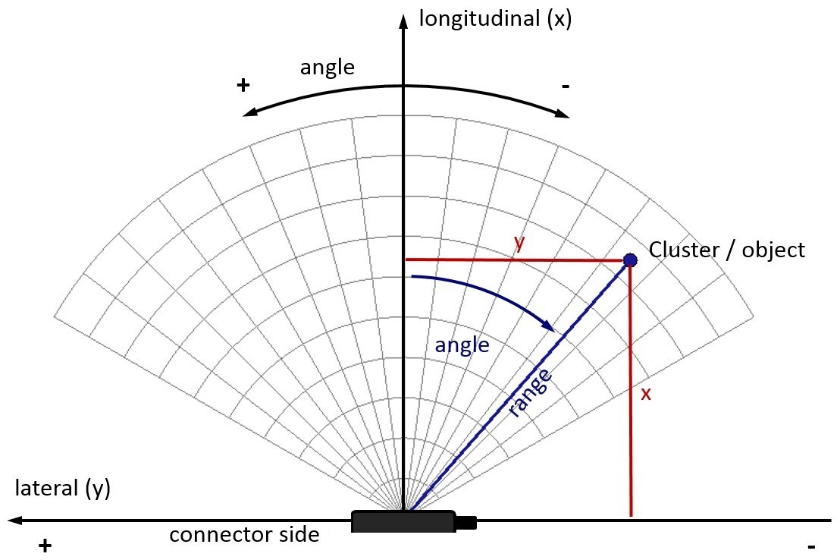

Figure 1: Nova Radar coordinate system for clusters and objects

Optionally, the output cluster and object lists can be filtered by setting filter criteria based on their attributes. Like this, the clusters or objects of interest that are sent on the CAN-bus can be selected. The filters for different attributes can be combined.

Furthermore, a region-based collision detection is implemented on the sensor. If objects are detected within up to eight defined regions, the sensor will issue a warning message.

# Cluster List

The Cluster list output consists of up to three message definitions that are sent in a regular interval (about 70 to 80 ms).

* 1. ***Cluster_0_Status*** (0x600) – The first message contains list header information,

i.e. the number of near scan clusters and number of far scan clusters that are sent afterwards.

* 1. ***Cluster_1_General*** (0x701) – This message contains the position and velocity of the clusters and is sent repeatedly for all the detected clusters (first near scan, then far scan). Each of the two cluster lists is range sorted. If there are more than 64 clusters, only the first 64 clusters are sent.
  2. ***Cluster_2_Quality*** (0x702) – This message contains the quality information of the clusters. It is sent repeatedly for all clusters in the same way as message ***Cluster_1_General*** (0x701).

If the quality information is sent, first all messages of type ***Cluster_1_General*** (0x701) are sent and afterwards all messages of type ***Cluster_2_Quality*** (0x702).



Figure 2: Overview of cluster list messages that are sent cyclically by the radar.



## Cluster list status (0x600)

The message ***Cluster_0_Status*** (0x600) contains the cluster list header information and is sent as first message of the cluster list output and only once per measurement cycle.

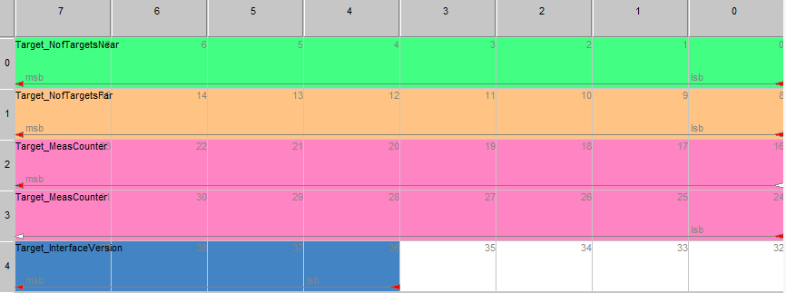

Figure 3: Cluster_0_Status - message layout (0x600)

Table 2: Cluster_0_Status - message content (0x600)

|  |  |  |  |  |  |  |
| --- | --- | --- | --- | --- | --- | --- |
| **Signal** | **Start** | **Len** | **Min** | **Max** | **Res** | **Unit** |
| Cluster_NofClustersNear | 0 | 8 | 0 | 255 | 1 | - |
| Cluster_NofClustersFar | 8 | 8 | 0 | 255 | 1 | - |
| Cluster_MeasCounter | 24 | 16 | 0 | 65535 | 1 | - |
| Cluster_InterfaceVersion | 36 | 4 | 0 | 15 | 1 | always “1” |

Table 3: Cluster_0_Status – signal description (0x600).

|  |  |  |
| --- | --- | --- |
| **Start** | **Signal** | **Description** |
| 0 | Cluster_NofClustersNear | Number of detected clusters in the near range scan (see below) |
| 8 | Cluster_NofClustersFar | Number of detected clusters in the far range scan  (Near range and far range together max. 64 clusters; in case of activation of the quality mode app. 110 – 120 clusters before the CAN-Bus gets an overrun, which must be avoided)  this value is not supported |
| 24 | Cluster_MeasCounter | Measurement cycle counter (counting up since startup of sensor and restarting at 0 when > 65535) |
| 36 | Cluster_InterfaceVersion | Cluster list CAN interface Version-No. .  It is always “**1**” till any Cluster Identifier will be changed in any coming SW-update. |

## Cluster general information (0x701)

This message contains the position and velocity of the clusters and is sent repeatedly for all the detected clusters (first near scan, then far scan). Each of the two cluster lists is range sorted. If there are more than 64 clusters, only the first 64 clusters are sent.

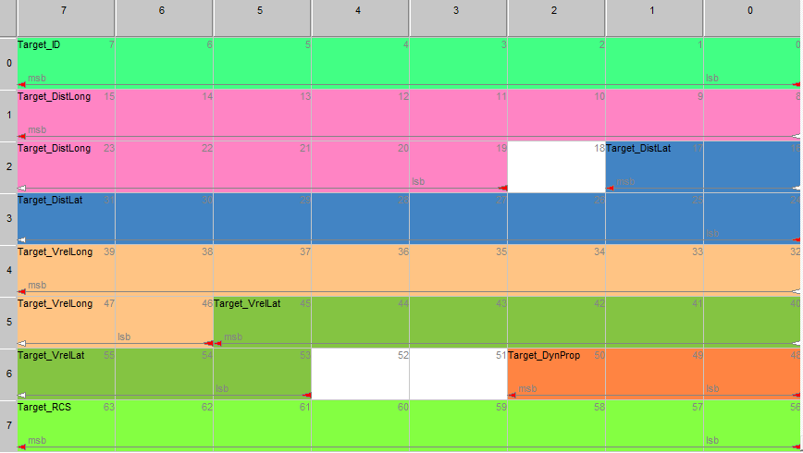

Figure 4: Cluster_1_General - message layout (0x701)

Table 4: Cluster_1_General - message content (0x701)

|  |  |  |  |  |  |  |  |
| --- | --- | --- | --- | --- | --- | --- | --- |
| **Signal** | **Start** | **Len** | **Offset** | **Min** | **Max** | **Res** | **Unit** |
| Cluster_ID | 0 | 8 |  | 0 | 255 | 1 |  |
| Cluster_DistLong | 19 | 13 | -500 | -500 | +1138.2 | 0.2 | m |
| Cluster_DistLat | 24 | 10 | -102.3 | -102.3 | +102.3 | 0.2 | m |
| Cluster_VrelLong | 46 | 10 | -128.00 | -128.00 | 127.75 | 0.25 | m/s |
| Cluster_DynProp | 48 | 3 |  | 0 | 7 | 1 | 0x0: moving 0x1: stationary 0x2: oncoming 0x3: stationary candidate  0x4: unknown 0x5: crossing stationary 0x6: crossing moving  0x7: stopped |

|  |  |  |  |  |  |  |  |
| --- | --- | --- | --- | --- | --- | --- | --- |
| Cluster_VrelLat | 53 | 9 | -64.00 | -64.00 | 63.75 | 0.25 | m/s always “0” |
| Cluster_RCS | 56 | 8 | -64.0 | -64.0 | 63.5 | 0.5 | dBm² |

Table 5: Cluster_1_General - signal description (0x701)

|  |  |  |
| --- | --- | --- |
| **Start** | **Signal** | **Description** |
| 0 | Cluster_ID | Cluster number |
| 19 | Cluster_DistLong | Longitudinal (x) coordinate |
| 24 | Cluster_DistLat | Lateral (y) coordinate |
| 46 | Cluster_VrelLong | Relative velocity in longitudinal direction (x) |
| 53 | Cluster_VrelLat | Relative velocity in lateral direction (y) This value is permanently set to “Zero” |
| 48 | Cluster_DynProp | Dynamic property of cluster to indicate if it is moving or not |
| 56 | Cluster_RCS | Radar cross section |

## Cluster quality information (0x702)

This message contains the quality information of the clusters. It is sent repeatedly for all clusters in the same way as message ***Cluster_1_General*** (0x701). If this message is activated the maximum number of clusters has to be limited to 125 either by filtering or environment.

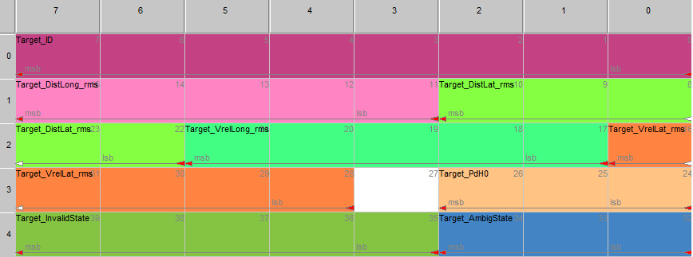

Figure 5: Cluster_2_Quality - message layout (0x702)

Table 6: Cluster_2_Quality - message content (0x702)

|  |  |  |  |  |  |  |
| --- | --- | --- | --- | --- | --- | --- |
| **Signal** | **Start** | **Len** | **Min** | **Max** | **Res** | **Unit** |
| Cluster_ID | 0 | 8 | 0 | 255 | 1 | - |
| Cluster_DistLong_rms | 11 | 5 | 0 | 31 | 1 | see Table 36 |
| Cluster_VrelLong_rms | 17 | 5 | 0 | 31 | 1 | see Table 36 |
| Cluster_DistLat_rms | 22 | 5 | 0 | 31 | 1 | see Table 36 |
| Cluster_Pdh0 | 24 | 3 | 0 | 7 | 1 | 0x0: invalid 0x1: <25%  0x2: <50%  0x3: <75%  0x4: <90%  0x5: <99%  0x6: <99.9%  0x7: <=100% |
| Cluster_VrelLat_rms | 28 | 5 | 0 | 31 | 1 | see Table 36 |

|  |  |  |  |  |  |  |
| --- | --- | --- | --- | --- | --- | --- |
| Cluster_AmbigState | 32 | 3 | 0 | 7 | 1 | 0x0: invalid (cannot be used) 0x1: ambiguous (cluster is not clear as there is fuzziness (darkness, ambiguity)). (Should not be used and not recommended anyway, because it could be there twice or even more times)  0x2: staggered ramp (the cluster is not clear somehow as the fuzziness (ambiguity) has been resolved partially). (Should not be used and not recommended anyway)  0x3: unambiguous (everything is clear, the fuzziness(ambiguity) has been resolved – it can be used and recommended for usage)  0x4: stationary candidates (everything is clear and probably there is something stationary (fixed) as the fuzziness(ambiguity) has been resolved – it can be used and recommended for usage) |

|  |  |  |  |  |  |  |
| --- | --- | --- | --- | --- | --- | --- |
| Cluster_InvalidState | 35 | 5 | 0 | 31 | 1 | 0x00: Valid  0x01: Invalid due to low RCS 0x02: Invalid due to near-field  artefact  0x03: Invalid far range Cluster because not confirmed in near range  0x04: Valid Cluster with low RCS  0x05: reserved  0x06: Invalid Cluster due to high mirror probability  0x07: Invalid because outside sensor field of view  0x08: Valid Cluster with azimuth correction due to elevation  0x09: Valid Cluster with high child probability  0x0A: Valid Cluster with high probability of being a 50 deg artefact  0x0B: Valid Cluster but no local maximum  0x0C: Valid Cluster with high artefact probability  0x0D: reserved  0x0E: Invalid Cluster because it is a harmonics  0x0F: Valid Cluster above 95 m in near range  0x10: Valid Cluster with high multi-target probability  0x11: Valid Cluster with suspicious angle |

Table 7: Cluster_2_Quality - signal description (0x702)

|  |  |  |
| --- | --- | --- |
| **Start** | **Signal** | **Description** |
| 0 | Cluster_ID | Cluster number |
| 11 | Cluster_DistLong_rms | Standard deviation of longitudinal distance |
| 22 | Cluster_DistLat_rms | Standard deviation of lateral distance |
| 17 | Cluster_VrelLong_rms | Standard deviation of longitudinal relative velocity |
| 28 | Cluster_VrelLat_rms | Standard deviation of lateral relative velocity |

|  |  |  |
| --- | --- | --- |
| 24 | Cluster_Pdh0 | False alarm probability of Cluster (i.e. probability for being an artefact caused by multipath or similar) |
| 32 | Cluster_AmbigState | State of Doppler (radial velocity) ambiguity solution (see the seventh raw in table 34 for more details) |
| 35 | Cluster_InvalidState | State of Cluster validity state (see Table 34 for more details) |

Table 8: Signal value table for Cluster_DistLong_rms, Cluster_DistLat_rms, Cluster_VrelLong_rms and Cluster_VrelLat_rms (0x702).

|  |  |
| --- | --- |
| **Parameter** | **Value for signals**  **Cluster_DistLong_rms, Cluster_DistLat_rms [m] Cluster_VrelLong_rms, Cluster_VrelLat_rms [m/s]** |
| 0x0 | <0.005 |
| 0x1 | <0.006 |
| 0x2 | <0.008 |
| 0x3 | <0.011 |
| 0x4 | <0.014 |
| 0x5 | <0.018 |
| 0x6 | <0.023 |
| 0x7 | <0.029 |
| 0x8 | <0.038 |
| 0x9 | <0.049 |
| 0xA | <0.063 |
| 0xB | <0.081 |
| 0xC | <0.105 |
| 0xD | <0.135 |
| 0xE | <0.174 |
| 0xF | <0.224 |
| 0x10 | <0.288 |
| 0x11 | <0.371 |
| 0x12 | <0.478 |
| 0x13 | <0.616 |
| 0x14 | <0.794 |
| 0x15 | <1.023 |
| 0x16 | <1.317 |
| 0x17 | <1.697 |
| 0x18 | <2.187 |
| 0x19 | <2.817 |

|  |  |
| --- | --- |
| 0x1A | <3.630 |
| 0x1B | <4.676 |
| 0x1C | <6.025 |
| 0x1D | <7.762 |
| 0x1E | <10.000 |
| 0x1F | invalid |

# Object List

The object list output consists of up to five message definitions that are sent in a regular interval.

* 1. ***Object_0_Status*** (0x60A) – The first message contains list header information,

i.e. the number of objects that are sent afterwards

* 1. ***Object_1_General*** (0x60B) – This message contains the position and velocity of the objects and is sent repeatedly for all the tracked objects.
  2. ***Object_2_Quality*** (0x60C) – This message contains the quality information of the objects. It is sent repeatedly for all objects in the same way as message ***Object_1_General*** (0x60B).
  3. ***Object_3_Extended*** (0x60D) – This message contains additional object properties. It is sent repeatedly for all objects in the same way as message ***Object_1_General*** (0x60B).
  4. ***Object_4_Warning*** (0x60E). This message contains the collision detection warning state. It is sent repeatedly for all objects in the same way as message ***Object_1_General*** (0x60B).

If the quality information, extended information and/or warning state is sent, first all messages of type ***Object_1_General*** (0x60B) are sent and afterwards all messages of type ***Object_2_Quality*** (0x60C), afterwards of type ***Object_3_Extended*** (0x60D) and/or afterwards of type ***Object_4_Warning*** (0x60E).



Figure 6: Overview of object list messages that are sent cyclically by the radar



## Object list status (0x60A)

The message ***Object_0_Status*** (0x60A) contains the object list header information and is sent as first message of the cluster list output and only once per measurement cycle.

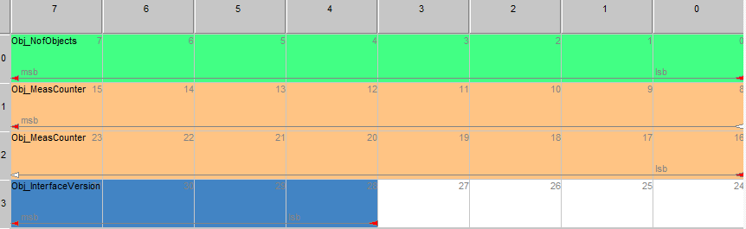

Figure 7: Object_0_Status - message layout (0x60A)

Table 9: Object_0_Status - message content (0x60A)

|  |  |  |  |  |  |  |
| --- | --- | --- | --- | --- | --- | --- |
| **Signal** | **Start** | **Len** | **Min** | **Max** | **Res** | **Unit** |
| Object_NofObjects | 0 | 8 | 0 | 255 | 1 | - |
| Object_MeasCounter | 16 | 16 | 0 | 65535 | 1 | - |
| Object_InterfaceVersion | 28 | 4 | 0 | 15 | 1 | always “1” |

Table 10: Object_0_Status - signal description (0x60A)

|  |  |  |
| --- | --- | --- |
| **Start** | **Signal** | **Description** |
| 0 | Object_NofObjects | Number of objects (max. 64 Objects) |
| 16 | Object_MeasCounter | Measurement cycle counter (counting up since startup of sensor and restarting at 0 when > 65535) |
| 28 | Object_InterfaceVersion | Object list CAN interface Version-No. .  It is always “**1**” till any Object Identifier will be changed in any coming SW-update. |



## Object general information (0x60B)

This message contains the position and velocity of the objects and is sent repeatedly for all the tracked objects.

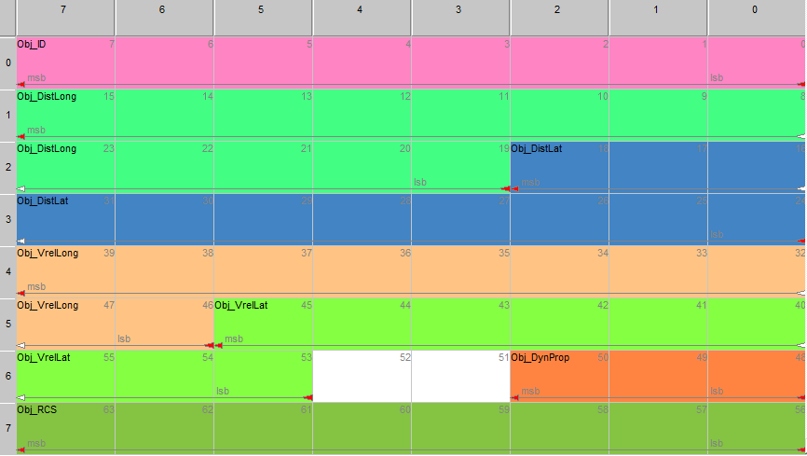

Figure 8: Object_1_General - message layout (0x60B)

Table 11: Object_1_General - message content (0x60B)

|  |  |  |  |  |  |  |  |
| --- | --- | --- | --- | --- | --- | --- | --- |
| **Signal** | **Start** | **Len** | **Offset** | **Min** | **Max** | **Res** | **Unit** |
| Object_ID | 0 | 8 |  | 0 | 255 | 1 |  |
| Object_DistLong | 19 | 13 | -500 | -500 | +1138.2 | 0.2 | m |
| Object_DistLat | 24 | 11 | -204.6 | -204.6 | +204.8 | 0.2 | m |
| Object_VrelLong | 46 | 10 | -128.00 | -128.00 | 127.75 | 0.25 | m/s |
| Object_DynProp | 48 | 3 |  | 0 | 7 | 1 | 0x0: moving 0x1: stationary 0x2: oncoming 0x3: stationary  candidate 0x4: unknown 0x5: crossing  stationary 0x6: crossing  moving 0x7: stopped |
| Object_VrelLat | 53 | 9 | -64.00 | -64.00 | 63.75 | 0.25 | m/s |
| Object_RCS | 56 | 8 | -64.0 | -64.0 | 63.5 | 0.5 | dBm² |

Table 12: Object_1_General - signal description (0x60B)

|  |  |  |
| --- | --- | --- |
| **Start** | **Signal** | **Description** |
| 0 | Object_ID | Object ID (since objects are tracked, the ID is kept throughout measurement cycles and does not have to be consecutive) |
| 19 | Object_DistLong | Longitudinal (x) coordinate |
| 24 | Object_DistLat | Lateral (y) coordinate |
| 46 | Object_VrelLong | Relative velocity in longitudinal direction (x)  stationary candidates  => vrel (y) made by own speed and yaw rate  => rest of speed projected to (x) Math.:  f_VrelY = - (f_DistX + LongPosToRot) * YawRate  f_VrelX = (f_VrelRad - sin_( f_AzAngle ) * f_VrelY)/cos_( f_AzAngle )  otherwise (moving candidates):  => projected to (x) Math.:  f_VrelY = 0.0  f_VrelX = f_VrelRad/COS_( f_AzAngle )  if cos_( f_AzAngle ) = 0, => f_VrelRad is used |
| 53 | Object_VrelLat | Relative velocity in lateral direction (y) (see (x) above) |
| 48 | Object_DynProp | Dynamic property of the object indicating if the object is moving or stationary (this value can only be determined correctly if the speed and yaw rate is given correctly) |
| 56 | Object_RCS | Radar cross section |

## Object quality information (0x60C)

This message contains the quality information of the objects. It is sent repeatedly for all objects in the same way as message ***Object_1_General*** (0x60B).

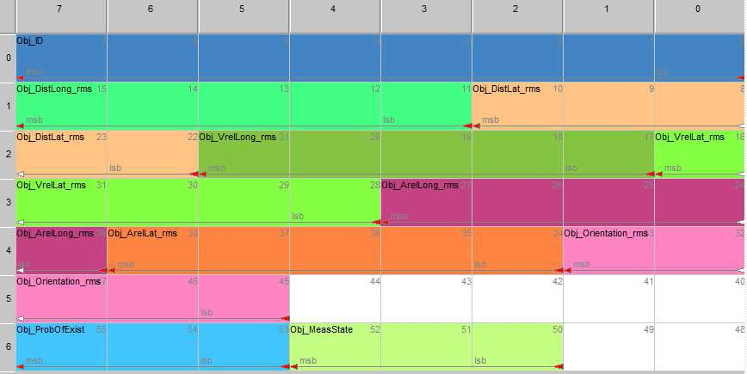

Figure 9: Object_2_Quality - message layout (0x60C)

Table 13: Object_2_Quality - message content (0x60C)

|  |  |  |  |  |  |  |
| --- | --- | --- | --- | --- | --- | --- |
| **Signal** | **Start** | **Len** | **Min** | **Max** | **Res** | **Unit** |
| Obj_ID | 0 | 8 | 0 | 255 | 1 | - |
| Obj_DistLong_rms | 11 | 5 | 0 | 31 | 1 | m |
| Obj_VrelLong_rms | 17 | 5 | 0 | 31 | 1 | m/s |
| Obj_DistLat_rms | 22 | 5 | 0 | 31 | 1 | m |
| Obj_VrelLat_rms | 28 | 5 | 0 | 31 | 1 | m/s |
| Obj_ArelLat_rms | 34 | 5 | 0 | 31 | 1 | m/s2 |
| Obj_ArelLong_rms | 39 | 5 | 0 | 31 | 1 | m/s2 |
| Obj_Orientation_rms | 45 | 5 | 0 | 31 | 1 | deg |
| Obj_MeasState | 50 | 3 | 0 | 7 | 1 | 0x0: deleted 0x1: new  0x2: measured 0x3: predicted 0x4: deleted for merge  0x5: new from  merge |

|  |  |  |  |  |  |  |
| --- | --- | --- | --- | --- | --- | --- |
| Obj_ProbOfExist | 53 | 3 | 0 | 7 | 1 | 0x0: invalid 0x1: <25%  0x2: <50%  0x3: <75%  0x4: <90%  0x5: <99%  0x6: <99.9%  0x7: <=100% |

Table 14: Object_2_Quality – signal description (0x60C)

|  |  |  |
| --- | --- | --- |
| **Start** | **Signal** | **Description** |
| 0 | Obj_ID | Object ID (since objects are tracked, the ID is kept throughout measurement cycles and does not have to be consecutive) |
| 11 | Obj_DistLong_rms | Standard deviation of longitudinal distance |
| 17 | Obj_VrelLong_rms | Standard deviation of longitudinal relative velocity |
| 22 | Obj_DistLat_rms | Standard deviation of lateral distance |
| 28 | Obj_VrelLat_rms | Standard deviation of lateral relative velocity |
| 34 | Obj_ArelLat_rms | Standard deviation of lateral relative acceleration |
| 39 | Obj_ArelLong_rms | Standard deviation of longitudinal relative acceleration |
| 45 | Obj_Orientation_rms | Standard deviation of orientation angle (see: figure 3) |
| 50 | Obj_MeasState | Measurement state indicating if the object is valid and has been confirmed by clusters in the new measurement cycle:  0x0: Deleted Object – Object has been deleted – is displayed during the last cycles of transmission just before the object ID disappears.  0x1: New Object is created – is displayed during the first cycles of transmission just after the object ID is created. Can also be checked by the character *Object_MeasCounter*.  0x2: Measured – Object creation has been confirmed by the actual measurement. Cluster could be created.  0x3: Predicted - Object creation could not be confirmed by the actual measurement. Cluster could not be created.  0x4: Deleted for merge - Object became deleted in order to be merged with another Object.  0x5: New from merge – new Object became created after a merge. |
| 53 | Obj_ProbOfExist | Probability of existence |

Table 15: Signal value table for Obj_Orientation_rms, Obj_DistLong_rms, Obj_DistLat_rms, Obj_VrelLong_rms, Obj_VrelLat_rms, Obj_ArelLat_rms, Obj_ArelLong_rms (0x60C).

|  |  |  |
| --- | --- | --- |
| **Parameter** | **Values for signal Obj_Orientation_rms [deg]** | **Value for signals**  **Obj_DistLong_rms, Obj_DistLat_rms [m] Obj_VrelLong_rms, Obj_VrelLat_rms [m/s] Obj_ArelLat_rms, Obj_ArelLong_rms [m/s²]** |
| 0x0 | <0.005 | <0.005 |
| 0x1 | <0.007 | <0.006 |
| 0x2 | <0.010 | <0.008 |
| 0x3 | <0.014 | <0.011 |
| 0x4 | <0.020 | <0.014 |
| 0x5 | <0.029 | <0.018 |
| 0x6 | <0.041 | <0.023 |
| 0x7 | <0.058 | <0.029 |
| 0x8 | <0.082 | <0.038 |
| 0x9 | <0.116 | <0.049 |
| 0xA | <0.165 | <0.063 |
| 0xB | <0.234 | <0.081 |
| 0xC | <0.332 | <0.105 |
| 0xD | <0.471 | <0.135 |
| 0xE | <0.669 | <0.174 |
| 0xF | <0.949 | <0.224 |
| 0x10 | <1.346 | <0.288 |
| 0x11 | <1.909 | <0.371 |
| 0x12 | <2.709 | <0.478 |
| 0x13 | <3.843 | <0.616 |
| 0x14 | <5.451 | <0.794 |
| 0x15 | <7.734 | <1.023 |
| 0x16 | <10.971 | <1.317 |
| 0x17 | <15.565 | <1.697 |
| 0x18 | <22.081 | <2.187 |
| 0x19 | <31.325 | <2.817 |
| 0x1A | <44.439 | <3.630 |
| 0x1B | <63.044 | <4.676 |
| 0x1C | <89.437 | <6.025 |
| 0x1D | <126.881 | <7.762 |
| 0x1E | <180.000 | <10.000 |
| 0x1F | invalid | invalid |

## Object extended information (0x60D)

This message contains additional object properties. It is sent repeatedly for all objects in the same way as message ***Object_1_General*** (0x60B).

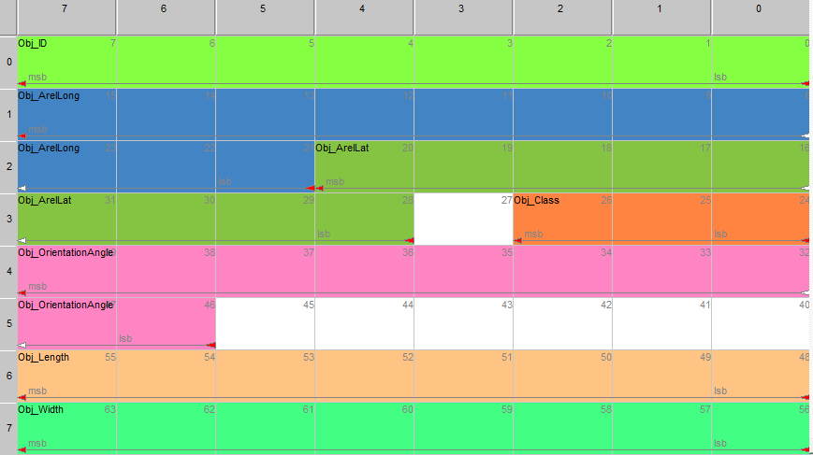

Figure 10: Object_3_Extended - message layout (0x60D)

Table 16: Object_3_Extended - message content (0x60D)

|  |  |  |  |  |  |  |  |
| --- | --- | --- | --- | --- | --- | --- | --- |
| **Signal** | **Start** | **Len** | **Offset** | **Min** | **Max** | **Res** | **Unit** |
| Object_ID | 0 | 8 |  | 0 | 255 | 1 |  |
| Object_ArelLong | 21 | 11 | -10.00 | -10.00 | 10.47 | 0.01 | m/s² |
| Object_Class | 24 | 3 |  | 0 | 7 | 1 | 0x0: point 0x1: car 0x2: truck  0x3: not in use 0x4: motorcycle 0x5: bicycle 0x6: wide  0x7: reserved |
| Object_ArelLat | 28 | 9 | -2.50 | -2.50 | 2.61 | 0.01 | m/s² always “0” |
| Object_OrientationAngel | 46 | 10 | -180.00 | -180.00 | 180.00 | 0.4 | deg |
| Object_Length | 48 | 8 |  | 0.0 | 51.0 | 0.2 | m |
| Object_Width | 56 | 8 |  | 0.0 | 51.0 | 0.2 | m |

Table 17: Object_3_Extended - signal description (0x60D)

|  |  |  |
| --- | --- | --- |
| **Start** | **Signal** | **Description** |
| 0 | Object_ID | Object ID (since objects are tracked, the ID is kept throughout measurement cycles and does not have to be consecutive) |
| 21 | Object_ArelLong | Relative acceleration in longitudinal direction |
| 24 | Object_Class | 0x0: point 0x1: car 0x2: truck  0x3: not in use 0x4: motorcycle 0x5: bicycle 0x6: wide  0x7: reserved |
| 28 | Object_ArelLat | Relative acceleration in lateral direction (y)  This value is permanently set to “Zero” see Cluster_VrelLat (Table 33) |
| 46 | Object_OrientationAngel | Orientation angle of the object (see: figure 3 - picture above); the change of an angle created by turning movement of a tracked obstacle over time. The creation of that value always starts at “0” and increases depending on a certain rotation of the obstacle. It keeps “0” if a rotation does not happen. |
| 48 | Object_Length | Length of the tracked object |
| 56 | Object_Width | Width of the tracked object |

## Object collision detection warning (0x60E)

This message contains the collision detection warning state. It is sent repeatedly for all objects in the same way as message ***Object_1_General*** (0x60B).

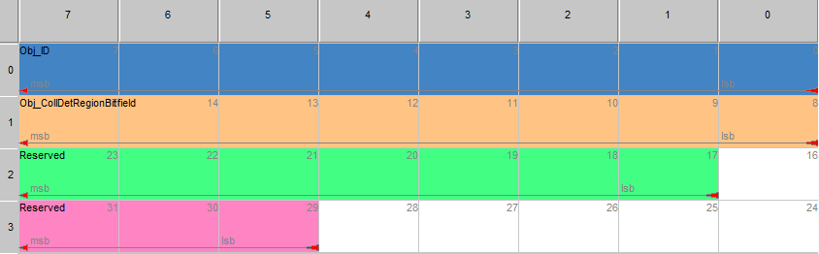

Figure 11: Object_4_Warning - message layout (0x60E)

Table 18: Object_4_Warning - message content (0x60E)

|  |  |  |  |  |  |  |
| --- | --- | --- | --- | --- | --- | --- |
| **Signal** | **Start** | **Len** | **Min** | **Max** | **Res** | **Unit** |
| Object_ID | 0 | 8 | 0 | 255 | 1 |  |
| Object_CollDetRegionBitfield | 8 | 8 | 0 | 255 | 1 |  |

Table 19: Object_4_Warning - signal description (0x60E)

|  |  |  |
| --- | --- | --- |
| **Start** | **Signal** | **Description** |
| 0 | Object_ID | Object ID (since objects are tracked, the ID is kept throughout measurement cycles and does not have to be consecutive) |
| 8 | Object_CollDetRegionBitfield | Bit field of the regions, with bit set to 1 for regions that have a collision with this object |

# Detect List

The detect list output consists of up to two message definitions that are sent in a regular interval.

1. ***Detect_0_Status*** (0x70A) – The first message contains list header information, i.e. the number of objects that are sent afterwards
2. ***Detect _1_General*** (0x70B) – This message contains the position and velocity of the detects and is sent repeatedly for all the tracked objects.

If the detects information is sent, first messages of type ***Detect _0_General*** (0x70A) are sent and afterwards all messages of type ***Detect_1_Quality*** (0x70B).



Figure 12: Overview of detect list messages that are sent cyclically by the radar



## Detect list status (0x70A)

The message ***Object_0_Status*** (0x60A) contains the object list header information and is sent as first message of the cluster list output and only once per measurement cycle.

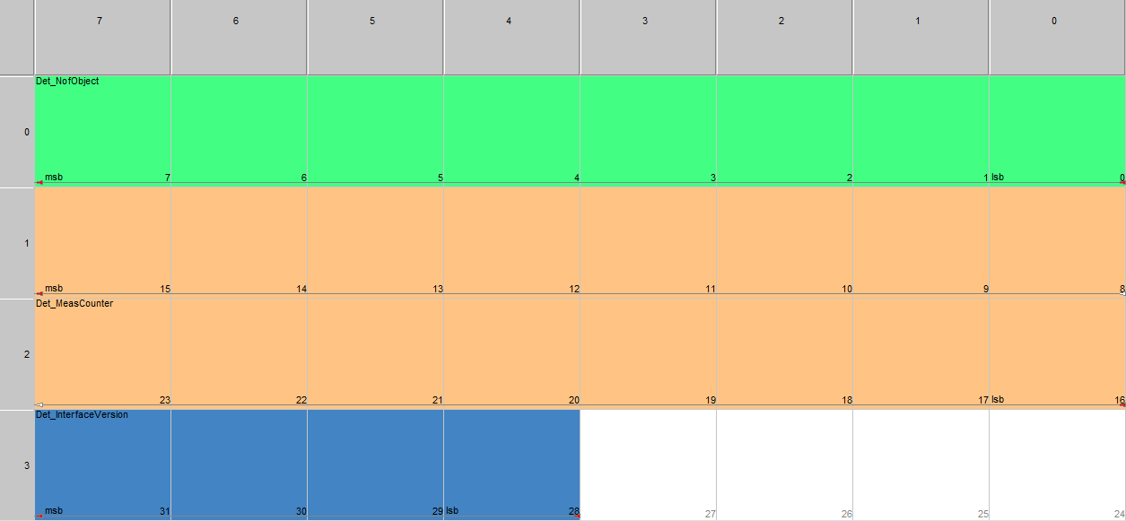

Figure 13: Detect_0_Status - message layout (0x70A)

Table 20: Detect_0_ Status - message content (0x70A)

|  |  |  |  |  |  |  |
| --- | --- | --- | --- | --- | --- | --- |
| **Signal** | **Start** | **Len** | **Min** | **Max** | **Res** | **Unit** |
| Detect_NofObjects | 0 | 8 | 0 | 255 | 1 | - |
| Detect_MeasCounter | 16 | 16 | 0 | 65535 | 1 | - |
| Detect_InterfaceVersion | 28 | 4 | 0 | 15 | 1 | always “1” |

Table 21: Detect_0_Status - signal description (0x70A)

|  |  |  |
| --- | --- | --- |
| **Start** | **Signal** | **Description** |
| 0 | Detect_NofObjects | Number of detects (max. 64 Objects) |
| 16 | Detect_MeasCounter | Measurement cycle counter (counting up since startup of sensor and restarting at 0 when > 65535) |
| 28 | Detect_InterfaceVersion | Detect list CAN interface Version-No. .  It is always “**1**” till any Detect Identifier will be changed in any coming SW-update. |

## Detect general information (0x70B)

This message contains the position and velocity of the objects and is sent repeatedly for all the tracked objects.

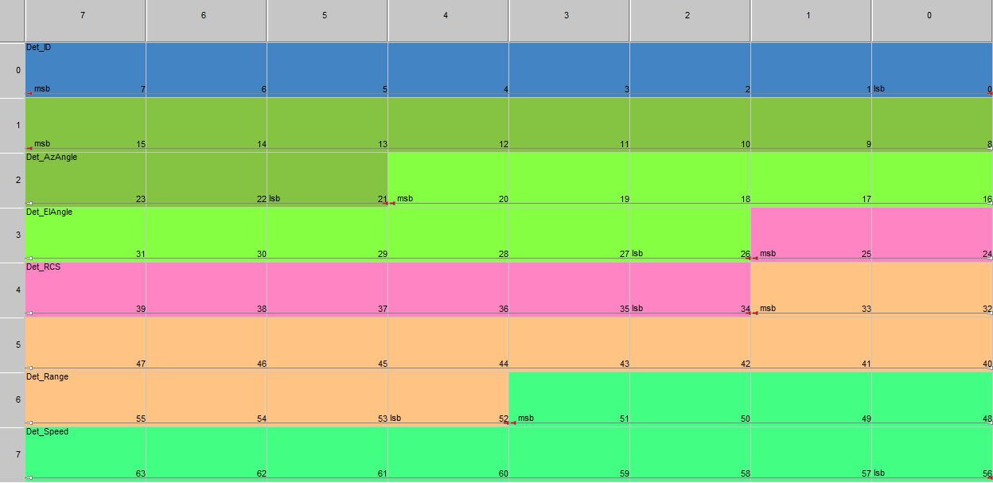

Figure 14: Detect_1_General - message layout (0x70B)

Table 22: Detect_1_General - message content (0x70B)

|  |  |  |  |  |  |  |  |
| --- | --- | --- | --- | --- | --- | --- | --- |
| **Signal** | **Start** | **Len** | **Offset** | **Min** | **Max** | **Res** | **Unit** |
| Detect_ID | 0 | 8 |  | 0 | 255 | 1 |  |
| Detect_AzAngle | 21 | 11 | -90 | -90 | 90 | 0.1 | ° |
| Detect_ElAngle | 26 | 11 | -90 | -90 | 90 | 0.1 | ° |
| Detect_RCS | 34 | 8 | -64 | -64 | 63.5 | 0.5 | dBm² |
| Detect_Range | 52 | 14 |  | 0 | 327.66 | 0.02 | m |
| Detect_Speed | 56 | 12 | -100 | -64 | 104.75 | 0.05 | m/s |

Table 23: Detect_1_General - signal description (0x70B)

|  |  |  |
| --- | --- | --- |
| **Start** | **Signal** | **Description** |
| 0 | Detect_ID | Detect number |
| 21 | Detect_AzAngle | Azimuth angle |
| 26 | Detect_ElAngle | Elevation angle |
| 34 | Detect_RCS | Radar cross section |
| 52 | Detect_Range | Relative distance |
| 56 | Object_Speed | Relative velocity |