# Assignment #7: Learning Hidden Models

[**Requirement**: You need to derive the formula for the inference & learning steps. Try to use ***pseudo codes*** to present your algorithm.]

1. For the below restricted Boltzmann machine with 0-1 binary variables, the weights for pairwise interactions are ***w***, and the weights for single nodes are ***α***and***β***.

1) Please write down its Gibbs distribution (parameters are **UNKNOWN, but only two free parameters *a* & *b*!!**).

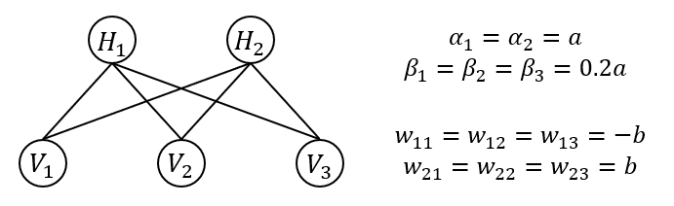

2) Please design a learning algorithm if $V_{1}, V_{2}, V_{3}$ are always observed and $H_{1}, H_{2}$ are hidden variables. (*Hint: remember the iterative process*)

3) **Practice (*Required!!*): write your own codes for the learning:**

1. Please find the data via the web learning (网络学堂).
2. Infer the hidden variable for each data point.
3. Report the estimated parameters (you’d better visualize the learning process).

4) (*Optional*) Compare the performances of using different inference and parameter learning algorithms. Please give your own comments.