# Assignment #6: Variational Inference

[**Requirement**: You need to derive the formula for the variational inference. Try to use ***pseudo codes*** to present your algorithm.]

1. For a 5-node pairwise **Markov random field** (restricted Boltzmann Machine) of 0-1 binary variables, the weights for pairwise interactions are ***w***and ***h***, and the weights for single nodes are ***α***and *β*.

1) Please write down its Gibbs distribution.

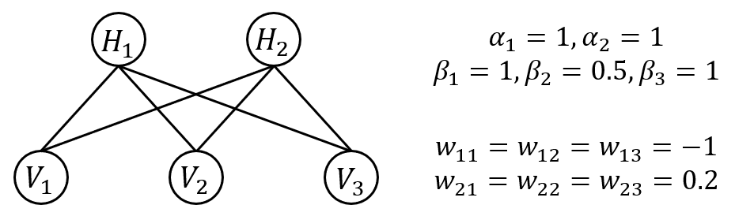

2) Please design a **cluster graph** based algorithm for inference.

Practice (***Optional!!***): write your own codes to do belief propagation. Please:

1. Plot the belief (marginal distribution) updating process of the five nodes of the first 100 iterations;
2. Report the marginal distribution of the five nodes, respectively.

3) Please derive the **mean-field variational inference** for inference.

**Practice (*Required!!*): write your own codes for the inference:**

1. Plot the belief (marginal distribution) updating process of the five nodes of the first 100 iterations;
2. Report the marginal distribution of the five nodes, respectively.

4) Compare the inference results of Gibbs sampling, MH algorithm and mean-field inference. Please give your own comments.