**第1次作业**

自硕21 崔晏菲 2021210976

**1. UCSC Genome Browser**

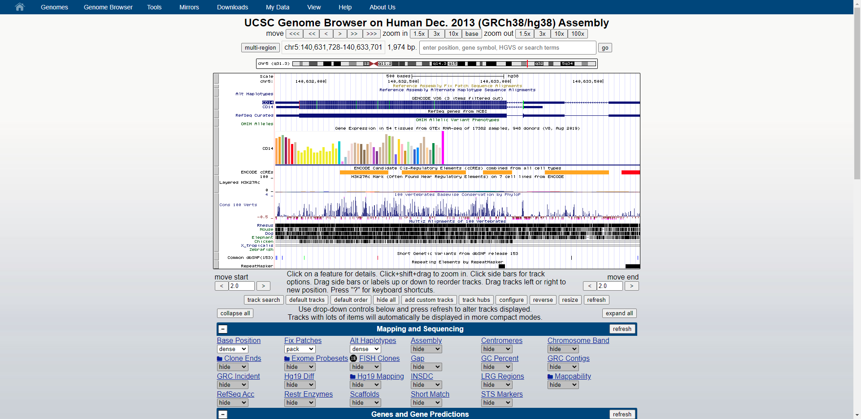

这本质上是一个关系型数据库。

**2. Count the number of protein-coding genes on each chromosome.**

|  |  |
| --- | --- |
| 染色体 | 蛋白质编码基因数 |
| chr1 | 20,376 |
| chr2 | 16,951 |
| chr3 | 14,438 |
| chr4 | 9,533 |
| chr5 | 11,020 |
| chr6 | 10,604 |
| chr7 | 11,016 |
| chr8 | 9,693 |
| chr9 | 7,768 |
| chr10 | 8,124 |
| chr11 | 13,631 |
| chr12 | 12,939 |
| chr13 | 4,244 |
| chr14 | 8,517 |
| chr15 | 8,603 |
| chr16 | 11,048 |
| chr17 | 13,708 |
| chr18 | 4,497 |
| chr19 | 13,790 |
| chr20 | 5,456 |
| chr21 | 2,983 |
| chr22 | 4,996 |
| chrX | 7,169 |
| chrY | 976 |

**3. Summarize length distributions of exons, introns and genes on each chromosome and in the whole genome using histograms, and also provide statistics like median, mean, max/min, etc..**

**3.1 外显子长度分布**

