Lab1

z5382484-LinXing Jia

**Exercise 1:**

1.The series of IP addresses that appear when using the nslookup command on the Telstra website are all its IP addresses. This is to avoid system overload, which may occur when a website suddenly generates high traffic or large-scale activity, and multiple IP addresses can spread the traffic. Improve the efficiency and usefulness of your website.

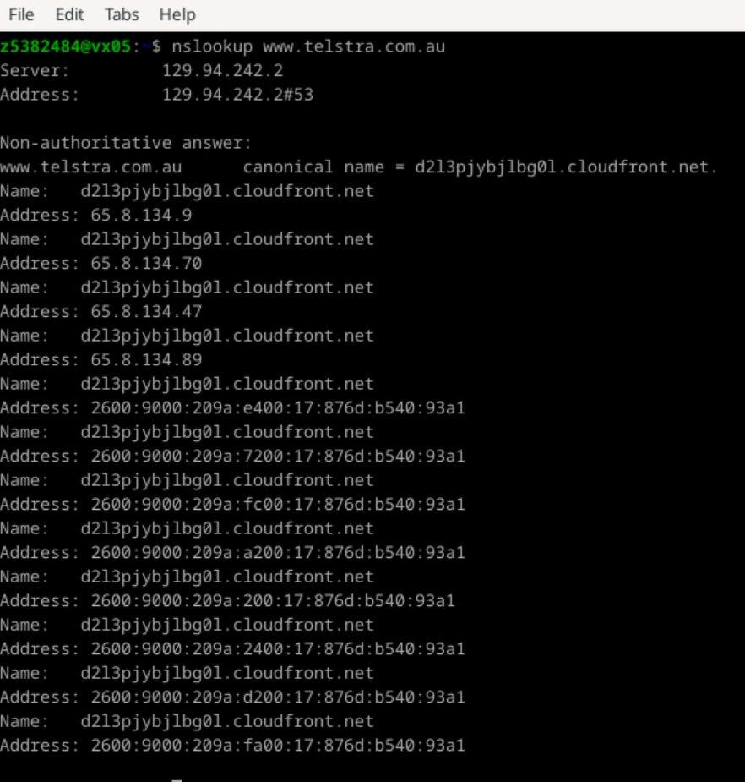

2.

The name of IP address 127.0.0.1 is localhost, which is usually used to refer to the local computer. localhost is usually used for testing, development and debugging.

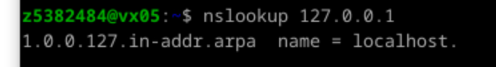

**Exercise 2:**

1.www.google.co.uk

This site is reachable.

2.www.columbia.edu

This site is reachable.

3.www.wikipedia.org

This site is reachable.

4.ec.ho

This site is unreachable. No information can be obtained using the ping command, and the website cannot be accessed through web browser. This may be because the URL name is incorrect or the URL does not exist.



5.hhh.gs

This site is reachable.

6.defence.gov.au

This site is unreachable. But this website can be accessed through a web browser and is an Australian government website. In order to avoid attacks and hacker access, government agencies' websites usually set up firewalls to prevent ping requests (ICMP packets) from passing through. Therefore, even if the website can be accessed through a browser, it may not be possible to conduct a ping test from the external network.

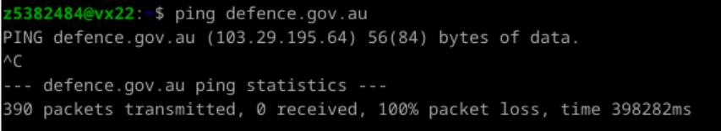

7.yes.no

This site is reachable.

8.one.one.one.one

This site is reachable.

9.theguardian.com

This site is reachable.

10.xn--i-7iq.ws

This site is reachable.

**Exercise 3:**

**1.**

1. The screenshot shows that when I used the traceroute command on the URL usi.ch, I got 21 pieces of data, which means that 20 routers passed through my workstation to usi.ch. The first five of these routers are part of the UNSW network based on their IP address(Within private IP address range). The sixth router is verified to belong to Australia, so the first five routers are part of UNSW.
2. The 11th router is the first outside Australia. Judging from the IP address, this website belongs to Singapore. It can also be seen from the RTT data that the data packet spends longer on the 11th router than before.
3. The 13th router is the first one in Europe. The RTT is very different between the 11th and 12th piece of data which means the packet travels further which will take more time. However, after checking, the 12th router still belongs to Australia(AARNeT). The thirteenth router contains the "uk" field, and the RTT data proves that it is the first router in the UK.

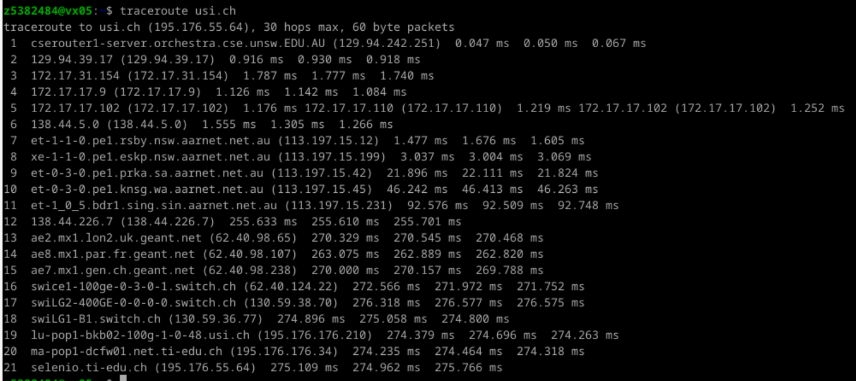

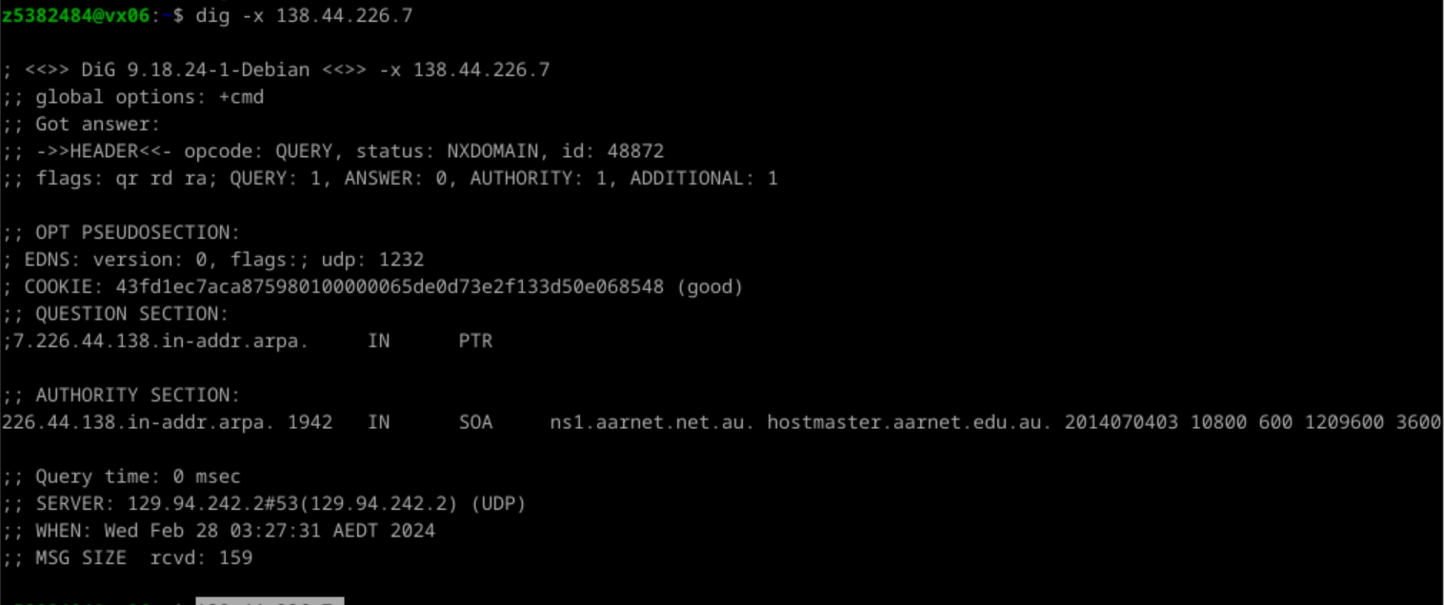

**2.**

1. As we can see from the three screenshots below, the paths from my workstation to these three destinations are spread out on the 6th router, and the first six routers are the same on these three paths.
2. The number of hops on each path is not proportional to the physical distance, The distance between UNSW and the University of Edinburgh in the UK is longer than the distance from the University of São Paulo in Brazil, but the number of hops is fewer, which is obviously not proportional.

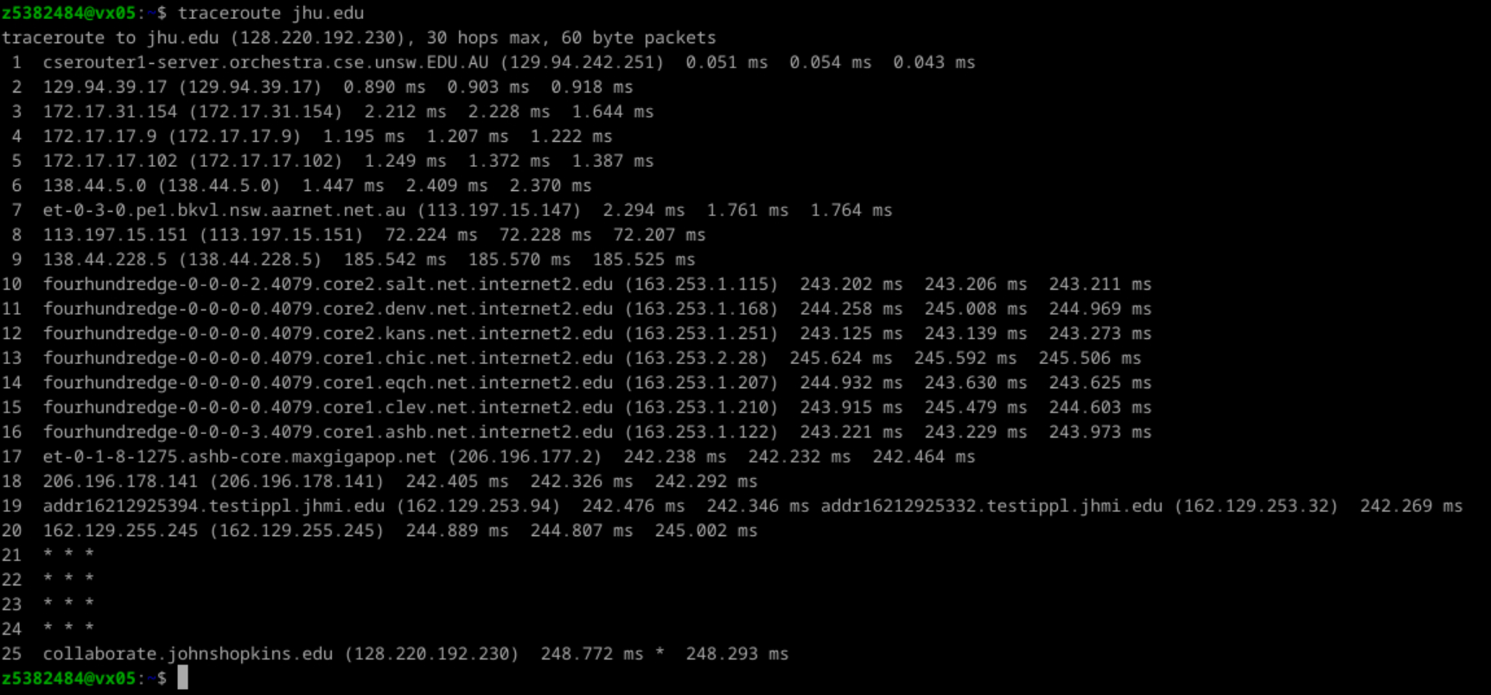

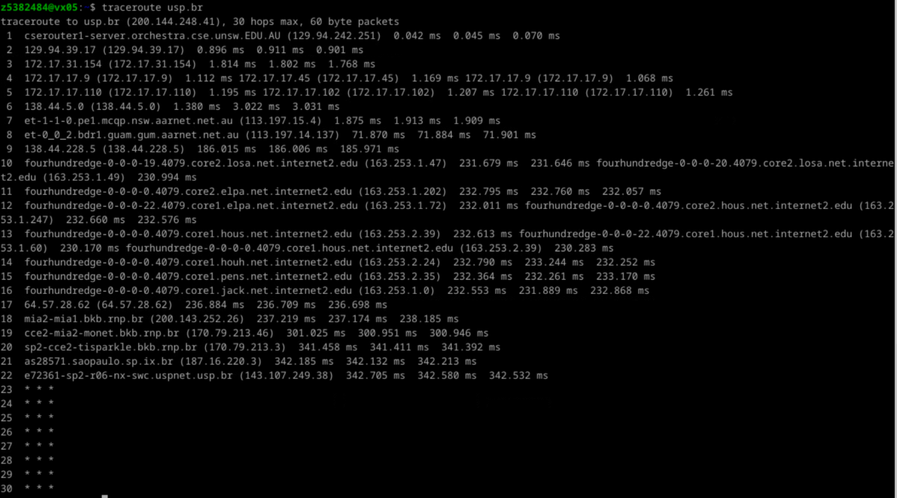

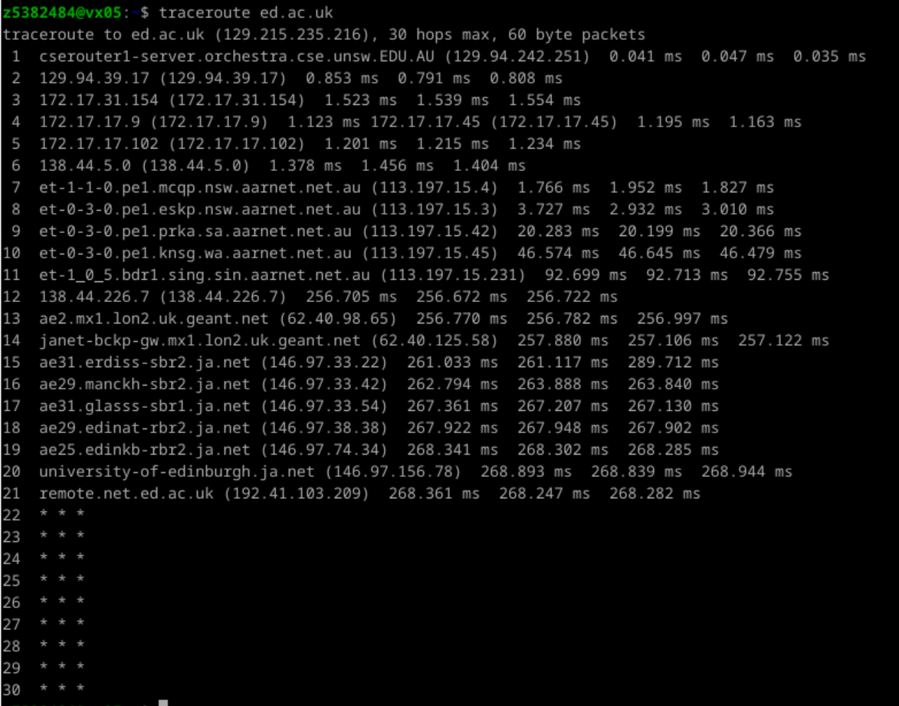

**3.**

1. The two selected IP addresses are:

www.net.princeton.edu：128.112.128.55

www.as13030.net：213.144.137.198

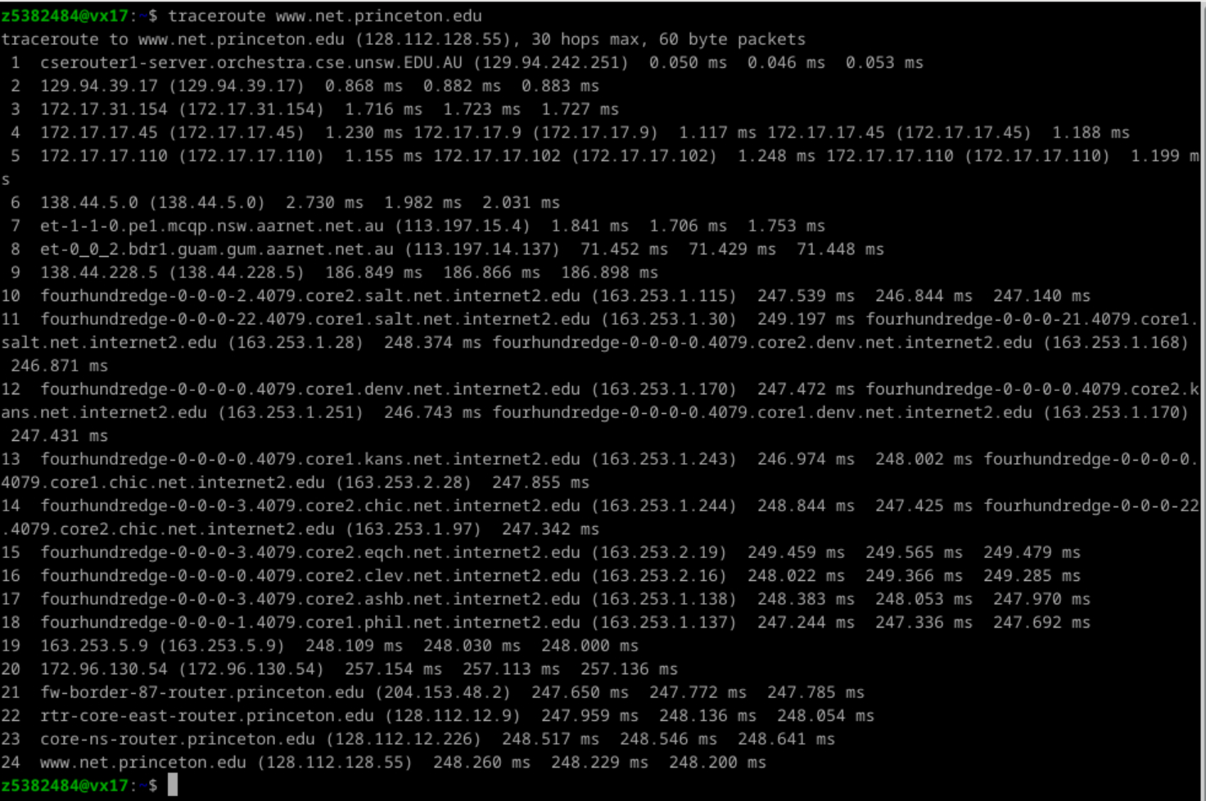

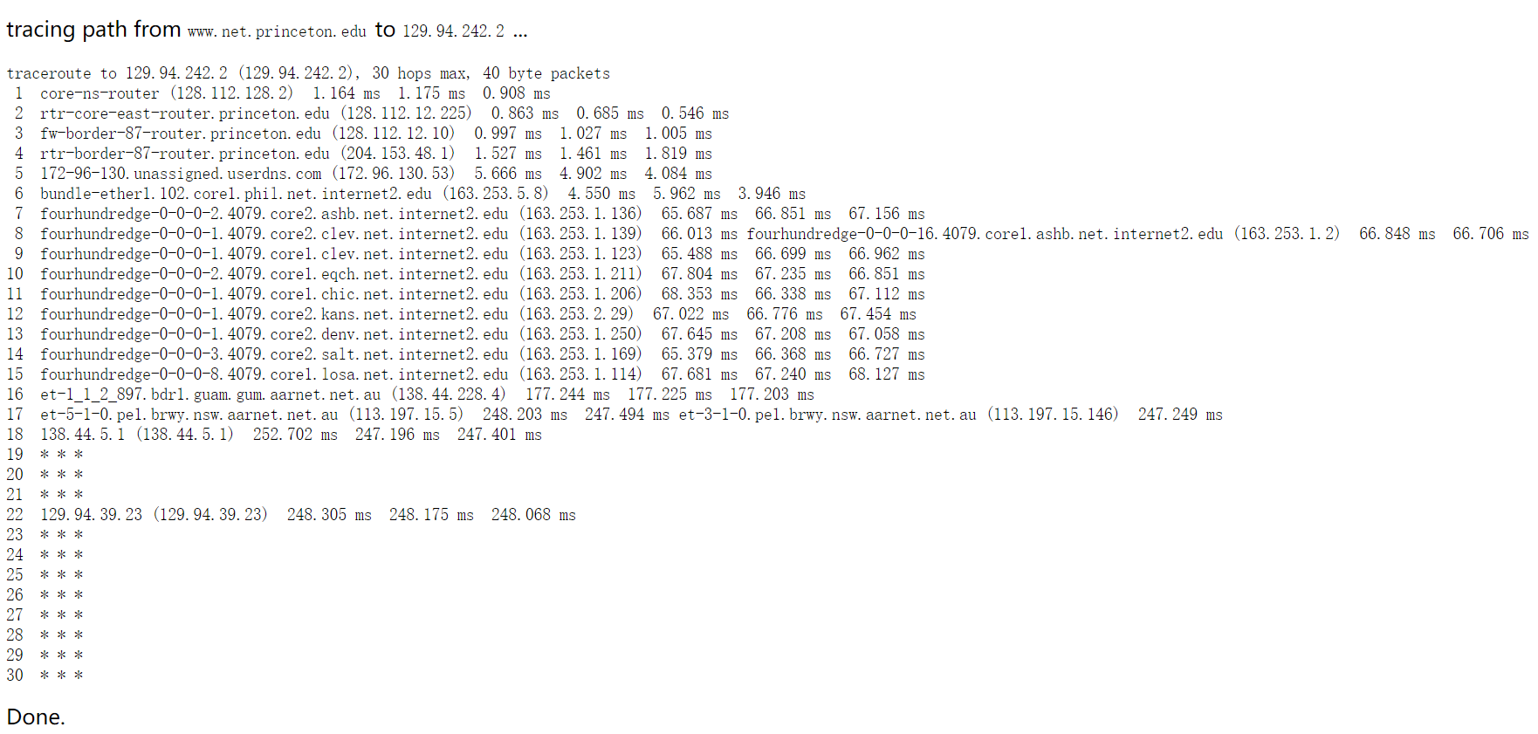

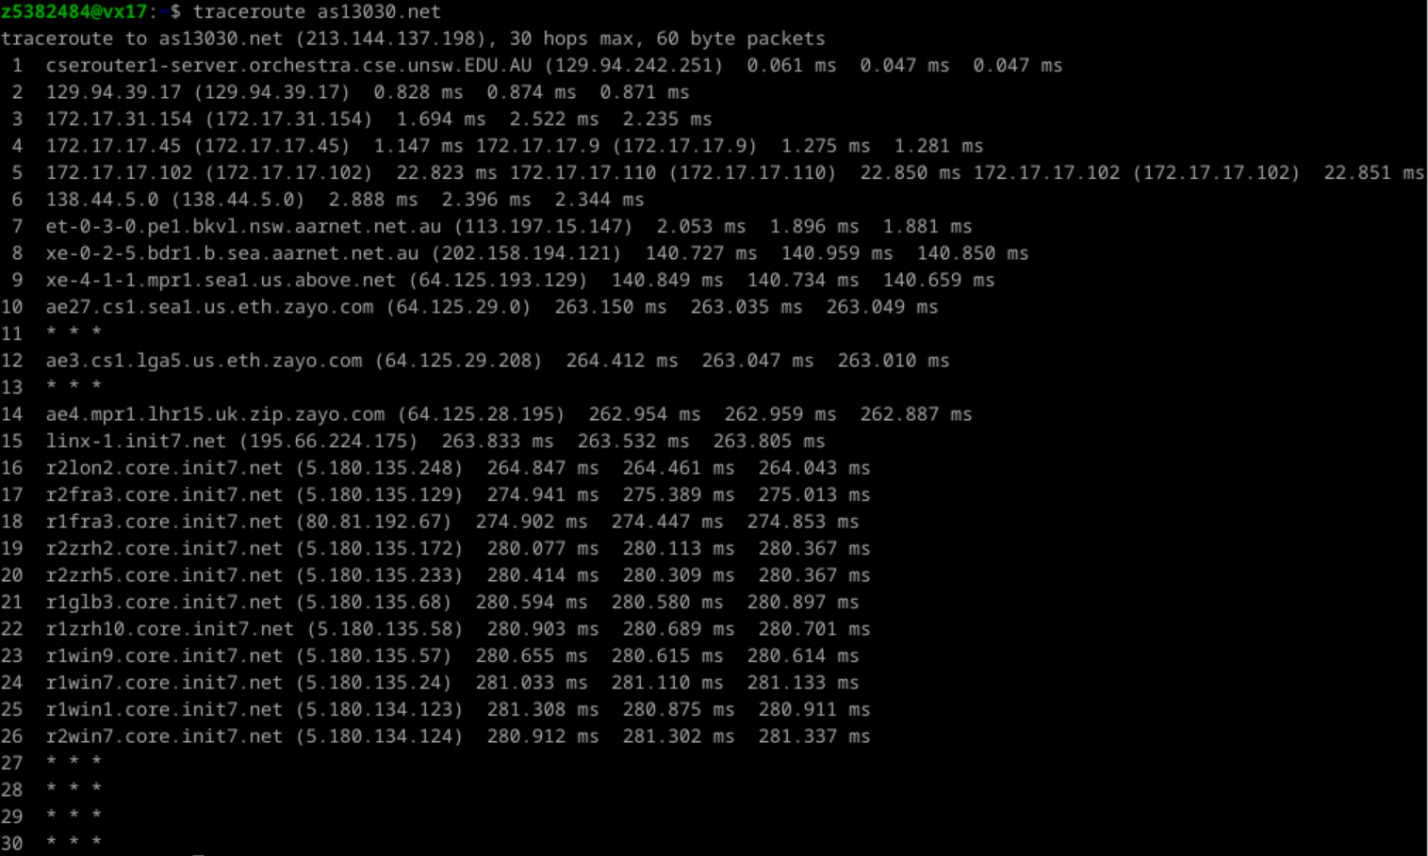

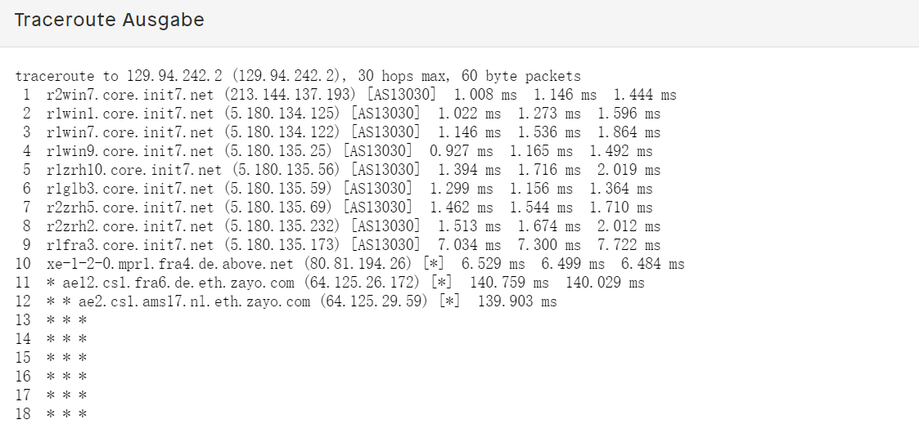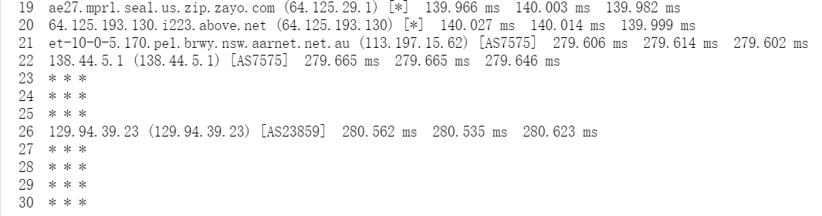

2.From the above figure, we can see that the reverse path and the forward path pass through different routers. This is because a router may choose a path based on a specific routing policy, such as router configuration, network protocol, or routing information in a routing table. Therefore, different routers may be selected for the forward path and reverse path at different times or situations.

3.I did not observe the same IP address appearing in the forward and reverse paths from my machine to these two websites. This is likely because the same website can have multiple IP addresses, in order to share traffic and improve performance. Routers also usually randomly select IP addresses during the transmission of data packets to avoid network traffic load.

**Exercise 4:**

1. The physical distance between UNSW University and the three locations is as follows:

Darwin:3151km, Sao Paulo:13370km , Edinburgh:16869km.

The shortest known possible time is the distance divided by the speed of light. Therefore, the shortest possible time T for UNSW data packets to reach these three locations is as follows:

Darwin:10.5ms, Sao Paulo:44.57ms , Edinburgh:56.23 ms.

1. From the *avg.txt file, we can know that the minimum RTT (select the value of the 50-byte data packet) of these three locations are,

Darwin:54.077ms, Sao Paulo:341.952ms , Edinburgh:268.561 ms.

and the calculated ratios are:

Darwin:5.15, Sao Paulo:7.67 , Edinburgh:4.78.

Draw the image as follows:

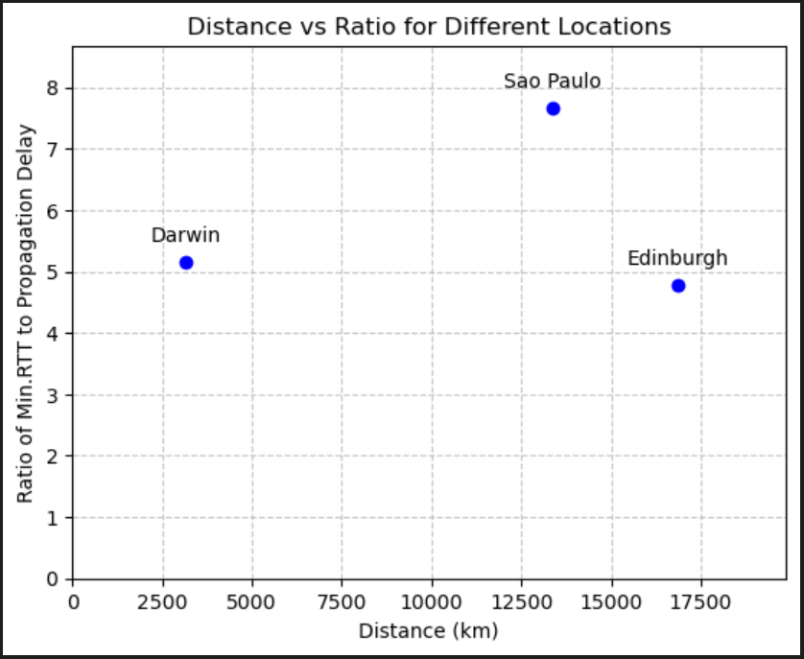

1. The reasons are as follows:
2. Light propagates in a straight line, but the transmission path of data packets is not a “straight line”. It usually needs to pass through many routers and network nodes, which will increase the transmission delay and reduce the transmission speed.
3. There are various delays in the transmission process of data packets, including propagation delay, transmission delay, processing delay and queuing delay. When encountering a sudden increase in network traffic, the router may face congestion, causing data packets to be queued for processing. This also increases latency.

**4.** The delay time of a router to reach the destination usually changes with time, rather than being fixed. The router may encounter various situations in the process of transmitting data, such as network congestion. When network traffic increases, the router may face congestion, causing data packets to be queued for processing, which will increase the delay time. There are also network failures and other situations that may result in packet loss.

**5.** The delay effects of the three paths are as follows:

cdu.edu.au：

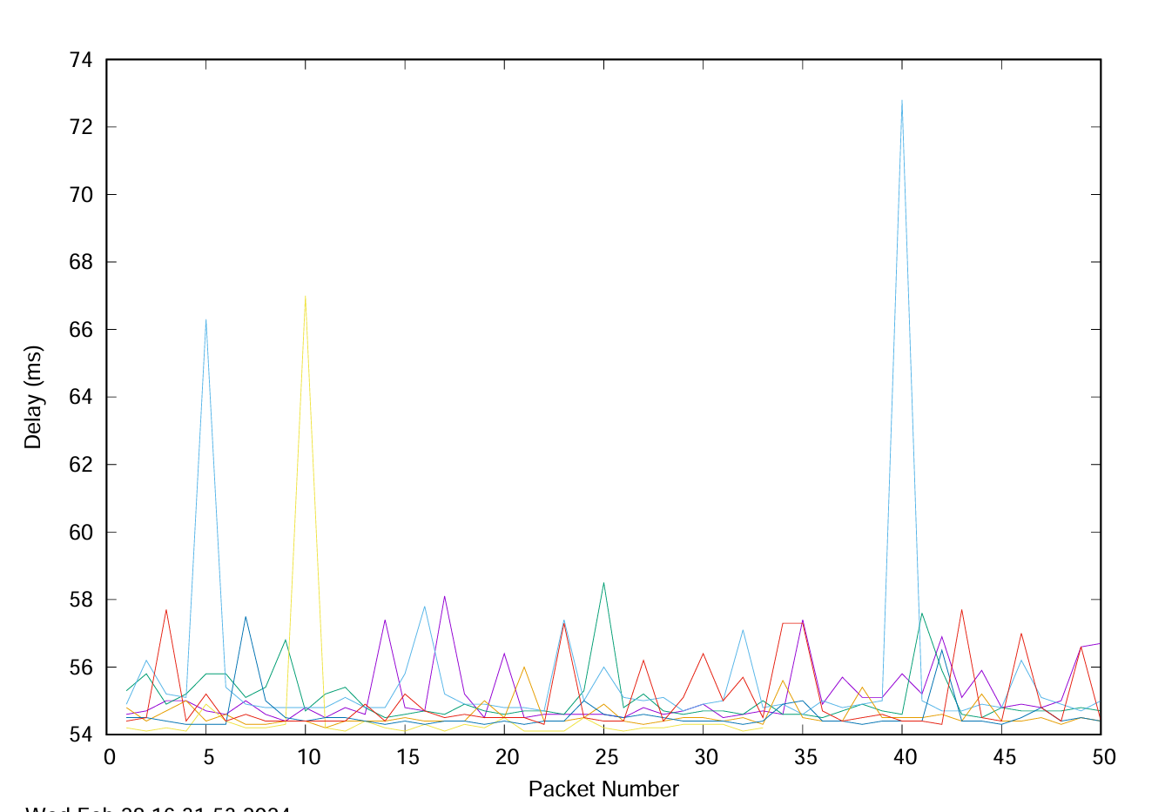

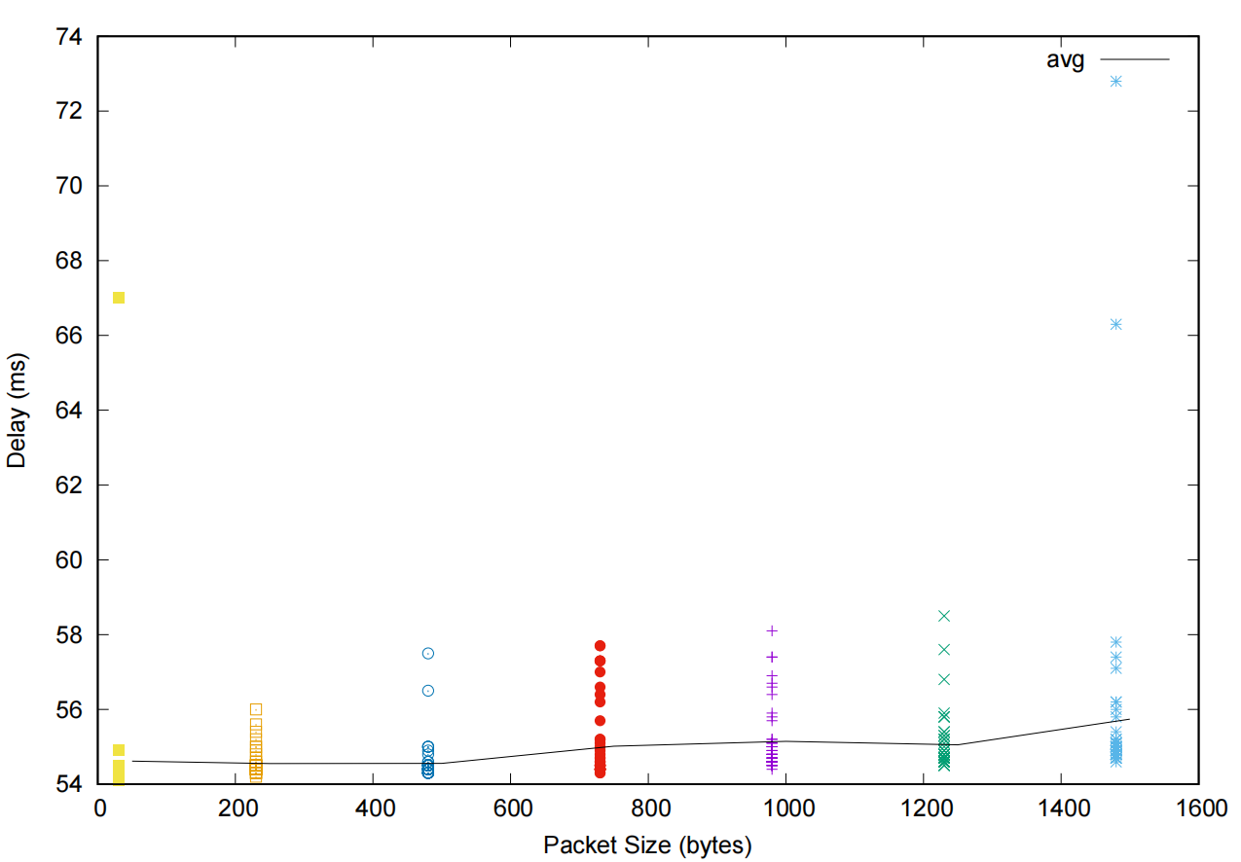

usp.br：

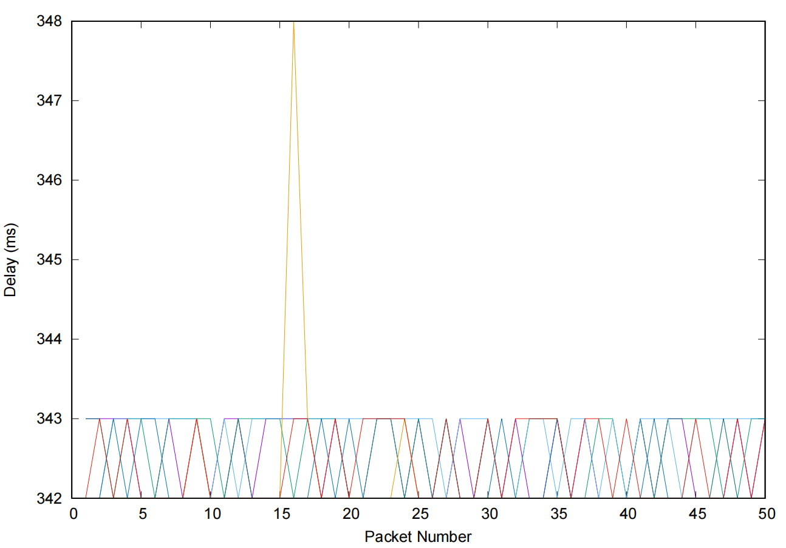

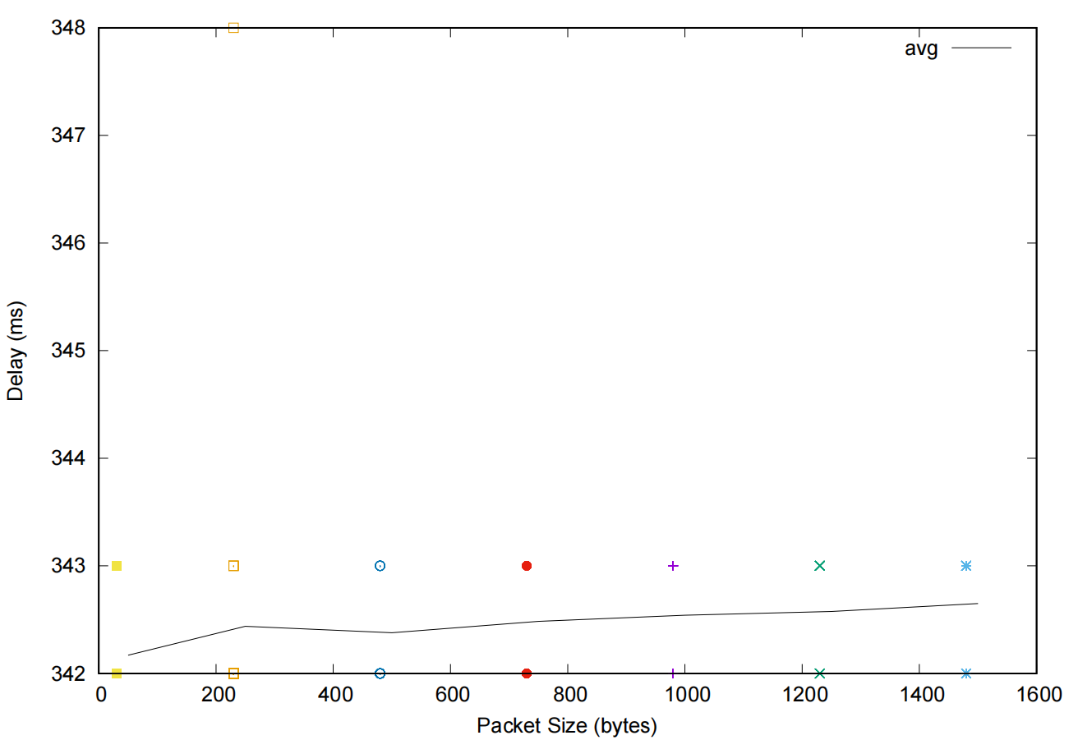

ed.ac.uk：

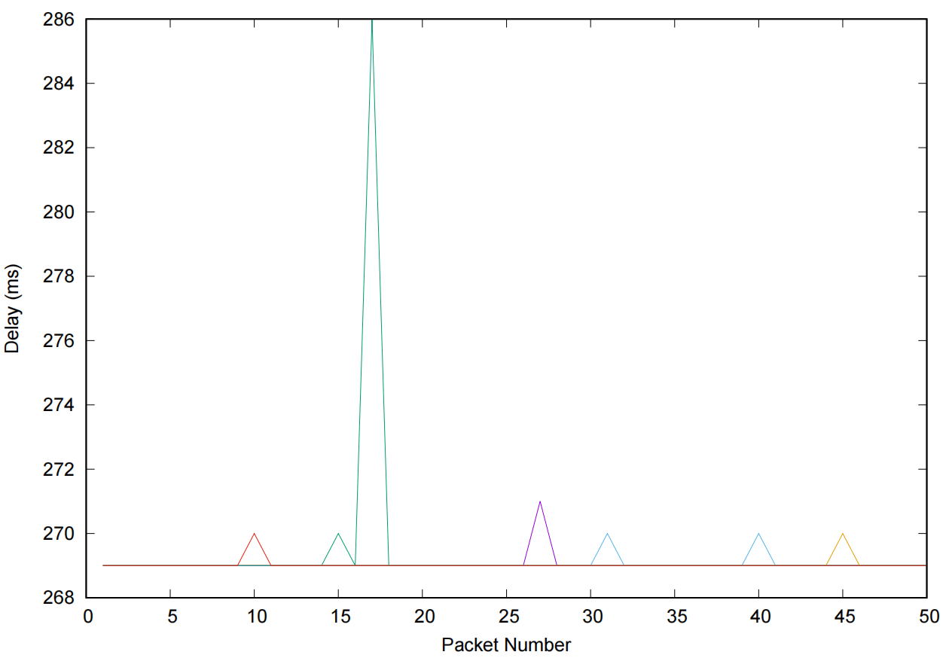

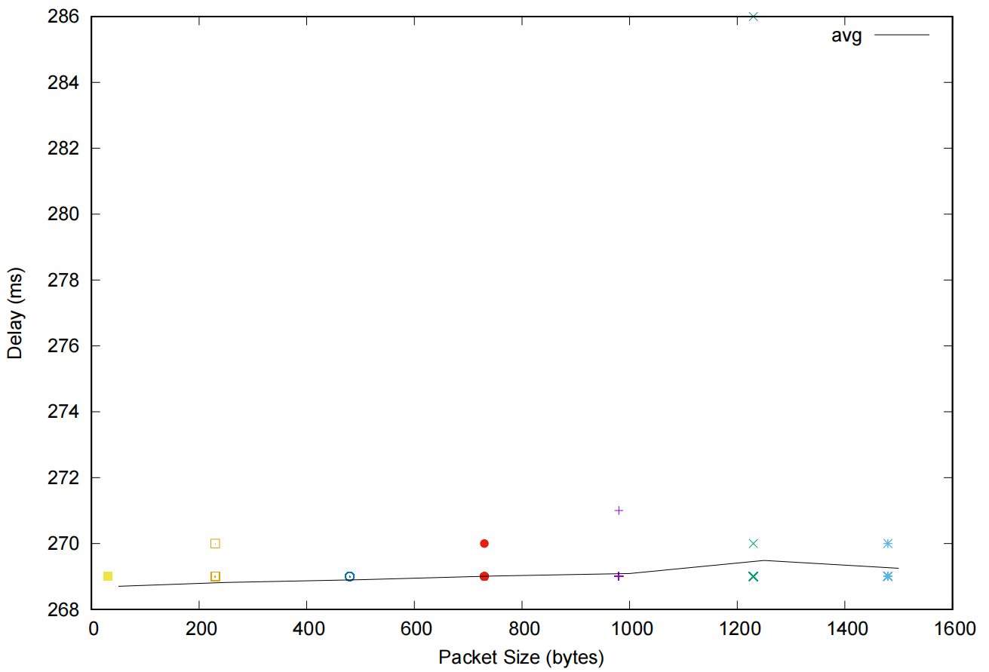

Among the measured delays, propagation delay and transmission delay are independent of packet size, while processing delay and queuing delay are dependent on packet size.

Propagation delay: This delay is equal to the ratio of the physical link length d and the propagation speed s, that is dProp= d/s. Therefore, the propagation delay depends on the length of the physical link and the propagation speed.

Transmission delay: This delay is equal to the ratio of the length L of the data packet and the link bandwidth R, that is, dtrans=L/R, regardless of the size of the data packet.

Processing latency: Processing latency is the time it takes for a router or device to process a packet. Processing latency may be affected by packet size, as larger packets may require more processing work.

Queuing delay: This delay is caused by waiting for transmission on the output link. This depends on how congested the router is, as large packets may take up more buffer space, resulting in longer queuing delays.