**Result Report for Exp3 and UCB1**



**Part 1: Result of Exp3**

Change Parameter gamma and change when to re-initialize the algorithm.

0.3_Hours: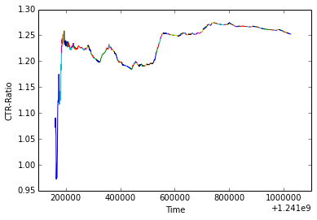

0.5_Hours: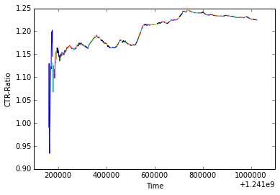

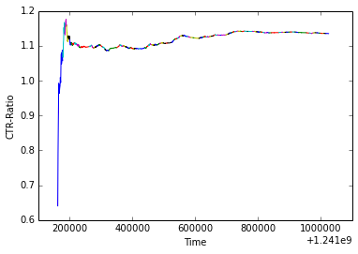

0.7_Hours:

0.3_SingleDay: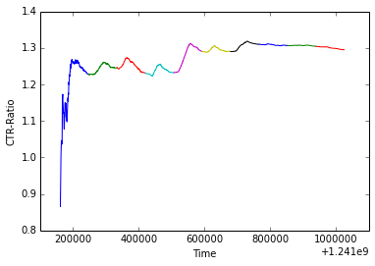

0.5_SingleDay: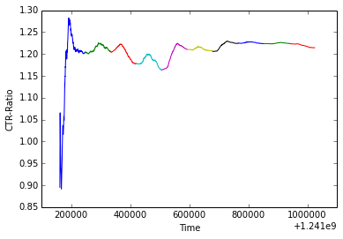

0.7_SingleDays:

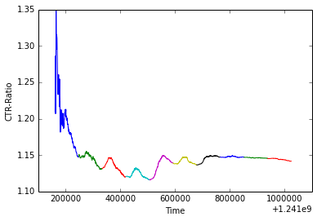

0.3_MultipleDays:

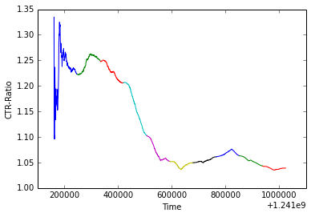

0.5_MultipleDays:

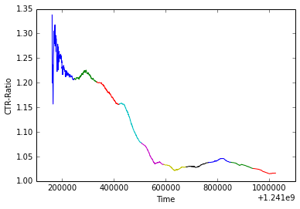

0.7_MultipleDays:

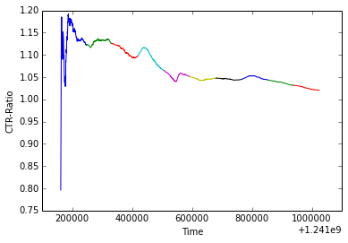

**Result Analysis:**

When reinitialize time interval is short, for example reinitialize every 2 hours, the CTR generally keep increasing (although there is also some decreases during certain hours), and the performance is better when parameter gamma is smaller. This reasonable because it means exploitation is preferred when time interval is really short.

When re-initialize time interval is long, for example re-initialize every single day, the CTR first increase and then decrease in one time interval(one day) . This may because of user preference shifting over time.

Do not re-initialize during these 10 days is a more extreme case, the CTR first increase a little bit and then generally keep decreasing.

**Part 2: Results of UCB1**

Re-initialize every 2 Hours: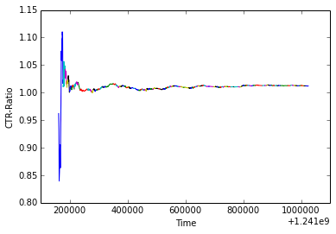

Re-initialize every Single Day：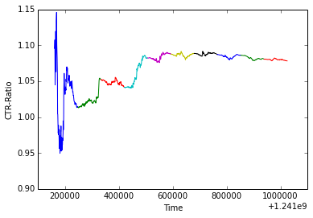

Do not re-initialize (MultipleDay):

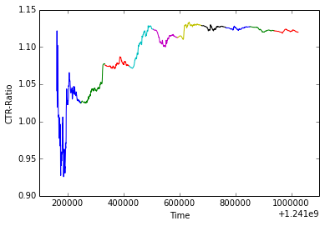

**Analysis:**

According to UCB1 algorithm, it firstly play each of all arms once. So when re-initialize time interval is short(2 hours), and new articles keep popping up, UCB1 will always chose new articles. This make the performance of UCB1 like random. But when re-initialize time interval is longer(every one Single day and ten days), the performance will be better.