Apache HTTP Server

a documentation Manual



30 Baldovino, Britanny Meneses

05 Cabrera, Gian Luigi Madarang  
08 Culanag, Ian Jemuel Nacorda

34 Elegado, Angel Nica Ticwala  
16 Ishii, Satoyoshi Lumalang  
17 Jumawid, Ronnie Jr. Sabado  
25 Supnet, Dominic Ethan Marasigan

TABLE OF CONTENTS

Prerequisites …………………………………………………………………………………….1

Setting Up Apache Virtual Host ……………………………………………..........................2

Creating a Directory …………………………………………………………………….3

Grant Permissions ……………………………………………………………………...4

Create Files to be Served ..…………………………………………………………….5

Create Virtual Host Files .……………………………………………………………...6

Enable the Virtual Host Files …………………………………………………………..7

Set up Local Host File ………………………………………………………………….8

Testing …………………………………………………………………………………...7

Enabling Compression

Enabling Caching

Create virtual hosts mapped to the domain names webtech1.negotiage.org

PREREQUISITE

Before anything else, we need to make sure that apache is installed. To do so we begin by typing,





After making sure that apache is installed we can now start with the Virtual hosts

SETTING UP APACHE VIRTUAL HOST

CREATING A DIRECTORY

Apache has its default web content under the /var/www/html, but for this project we will specify another location for our content for it to be separate from the default content.

We will set individual directories under the /var/www directory.



Because of these commands we have generated 3 directories



And under the generated directories contains public_html that would store the content of the project



GRANTING PERMISSIONS

Now that we have constructed the directory for our content we have to change the ownership of the said directory. We can do that by typing the command:



The $USER represents the current user logged in



This command ensures that the web server has the permissions it need to server the content under the directory

CREATING FILES TO BE SERVED

The content we’ll use for the three virtual hosts are the advocacy sites that the group has created. For our repository, we used GitHub, and in order to clone that same repository in Ubuntu Server, we must first install Git:

  


After installation, we clone the Git repository we have on GitHub by executing the command:



Doing so would clone the repository to our server. The directories are then transferred to the appropriate subdirectories (/var/www/www/group3a.org/public_html, etc..) To do so, we copy the corresponding directory of each:



And then we delete the current public_html which is set earlier by default

And finally rename the directory to ‘public_html’ using the command below

The process is repeated for the other advocacy sites.

CREATE VIRTUAL HOSTS FILES

Apache has a default virtual host file named 000-default.conf. We would use that as a basis for our virtual host files

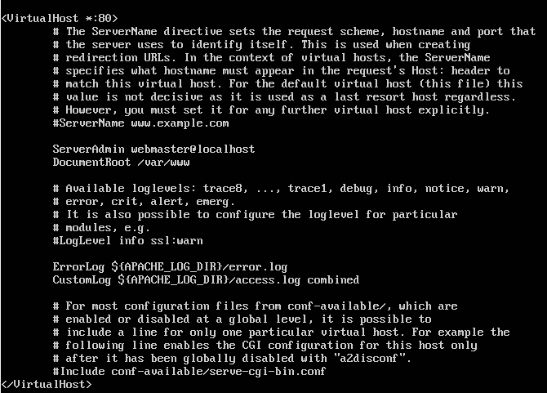

Begin by copying the 000-default.conf

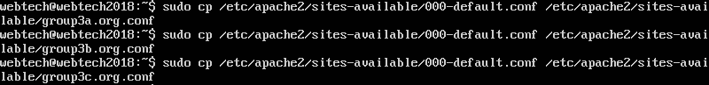

Next is to edit each file

group3a.conf should contain the ff:

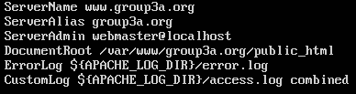

group3b.conf should contain the ff:

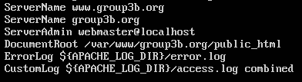

group3c.conf should contain the ff:

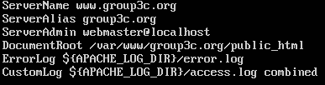

Enable the Virtual Host File

After creating the virtual host file we used the a2ensite tool to enable the sites



Then disable 000-default.conf



Next is to reload the server



Set up local host file

If you are using the option Host-only Adapter then make sure to go to global tools found on the upper right of your vm

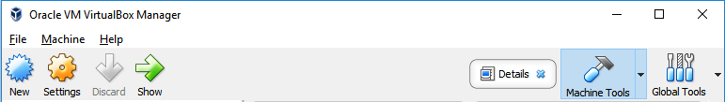

Then click the Host Network Manager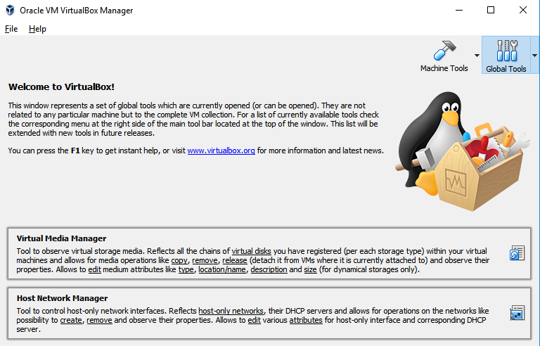

Afterwards you will reach this section

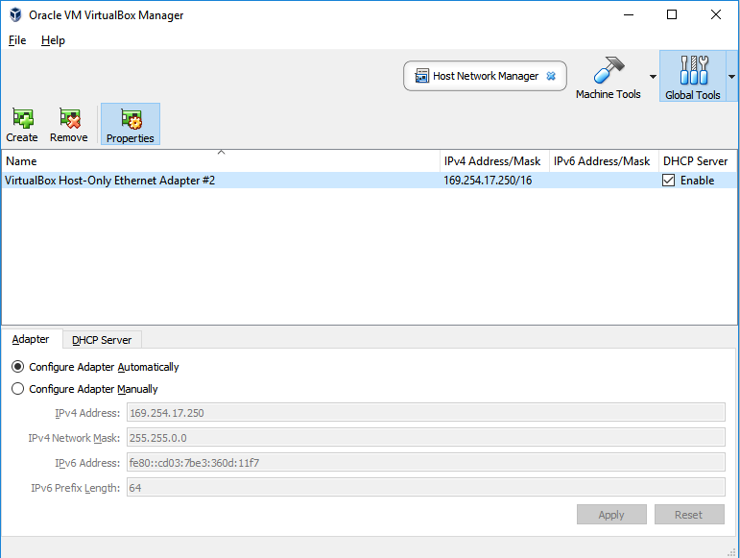

Make sure to create a Host-Only network and enable the DHCP server so that you will be given an IP address

In the VM type hostname to check IP address of your machine



After knowing the needed info open your host file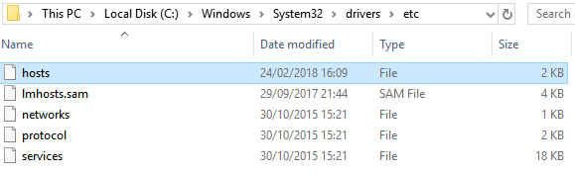

After opening your host file edit it and add the IP address of your VM and the domain name



Testing the url

After editing your host file test it by opening your browser and input the domain name you specified in the ServerName in your virtual host file



If successful, the advocacy website shall now display when the domain name is typed in the browser.

ENABLING COMPRESSION

In order to serve compressed content to clients, we modify the configuration file of our website. We begin by typing:



This will execute nano and take us to the .conf file, we then add the directive

AddOutputFilterByType DEFLATE text/html text/css

to compress html and css content types.

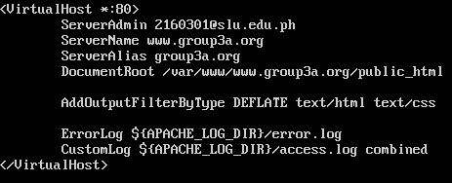

And then we save the file, reload the server to apply (as specified before).

ENABLING CACHING

//gian ethan

CONTENT NEGOTIATION

ACCESS CONTROL

ENABLING SERVER-SIDE INCLUDES

The first thing needed to be done is to enable the Includes module. It can be enabled with the command:



We then open the configuration file:



We add these lines inside the configuration file; take note that Includes havs to be added at the end of Options. Another thing to consider is that the AddType and AddOutputFules directives for .shtml are needed for older versions of Ubuntu.

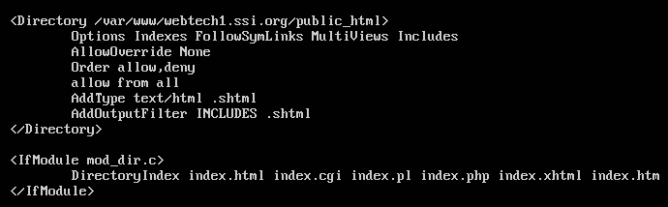

Again, for changes to take effect, the server must be restarted.

We will then be testing if it works. We’ll be creating an SSI test file with the contents:

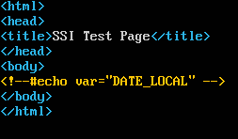 this would be save in /var/www/ssi-test.shtml

Typing http://127.0.0.1/ssi-test.shtml

SSL/TLS ENCRYPTION

Create virtual hosts mapped to the domain names webtech1.negotiage.org

Begin by creating a directory that will store the content of the domain.



After typing that go to the created directory by typing



Next is to create files to be served do this by typing



And another one



And here is the content of the created files

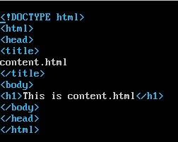

Next would be configuring the host hosts to enable clients to negotiate with the servers, using the HTTP Accept header

We start by creating a virtual host file as shown at the first part of this documentation.

This is the created virtual host file

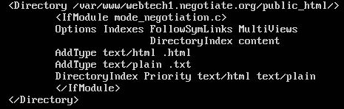

As a result

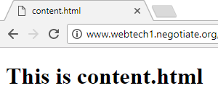

Next would be configuring the host hosts to enable clients to negotiate with the servers, using the HTTP Accept-language header

First is to edit the global configuration file of apache, to do so type



Then comment out the following to allow our virtual host to have it’s own configuration

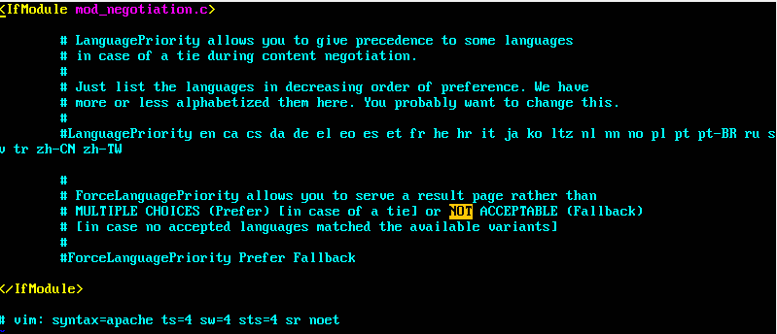

Afterwards save by typing :x and restart your apache. Make sure to configure the virtual host file of your domain

This is the added configuration in the webtech1.negotiation.org.conf

We made use of the MultiView for our negotiation with the client we specified the Directory Index as language,html so that the server will serve the file and find the specified extension appropriate for the client’s browser language settings

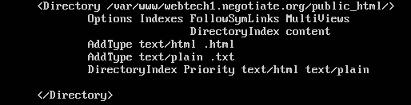

And this is the result of our configuration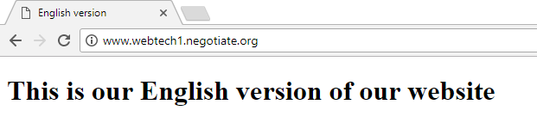

We can add languages in our client in our settings in chrome, also we can prioritize our language

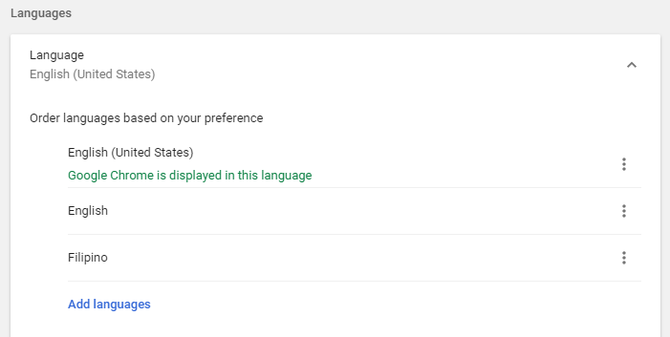

Here we have a client web browser that prioritizes English as the language of the web resources that will be served to the client