Apache HTTP Server

a documentation Manual



30 Baldovino, Britanny Meneses

05 Cabrera, Gian Luigi Madarang  
08 Culanag, Ian Jemuel Nacorda

34 Elegado, Angel Nica Ticwala  
16 Ishii, Satoyoshi Lumalang  
17 Jumawid, Ronnie Jr. Sabado  
25 Supnet, Dominic Ethan Marasigan

TABLE OF CONTENTS

Prerequisites …………………………………………………………………………………….1

Setting Up Apache Virtual Host ……………………………………………..........................2

Creating a Directory …………………………………………………………………….3

Grant Permissions ……………………………………………………………………...4

Create Files to be Served ..…………………………………………………………….5

Create Virtual Host Files .……………………………………………………………...6

Enable the Virtual Host Files …………………………………………………………..7

Set up Local Host File ………………………………………………………………….8

Testing …………………………………………………………………………………...7

PREREQUISITE

Before anything else, we need to make sure that apache is installed. To do so we begin by typing,





After making sure that apache is installed we can now start with the Virtual hosts

SETTING UP APACHE VIRTUAL HOST

CREATING A DIRECTORY

Apache has its default web content under the /var/www/html, but for this project we will specify another location for our content for it to be separate from the default content.

We will set individual directories under the /var/www directory.



Because of these commands we have generated 3 directories



And under the generated directories contains public_html that would store the content of the project



GRANTING PERMISSIONS

Now that we have constructed the directory for our content we have to change the ownership of the said directory. We can do that by typing the command:



The $USER represents the current user logged in



This command ensures that the web server has the permissions it need to server the content under the directory

CREATING FILES TO BE SERVED

ADD THE STEP by STEP process on how to add content

Create Virtual Host files

Apache has a default virtual host file named 000-default.conf. We would use that as a basis for our virtual host files

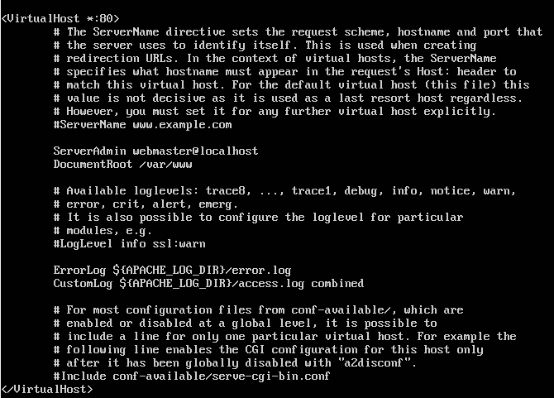

Begin by copying the 000-default.conf

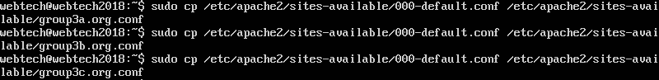

Next is to edit each file

group3a.conf should contain the ff:

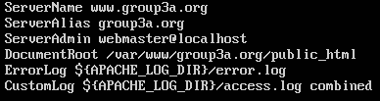

group3b.conf should contain the ff:

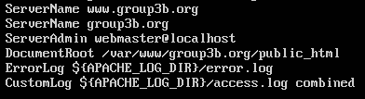

group3c.conf should contain the ff:

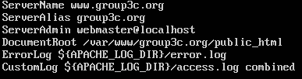

ServerName –

ServerAlias –

DocumentRoot –

Enable the Virtual Host File

After creating the virtual host file we used the a2ensite tool to enable the sites



Then disable 000-default.conf



Next is to reload the server



Set up local host file

If you are using the option Host-only Adapter then make sure to go to global tools found on the upper right of your vm

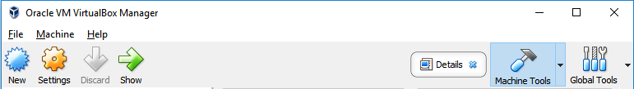

Then click the Host Network Manager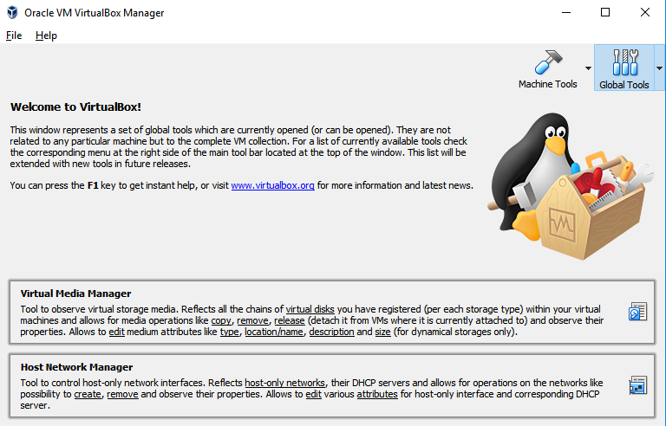

Afterwards you will reach this section

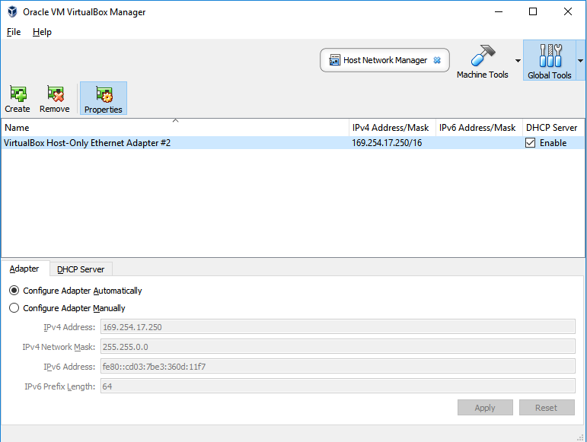

Make sure to create a Host-Only network and enable the DHCP server so that you will be given an IP address

In the VM type hostname to check IP address of your machine



After knowing the needed info open your host file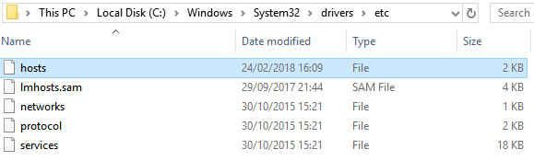

After opening your host file edit it and add the IP address of your VM and the domain name



Testing the url

After editing your host file test it by opening your browser and input the domain name you specified in the ServerName in your virtual host file