Diagrama Clase – rafinare  
  
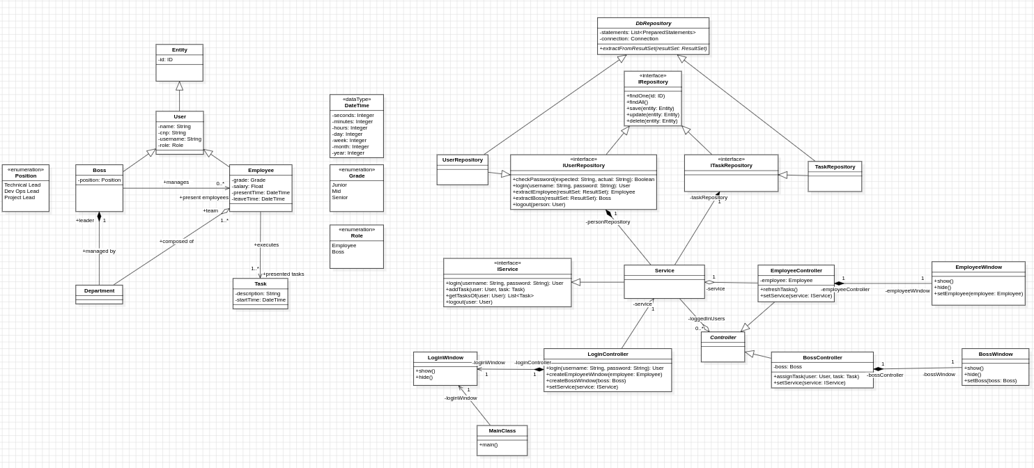

Diagrama secventa – Login Employee

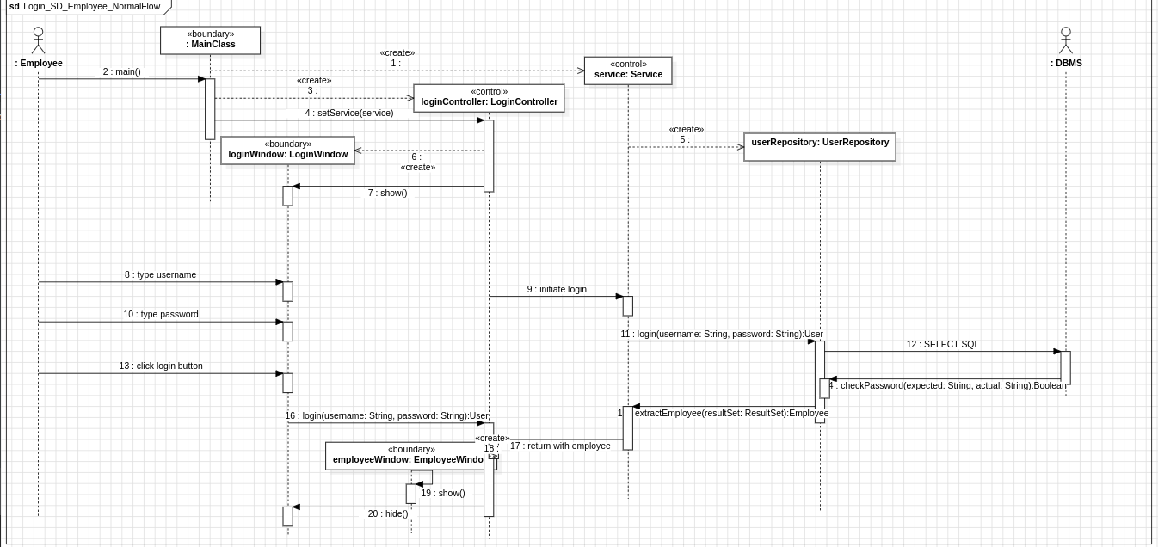

Diagrama comunicare – Login Employee