find / -type f -user cesargiraldovelez

find / -type f -user cesargiraldovelez 1> bueno.txt 2> malo.txt

\

Find / -type f -user cesagiraldovelez 1> bueno.txt 2> malo.txt

Cat bueno.txt

Cat malo.txt

Find / -type f -user > todo-aqui-v1.txt 2>&1



Find / -type f -user &> todo-aqui-v2.txt



Cat todo-aqui-v2.txt

Find / -type f -user cesargiraldovelez > bueno2.txt 2> /dev/null

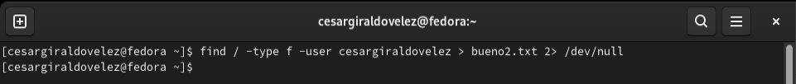

Cat bueno2.txt

