*Journal of Power Sources*

**SUPPORTING INFORMATION**

**An all-solid-state Metal Hydride - Sulfur Lithium-ion battery**

Pedro López-Arangurena,*, Nicola Bertib, Anh Ha Daoa, b, Junxian Zhangb, Fermín Cuevasb, Michel Latrocheb, Christian Jordya

aSaft, 111 boulevard Alfred Daney, 33074 Bordeaux Cedex, France

bUniversité Paris Est, ICMPE (UMR7182), CNRS, UPEC, F-94320 Thiais, France

*Corresponding author: E-mail: [pedro.lopezaranguren@saftbatteries.com](mailto:pedro.lopezaranguren@saftbatteries.com), Tel.: +33 [5 57 10 64 00](javascript:void(0))

1. **Characterization of the metal hydride composite**
   1. Structural characterization of the 0.8MgH2-0.2TiH2 powder

The crystallographic data of 0.8MgH2-0.2TiH2 composite as obtained from Rietveld analysis of XRD pattern is given in Table 1S. Phase composition, lattice parameters and crystallite size are in close agreement with previous results given in the literature [1].

**Table 1S:** Crystallographic data of hydride phases in 0.8MgH2-0.2TiH2 composite as obtained from Rietveld refinement.

|  |  |  |  |  |  |  |
| --- | --- | --- | --- | --- | --- | --- |
| Phase | Amount  (wt%) | Space group | Lattice parameters (Å) | | | Crystallite size  (nm) |
| *a* | *b* | *c* |
| ε-TiH2 | 43 | *I*4/*mmm* | 3.171 | 3.171 | 4.419 | 11 |
| β-MgH2 | 41 | *P*42/*mnm* | 4.518 | 4.518 | 3.029 | 6 |
| γ-MgH2 | 16 | *Pbcn* | 4.564 | 5.399 | 4.925 | 4 |

* 1. Microstructure of the 0.8MgH2-0.2TiH2 powder and the anode composite

Morphological and chemical examination of the 0.8MgH2-0.2TiH2 powder and the as-milled *M*H/LiBH4/C65 electrode (Fig. 1S) was first conducted with a high-resolution FEG SEM equipped with EDX microanalysis. As-milled powders were attached to a sticky carbon tape, and SEM images were acquired in secondary electron mode. To get further information on the spatial distribution of hydride phases within the powder nanocomposite, TEM analysis was done using a 200 kV FEG TEM device. The composite was immersed in dimethyl carbonate (DMC) and placed over a carbon grid. The spatial phase distribution was analyzed by image acquisition in High-Angle Annular Dark Field (HAADF) mode.

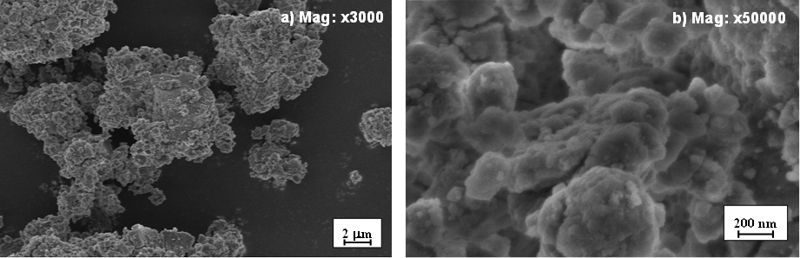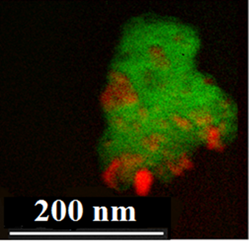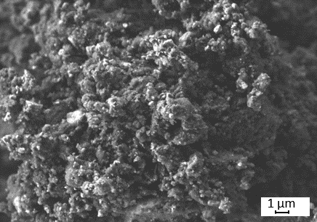

**c) Mag: x5000**

**d)**

**c)**

**Fig. 1S.** High-resolution SEM/TEM images of the 0.8MgH2-0.2TiH2 nanocomposite powder at two different magnifications: a) SEMx3000, b) SEMx50000 and c) SEM of the as-milled *M*H/LiBH4/C65 electrode. d)HAADF TEM image of the 0.8MgH2-0.2TiH2 composite. MgH2 and TiH2 identification is done by green and red colors, respectively.

C:\Users\Pedro\AppData\Local\Microsoft\Windows\INetCacheContent.Word\EDX.TIFAs shown in Fig. 1S, SEM micrographs reveal that 0.8MgH2-0.2TiH2 powder consist of micrometric agglomerates, with typical sizes comprised between 1 and 5 µm. These agglomerates are formed by nanometric particles with typical sizes comprised between 20 and 100 nm. Their spatial distribution was analyzed by HAADF-TEM image as displayed in Fig. 1Sd. This analysis reveals the co-existence and random-distribution of MgH2 and TiH2 phases within the powder aggregates. EDX analysis, which are not sensitive to hydrogen atoms, showed that the agglomerates contain both Mg and Ti atoms in agreement with the nominal composition [1] (Fig. 2S).

**Fig. 2S.** EDX spectrum of nanocomposite 0.8 MgH2-0.2 TiH2

1. **Characterization of the sulfur composite** 
   1. Microstructure of the sulfur/carbon composite

The microstructure of commercial sulfur and carbon Ketjen Black EC300J, and the S/KB composite powder after milling is shown in Fig. 3S.

N:\PECOSTORe\PaperFullCellMetalhydrideSulfur\Figures\SEM.tif

**Fig. 3S.** SEM images of a) commercial sulfur, b) carbon KB 300, c) and d) as-milled S/KB mixture.

Pristine S and carbon exhibit particle sizes in the order of 10-30 µm and below 100 nm, respectively. Figures 3Sc and c, obtained from the S/KB mixture, show that sulfur and carbon are uniformly mixed forming dense micrometer size particles.

* 1. Textural characterization of the sulfur/carbon composite

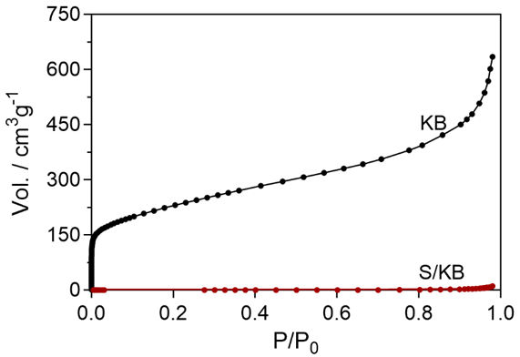N2 adsorption isotherms at -196 ºC of raw KB and as milled S/KB (Fig. 4S) were obtained using a BELSORP-miniII (MicrotracBEL).

**Fig. 4S:** Nitrogen adsorption curves for raw carbon Ketjen Black and the S/KB mixture after ball milling.

1. **Electrochemical Impedance Spectroscopy**

AC impedance measurements were obtained using an Autolab PGSTAT30 potentiostat, setting an input voltage perturbation and a frequency rate of 50 mV and 1MHz-1Hz, respectively. The measurements were carried out at 120 °C. To examine the factors determining the internal resistance of the complete cell, impedance spectra were performed on single pellets of the S/C65/LiBH4 anode, the S/KB/LiBH4 cathode and the complete cell at OCV, and at the initial charged and discharged states (Fig. 5S).

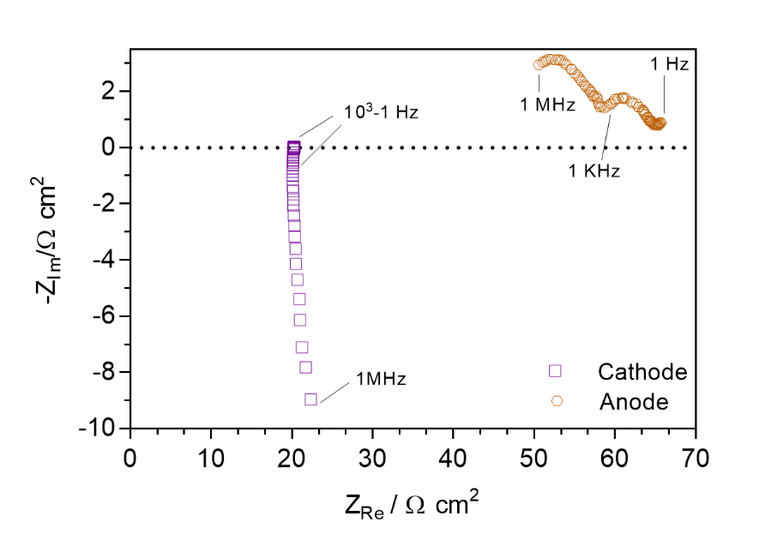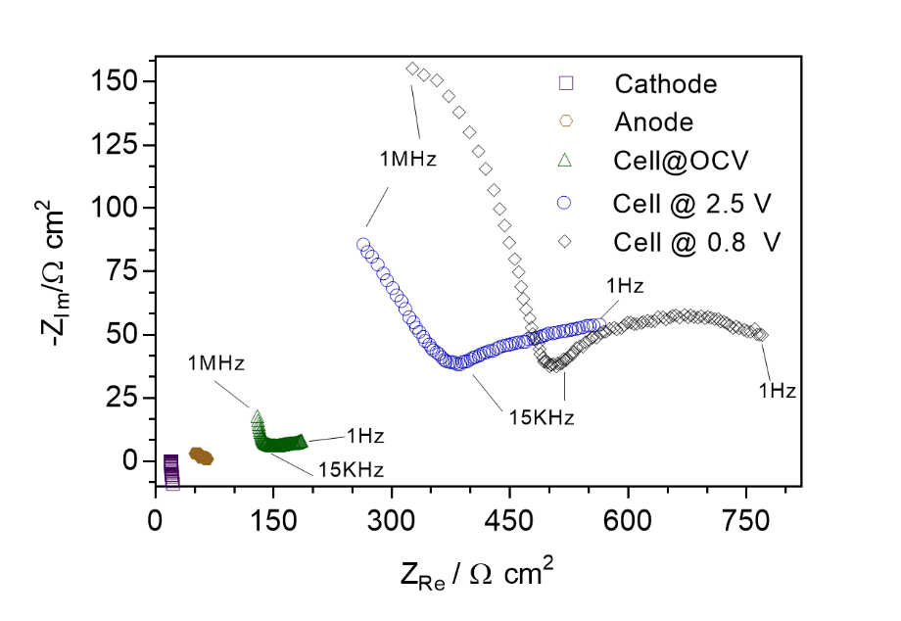

a)

b)

**Fig. 5S.** a) Impedance spectrum of the electrodes and the complete cell at OCV and after the initial charge and discharge at 2.5 V and 0.8 V, respectively. b) Magnification of the resistance contribution from the cathode and anode.

A resistance contribution lower than 100 Ω cm2, with a linear and a two semicircles profile (Fig. 5Sb), was found for the cathode and the anode, respectively. Two main regions corresponding to high- (1 MHz-15 KHz) and low – (15 KHz-1 Hz) frequency range are clearly observed for the complete cell profiles. The former one is atributed to the resistance of the solid electrolyte layer and Li migration, while the later is associated to charge transfer and diffusion phenomena [2]. In the complete cell at OCV the ionic conductivity of the electrolyte, associated to the high frequency semicircle, was calculated to be log(σ/S cm‑1)= ‑3.2. This value is in agreement with the lithium ionic conductivity of LiBH4 [3] and its similar to previous works of ASS batteries with LiBH4 as solid electrolyte [4]. For the profiles of the complete cell after the initial charge and discharge the following phenomena is hypothesized: after the first charge, S and LiH + Mg/Ti are formed in the cathode and the anode, respectively. These species are highly ionic insulators and, with the exception of the metals, highly electronic insulators [5], therefore contributing to the increase of the resistance of both, charge transfer and difussion. Aditionally, the possible formation of SEI may induce the increase on the resistance to Li migration. A similar profile with an increasing resistance to Li migration was found for the cell after the initial discharge. This may be explained by the loss of ionic and electric contact due to the large volume changes within the electrodes ocurring during the Li migration from the anode to the cathode electrode.

**References**

1. F. Cuevas, D. Korablov and M. Latroche, Phys. Chem. Chem. Phys. 14 (2012) 1200-1211
2. E. Barsoukov, J.R. Macdonald, Impedance Spectroscopy Theory, Experiment, and Applications, Wiley-Interscience, Canada, 2005.
3. M. Matsuo, Y. Nakamori and S. Orimo, Applied Physics Letters, 91, 2007.
4. A. Unemoto, T. Ikeshoji, S. Yasaku, M. Matsuo, V. Stavila, T. J. Udovic and S. Orimo, Chemistry of Materials, 27, 2015, 5407-5416.
5. M. Ikeya, Journal of the Physical Society of Japan, 42, 1977, 168-174.