Demerrick Moton

9 Feb 2017

Statistics: The Science of Decisions

**Background Information**

In a Stroop task, participants are presented with a list of words, with each word displayed in a color of ink. The participant’s task is to say out loud the *color of the ink* in which the word is printed. The task has two conditions: a congruent words condition, and an incongruent words condition. In the *congruent words* condition, the words being displayed are color words whose names match the colors in which they are printed: for example RED, BLUE. In the *incongruent words* condition, the words displayed are color words whose names do not match the colors in which they are printed: for example, PURPLE, ORANGE. In each case, we measure the time it takes to name the ink colors in equally-sized lists. Each participant will go through and record a time from each condition.

1. What is our independent variable? What is our dependent variable?

- Independent Variable: The colors, names, size, and condition of the list of words

- Dependent Variable: Time it takes to correctly name the ink color in equally-sized lists

2. What is an appropriate set of hypotheses for this task? What kind of statistical test do you expect to perform? Justify your choices.

I want to test whether words supersede colors in selective memory

H0: μincongruent <= μcongruent

HA: μincongruent > μcongruent

(One-Tailed Test)

Hypothesis: Since the congruent set represents primarily the words being recognized, the population mean for the congruent should be higher than the population mean for the incongruent set since people will recognize word associations more efficiently. To test this hypothesis, I will perform a one-tailed dependent t-test on the given sample to make an inference about the population.

The null hypothesis (H0) postulates that the mean recognition time for the congruent set (μcongruent) is greater than or equal to the mean recognition time for the incongruent set (μincongruent). This implies that the population can recognize color associations faster than word associations – the opposite of our suspicion.

The alternate hypothesis (HA) postulates that the mean recognition time for the congruent set is less than the mean recognition time for the incongruent set. This implies that the population can recognize word associations faster than color associations – this is in line out suspicions.

My assumptions are the following:

* Samples size(n) is less than 30
* Population statistics are not given
* The data is dependent because the samples are coupled
* One-tailed: will only test for one end of the distribution

3. Report some descriptive statistics regarding this dataset. Include at least one measure of central tendency and at least one measure of variability.

|  |  |
| --- | --- |
| **Congruent** | **Incongruent** |
| mean = 14.05 | mean = 22.02 |
| size = 24 | size = 24 |
| median = 14.35 | median = 21.01 |
| std. dev. = 3.56 | std. dev. = 4.80 |
| Q1 = 11.34 | Q1 = 18.644 |
| Q2 = 14.36 | Q2 = 21.01 |
| Q3 = 16.791 | Q3 = 24.52 |

4. Provide one or two visualizations that show the distribution of the sample data. Write one or two sentences noting what you observe about the plot or plots.

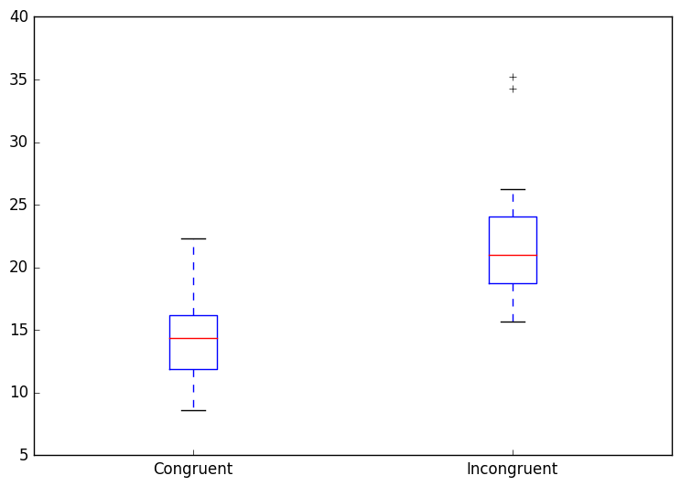

It’s clear that the response time for the congruent list was faster and that response time settled around 14-17 seconds for the congruent list and 17-22 for the incongruent list. The range for the incongruent list was slightly longer.

5. Now, perform the statistical test and report your results. What is your confidence level and your critical statistic value? Do you reject the null hypothesis or fail to reject it? Come to a conclusion in terms of the experiment task. Did the results match up with your expectations?

t-Test Specification:

Do words supersede colors in selective memory?

H0: μincongruent <= μcongruent

HA: μincongruent > μcongruent

(One-Tailed Test)

t-Test for two dependent samples:

Confidence Level: 95% (α=.05)

Critical Value (df = 23): 1.714

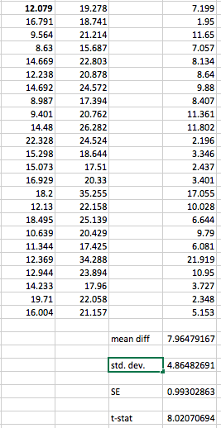

D_bar = 7.96

SE: 0.99

t-Statistic: 8.02

8.02 >= 1.714 so H0 is rejected

The difference between congruent and incongruent scores is statistically significant

The results matched my expectations – subjects recognized word associations more efficiently than just the color associations. I think that the first test may have had a small effect on the second, which is why they were assumed to be dependent. That is, maybe some users got better at taking the test once, and it affected the score on their second time taking it, but I think that effect would not be too significant.

6. Optional: What do you think is responsible for the effects observed? Can you think of an alternative or similar task that would result in a similar effect? Some research about the problem will be helpful for thinking about these two questions!

I think the effect may be due to the fact that as we grow older, we interpret words more frequently than we interpret colors – maybe because words carry more information and are more useful. I think I’ve seen a similar experiment where police have to look at a series of photos of situations and determine which of the situations depict a non-threat, medium-threat, or high-threat. They unconsciously picked out certain things to pay attention to while ignoring other things. I think trying this test on illiterate (or low-reading level) adults might be interesting to see how different the results would be vs literate adults.