Channel Islands National Park Kelp Forest Monitoring Program

Kelp Forest Community Trend Report 2005-2019

Table of Contents

# Abstract

What is the meaning of life?

# Acknowledgments

Thank.

# List of Acronyms

|  |  |
| --- | --- |
| **Acronym** | **Definition** |
| SMR | State Marine Reserve |
| FSC | Foliar Standing Crop |

# Introduction

In these analyses, we compared changes in diversity and biomass within benthic and fish communities at KFMP MPA reference sites since 2005. For the benthic community, we compiled data from each benthic survey type - 1m quadrats, 5m quadrats, and band transects, and eliminated redundant species between survey types, using only the “best” survey for each species. We then corrected for sampling differences between survey types by calculating estimated total site abundances (density (#/m²) * 2000 m² = estimated count at site), and calculated Shannon’s diversity index (or “Shannon Index” - a commonly used metric in ecology) for each site and year. Roving Diver Fish Counts, however, occur over the entirety of the site, so we calculated Shannon indicies using average counts for each species within a given site and year. (Continue about Biomass but we haven’t done those yet…)

To test whether MPA reserve status, island, or their interaction have a significant effect on benthic and fish diversity over time, we used a pair of generalized linear mixed models with Shannon Index as the independent variable, Reserve Status and Island as fixed effects, and Survey Year as a random effect (functionally equivalent to a two-way repeated measures ANOVA). Results that follow present the statistical outputs from these models, as well as visualizations of benthic and fish diversity over time, organized by reserve status and island.

# Methods

R analysis.

Maps of each MPA with sites shown.

## Equations Used

$\text{Shannon’s Diversity Index}=−\sum_{i=1}^{s}{ }P_{i}*ln(P_{i})$

Where

* $S$ is the total number of species in the community (species richness)
* $P_{i}$ is the proportion of the total # of individuals in the community of species $i$

$\text{Biomass}=\sum_{i=1}^{n}{\frac{1}{n}}*b*d$

Where

* n is the total number measured
* b is the biomass in grams for an individual at a given size
* d is the density in #/ $m^{2}$ for that species

Foliar Standing Crop = $0.0848*SD+0$

Where

* $0.0848$ is the regression coefficient relating stipe density to foliar standing crop (Rassweiler et al. 2018)
* $SD$ is the stipe density for a given site and year

# Statistical Analyses

Explain me

## Benthic Diversity

Model Formula: Shannon Index = Reserve Status * Island + (1 | Survey Year)

|  |  |  |  |  |
| --- | --- | --- | --- | --- |
|  | F | Df | Df.res | Pr(>F) |
| ReserveStatus | 8.911953 | 1 | 338 | 0.0030397 |
| IslandCode | 14.418744 | 3 | 338 | 0.0000000 |
| ReserveStatus:IslandCode | 2.378025 | 3 | 338 | 0.0696923 |

## Fish Diversity

Model Formula: Shannon Index = Reserve Status * Island + (1 | Survey Year)

|  |  |  |  |  |
| --- | --- | --- | --- | --- |
|  | F | Df | Df.res | Pr(>F) |
| ReserveStatus | 5.717594 | 1 | 338 | 0.0173422 |
| IslandCode | 58.220344 | 3 | 338 | 0.0000000 |
| ReserveStatus:IslandCode | 5.197032 | 3 | 338 | 0.0016039 |

## Kelp Biomass

Model Formula: Foliar Standing Crop = Reserve Status * Island + (1 | Survey Year)

|  |  |  |  |  |
| --- | --- | --- | --- | --- |
|  | F | Df | Df.res | Pr(>F) |
| ReserveStatus | 103.1235145 | 1 | 337.0172 | 0.0000000 |
| IslandCode | 60.7078118 | 3 | 337.0171 | 0.0000000 |
| ReserveStatus:IslandCode | 0.6485971 | 3 | 337.0173 | 0.5843066 |

# Figures

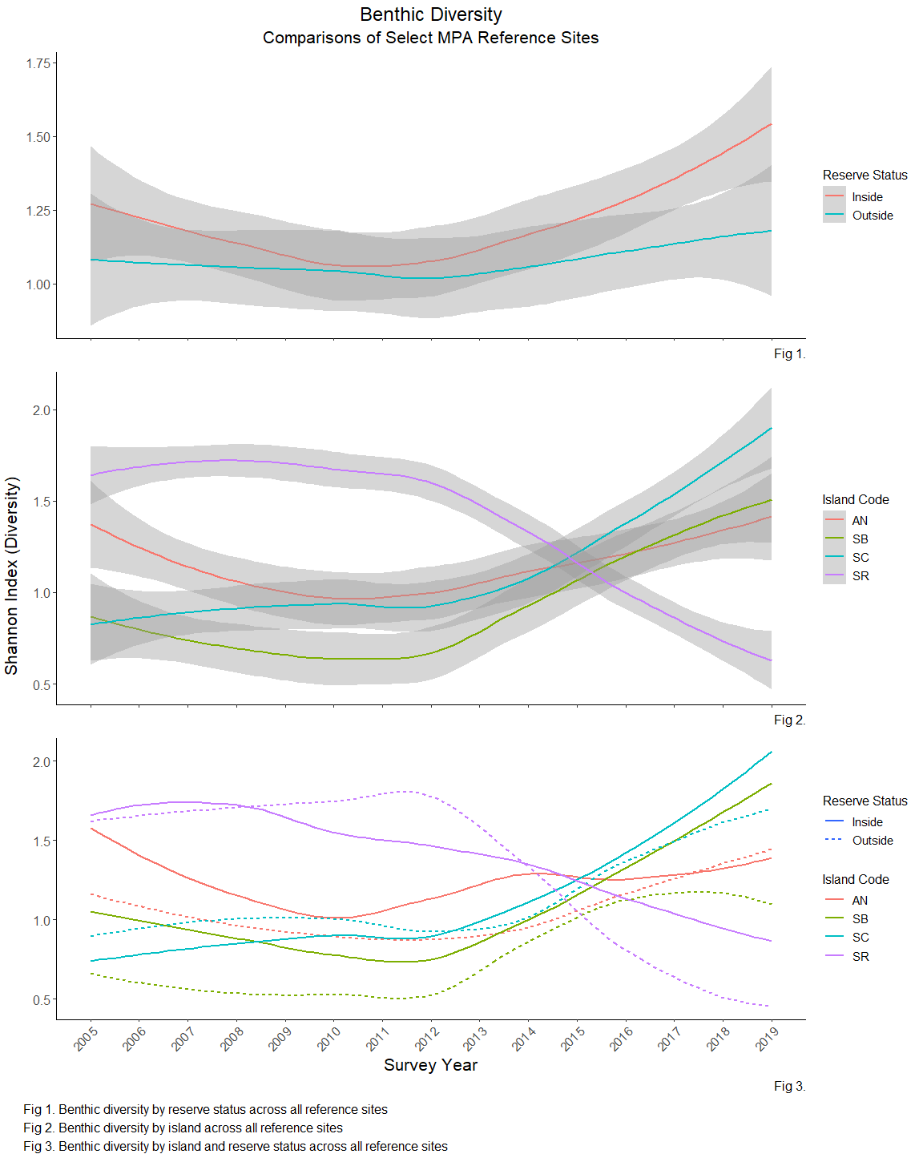

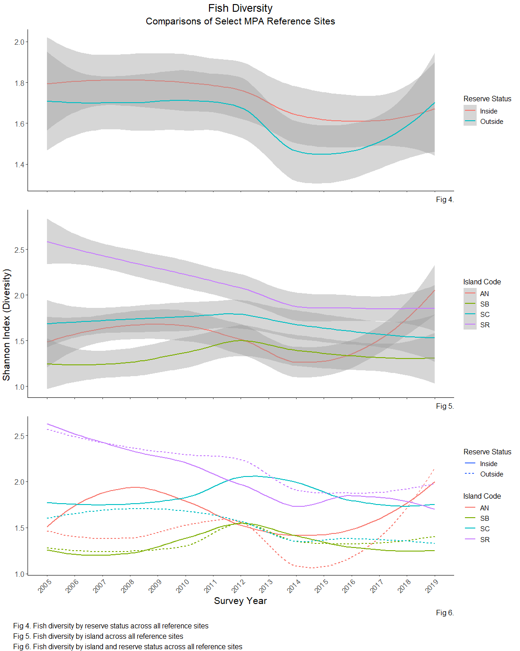

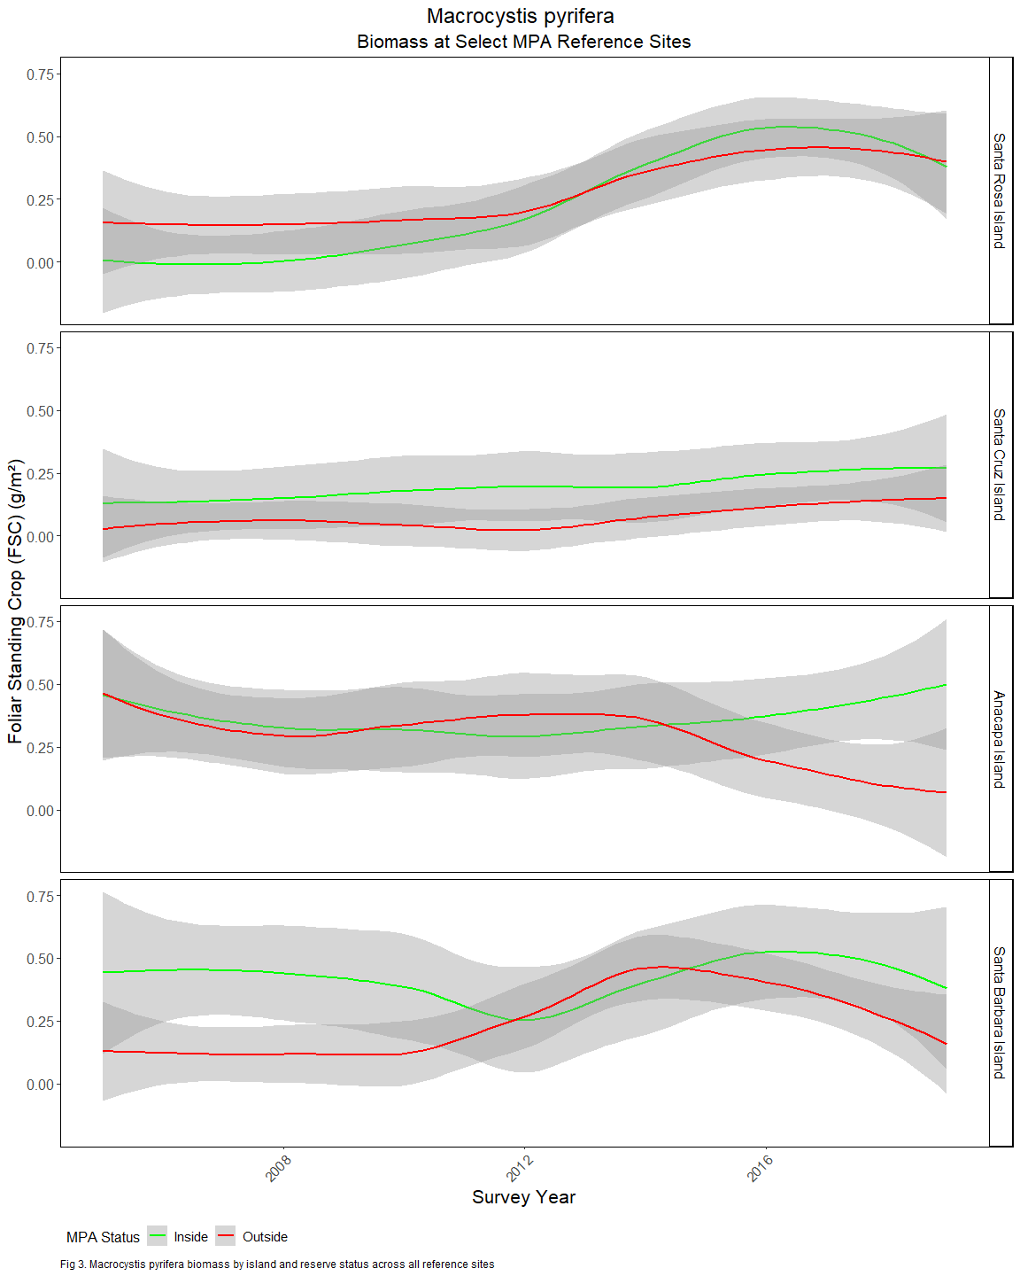

# Discussion

placeholder for discussion of trends once we’ve fleshed this out

# Literature Cited

Rassweiler et al 2018 - conversions to kelp biomass

# Appendix A. MPA Biomass over time for benthic species

Estimated biomass by MPA status and Island

